Bengali Letters

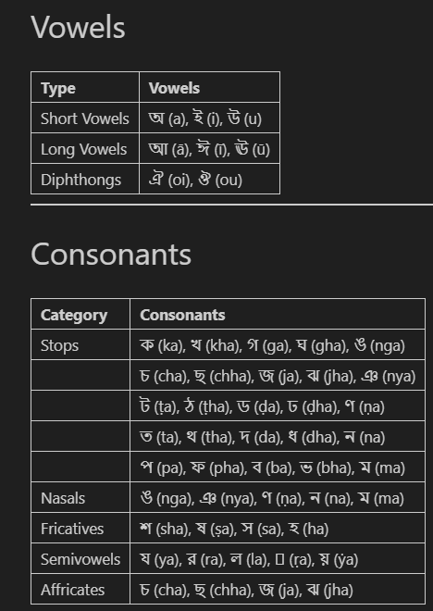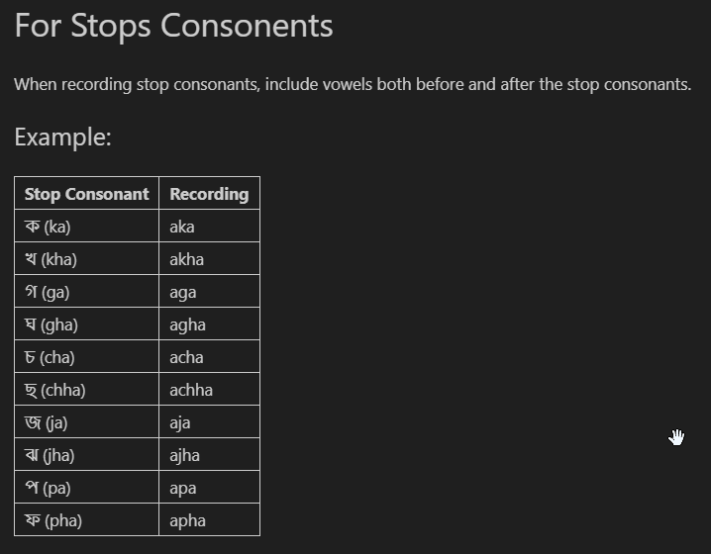

Vowels
Type | Phoneme (IPA) | Example Word | Description
Short Vowels | অ , ই , উ | অমি, তুমি | Brief in duration
Long Vowels | আ, ঈ , ঊ | রাম, নীল | Longer in duration
Diphthongs | ঐ, ঔ | ঐক্য, মৌ | Glide between two vowels

Short Vowels
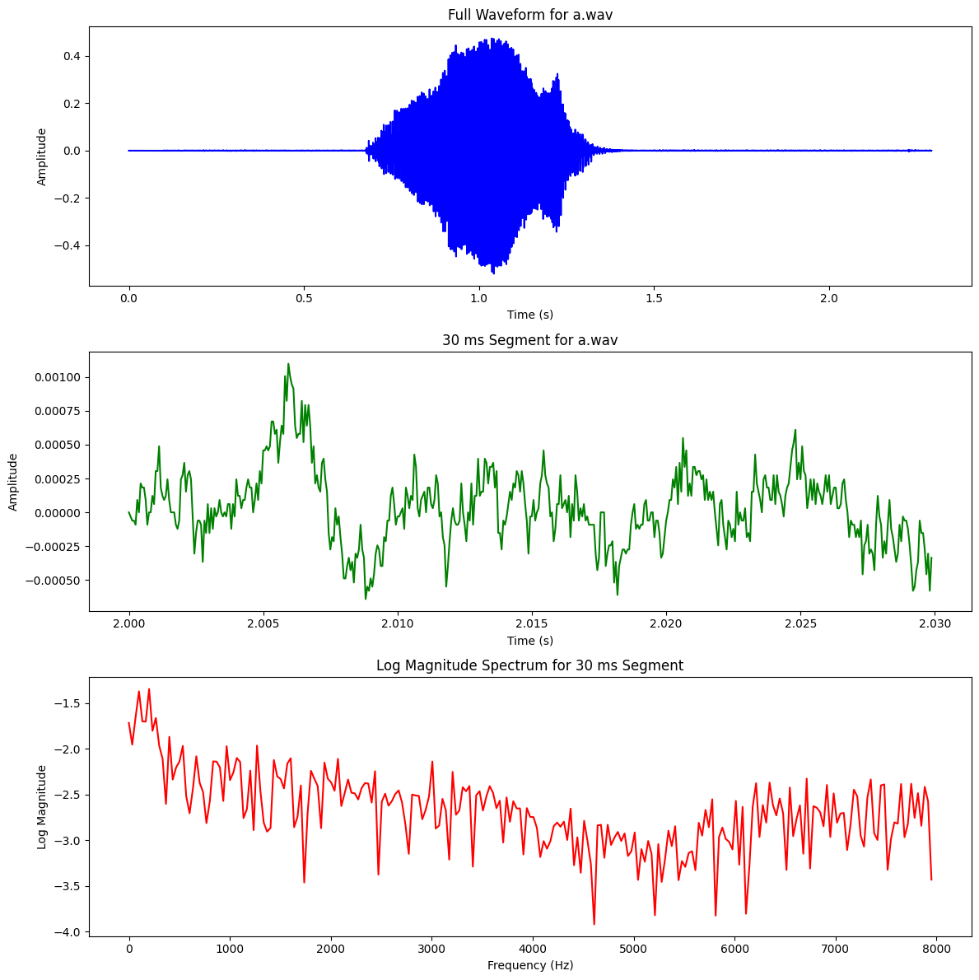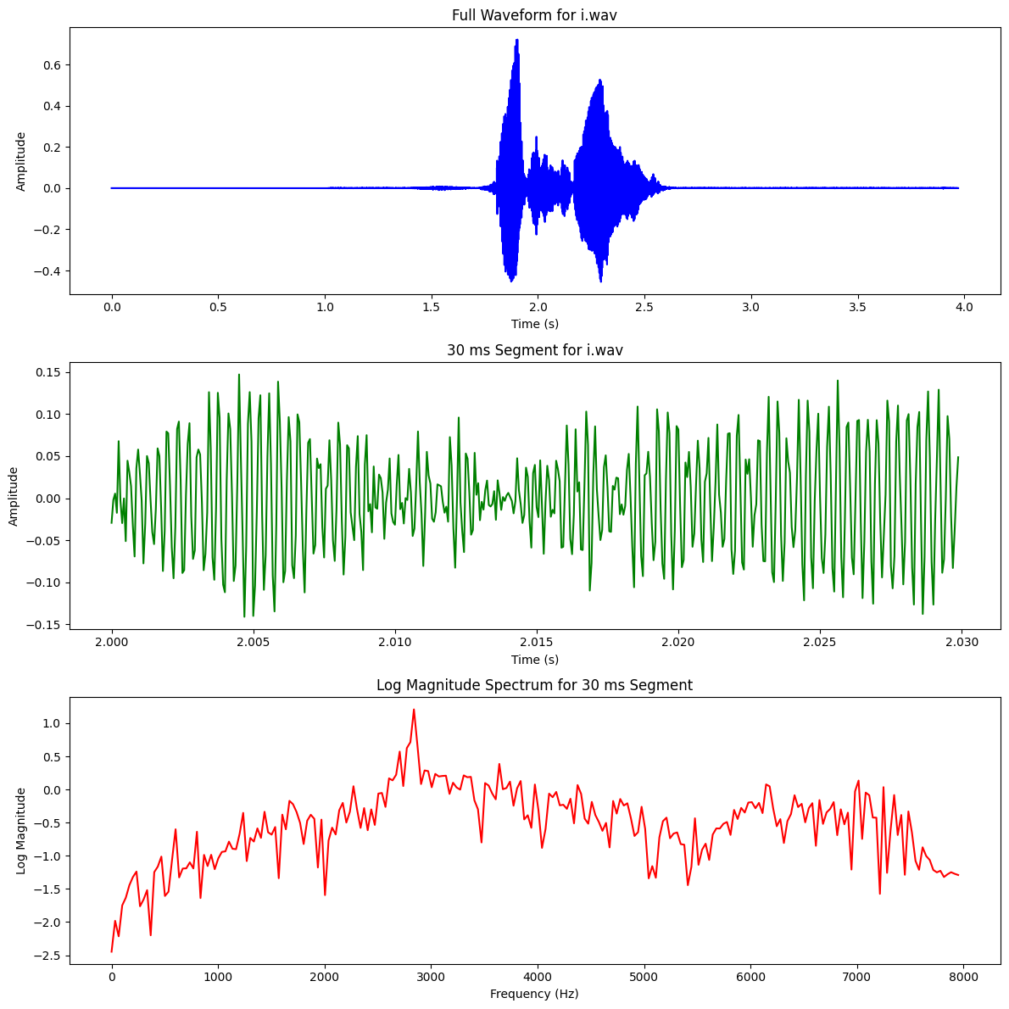
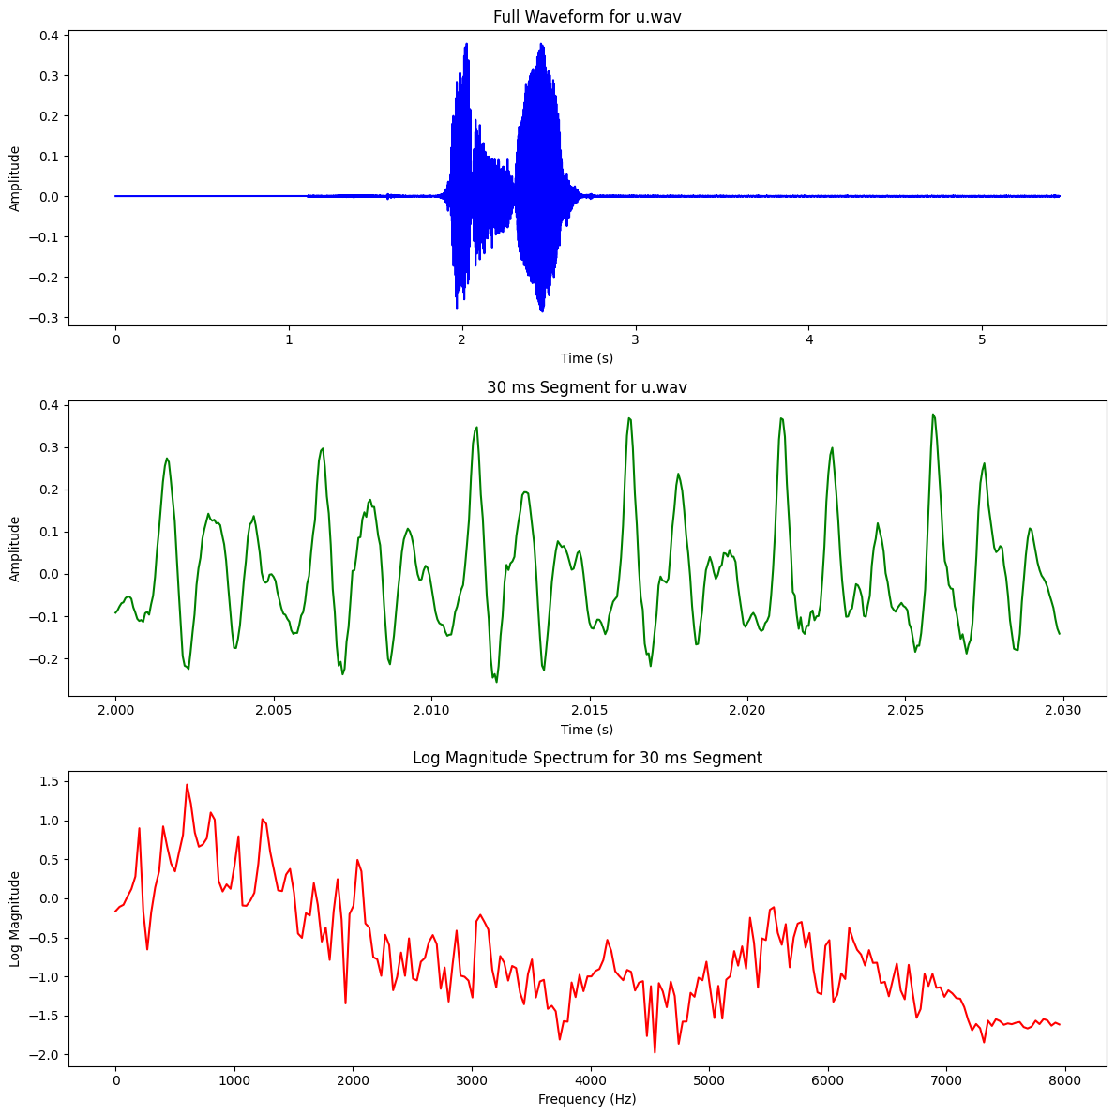

Vowels – Long

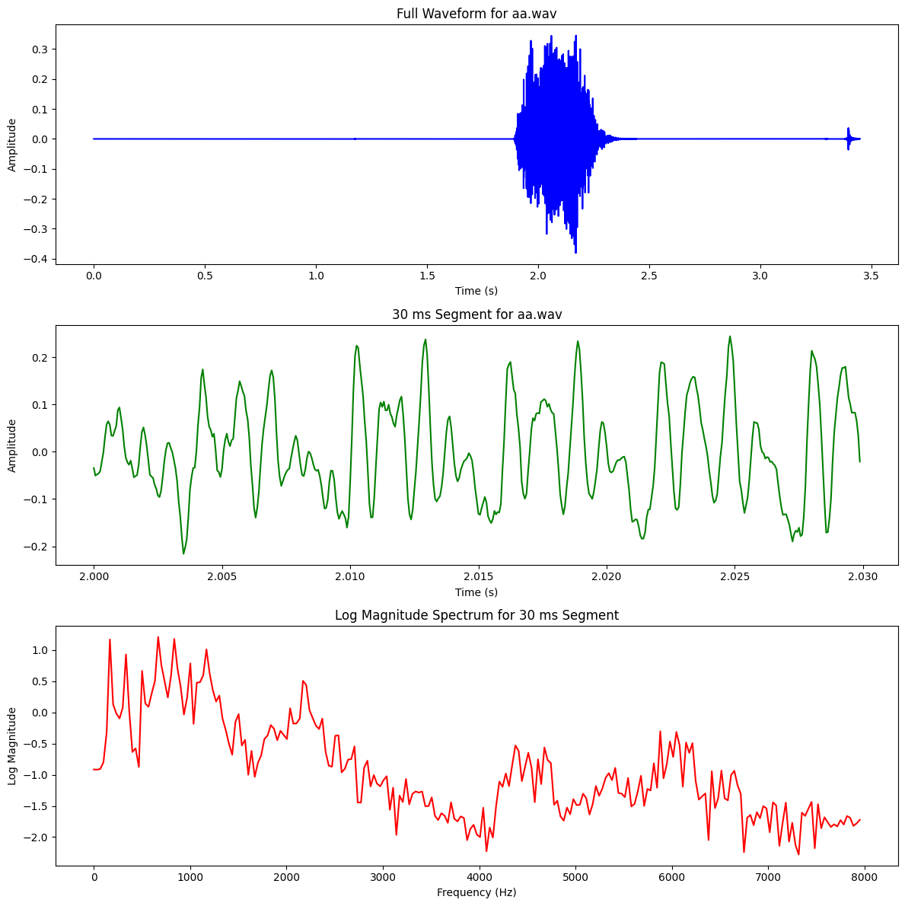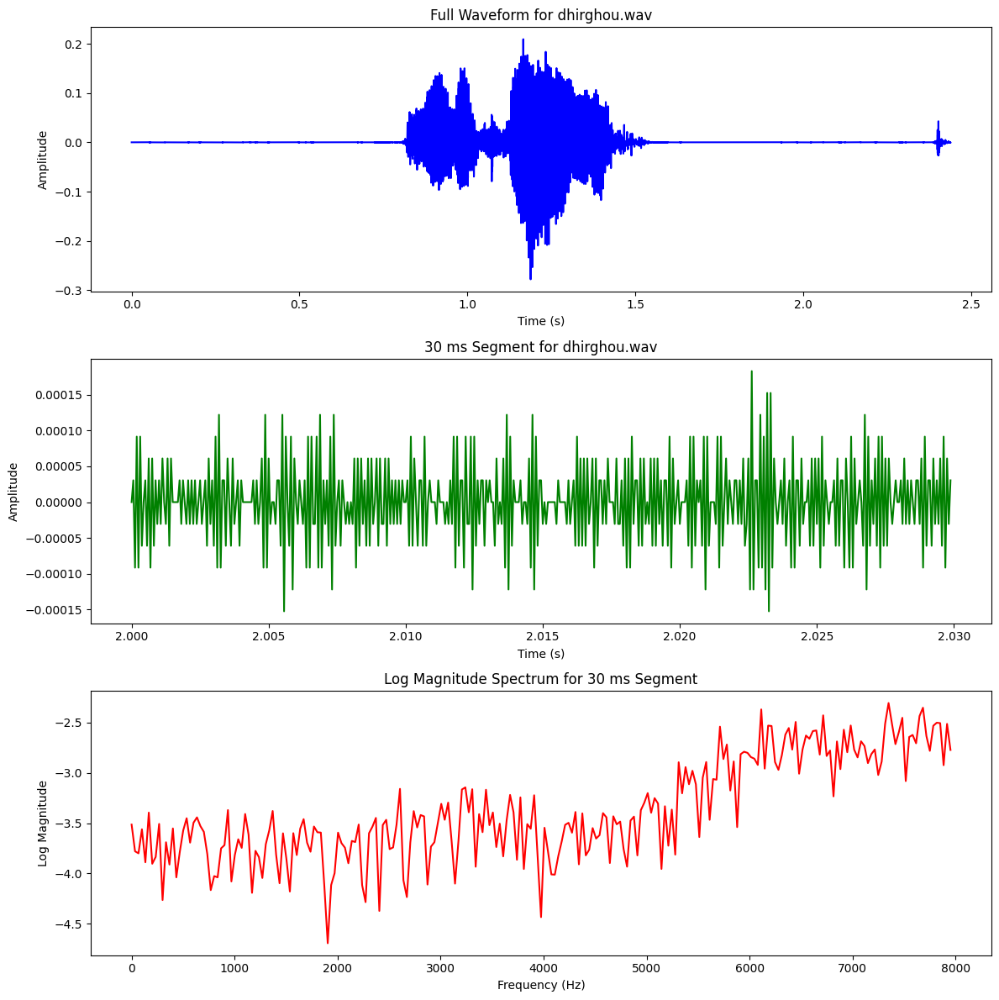

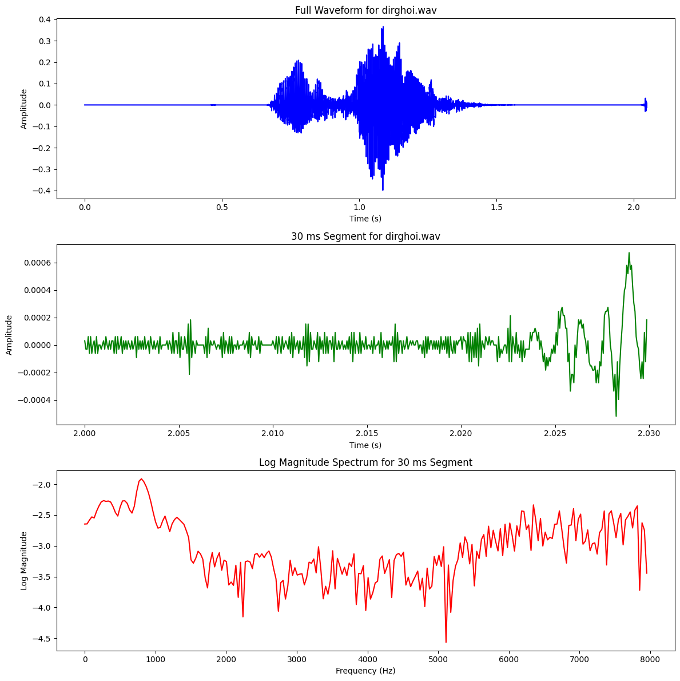

Dipthongs

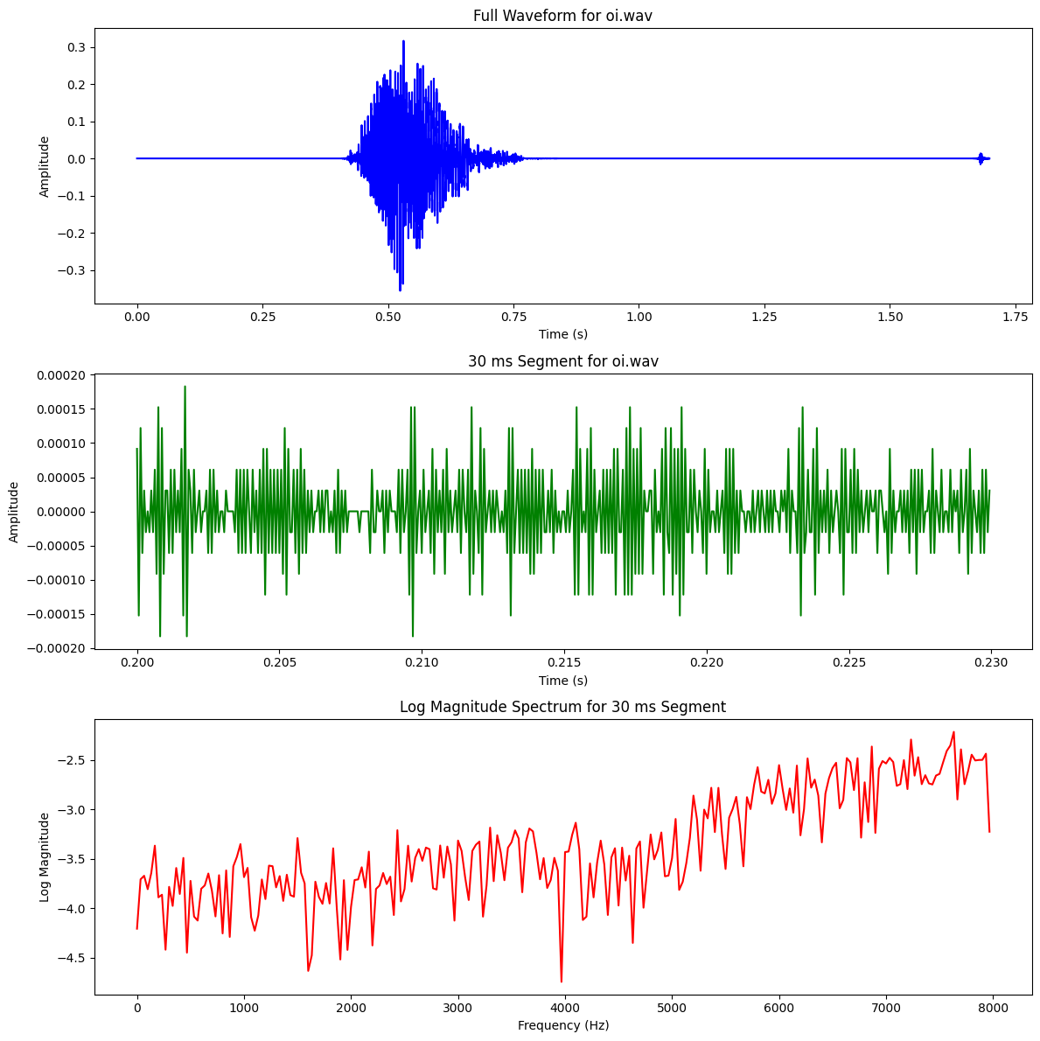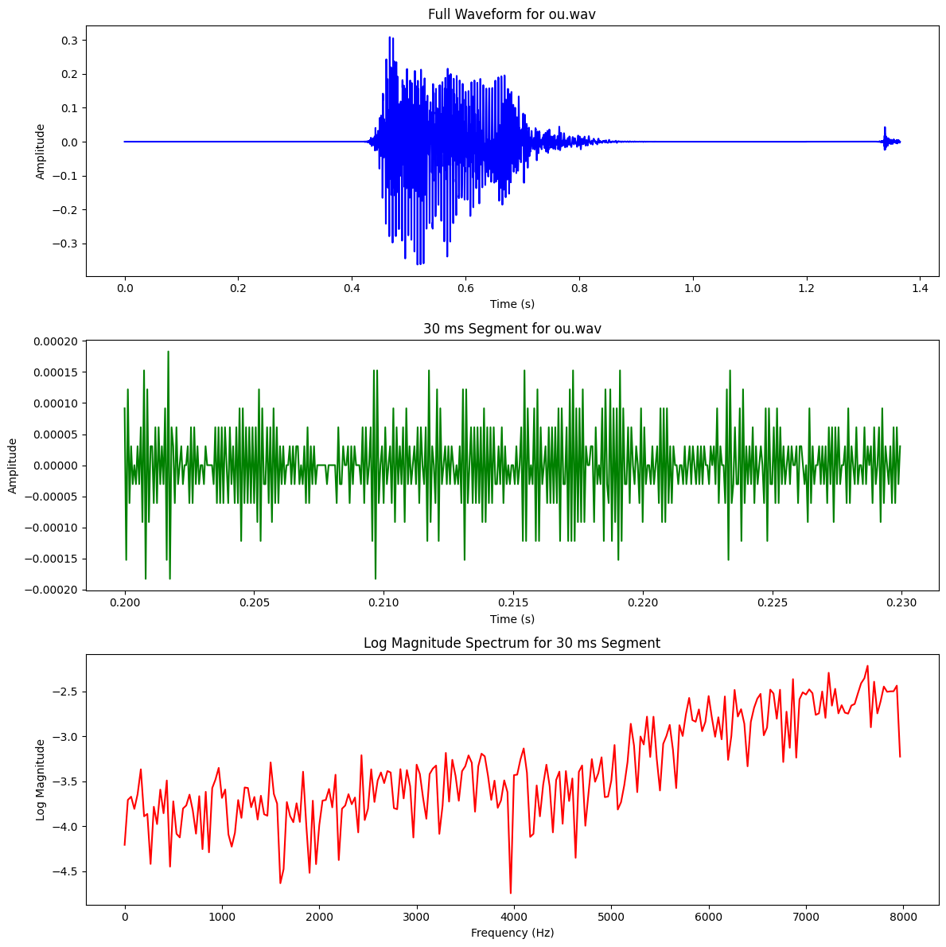

Consonents – Stops
Type | Phoneme (IPA) | Place of Articulation | Manner of Articulation
Affricates | চ , ছ | Palatal | Stop + Friction (Affricate)
Fricatives | শ , ষ, স | Alveopalatal, Retroflex | Fricative
Nasals | ম , ন, ঙ, ণ | Bilabial, Alveolar, Velar, Retroflex | Nasal
Semivowels | য , র, ল | Palatal, Retroflex, Alveolar | Approximant (Semivowel)
Stops | ক, খ, গ, ঘ,… | Velar, Palatal, etc. | Blocking Airflow

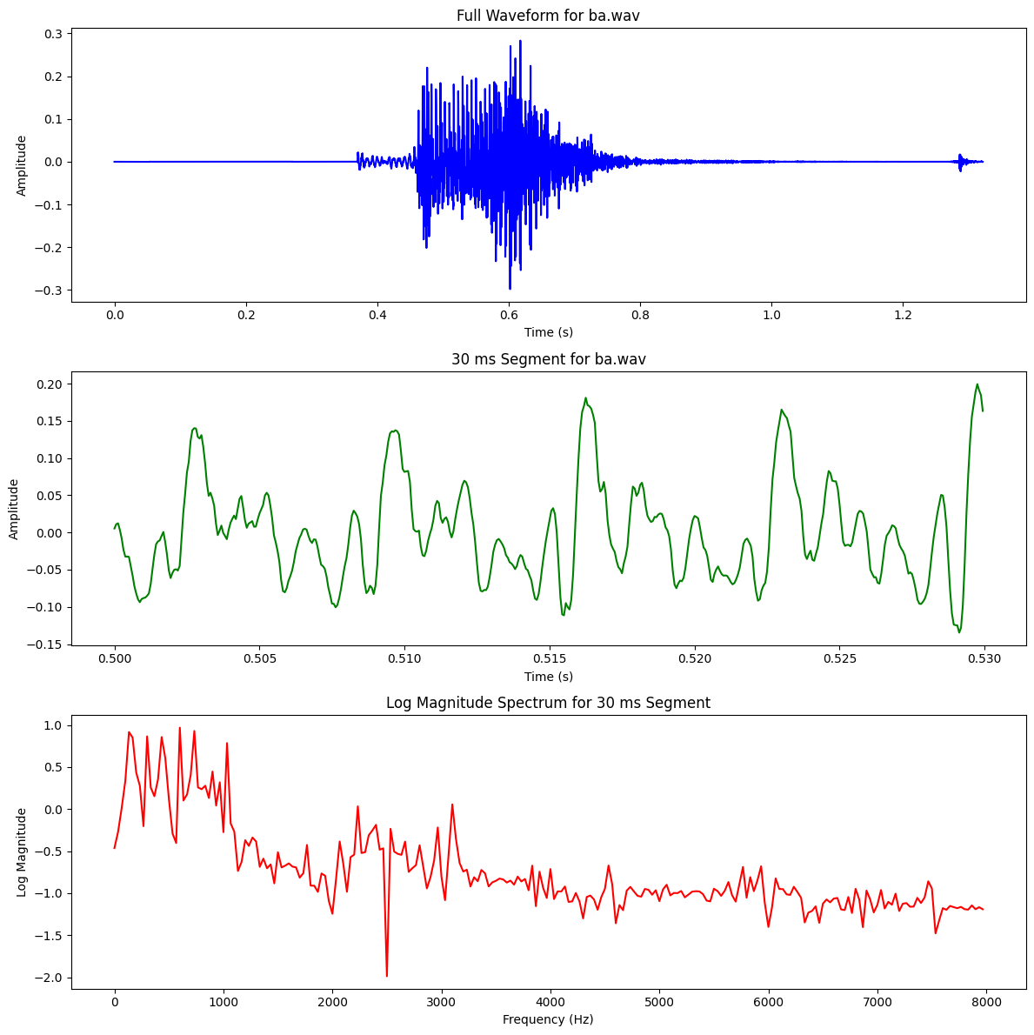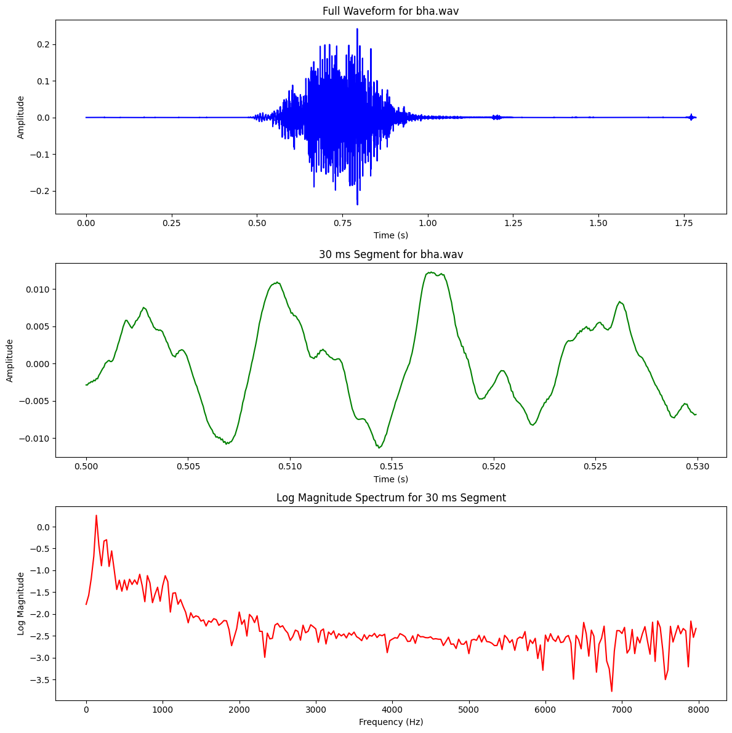
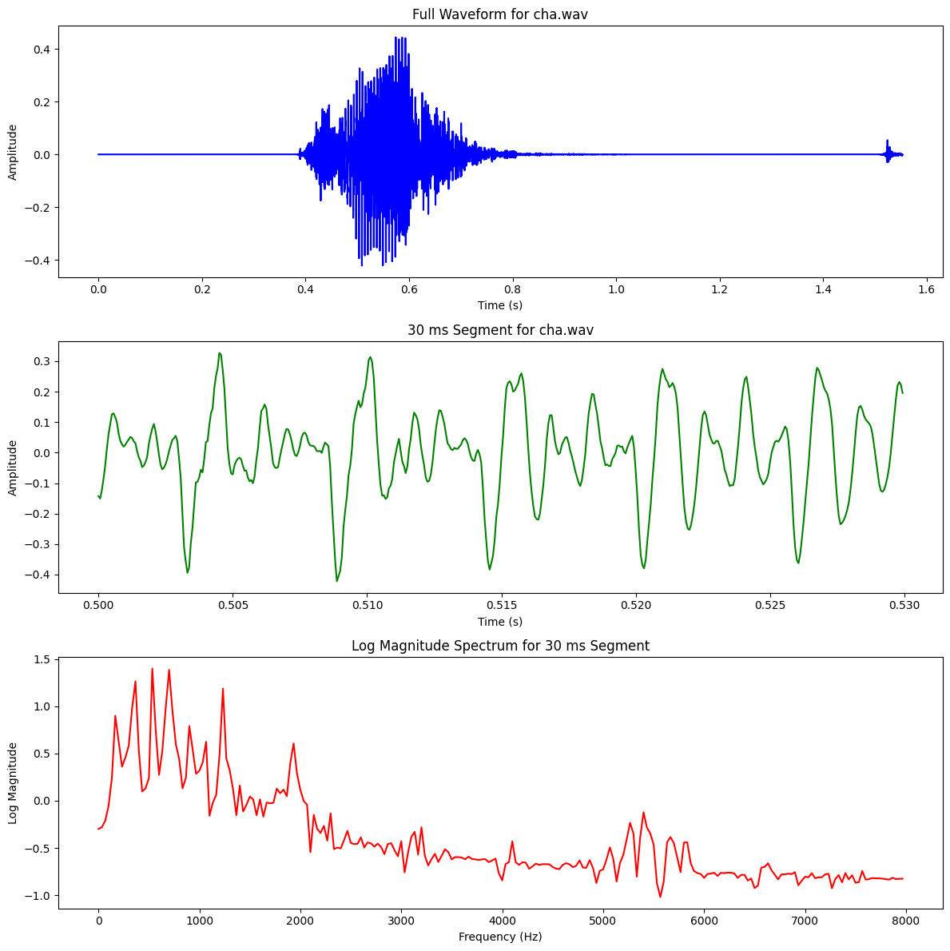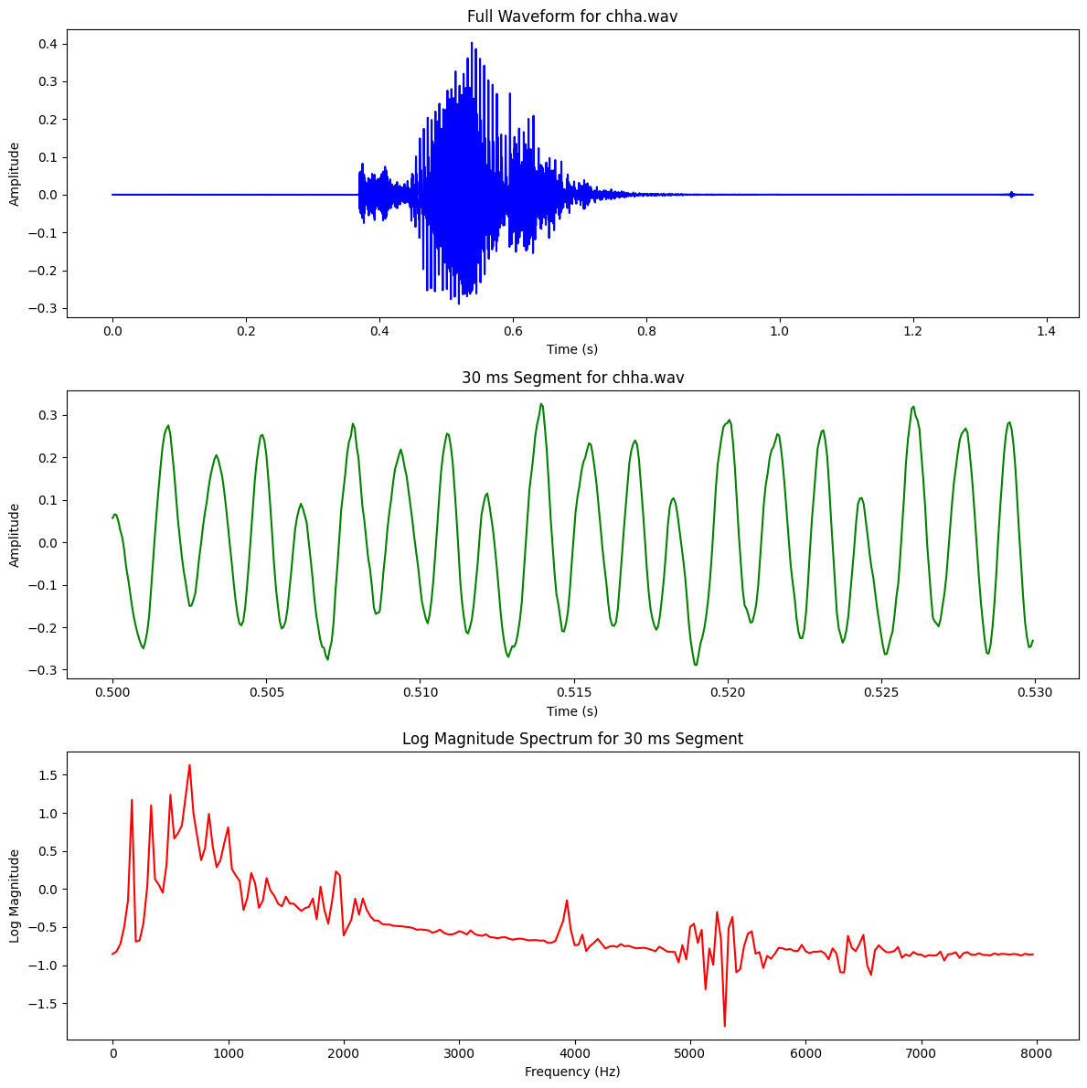

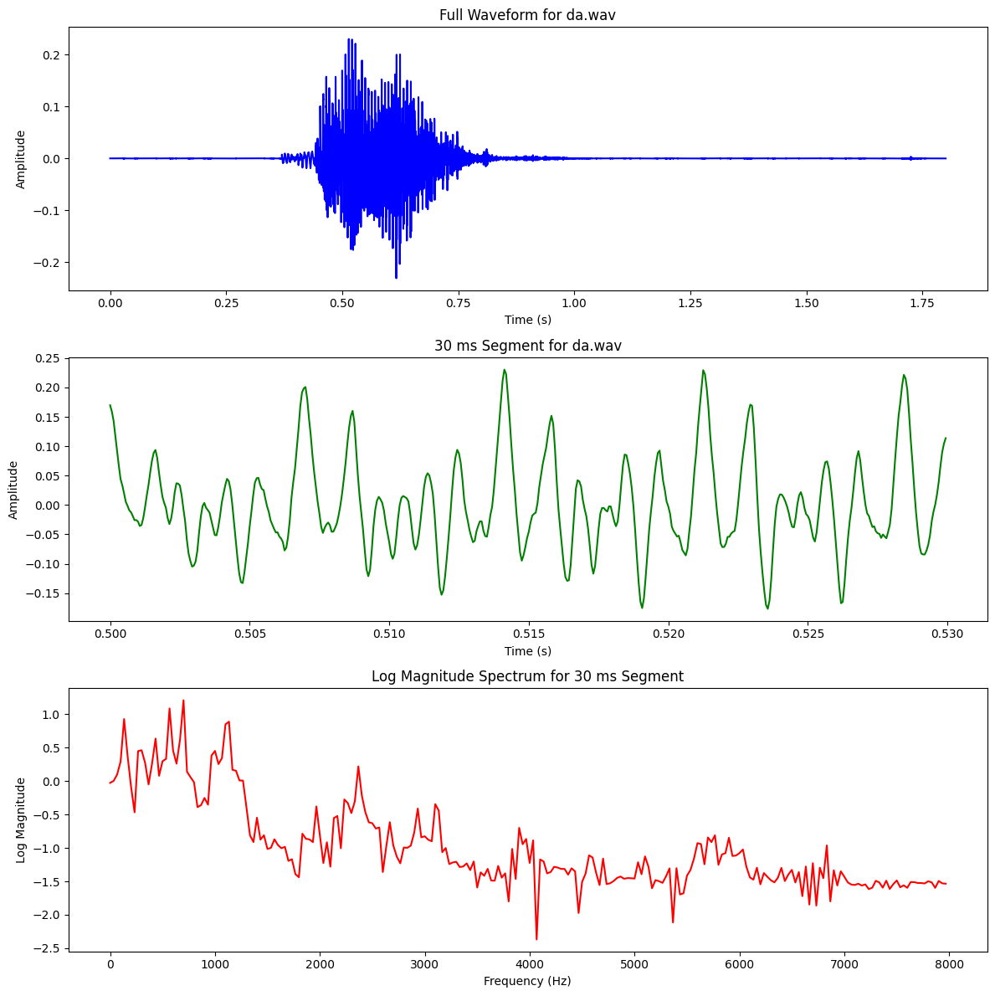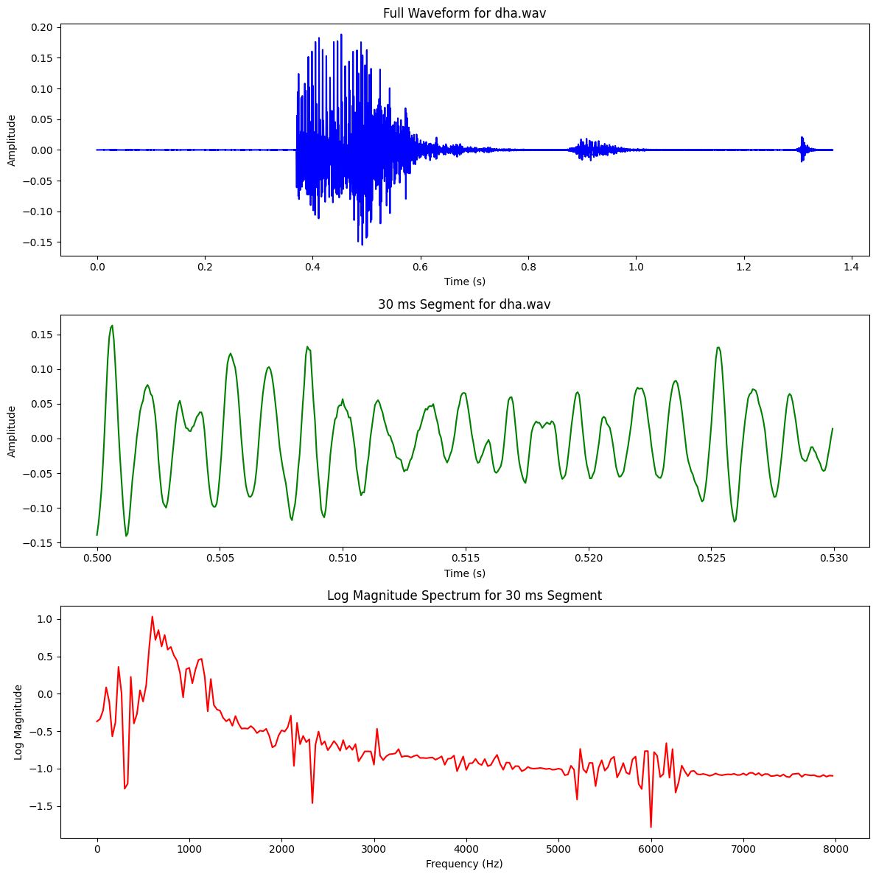

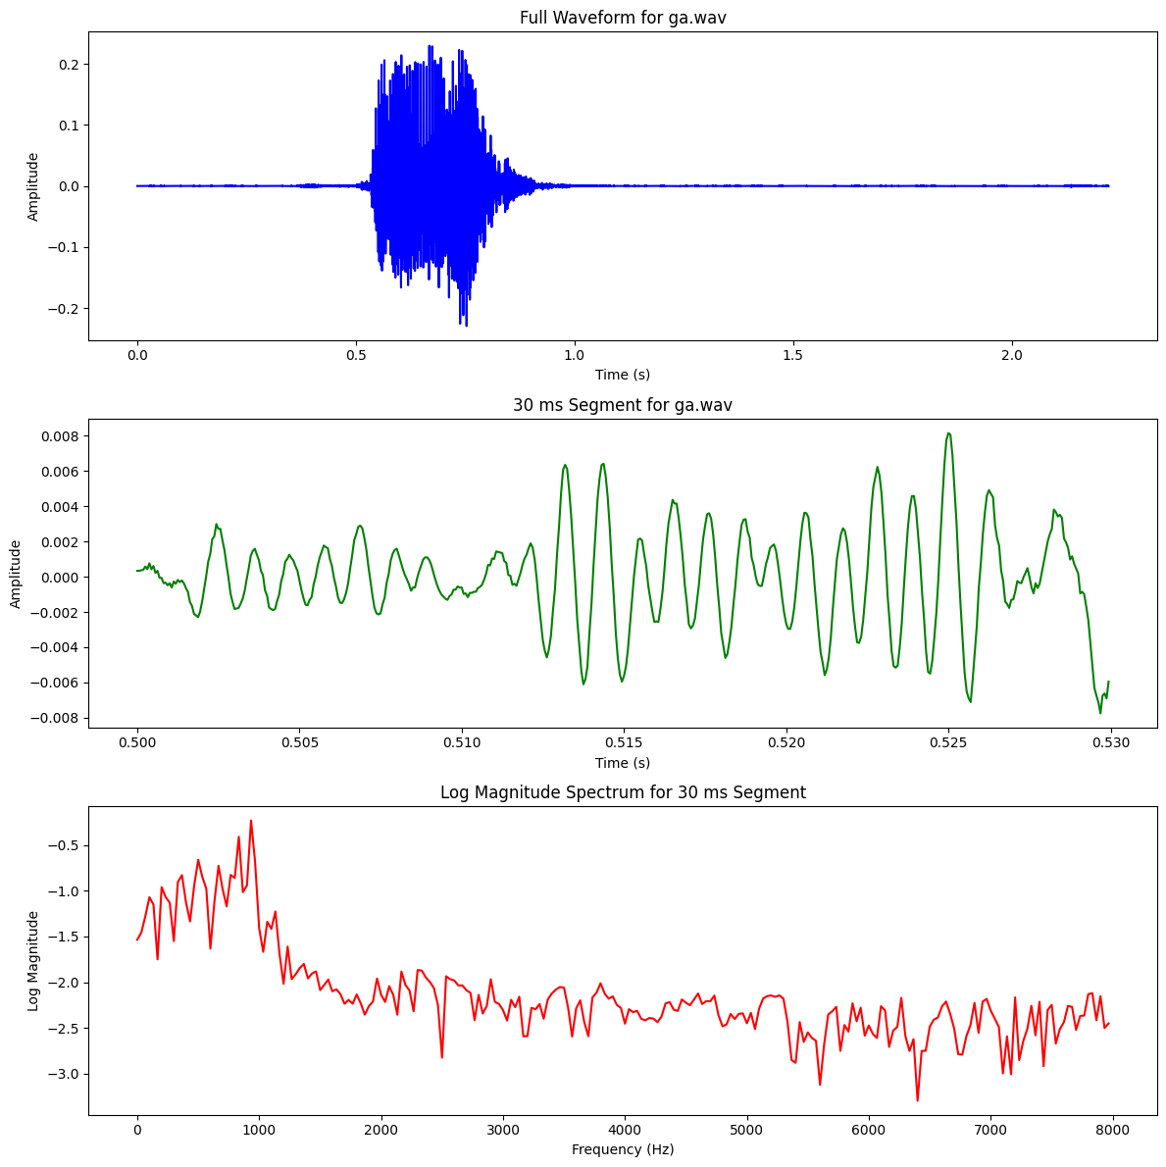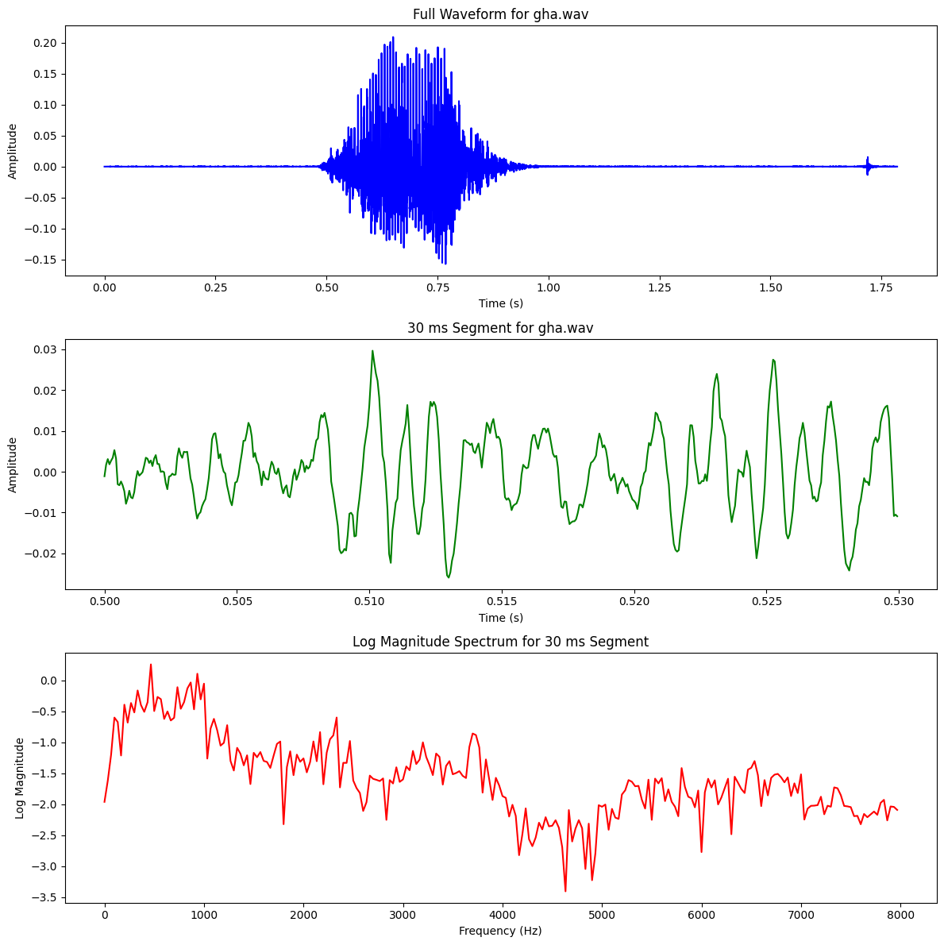

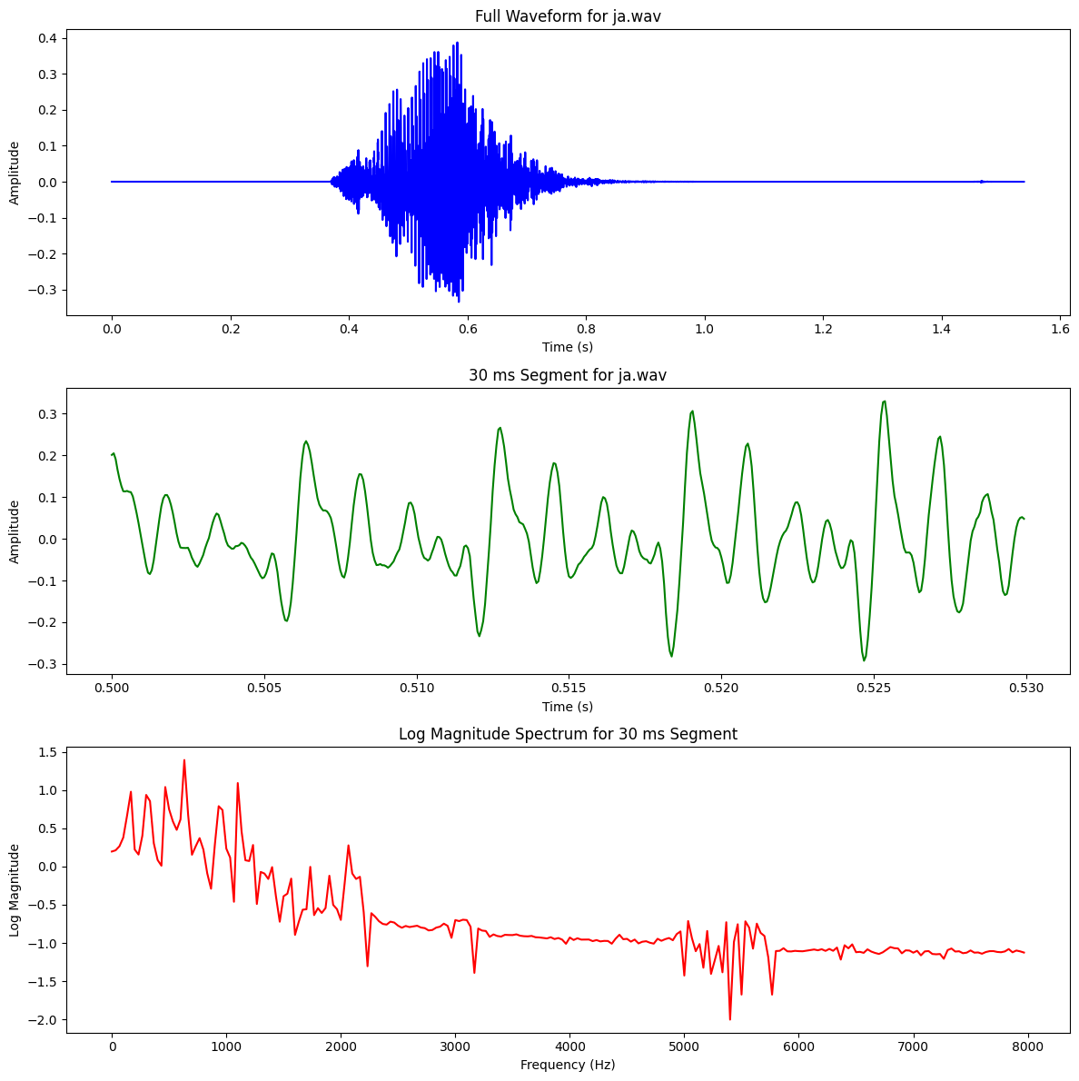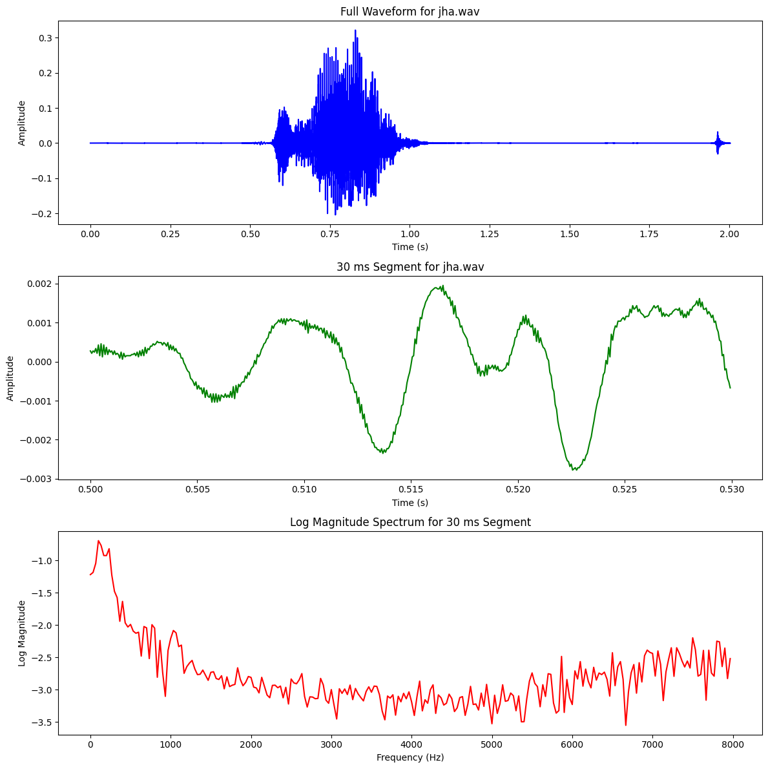

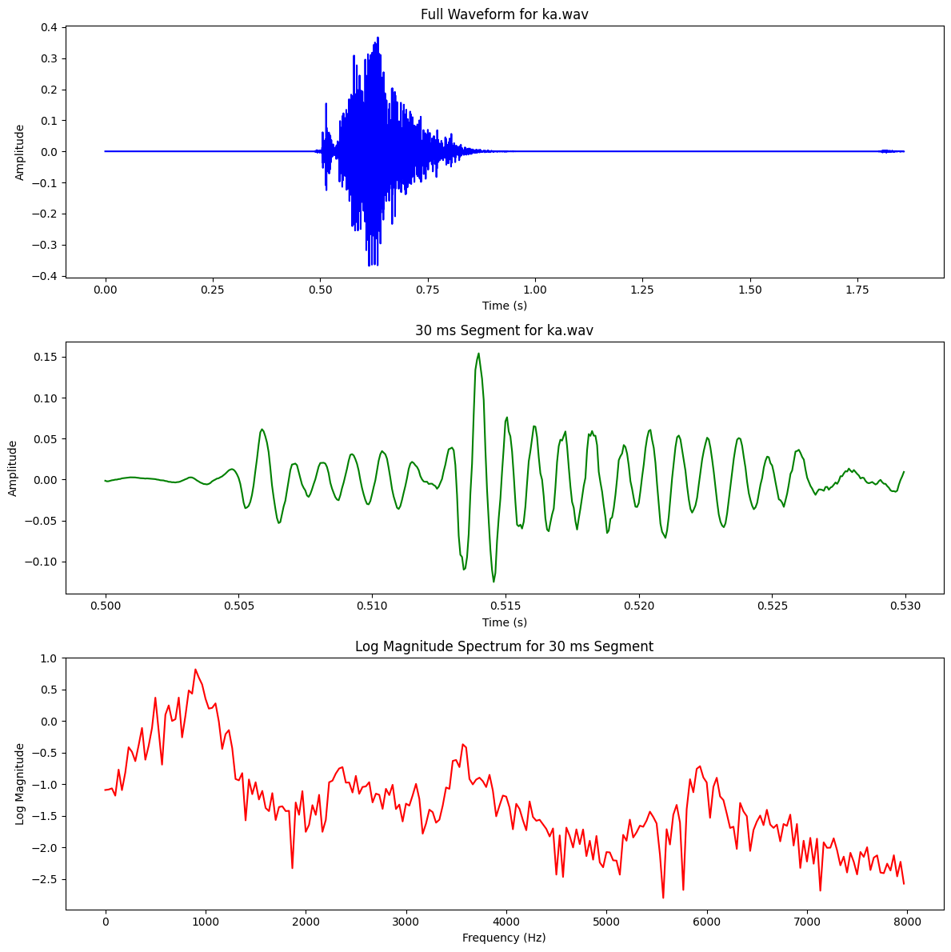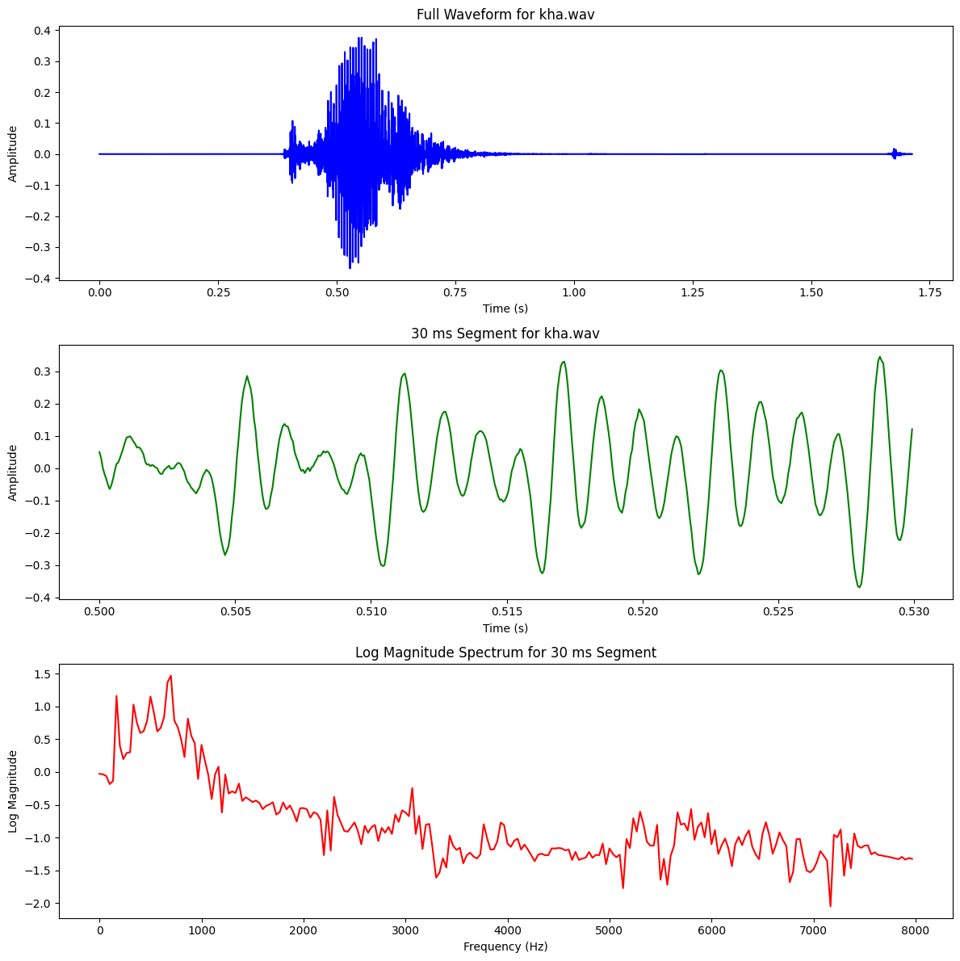
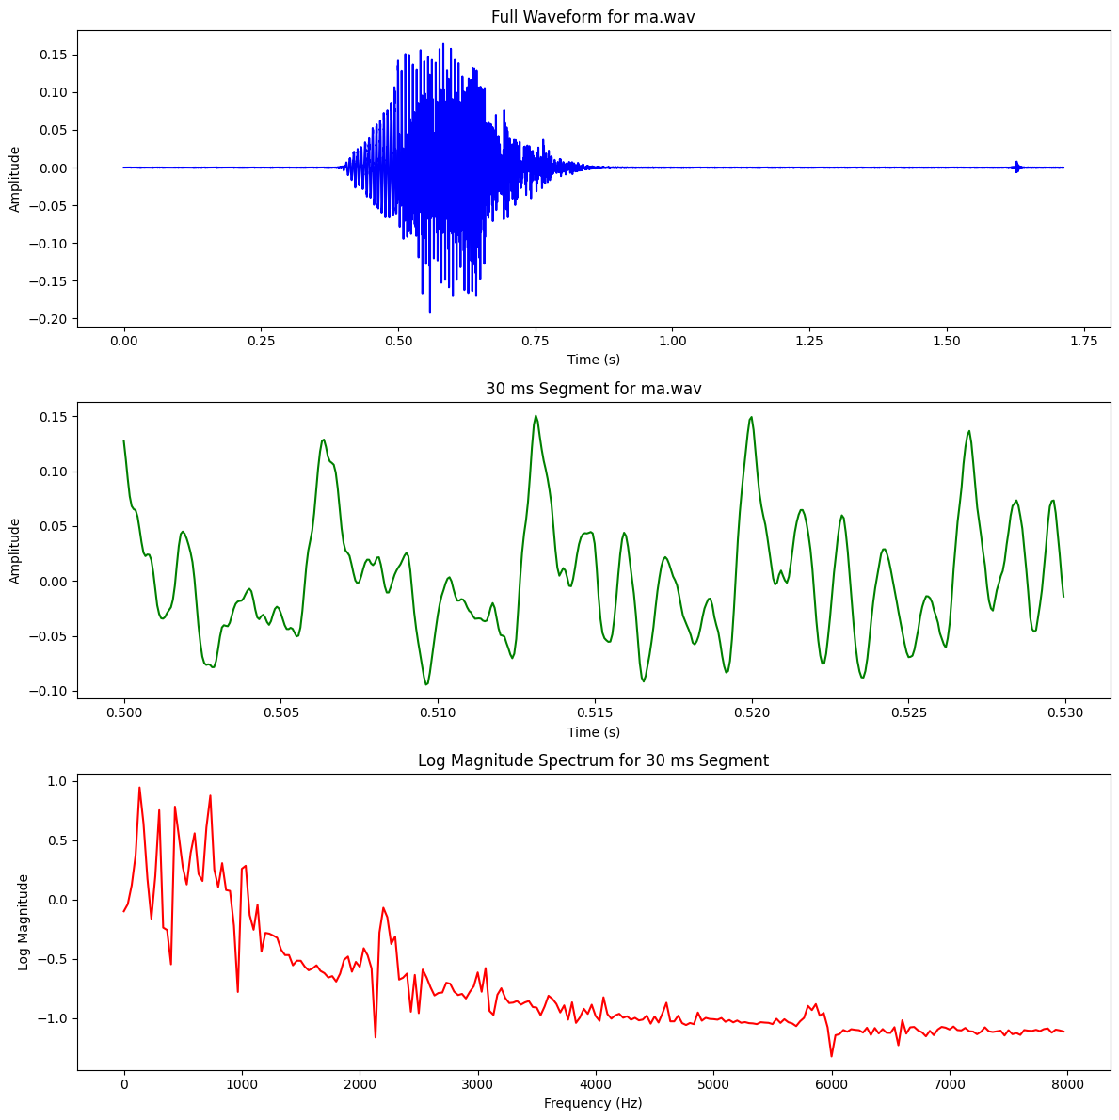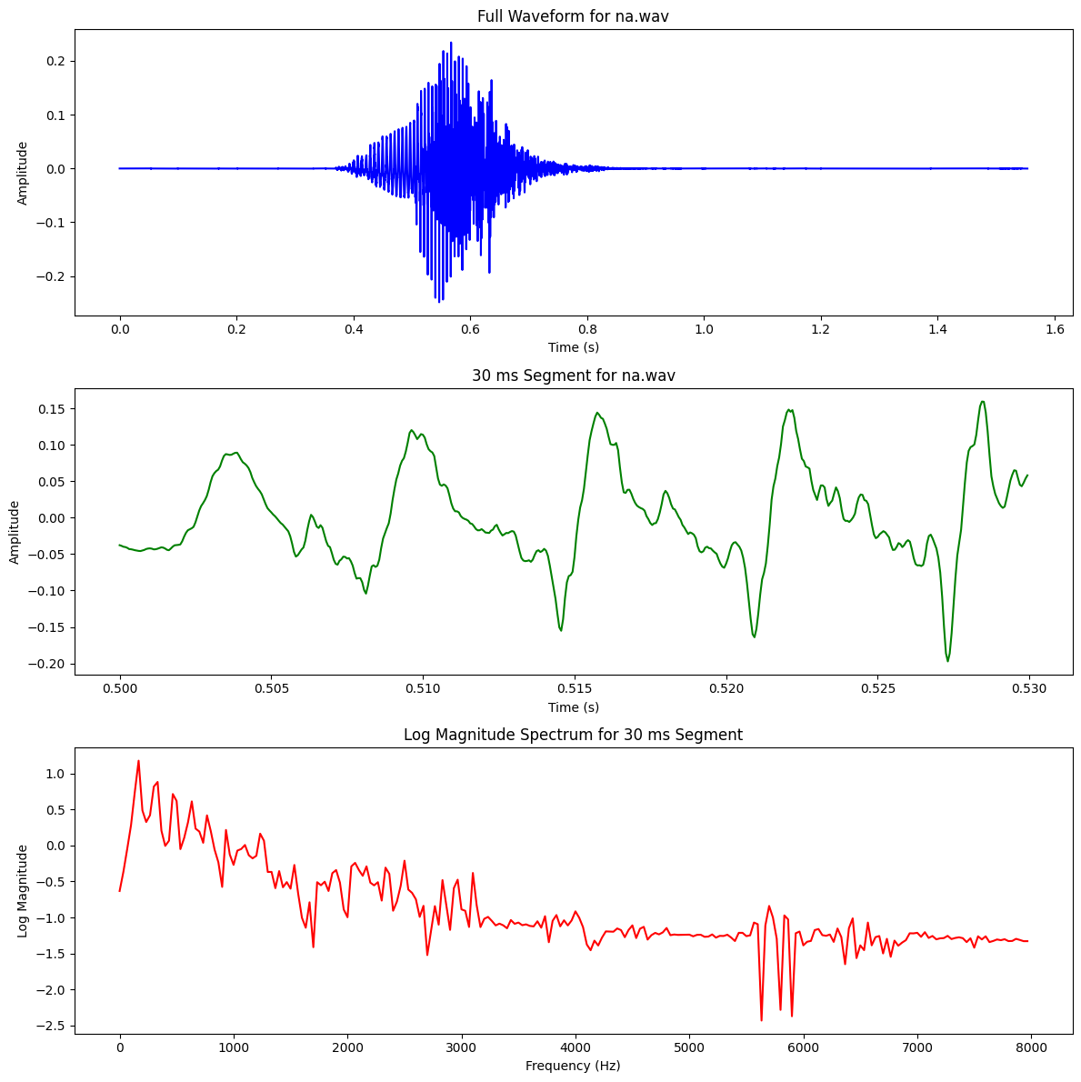
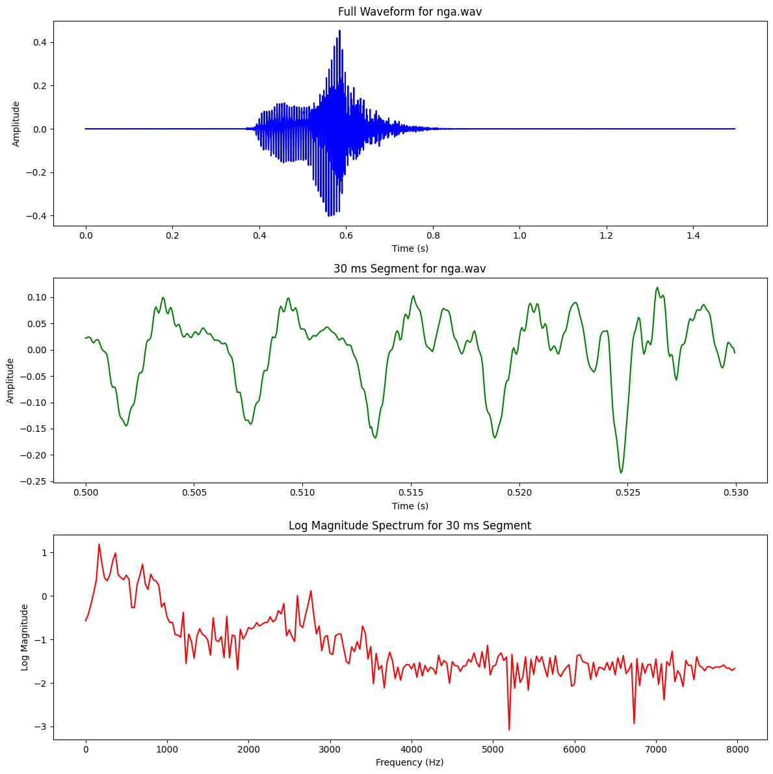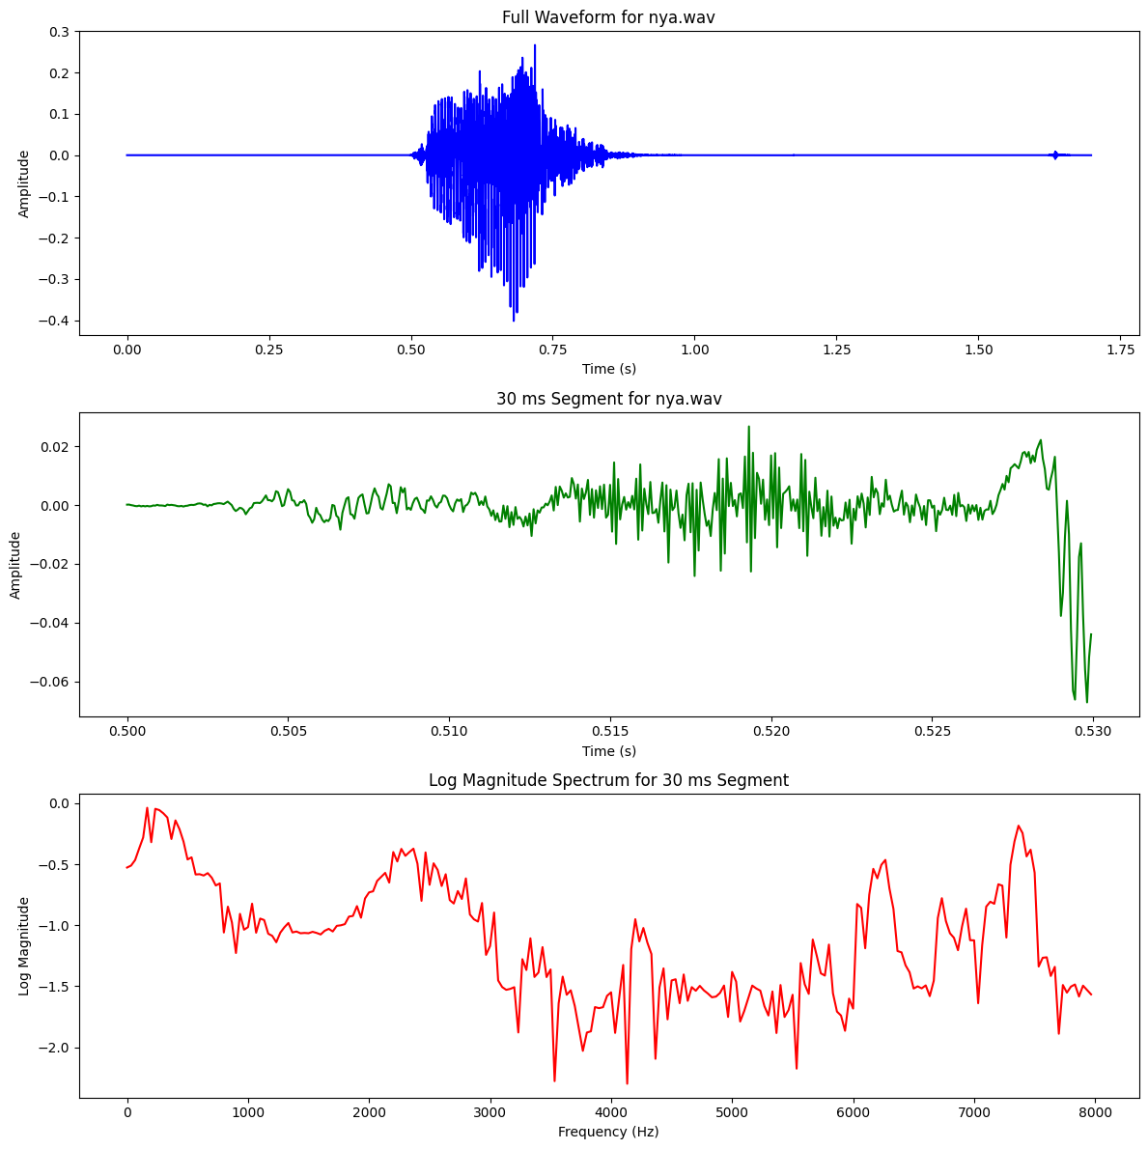

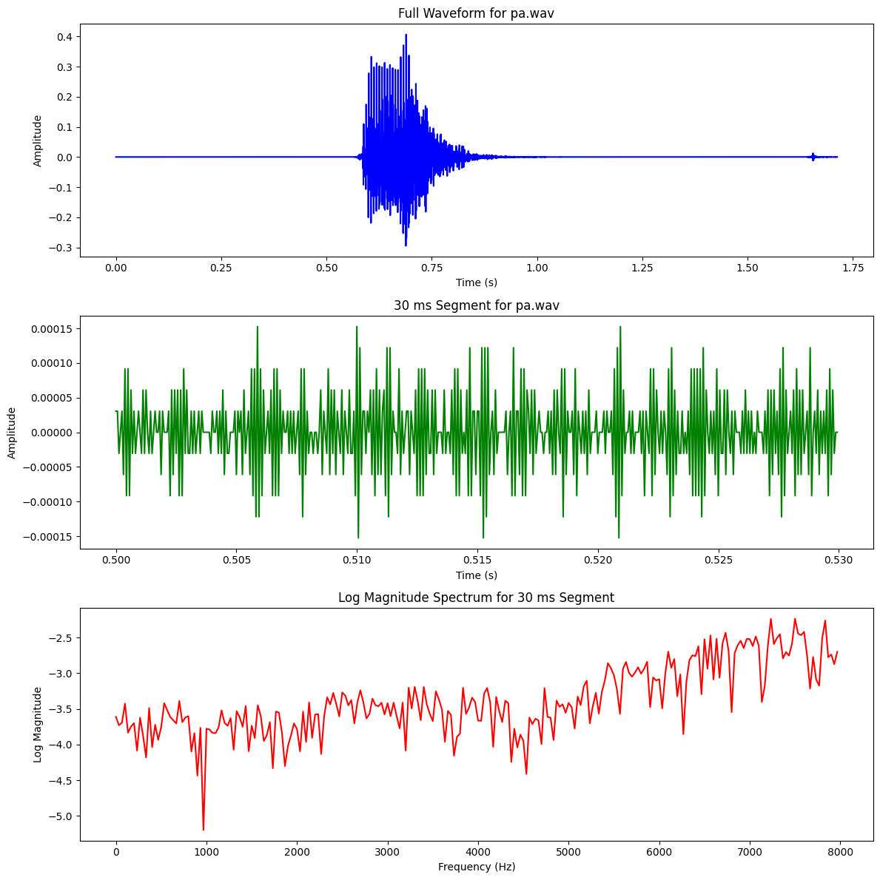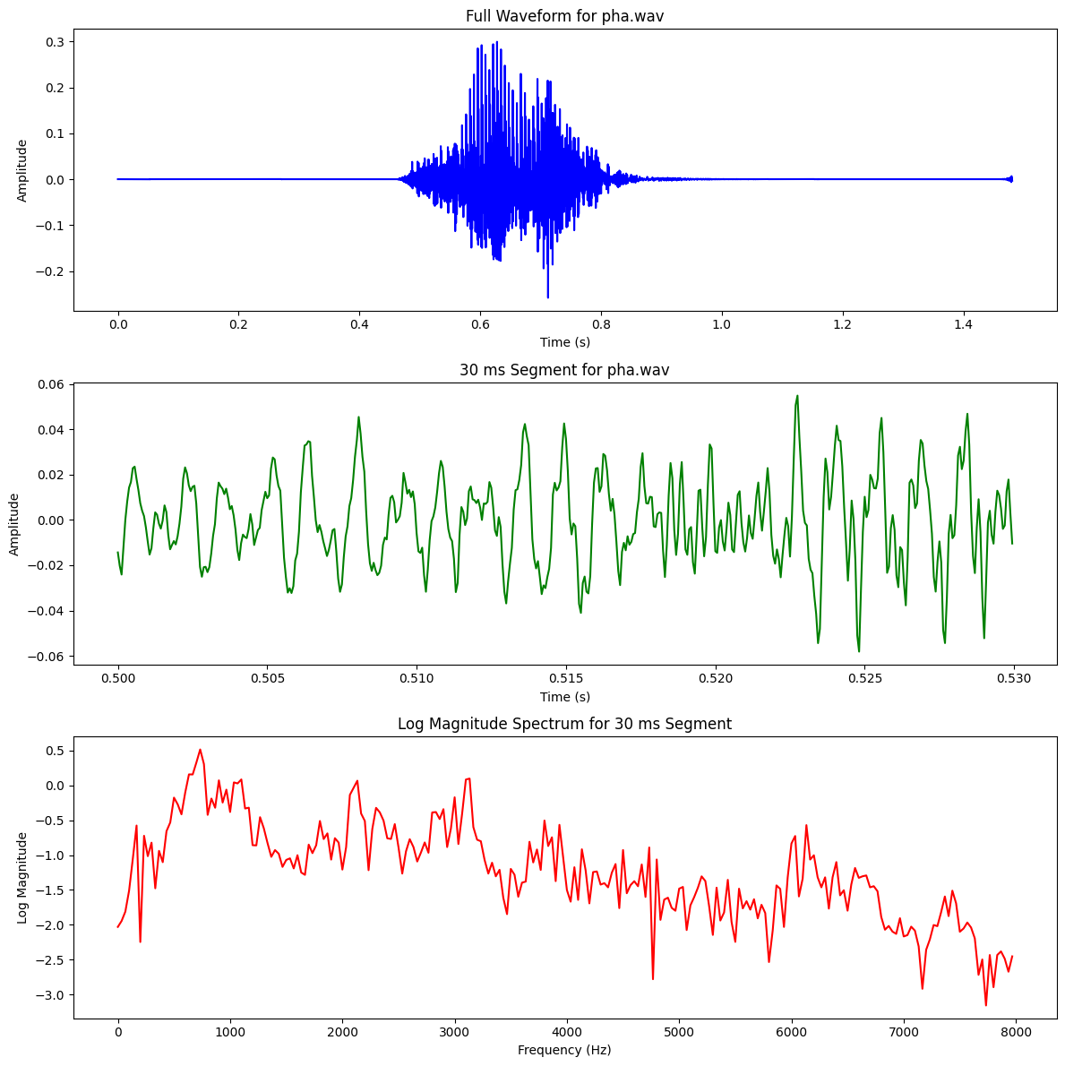

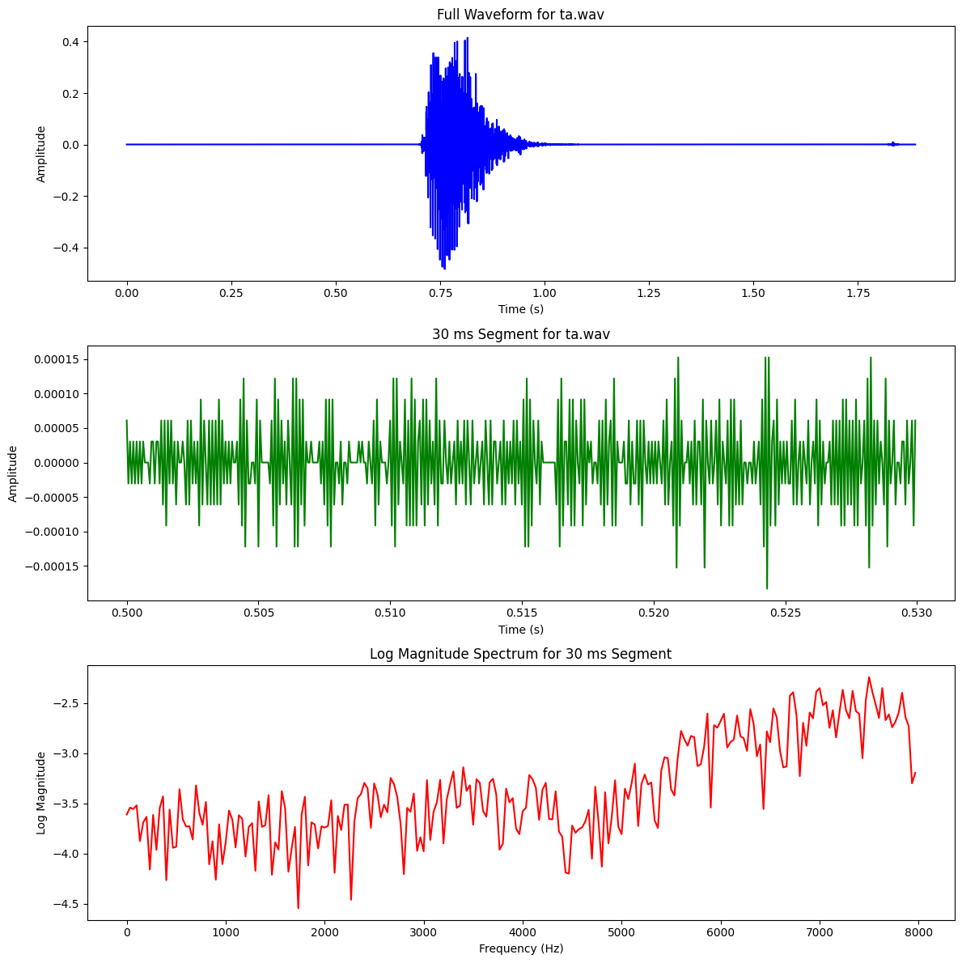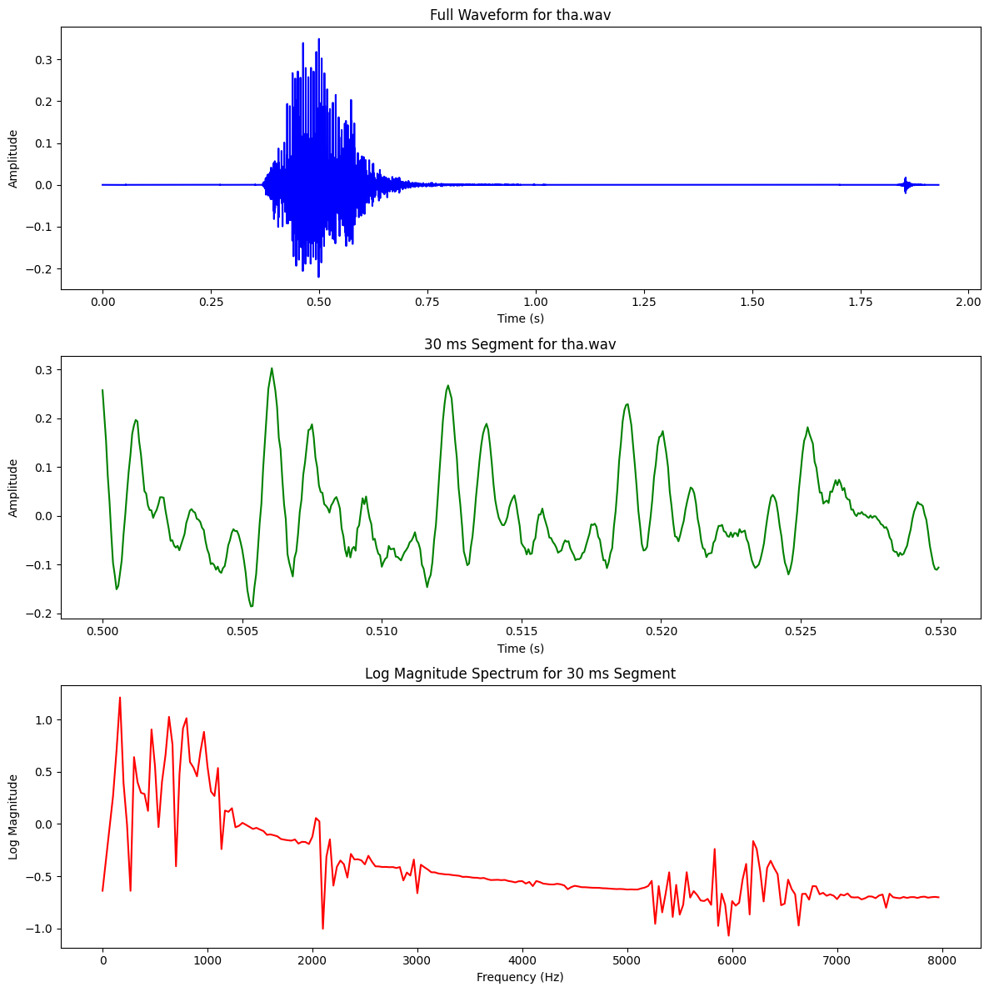

Consonant -Nasal
Type | Phoneme (IPA) | Place of Articulation | Manner of Articulation
Affricates | চ , ছ | Palatal | Stop + Friction (Affricate)
Fricatives | শ , ষ, স | Alveopalatal, Retroflex | Fricative
Nasals | ম , ন, ঙ, ণ | Bilabial, Alveolar, Velar, Retroflex | Nasal
Semivowels | য , র, ল | Palatal, Retroflex, Alveolar | Approximant (Semivowel)
Stops | ক, খ, গ, ঘ,… | Velar, Palatal, etc. | Blocking Airflow

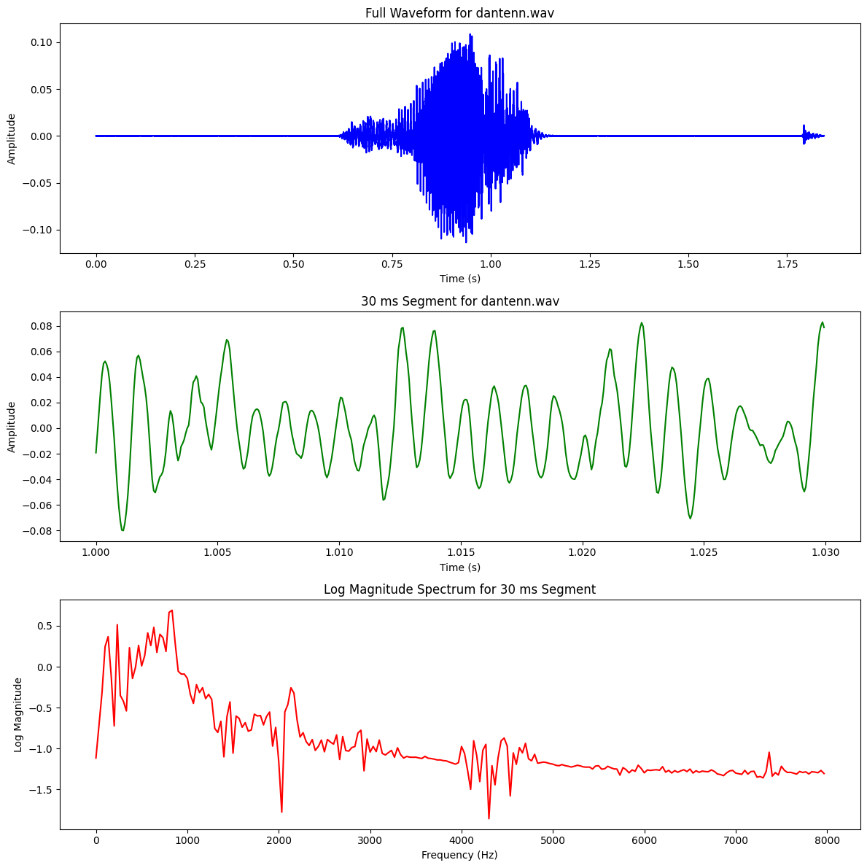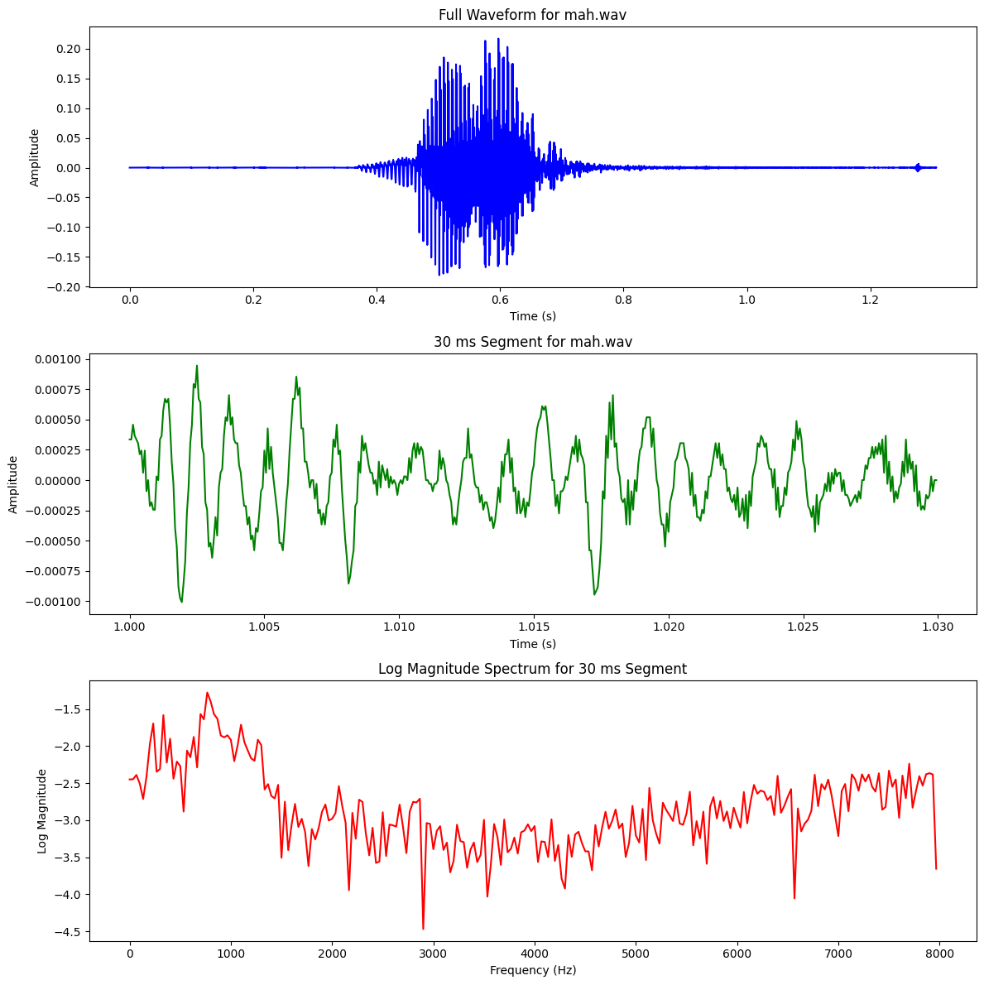
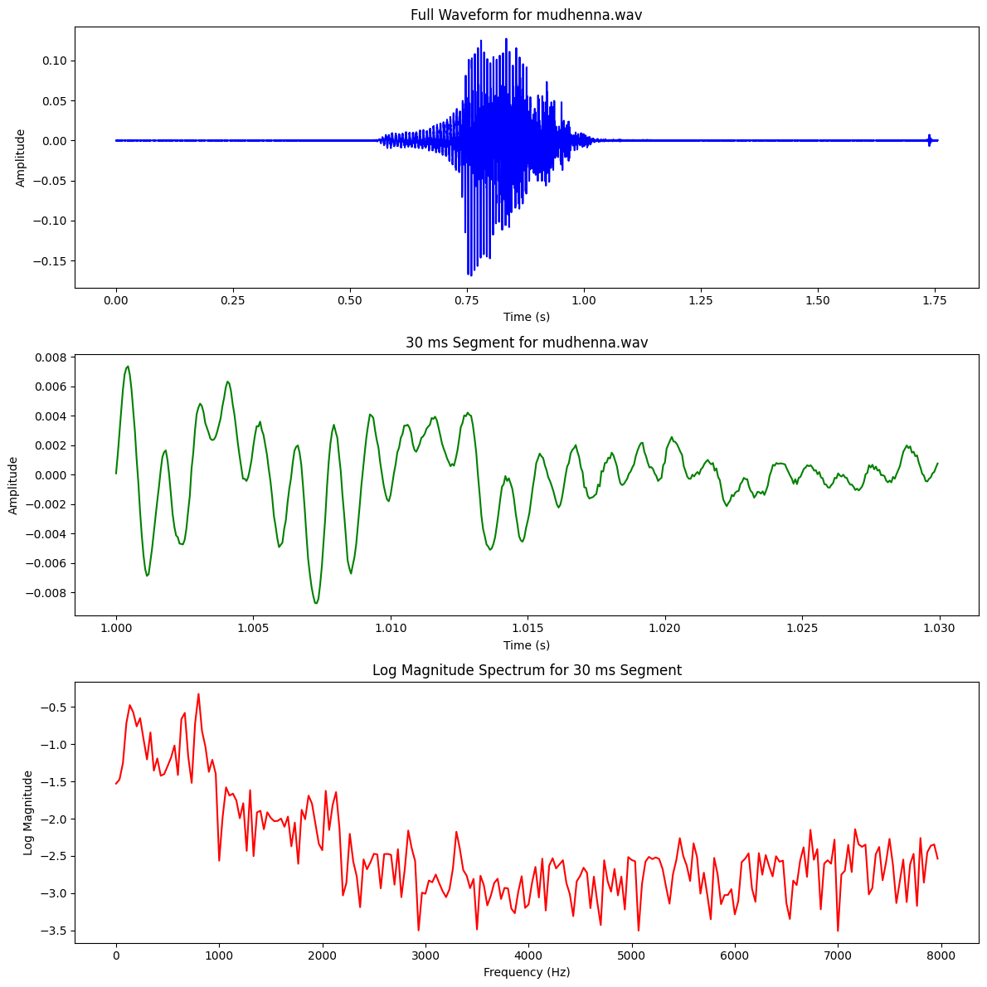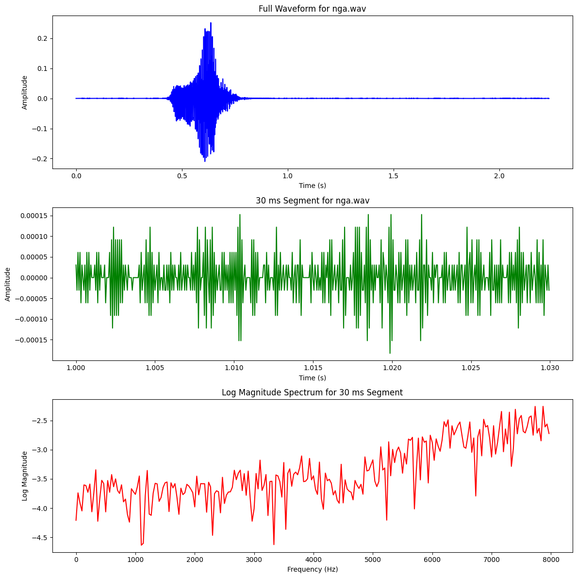
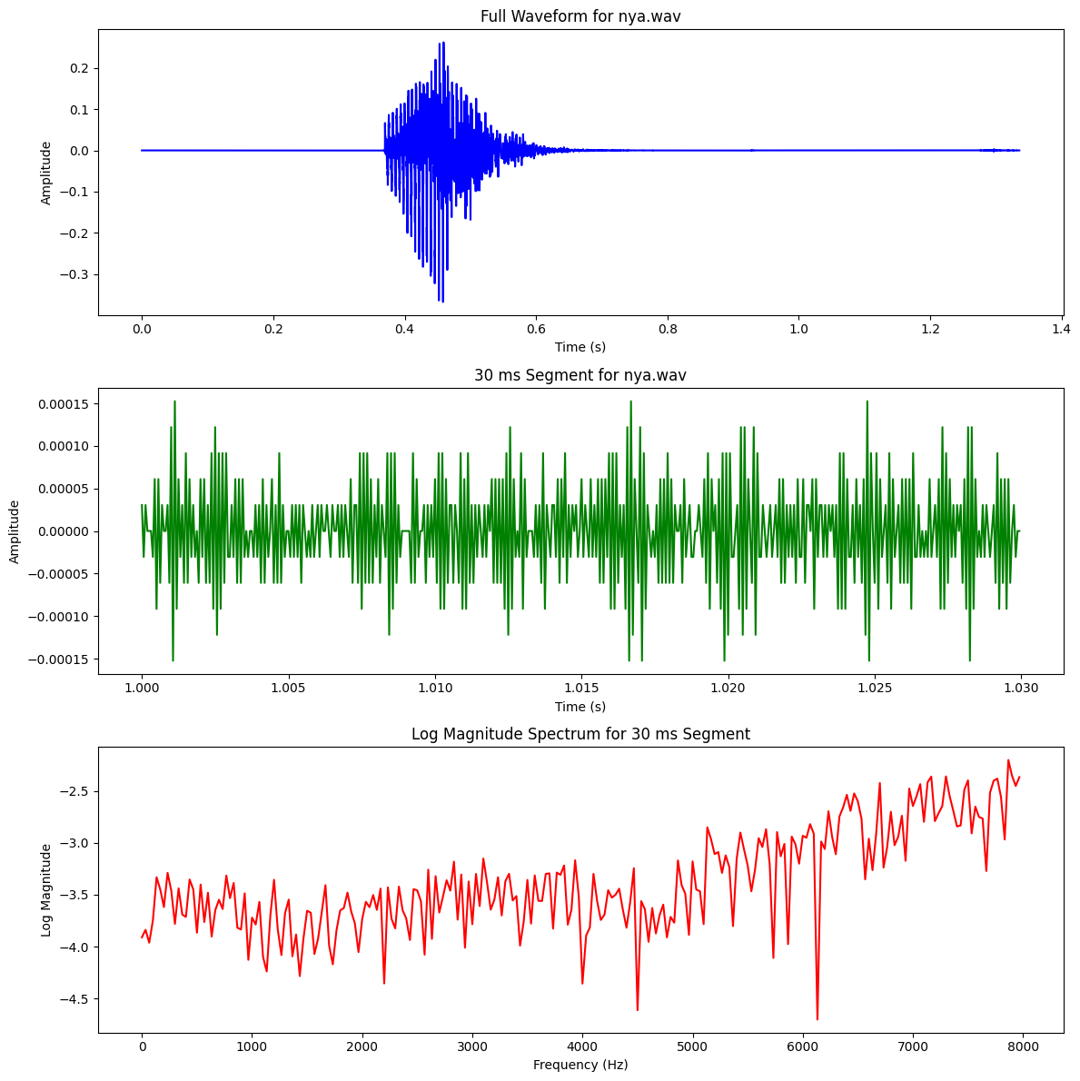

Consonants – Fricatives
Type | Phoneme (IPA) | Place of Articulation | Manner of Articulation
Affricates | চ , ছ | Palatal | Stop + Friction (Affricate)
Fricatives | শ , ষ, স | Alveopalatal, Retroflex | Fricative
Nasals | ম , ন, ঙ, ণ | Bilabial, Alveolar, Velar, Retroflex | Nasal
Semivowels | য , র, ল | Palatal, Retroflex, Alveolar | Approximant (Semivowel)
Stops | ক, খ, গ, ঘ,… | Velar, Palatal, etc. | Plosive - completely blocking the airflow in the vocal tract and then releasing it suddenly

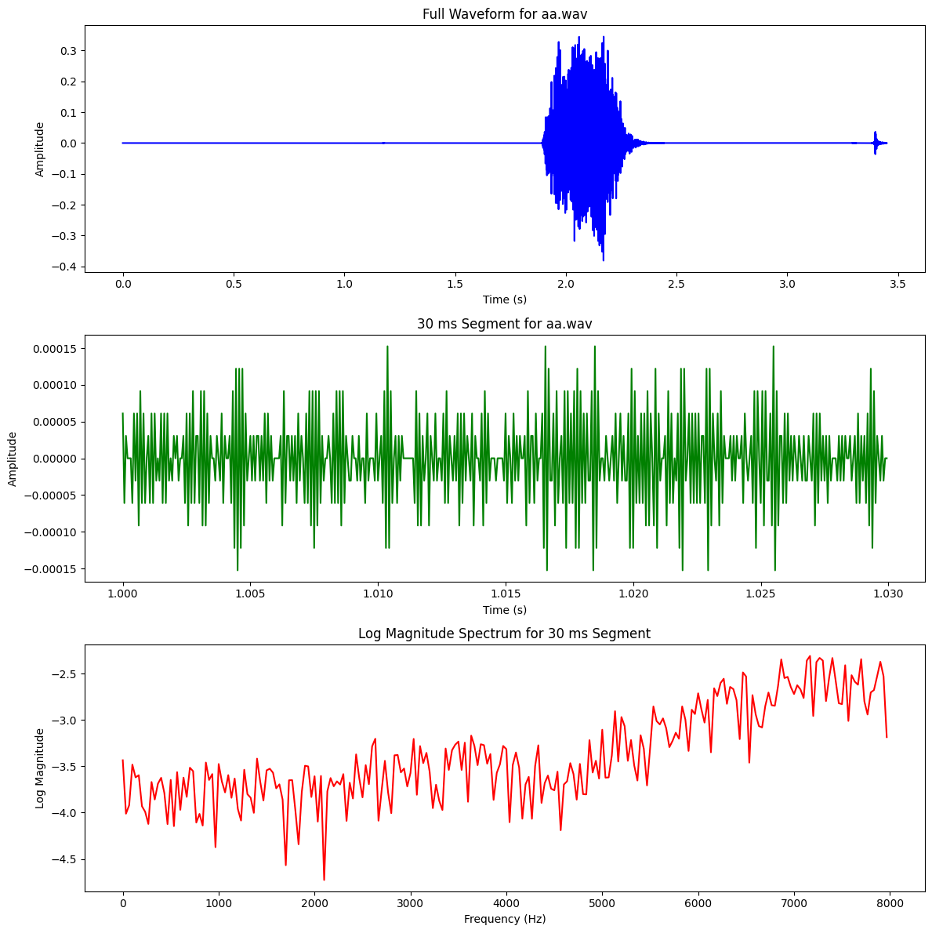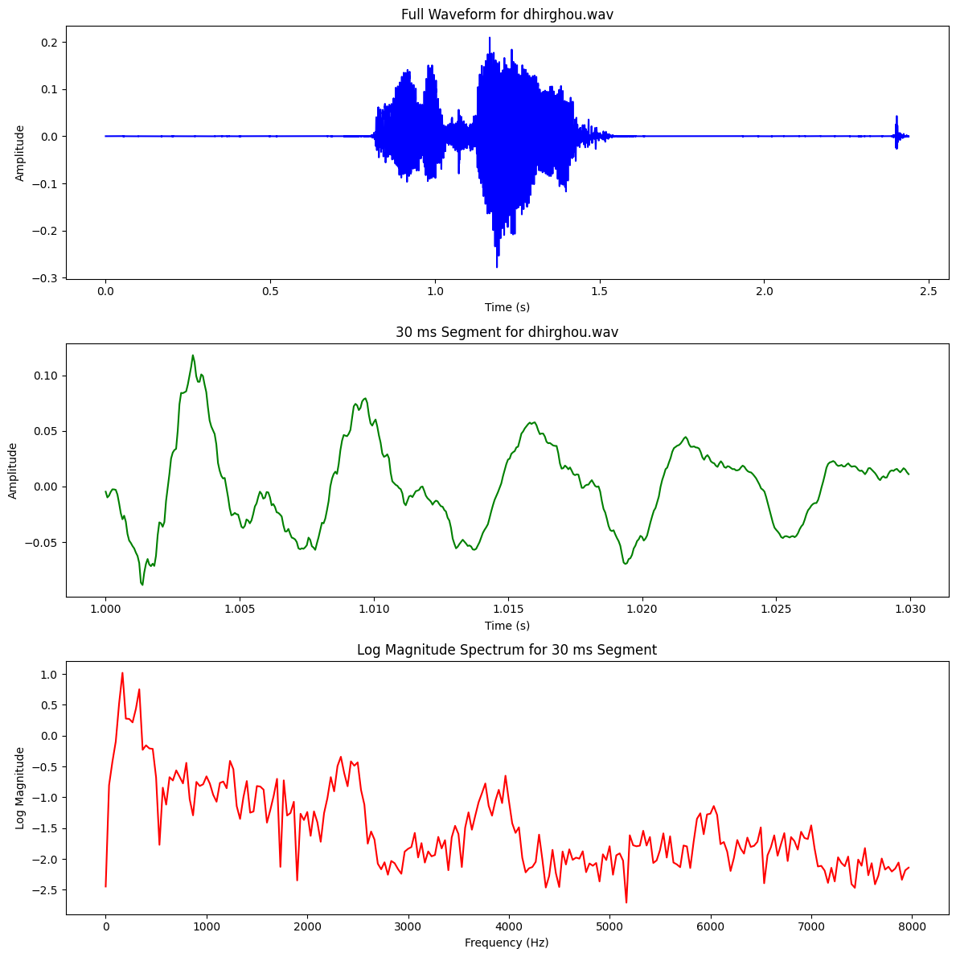

Consonants – SemiVowel
Type | Phoneme (IPA) | Place of Articulation | Manner of Articulation
Affricates | চ , ছ | Palatal | Stop + Friction (Affricate)
Fricatives | শ , ষ, স | Alveopalatal, Retroflex | Fricative
Nasals | ম , ন, ঙ, ণ | Bilabial, Alveolar, Velar, Retroflex | Nasal
Semivowels | য , র, ল | Palatal, Retroflex, Alveolar | Approximant (Semivowel)
Stops | ক, খ, গ, ঘ,… | Velar, Palatal, etc. | Plosive - completely blocking the airflow in the vocal tract and then releasing it suddenly

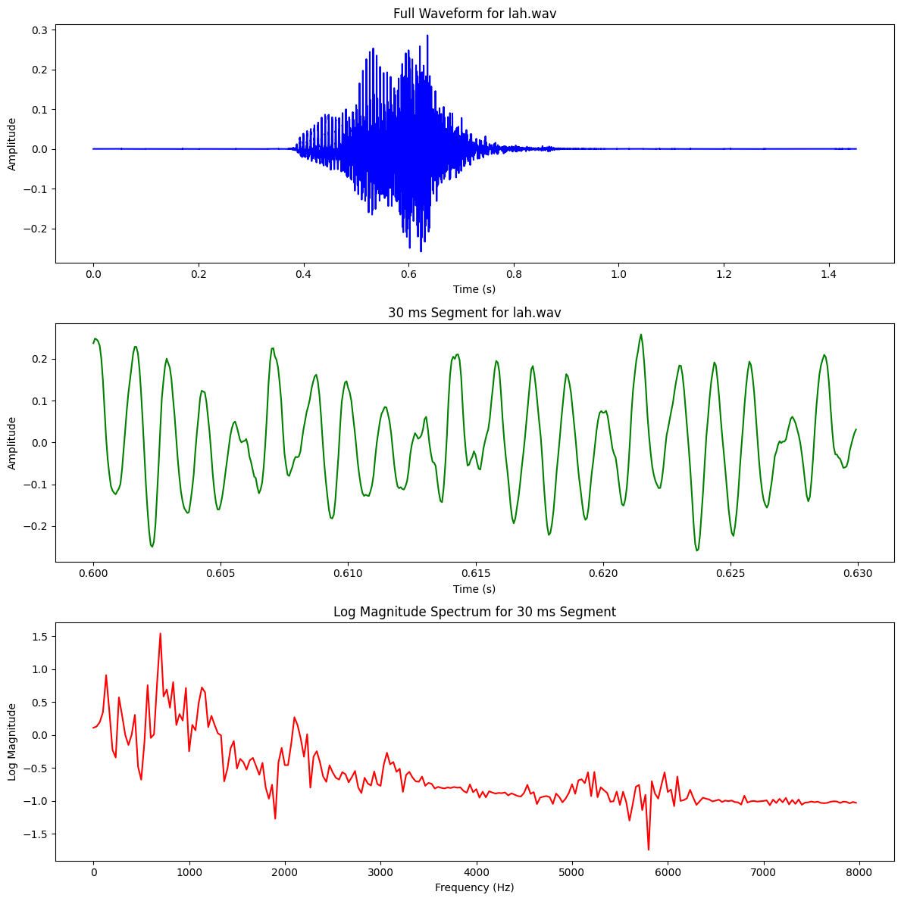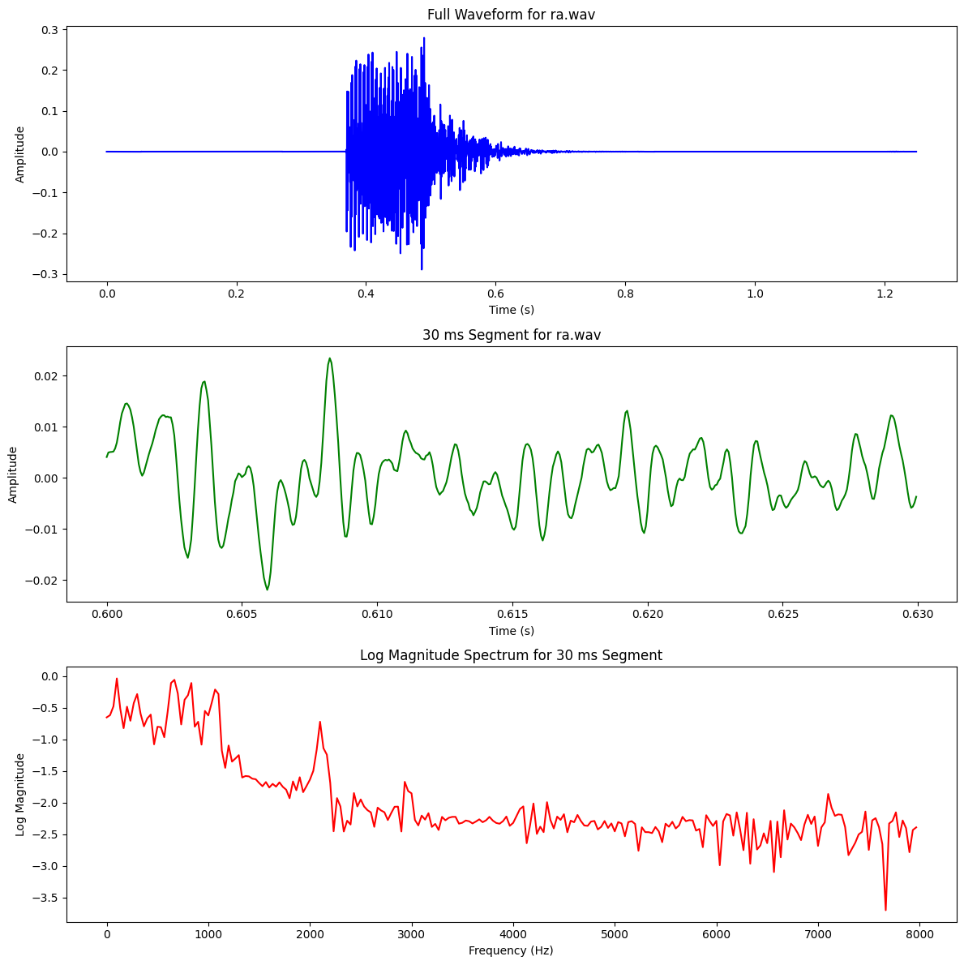
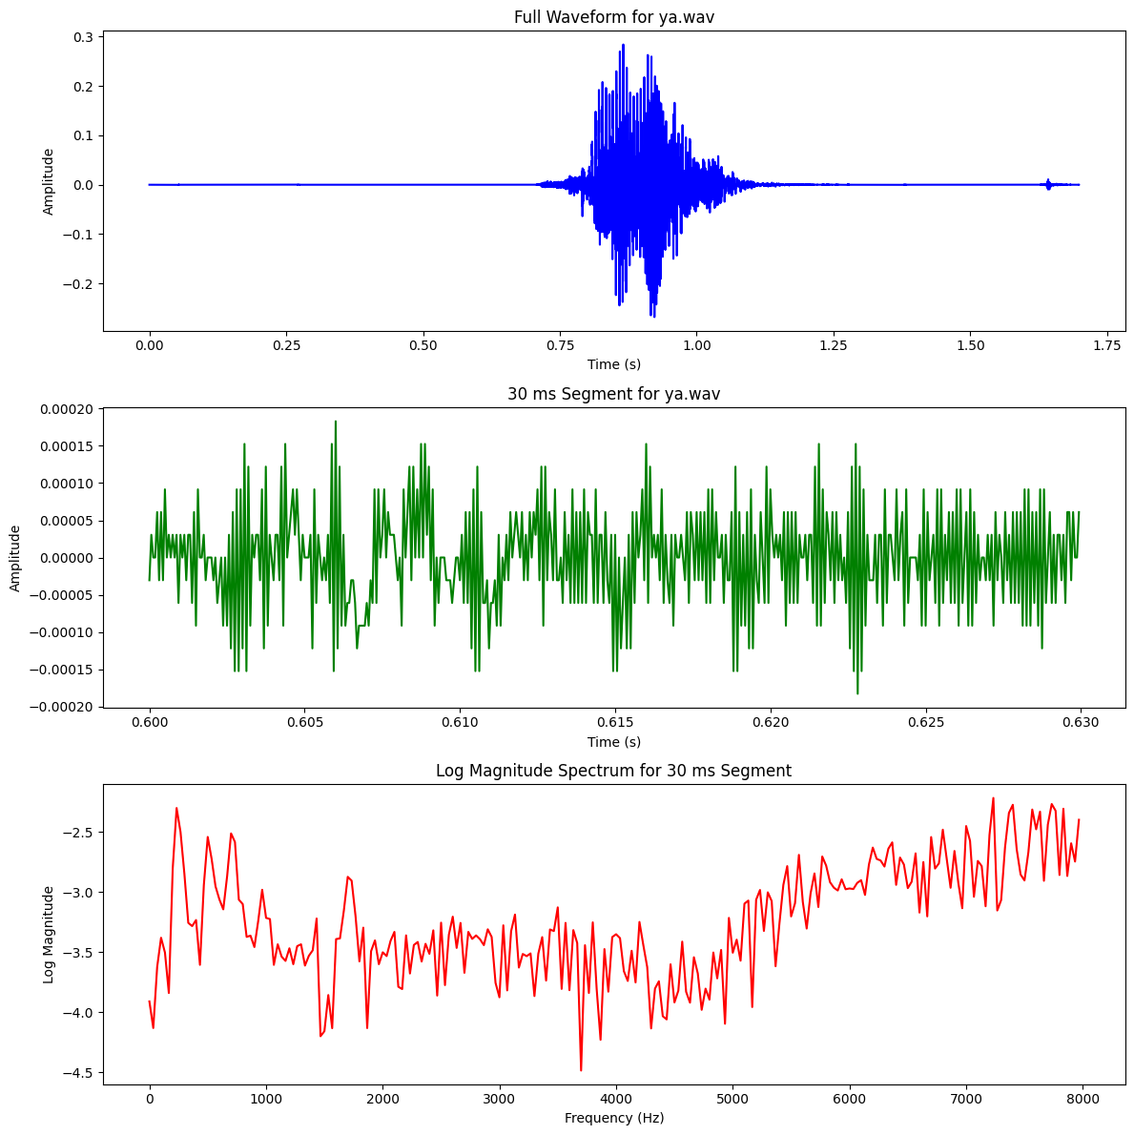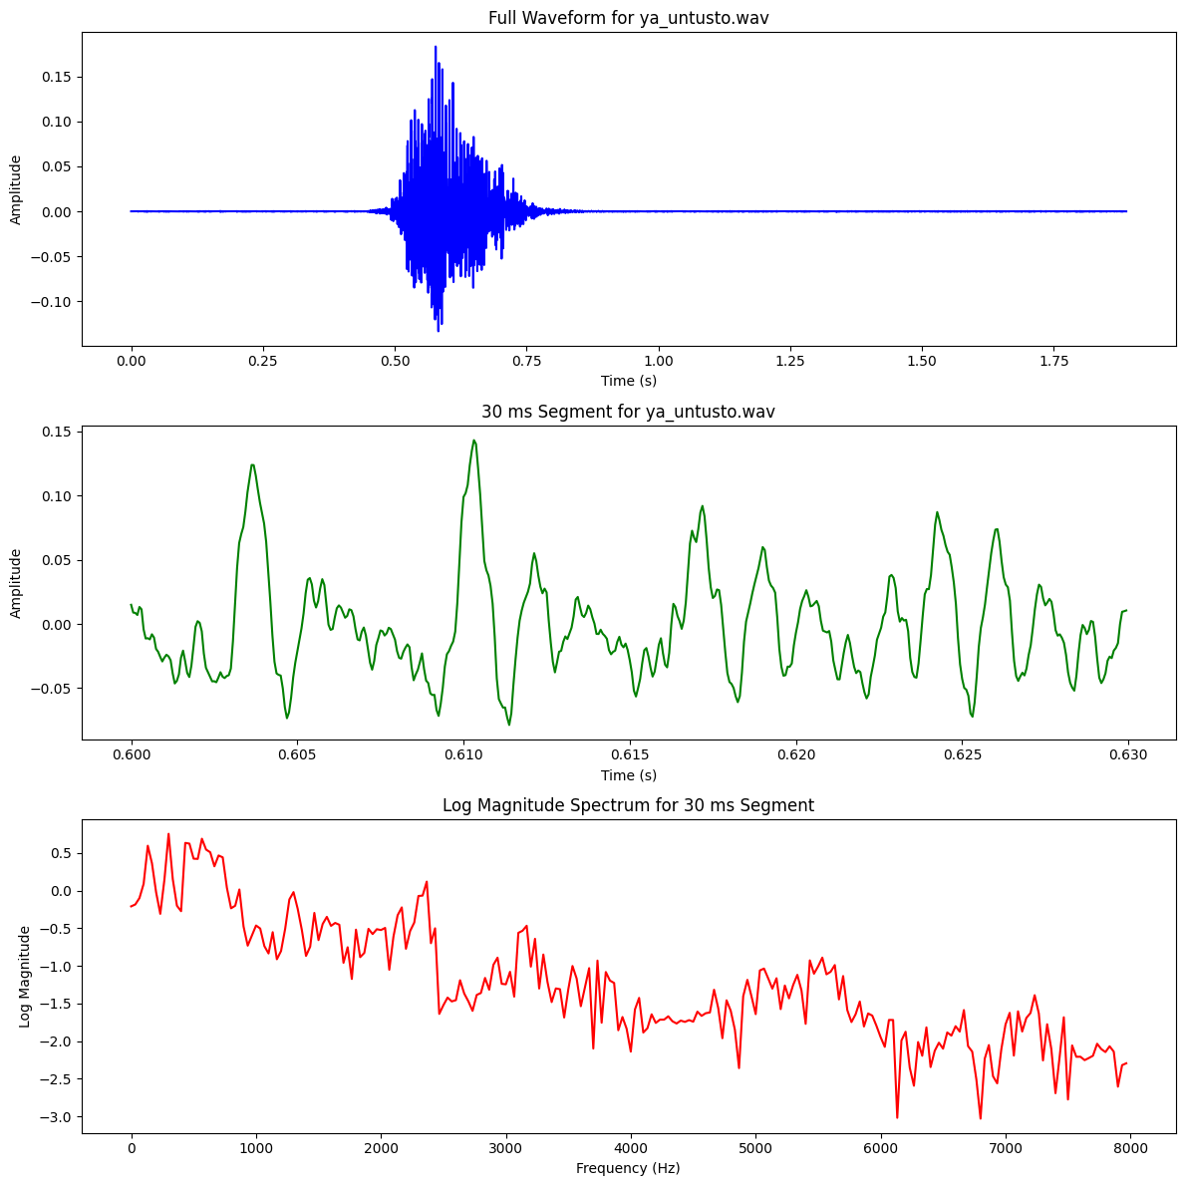

Consonants – Affricates
Type | Phoneme (IPA) | Place of Articulation | Manner of Articulation
Affricates | চ , ছ | Palatal | Stop + Friction (Affricate)
Fricatives | শ , ষ, স | Alveopalatal, Retroflex | Fricative
Nasals | ম , ন, ঙ, ণ | Bilabial, Alveolar, Velar, Retroflex | Nasal
Semivowels | য , র, ল | Palatal, Retroflex, Alveolar | Approximant (Semivowel)
Stops | ক, খ, গ, ঘ,… | Velar, Palatal, etc. | Plosive - completely blocking the airflow in the vocal tract and then releasing it suddenly

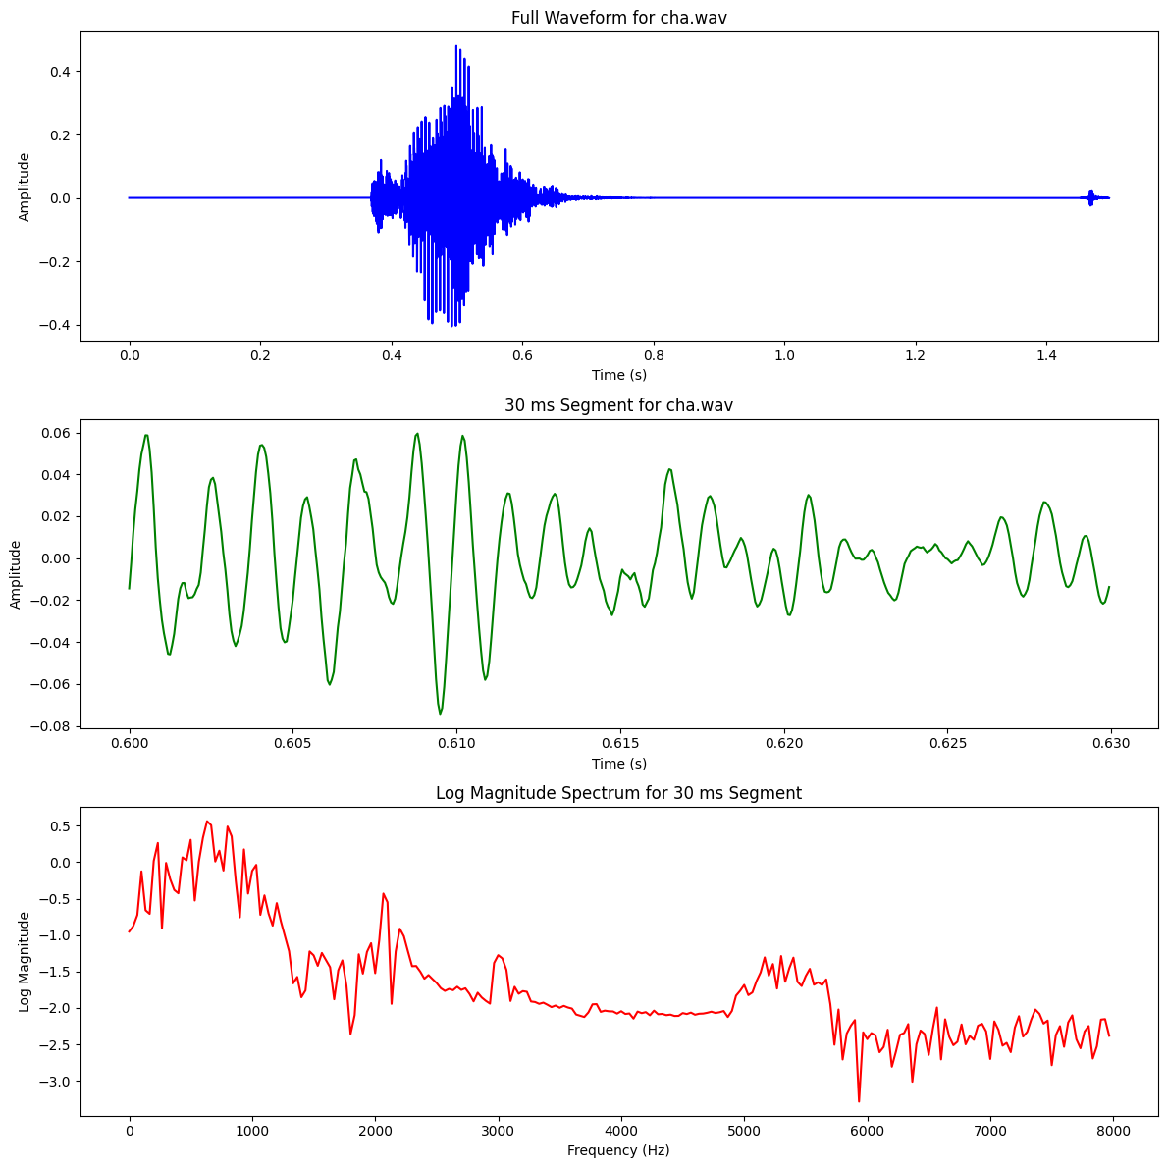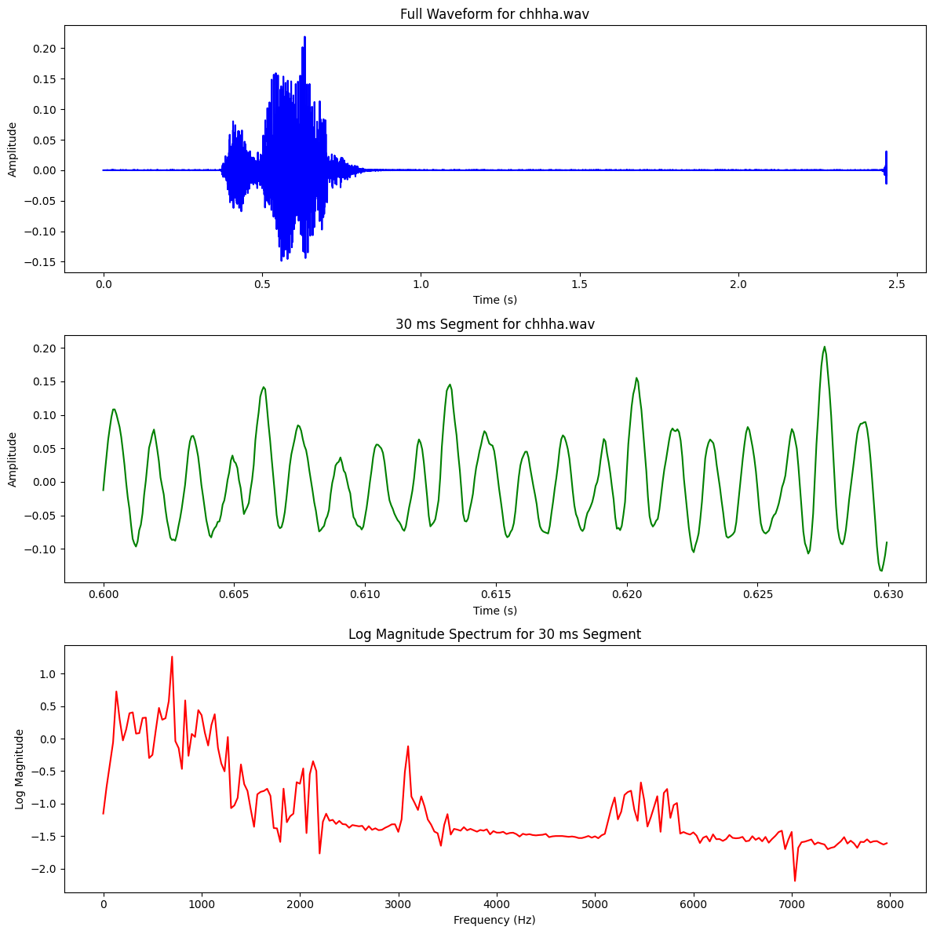
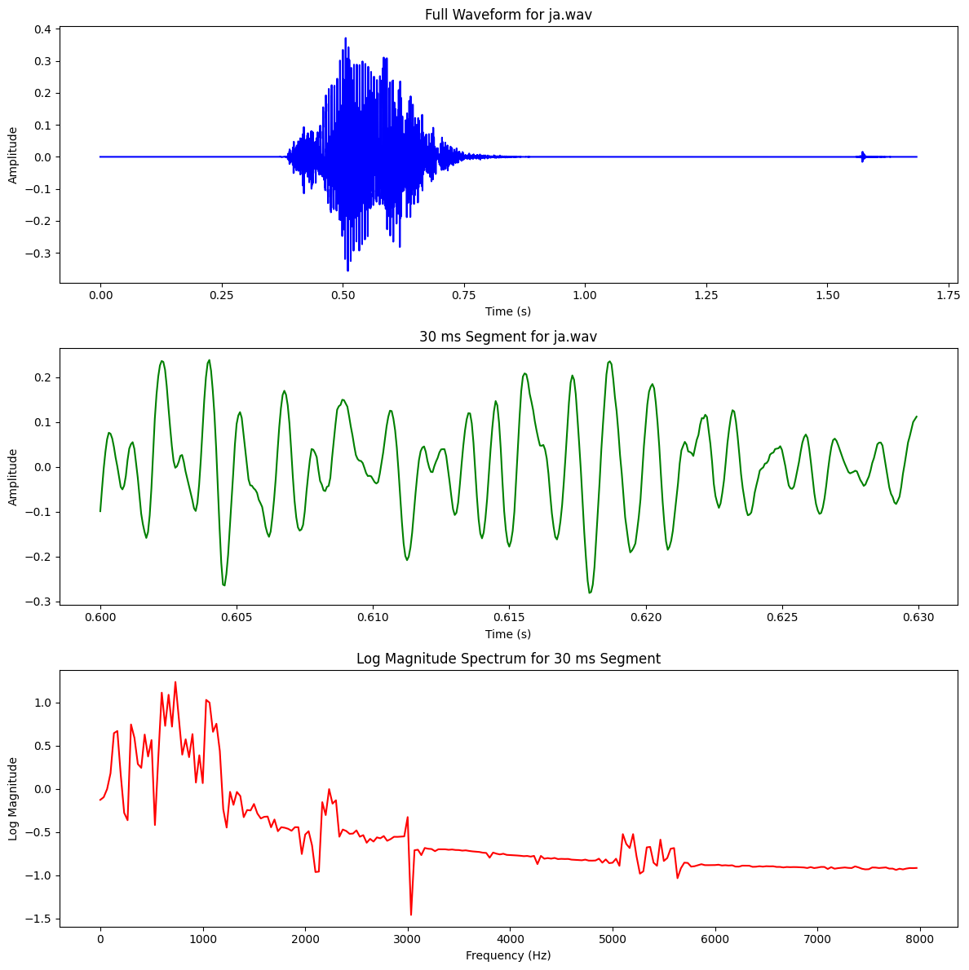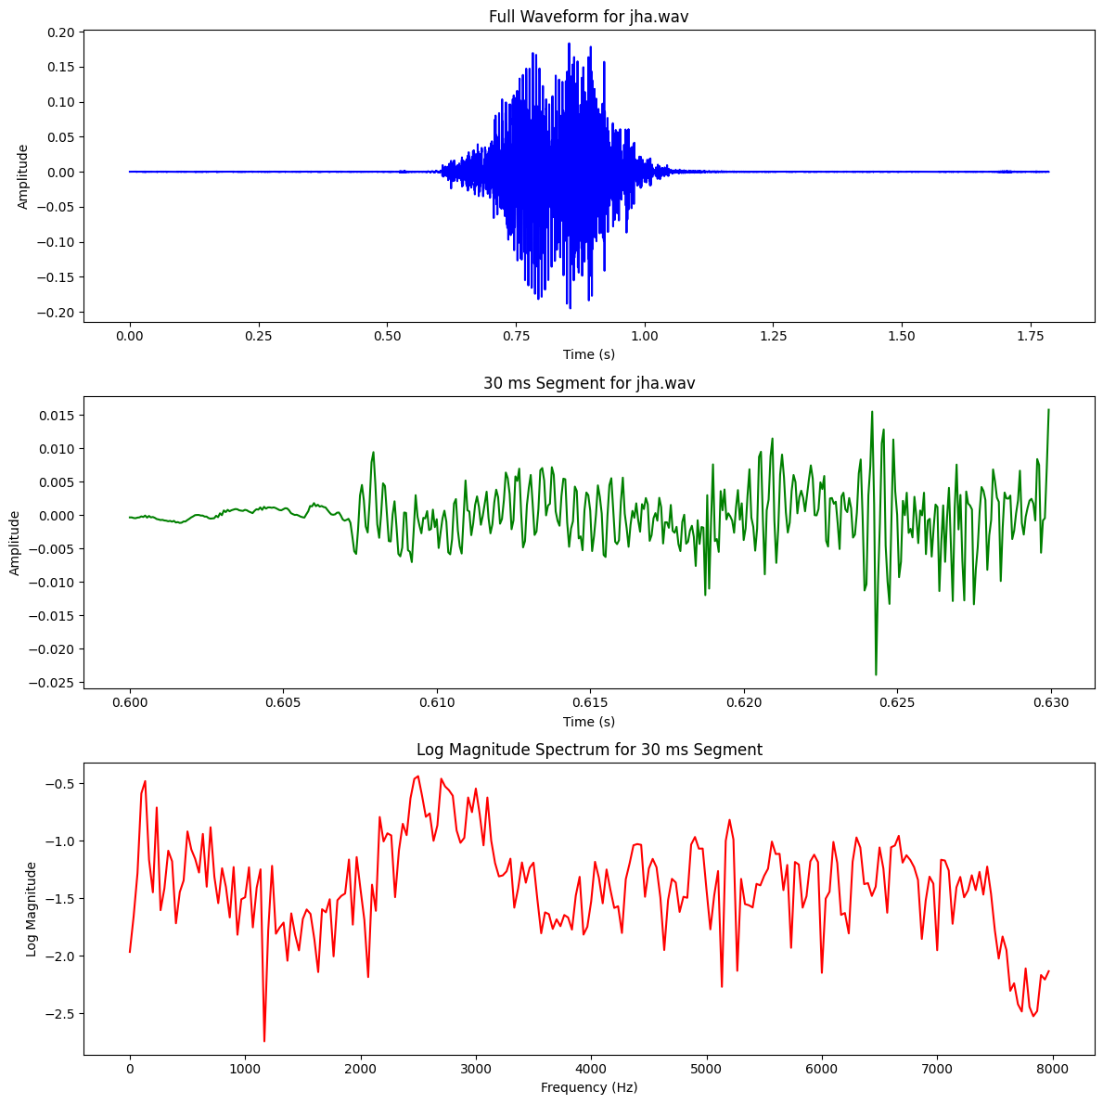

Stop with Vowels
Plosive - completely blocking the airflow in the vocal tract and then releasing it suddenly
Stop Consonant | Example Word | Vowel Context | Place of Articulation | Manner of Articulation
ক (k) | "অকা" (a+ka) | Short Vowel (অ) | Velar | Plosive
প (p) | "অপা" (a+pa) | Short Vowel (অ) | Bilabial | Plosive
ট (ṭ) | "অটা" (a+ṭa) | Short Vowel (অ) | Retroflex | Plosive
গ (g) | "অগা" (a+ga) | Short Vowel (অ) | Velar | Plosive
দ (d) | "অদা" (a+da) | Short Vowel (অ) | Alveolar | Plosive

