Day 1

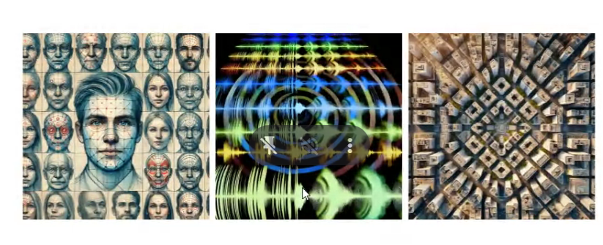
- Humans use pattern way of processing.
- Our cognitive systems is exposed to the knowledge of
  - Human faces
  - Top view of tall buildings
  - Audio Signals (middle one) may be difficult until we see it quite often
- How human cognitive system will do the process?
  - Not known, so people have found ways to mimic that.
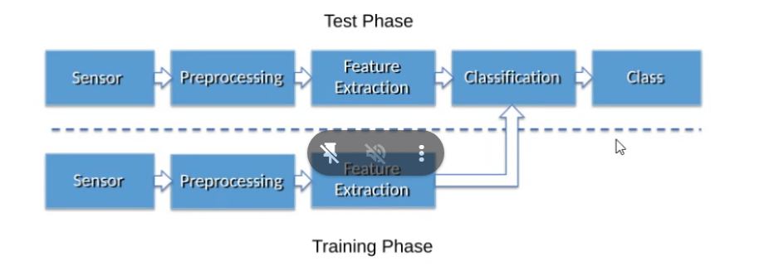

Difference between ML and DL
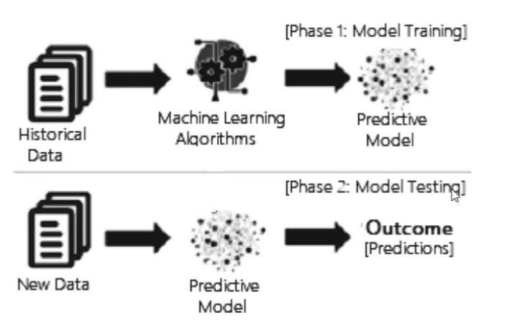
- The historical data in ML is to do prediction, classification algorithms from the processed data.
, but not do processing of raw data
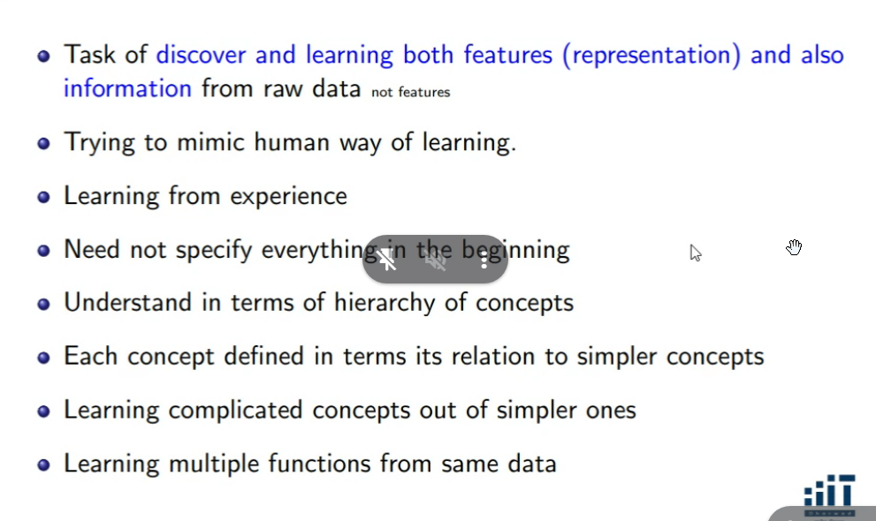
- In case of ML : Compared to Random Forest, SVM etc – Data in form of features
- In case of DL:
  - Processed data not required. Directly can work with raw data.
  - The model itself will derive the correct features and then come up with the model to reduce the variability.
  - Any layer with more than 3 layers is Deep Learning – this is not correct.
  - It can deal with raw data which has lot of variability to get smooth data and make the model out of it.
  - Not worried about feature extraction because the model will itself discover it.
  - ML – Good feature extraction is must, DL – no need to worry about that
  - ML – Need domain knowledge because that is required for feature extraction, DL – Not must
  - DL – Human way of processing, Learning from experience. Humans may not get complete hold on a first time on a subject, after reading several round, then expertise on that subject increases. DL models are like that. Initial layers process the raw information which may not be good discrimination, later layers prepare discrimination between classes. The later layers use the previous layers
    - Like when we see the human faces image, we first look at the human faces, then we look into gender, then fine grained things like nose, ear etc.
  - DL – Learning multiple things from single dataset
    - ML – For pets, Only classify cat/dog
    - DL – Breed of cat, playfulness of the pets
  - Appreciate the working principle will be to deal with raw data, top layer gives the conclusion of pet, while below layer will be facial features etc
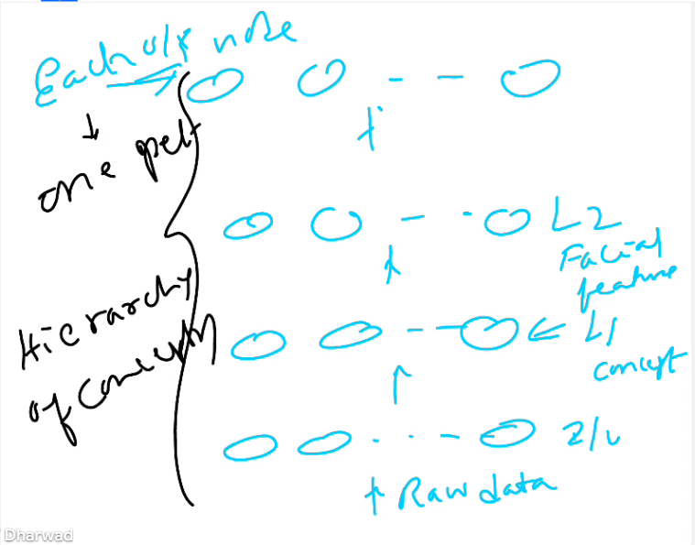

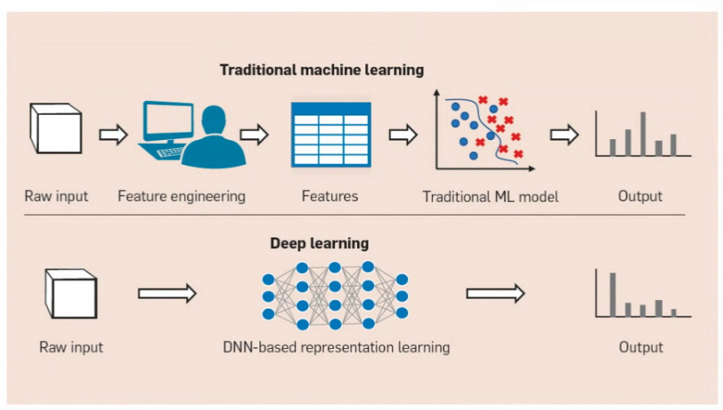

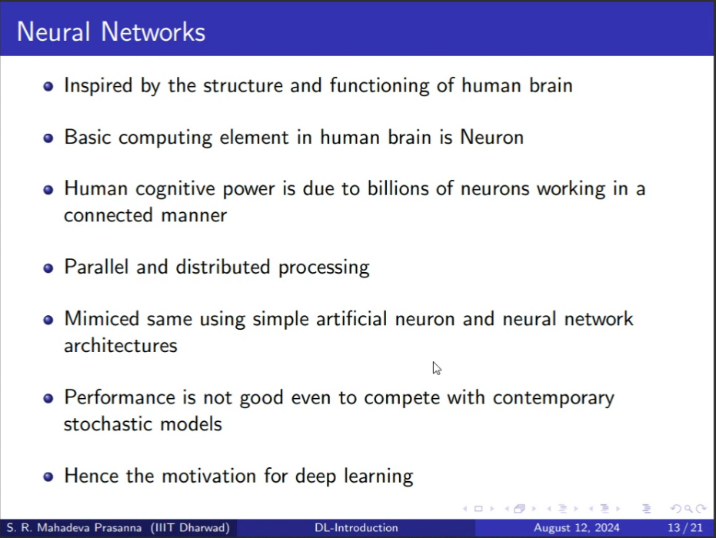

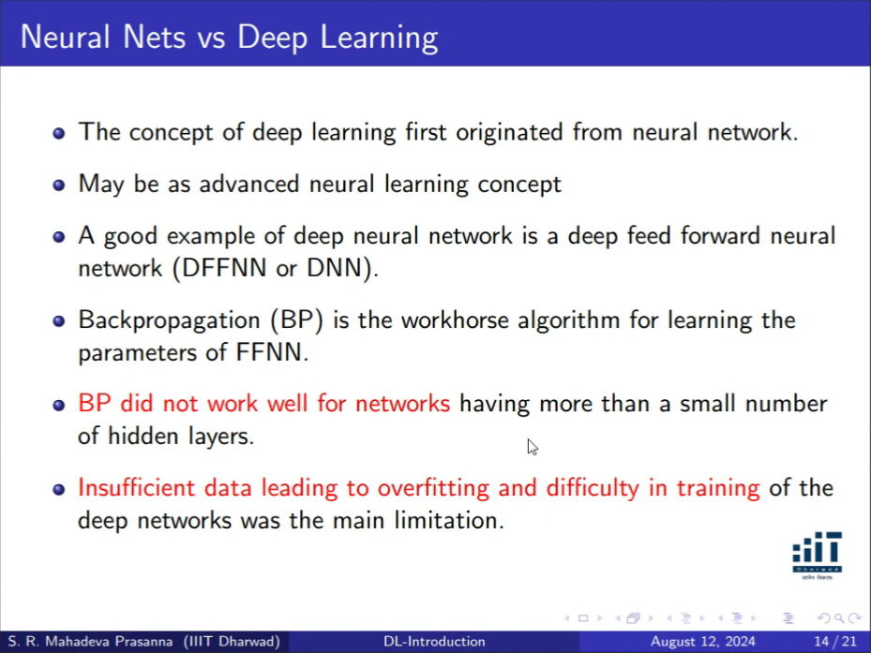

Transformers
    - Learn like human cognitive system. We see 100s of people everyday like transformer gets exposed to 100s of faces.
    - The learning capacity of DL is unable to be satisfied with the BP algorithm (used in FFNN). This is because amount of data available or fed to the DL was very less. Data connection was not good before.
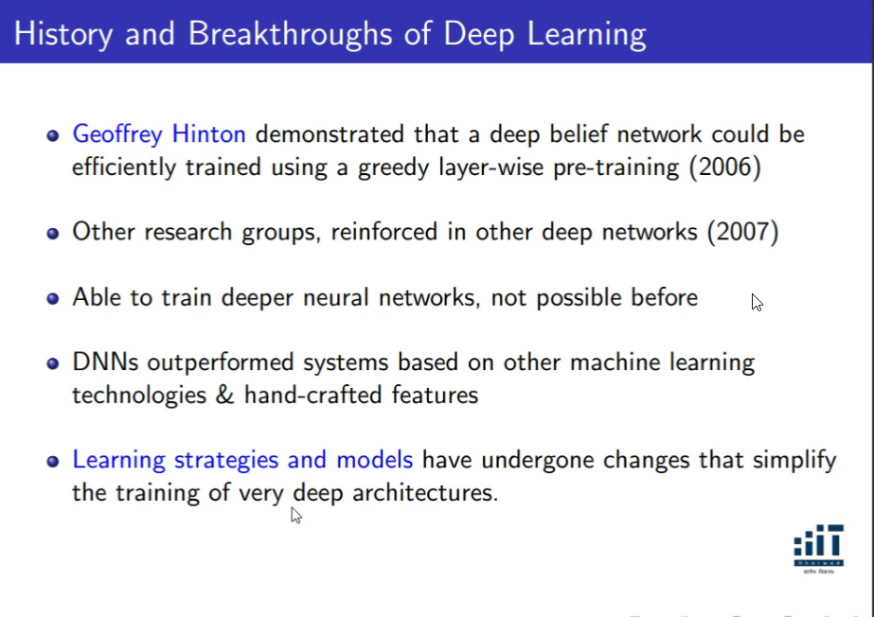
- Geoffrey Hinton’s team was silently working behind the hood.
  - Greedy – Layer wise learning: Pull out each layer and train, What I am learning can be reconstructed back. MNIST dataset was used to train deep belief network.
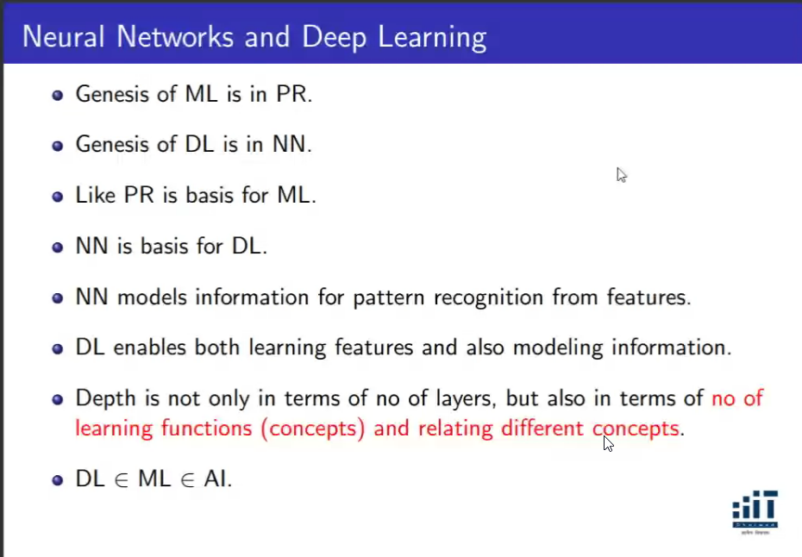
PR = Pattern Recognition (domain knowledge)
NN = Neural Network
Like Pattern recognition is basis of ML, NN is basis for DL.
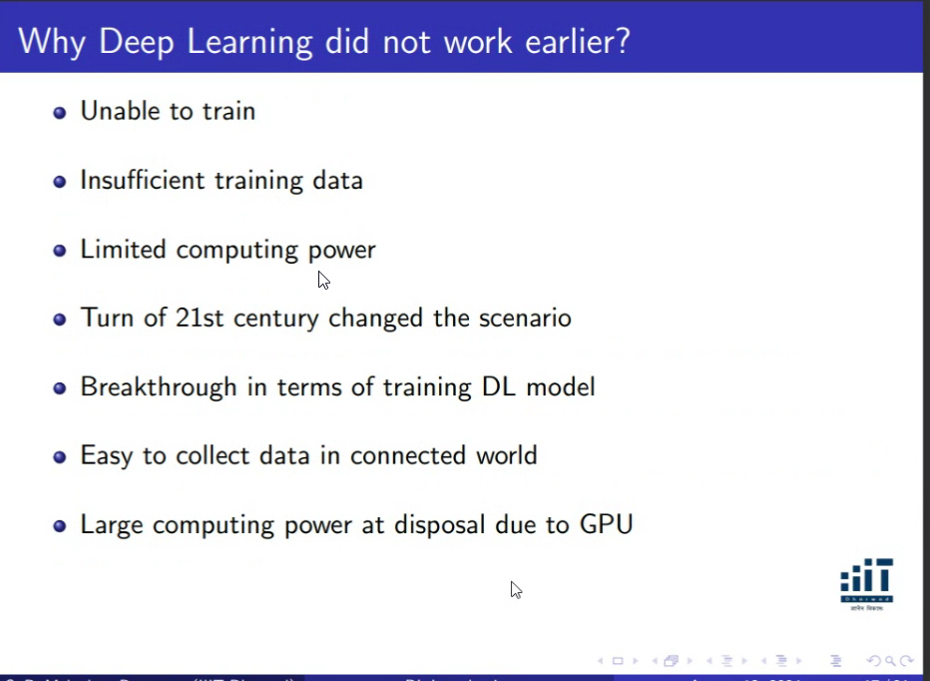
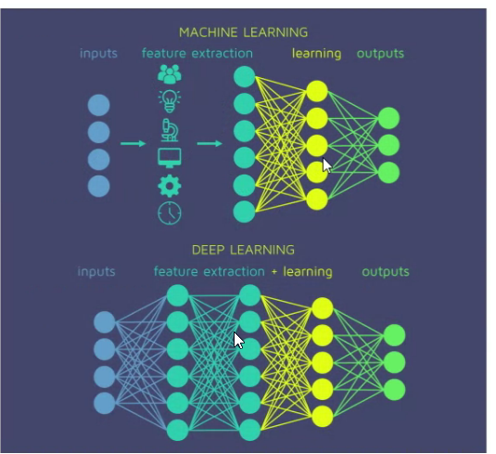
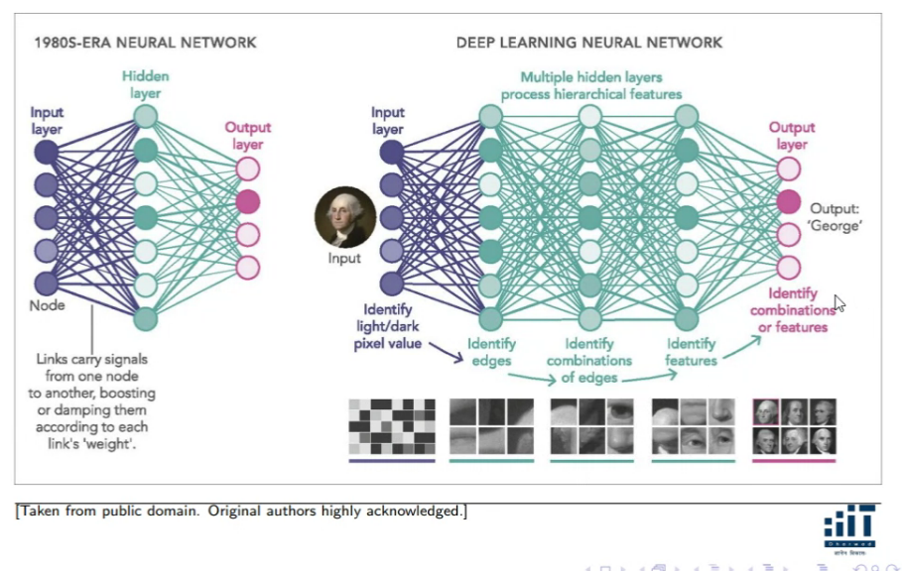

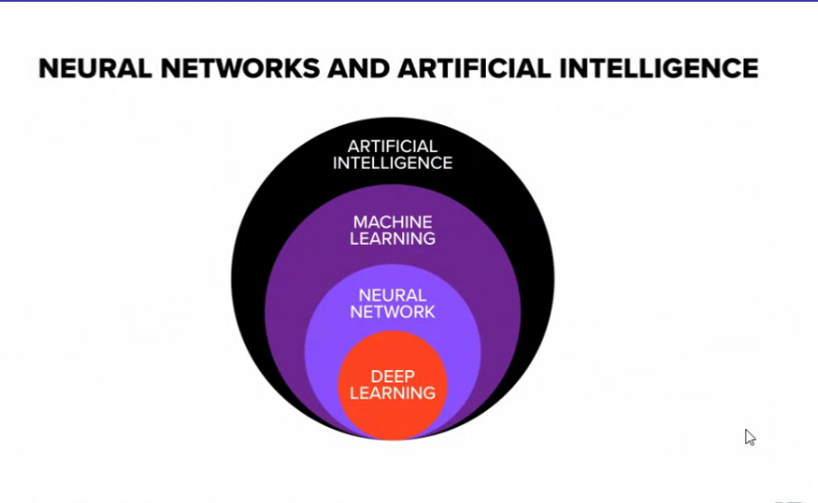
Within DL, now Generative AI is a new field.

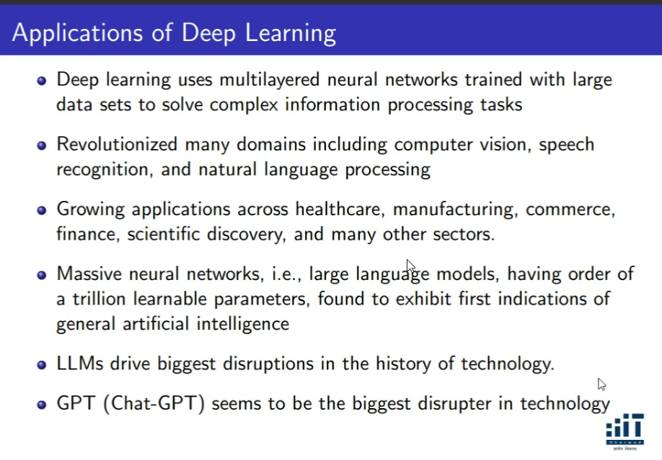
Clarity on these terminologies-
Pattern Recognition
NN

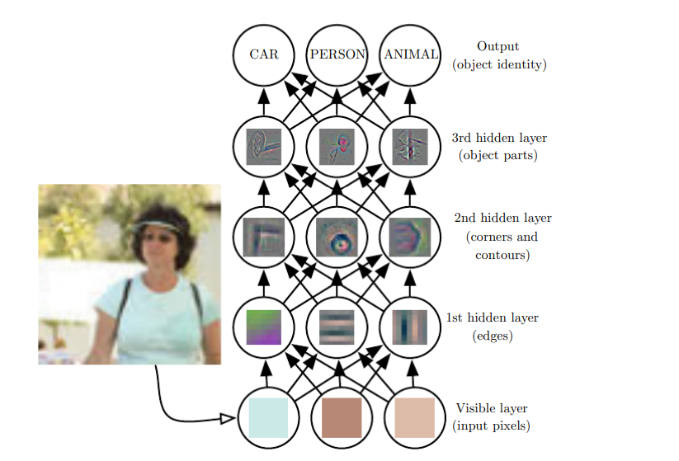

Day 2

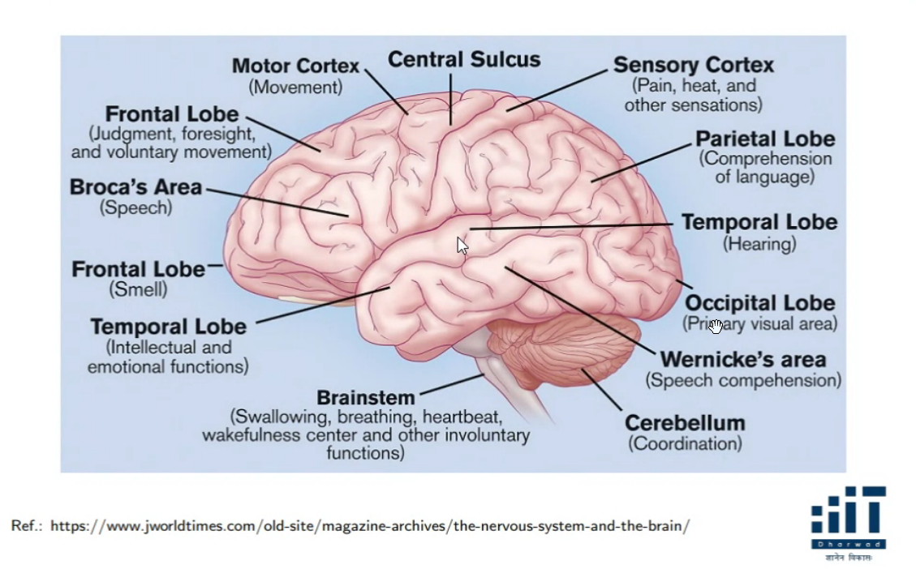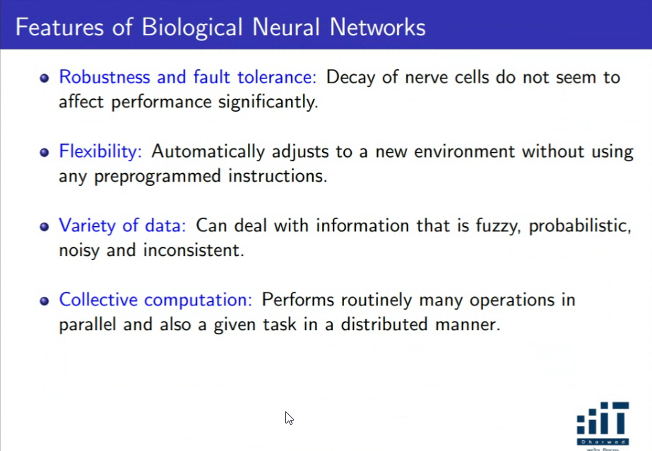
In human brain there are layers and then each layer contains many neurons. The input received in human brain can be applied simultaneously in multiple neurons in the next layers and then applied in several of neurons -> Artificial neural network.
You can apply in parallel and distributed

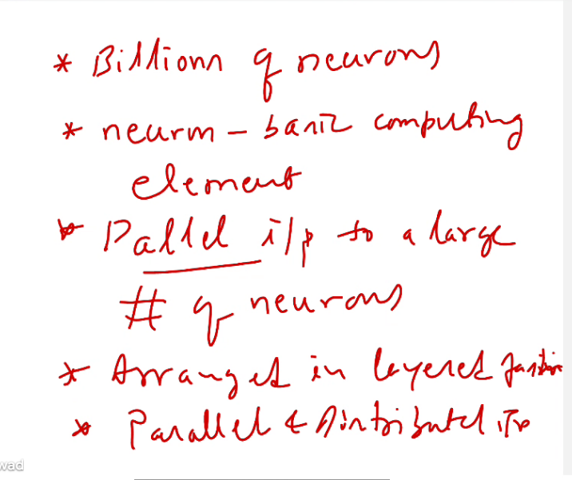
- Human brain contains billions of neurons
- Neurons – Basic Computing Element
- Parallel Input to a large number of neurons simultaneously.
- Parallel and distributed input – This was the big claim during this time because parallel processing was the crux.

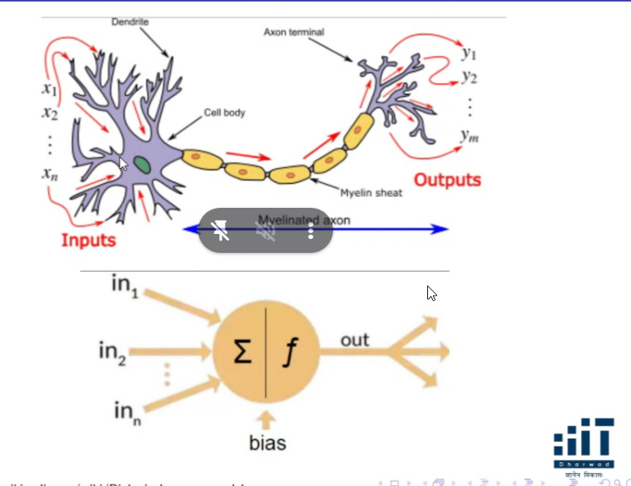
- Dendrite captures information and excites the state, which fires a trigger which makes a discharge to flow through the Axon and then the output gets flowed to Axon Terminal.
- The output at Axon Terminal are not repeatedly triggered or at the same power.
- Repeated triggering of Axon terminal increases the strength of dendrite terminal. If they are not triggered occasionally, the axon terminals gets weakening in strength -> Mimicking the Weights in Neural network.
- No information gets stored in neuron body, they are stored in the terminals.
- Also the discharged potential is not linear, there is a non-linearlity
- There is no storage in neuron, the weights are only thing which gets stored.
- No artificial neuron principals are discovered, DL uses the same concept of the neural network.

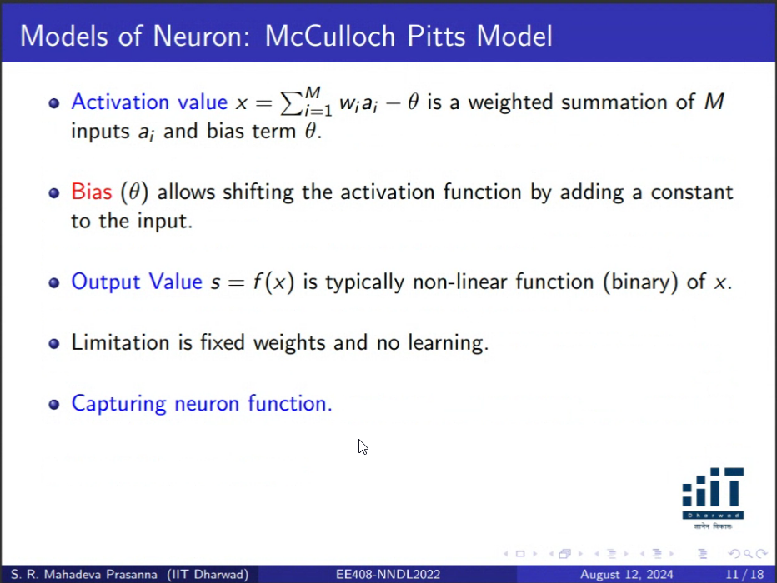

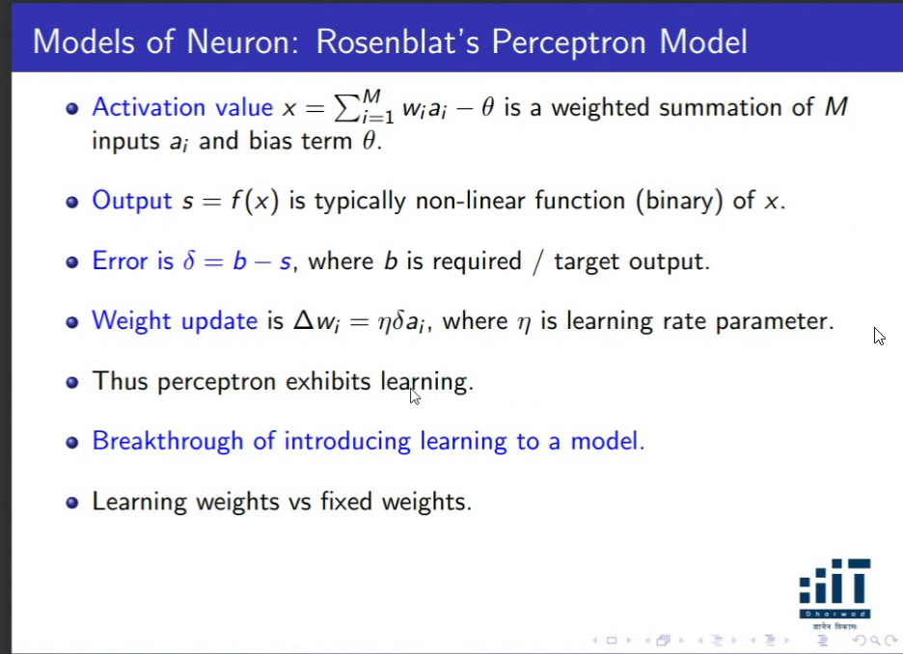
- When weight parameters and theta are learnt and adjusted to correct values, then the error = 0, b = s.
- Change of the weight’s parameters will be proportional to the unit dimension ai. No other algorithm for weight parameters, existing parameters are used to come up with the weight update.
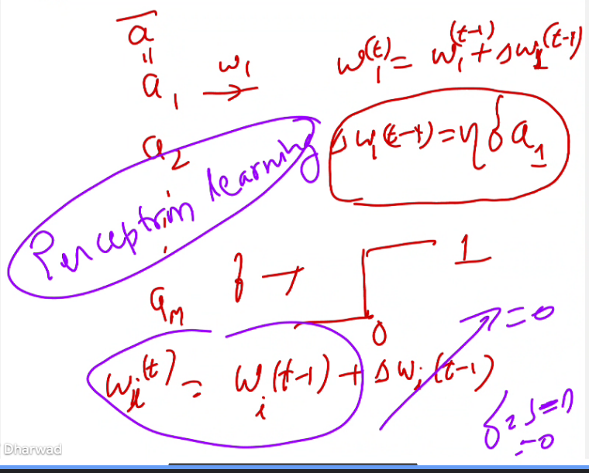
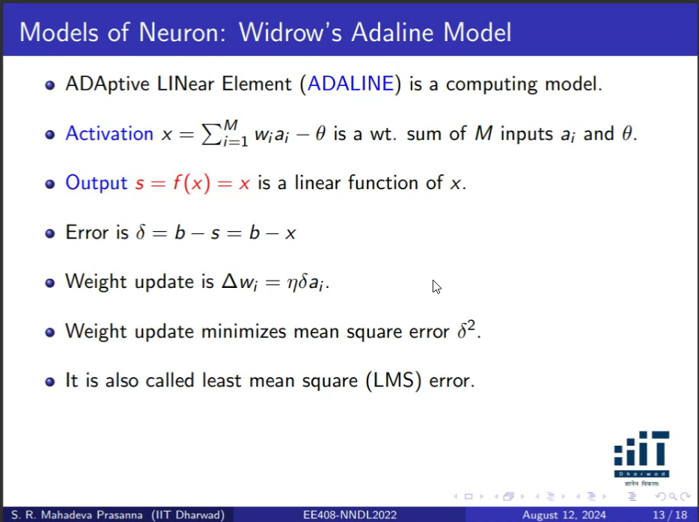
- It is used for distributing the weights equally among the outputs. So linear output is used.

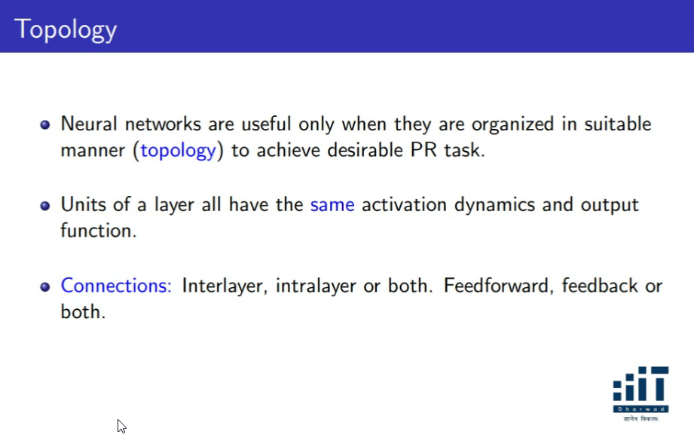
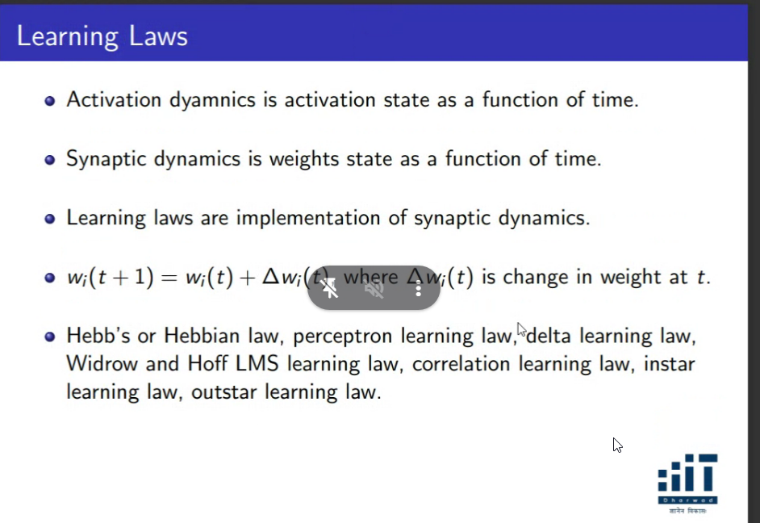

Feed Forward Topolgy
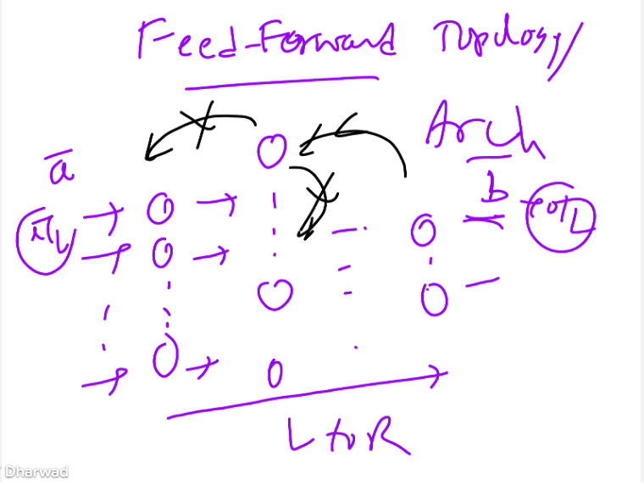
- Only from left -> right. Not from right to left or between other neurons.

Feedback Topology
- FeedForward + Possibility of flow coming from right to left, output to input and also between neurons
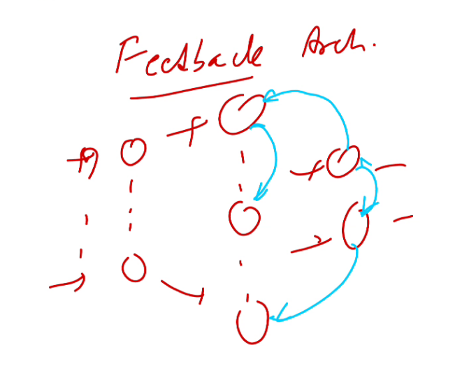

Combination
- Feedback for some layers, Feed forward for others.
Mostly feed forward neurons are used mostly.

Day 3

W1 will capture the uniquesness of a1 feature (eyes) such that during testing, if I feel that for a new face,
A1 domension represnents eye
A2 DIMENTION represents nose
A3 represents reporesents mouth
W
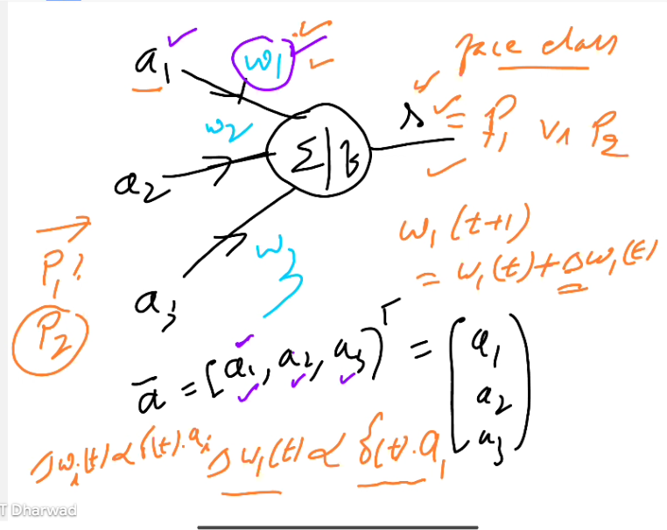
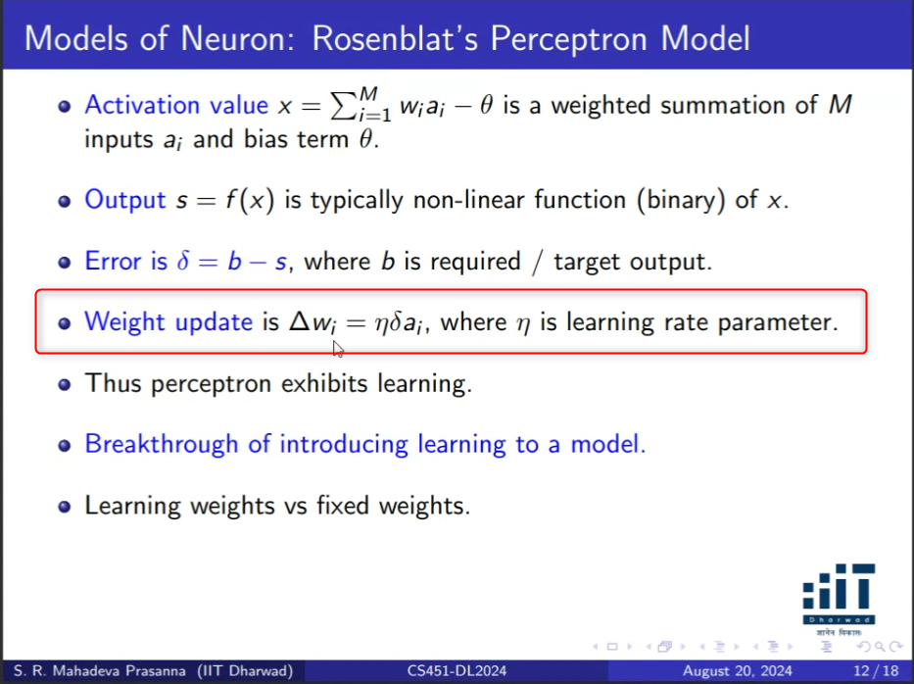
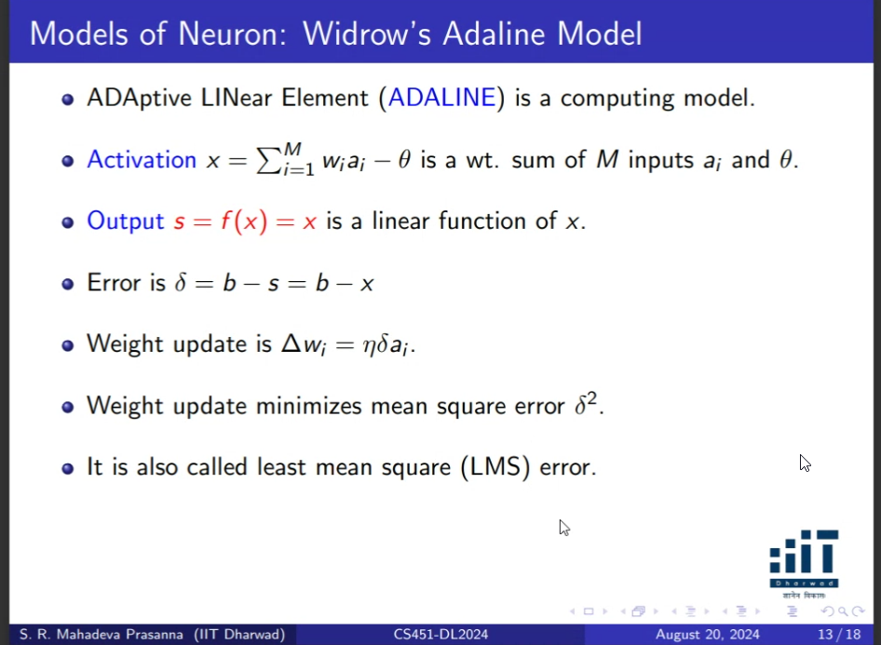
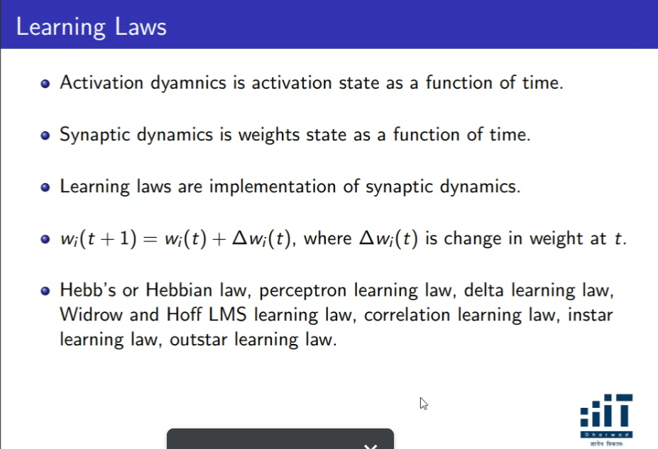
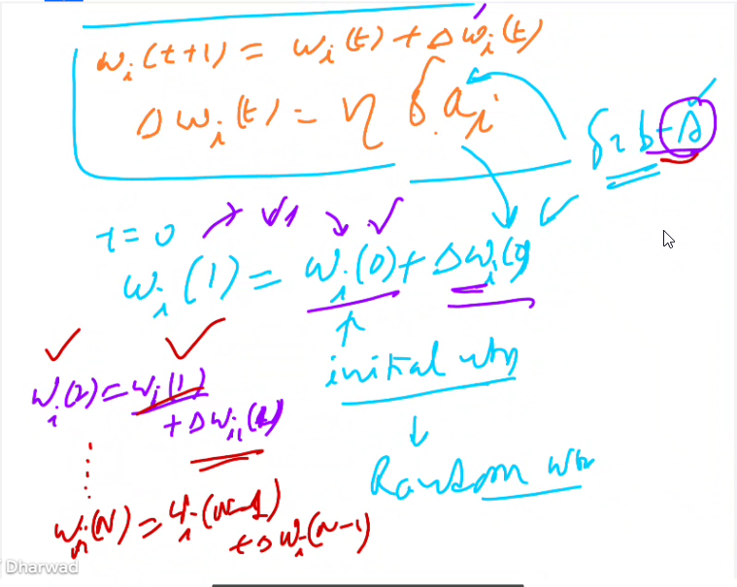
How do you say that weights are improving when you are going from one iteration to another ?
The second iteration while computing w(2) is using w(1) weights (calculated last iteration) which results in s. So in this process s slowly moves towards b.

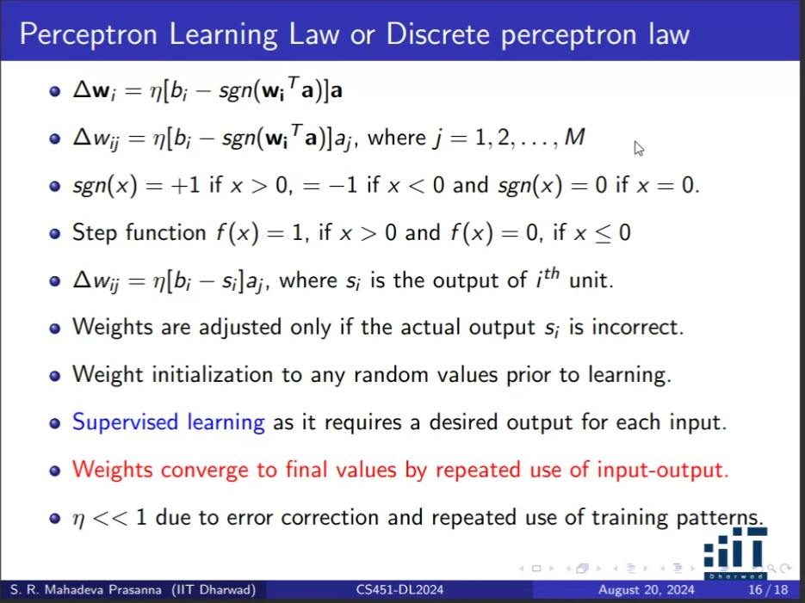
Step functions – not linear
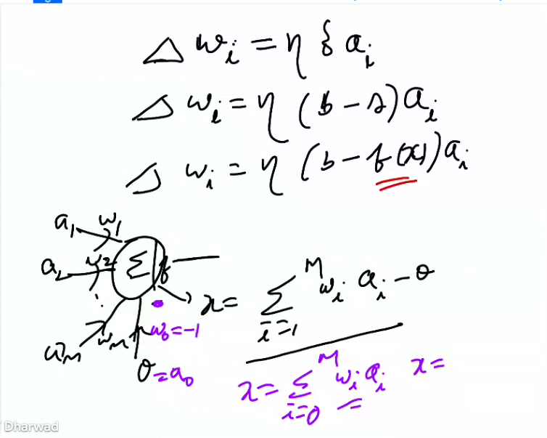

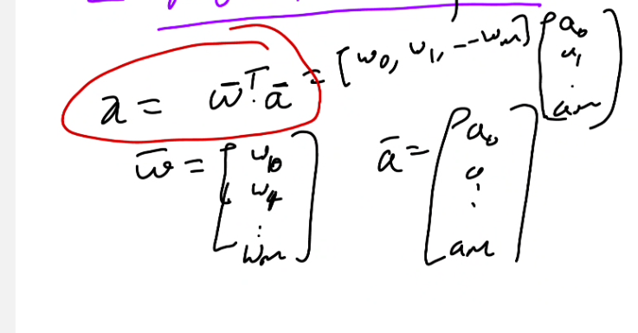
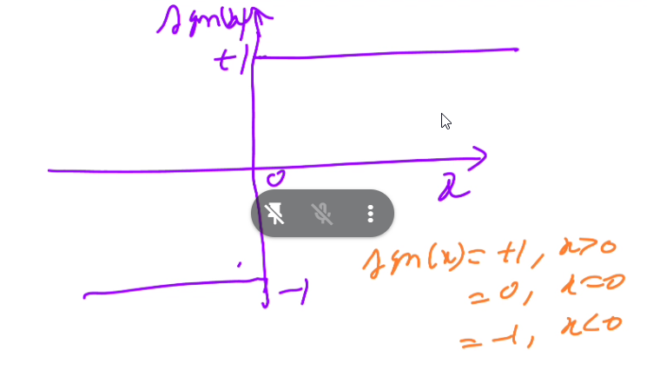
This signum function can be reduced to 2 equation step function (binary values)
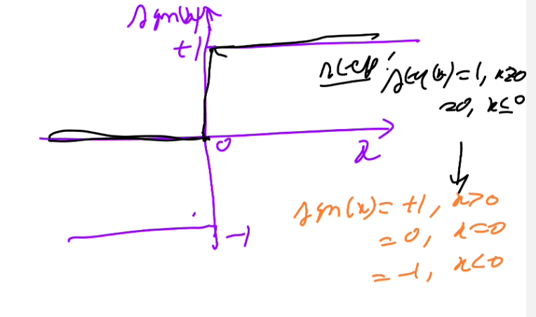
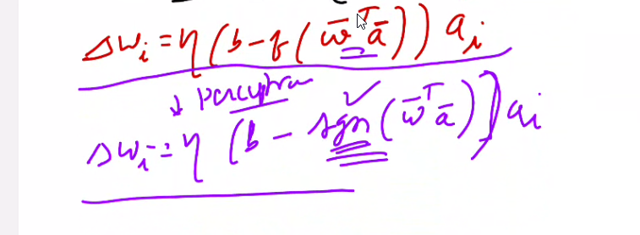
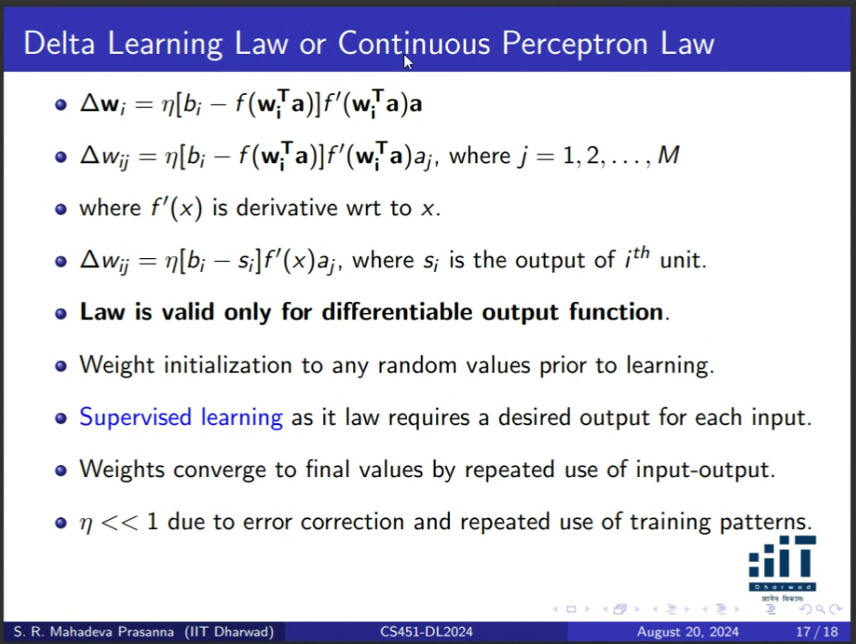
Discrete Perceptron law has some limitations, so continuous perceptron learning law.

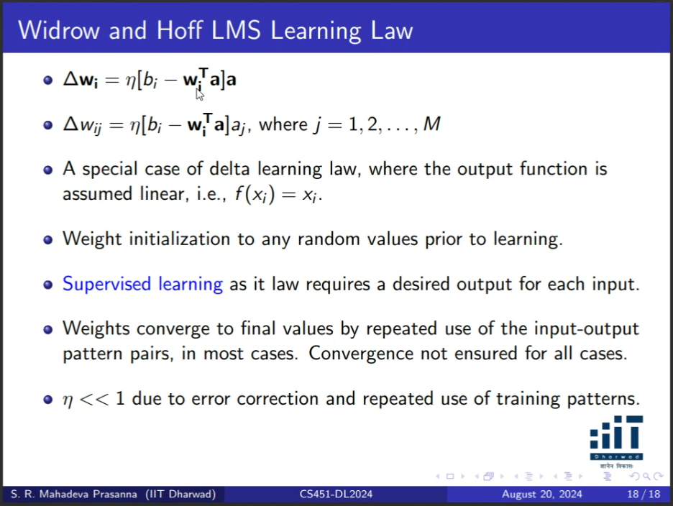
Here f is not there because it is a linear function.
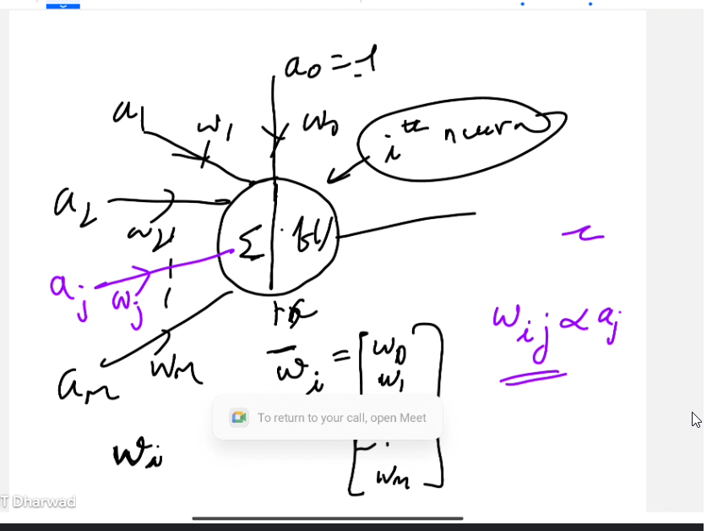


Feed Forward Neural Network
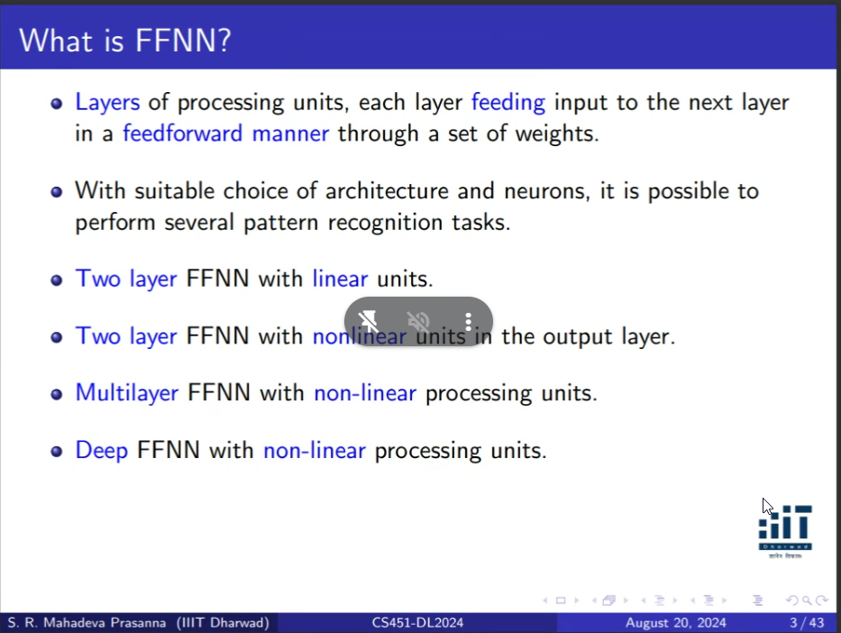
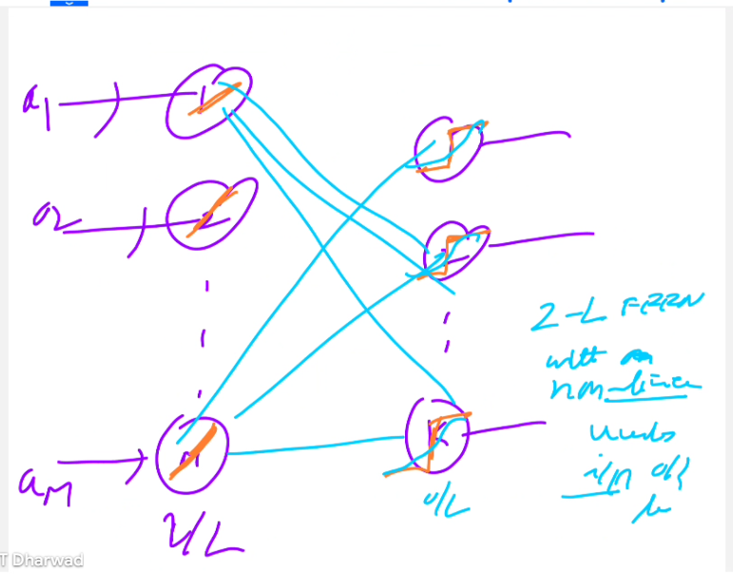
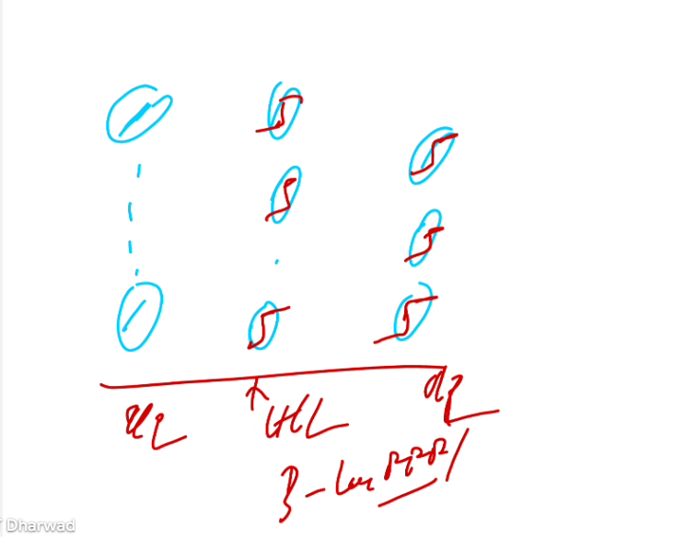

Day 4
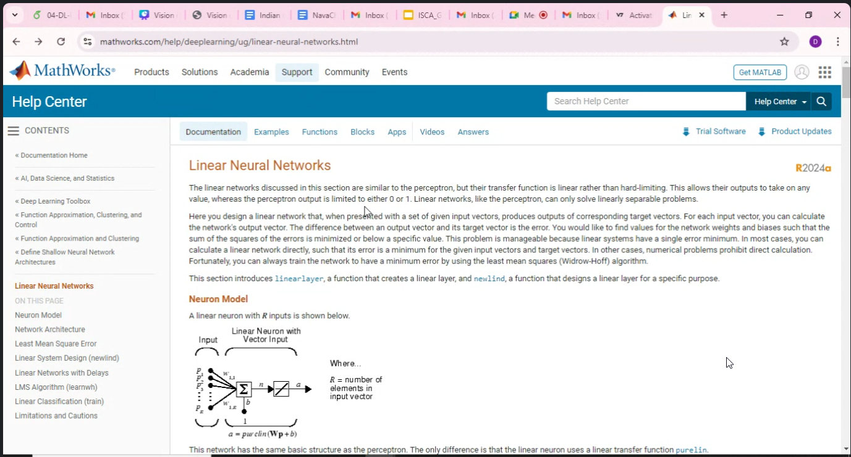
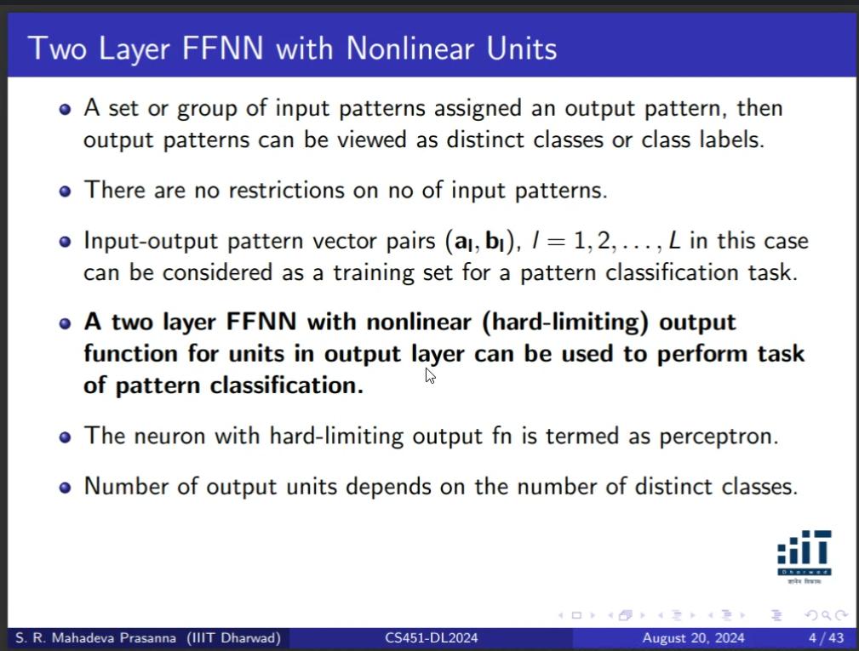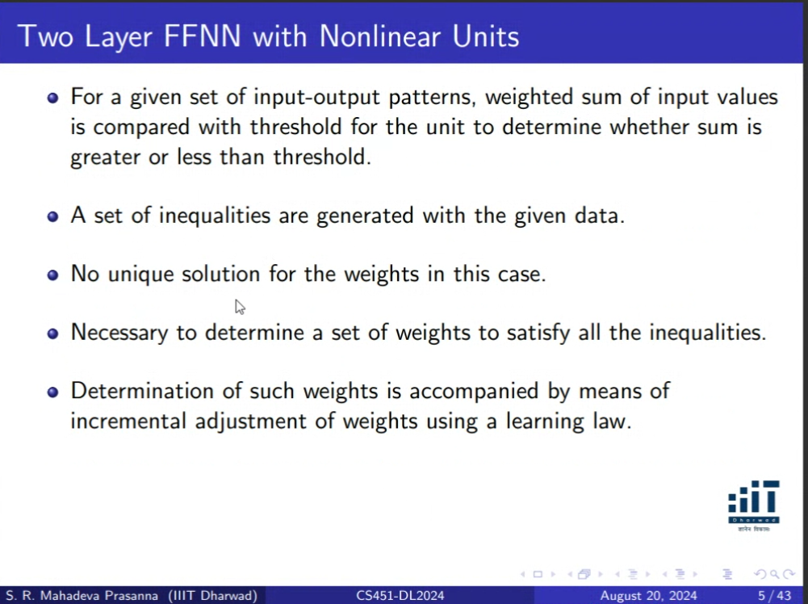

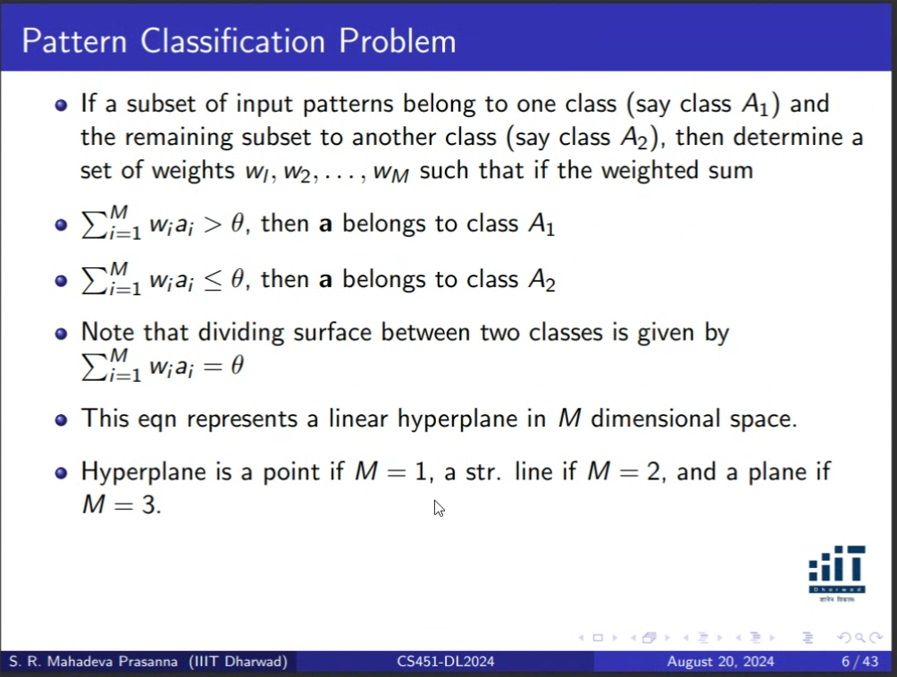

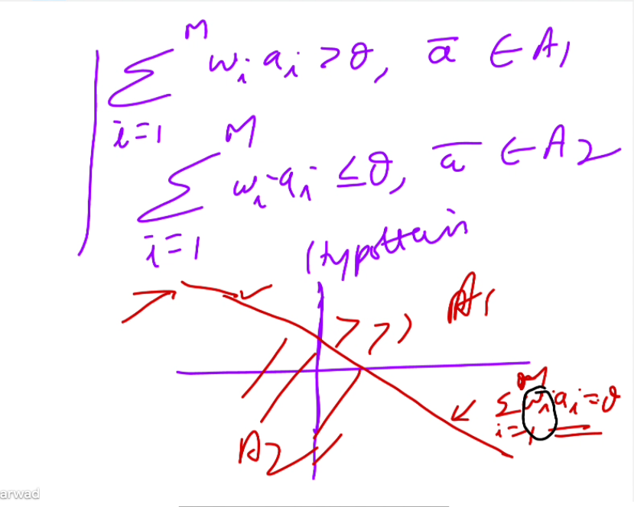
There can be many solutions. There can be many hyperplanes. So once I am able to meet the condition, I will stop the learning. So the hyper plane is correct, but this may not be the only solutions.

Day 4

DataDat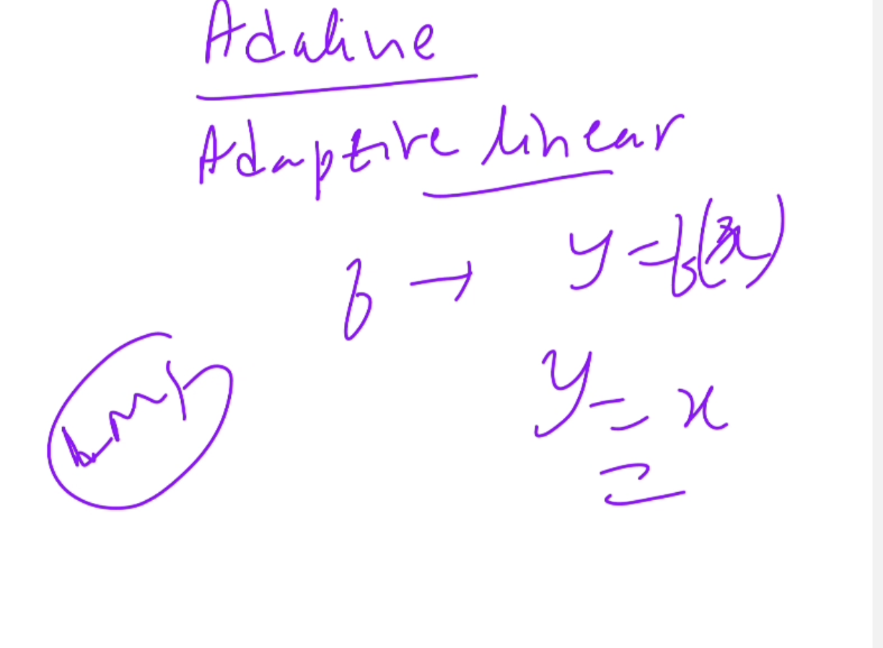

Data classes might be 2 but they may not be linearly sepratble

