Php-rest-api

<http://localhost/phpcrud/API/api-fetch-all.php>

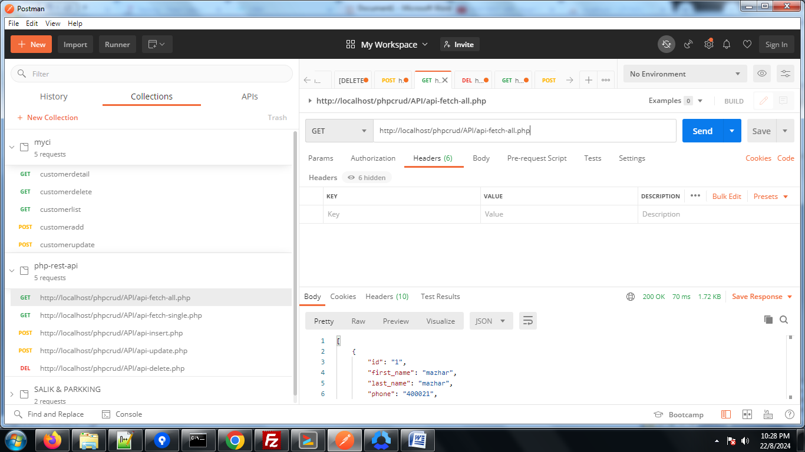

<http://localhost/phpcrud/API/api-fetch-single.php>

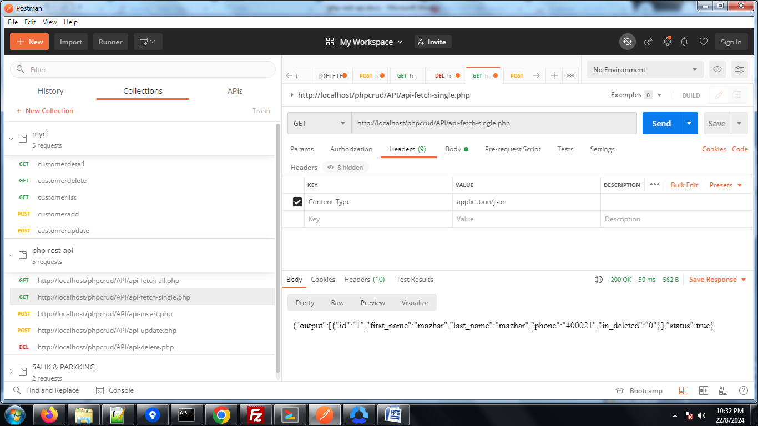

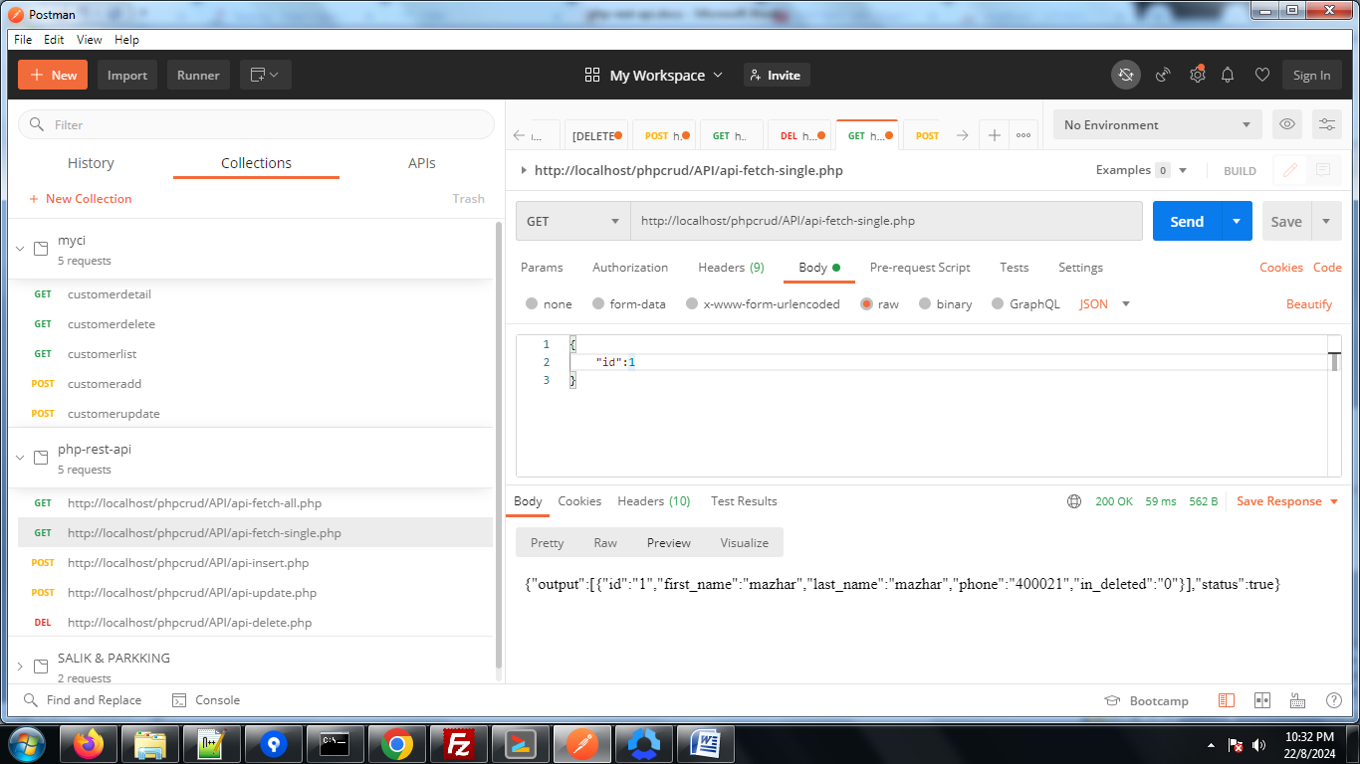

<http://localhost/phpcrud/API/api-insert.php>

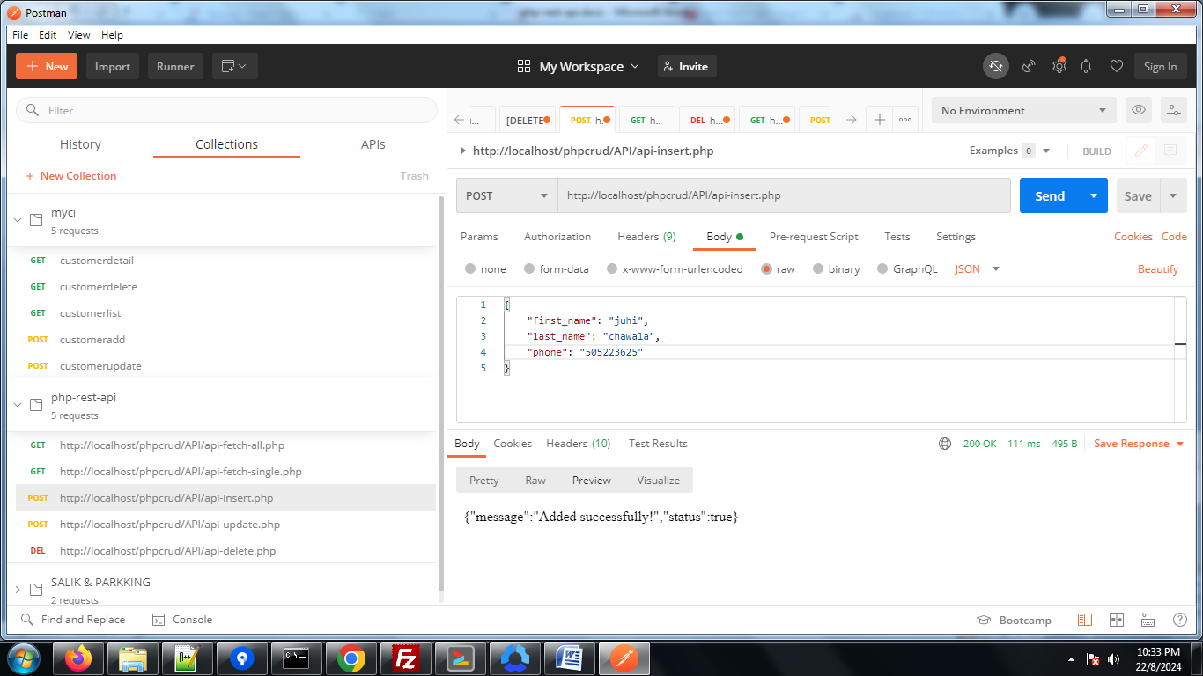

<http://localhost/phpcrud/API/api-update.php>

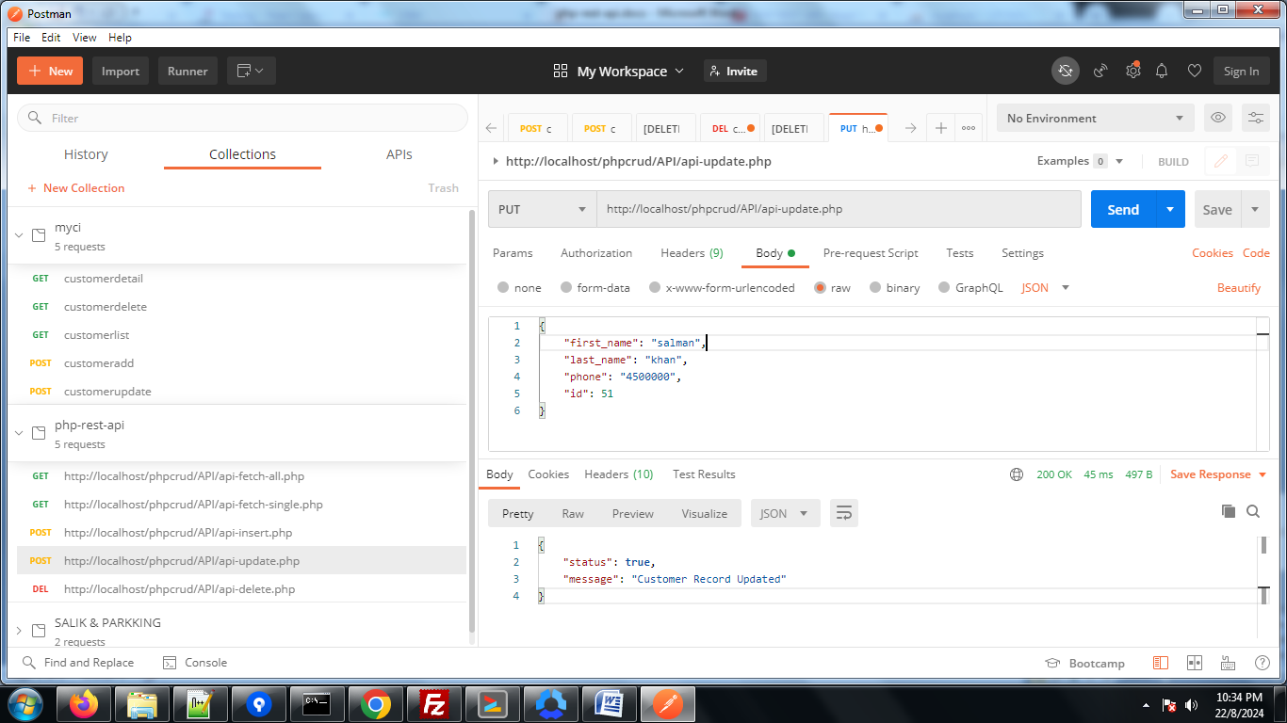

<http://localhost/phpcrud/API/api-delete.php>

