Lantern Notes
Screenshots from the Development Version
Mar 22, 2008

Getting Started

Logging In
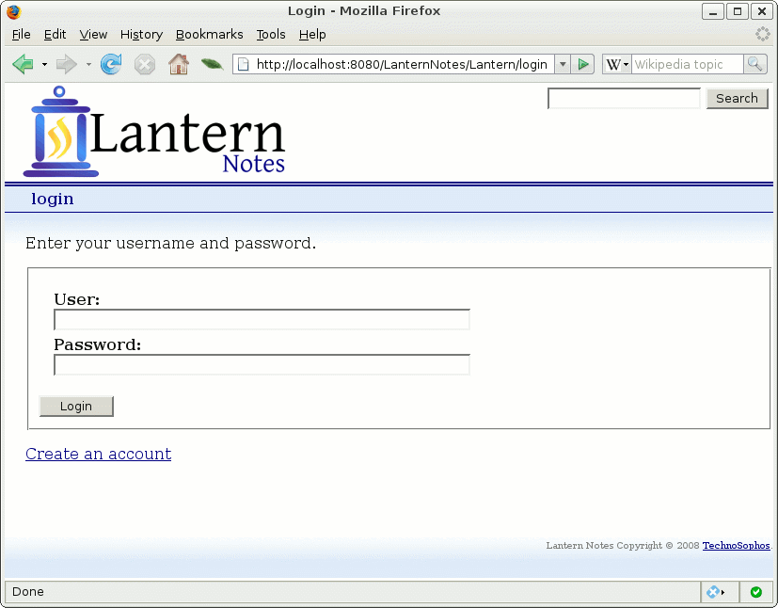
Enter a user name and password to log into the site.

Help
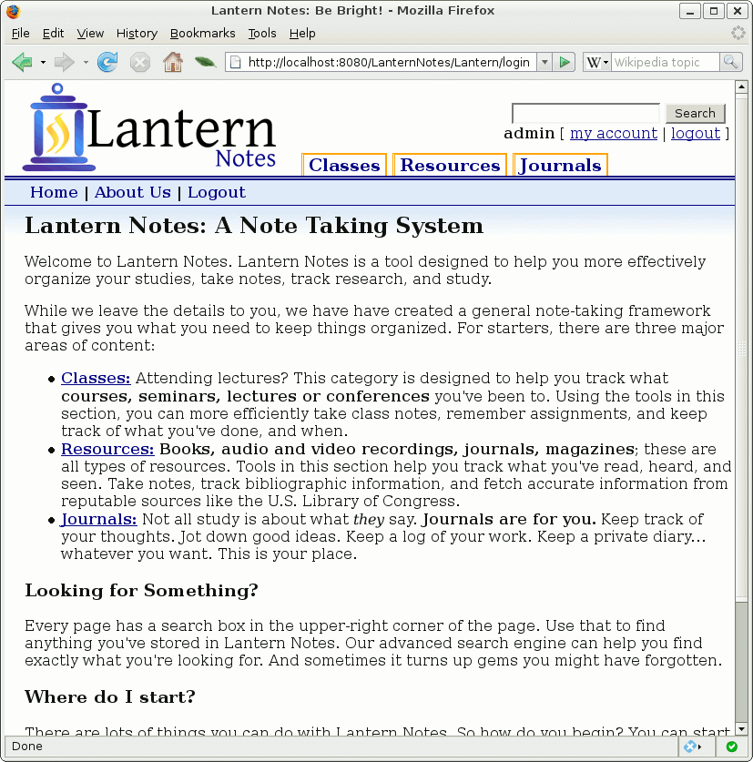
The first time a user logs in, she or he will see this brief explanation of what things are and how they are organized.

The tabs along the top are used to navigate to the various areas of the site: Classes, Resources, and Journal.

View Classes
The Classes tab is used to access the section of the application related to courses. It can also be used to track other lecture-like formats, including conferences or symposia.

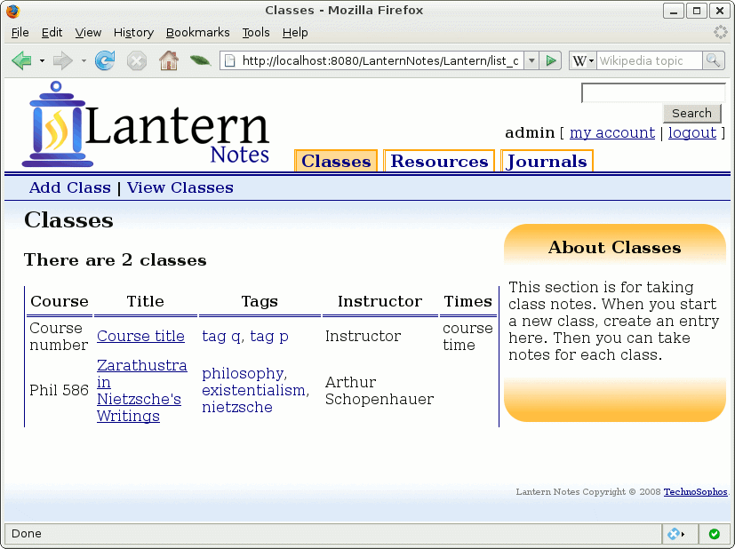
The main classes screen shows all existing classes. In the above example, there are two classes (The first one does not have particularly imaginative information.

In the right-hand side callout, there is some brief explanatory text. Next, we will create a new class.

To add a class, click on the Add Class link in the navigation bar (upper left hand corner).

Add a Class
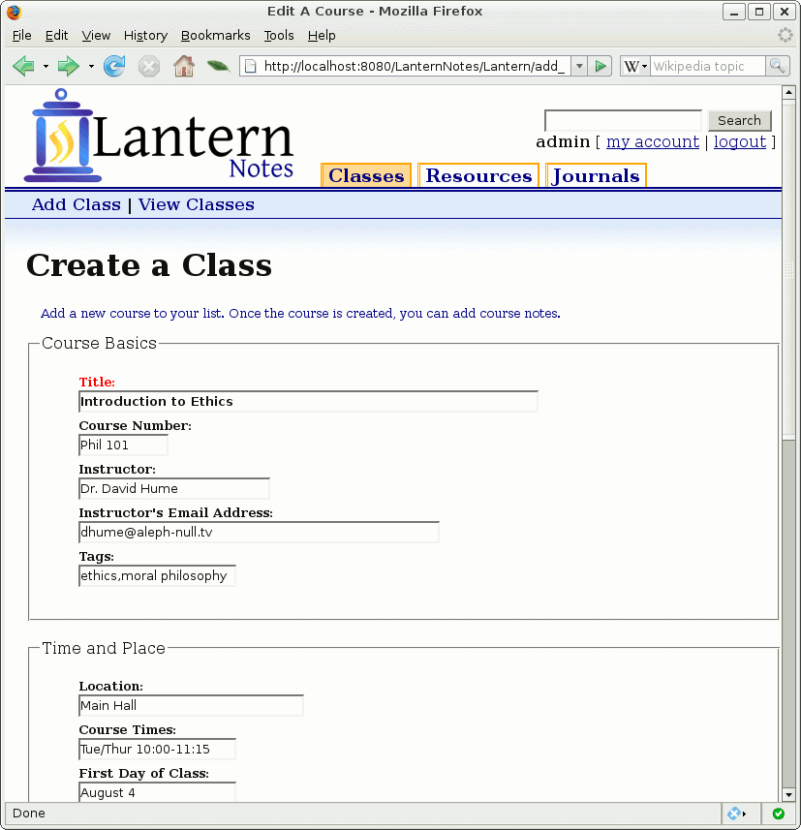
There are several fields to fill out when creating a class. Only Title (marked in red) is required. Course information, instructor contact information, and details about when the course meets are designed to help the user keep organized.
In future releases, these can be used to assemble a weekly schedule.
At the bottom of this form (not shown) is an area to paste in a syllabus.
When this form is submitted, a new course is added to the list of classes.

View Course
Once the course has been created, we can then go back and look at it:
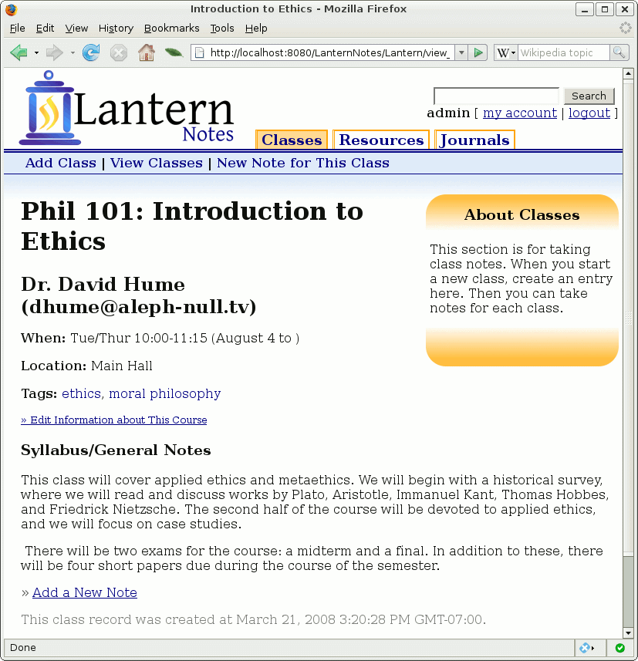
All of the information we just entered now appears on this page. (Note that the syllabus information is shown here, while it was not shown on the previous screen.
The Tags are used to link this class to other related content. We will see that in a moment. The Edit Information about This Course link returns us to the form we saw above. To start taking class notes for this course, click the Add a New Note link.

Add a Note
This is the main note editor:
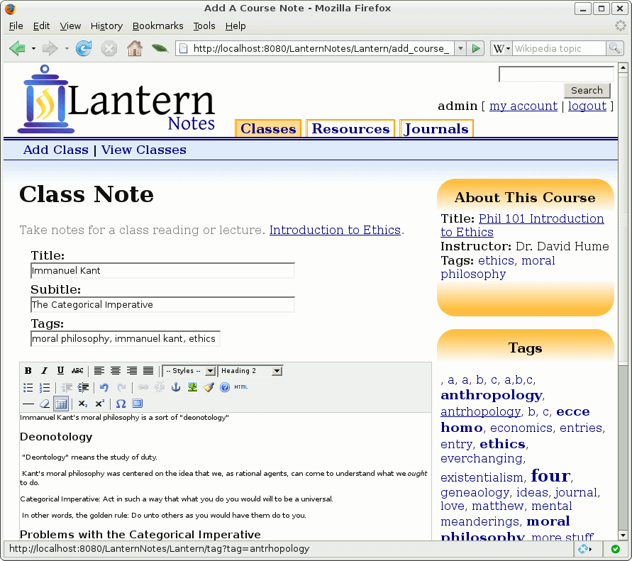
A note has a Title, a Subtitle, Tags (a free-form list of terms), and a main body section. None of the fields are required.
The note editor is a fully featured WYSIWYG editor similar to Word.
There are two callouts on the right-hand side. One, About This Course, provides basic information about the class that this note is for. In the example above, we are taking some class notes for the Phil 101: Introduction to Ethics course that we created previously.
The second callout is a tag cloud. This shows all of the tags that the user has already used. They are organized alphabetically (NB: There are a few single-letter placeholders which are part of the debugging code. They will not be present in production). The tag cloud is used to remind the user of frequently used tags.

View Class – With the New Note
Once the above note is saved, it is added to the class:
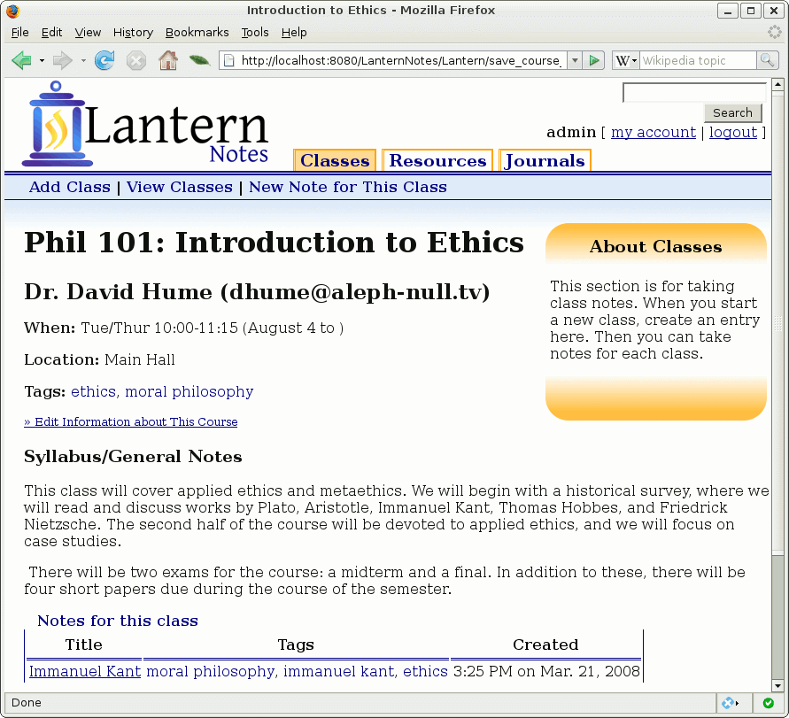
The section Notes for this Class, located at the bottom of the screen, lists all of the class notes taken so far.
Clicking on the title of the class note will take us to the note viewer, which will show the complete text of the note

View Class Note
Here we can see the full text of the note we entered previously:

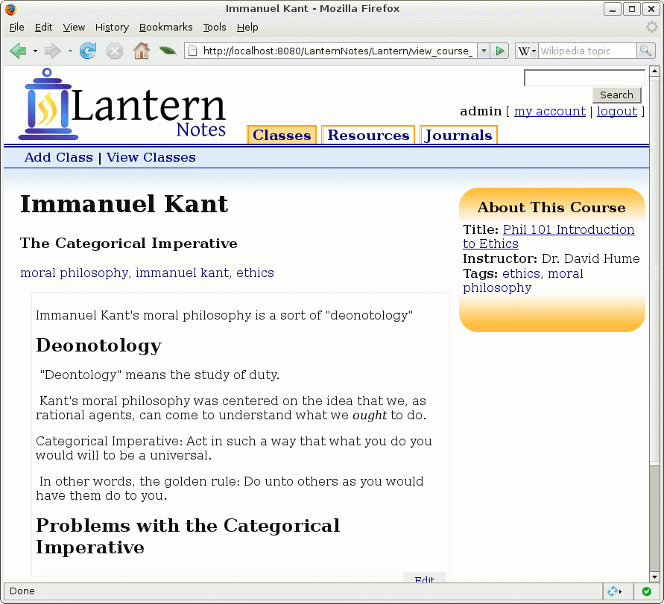
Notice the callout on the right, indicating which class this note is for. An Edit button appears in the lower right-hand corner.
Throughout Lantern Notes, any time a tag appears, it is presented as a link. Clicking a tag's link will take the user to a list of items that use that tag. We will see that in a few moments.

Summary of Classes
The Classes section is designed to help students keep on top of their courses. They can track lectures by taking notes (and remember – everything in Lantern can be searched). They can also use notes to track assignments, create study guides, and so on.
In future releases, the Classes section will have additional study aids, like flash cards and a study guide tool.

List Resources
The second tab in the tab bar links to Resources. This section is designed to help students track what they are researching – books, videos, audio recordings... whatever. (NB: This section may be renamed in the future.)
It is anticipated that the main uses of this section will be for taking reading notes and maintaining a bibliography.
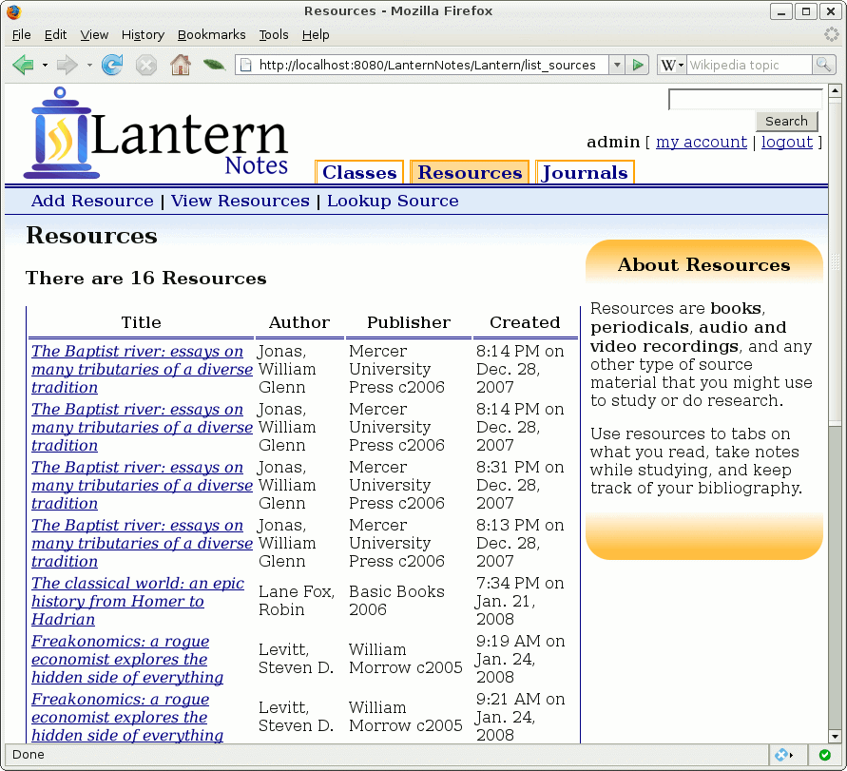
The main Resources page displays a list of all resources. (In the example above, we have loaded it with testing data, some of which is intentionally duplicated.)
There are two ways to add a resource. A resource can be hand entered (click Add Resource in the menu bar), or it can be looked up. We will click on Lookup Source in the menu bar, and look up a source.

Looking Up a Resource
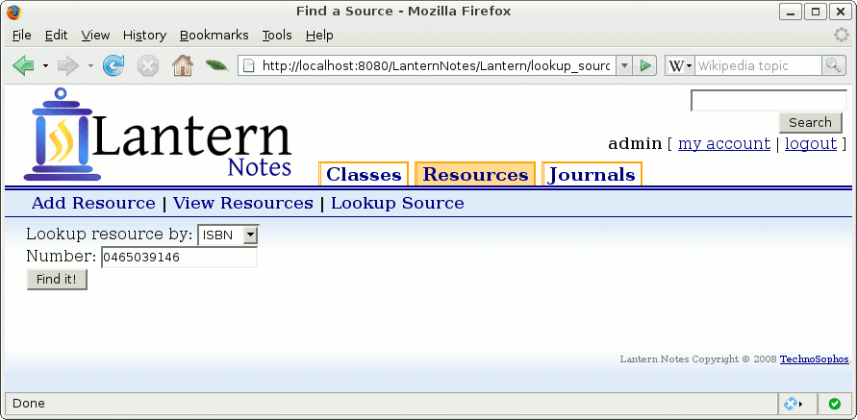
To look up a resource, all we need is some unique identifier for the source. Above, we are using an ISBN number (ISBN 10 and 14 are both supported). LCCN (Library of Congress Control Number) and ISSN (International Standard Serial Number) are also supported. Others, like Dewey Decimal Number, can be added if the back-end library supports them.
This particular lookup will query the United States Library of Congress library catalog. The Library of Congress maintains a huge collection, and most scholarly texts (including textbooks) can be found in their catalog.
Clicking Find It! will start the query. Usually, it takes between two and five seconds for the resource to be found.

View the Resource
Here is the resource returned by the Library of Congress:
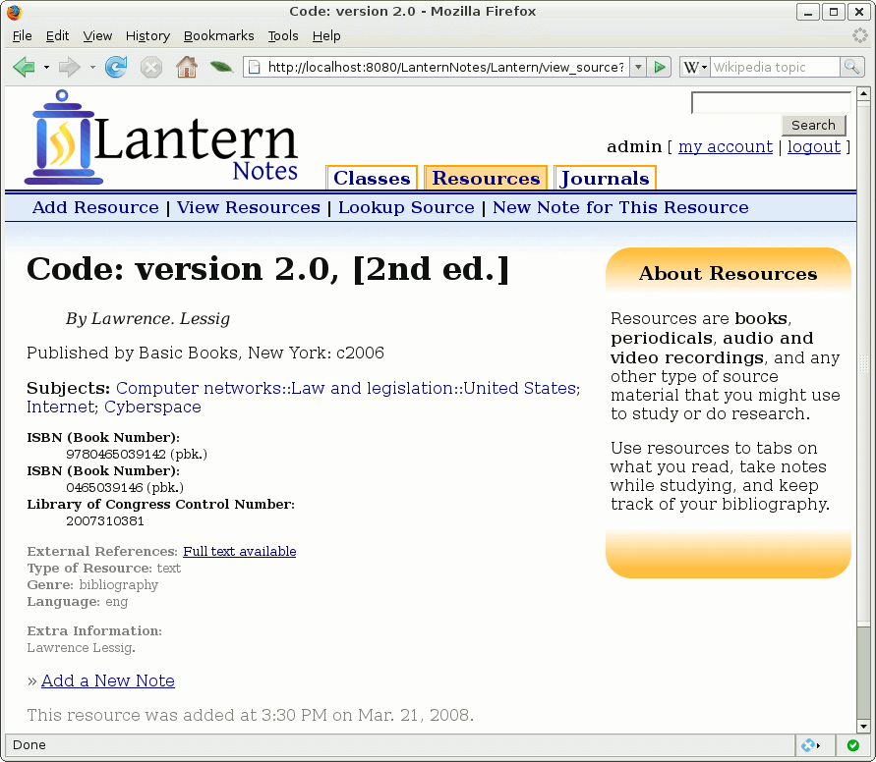
As can be seen above, we have just imported a fairly sophisticated set of data from the the Library of Congress. All of the information necessary for a bibliography is captured here.
Subject headings are also imported and linked. Once we have built a substantial reading list, we could navigate our resources by subject heading. This provides another navigation tool, which complements tagging. (A user can add tags to a resource, too, to connect that resource with other items in Lantern.)
Additional helpful information may also be imported from the LOC record. The link Full text available indicates that there is a free (and sanctioned) online version of the book. Clicking on the link would take us to that book.
To add a note to this book, we click on Add a New Note.

Add a Note to a Resource
Just as with a class, we can add a note to a resource:
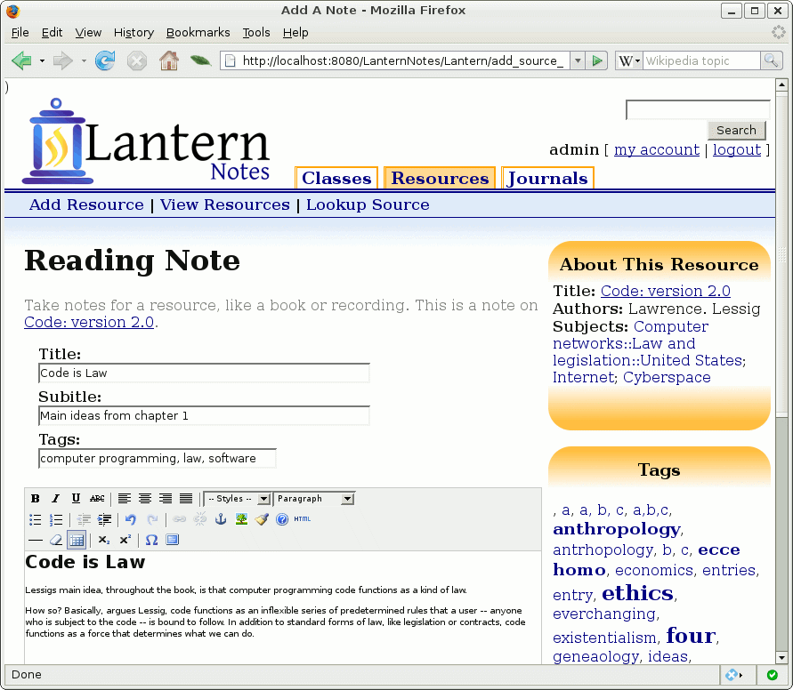
The structure is almost identical to that of the Class Note, except that it is specific to a resource instead.
Once we have created and saved a note, it will be visible in the list of notes for that resource, just as was the case with class notes. And we can access the note for viewing, too:

View a Resource Note
Here is what the above note looks like when we come back later to view it:

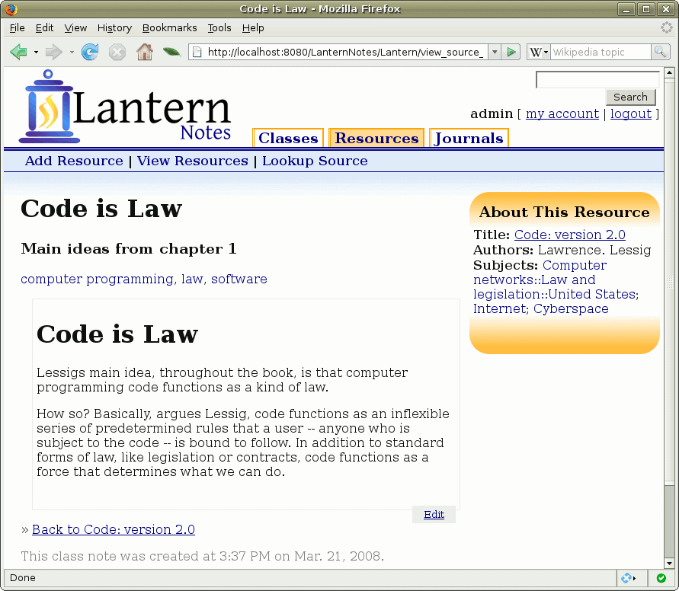
Again, this is similar to how notes work for classes.

Viewing the List of Resources with Our New Book
If we were to click on the View Resources link in the menu bar, it would take us back to the list of resources. This time, we can see Code: version 2.0, the book we just added.
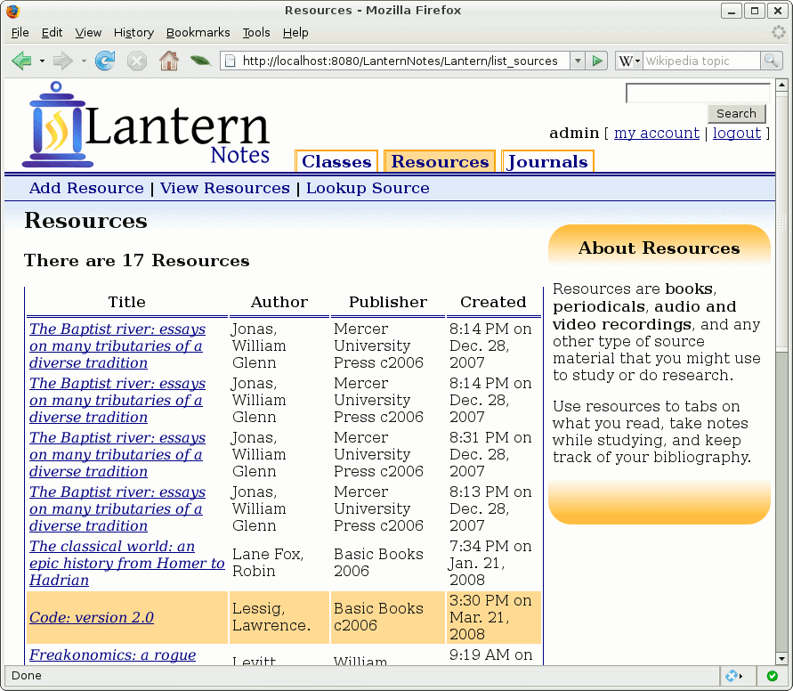
Note that it is highlighted in the screenshot above.

Summary of Resources
The Resources section is designed to help students track their studies. Bibliographies and book notes are an important part of student life – particularly because they play a huge role in writing term papers, a staple of college course work.
In a future version, Lantern will add two new features:
- Bibliography Builder: Drag and drop resources, and let Lantern build a bibliography for you.
- Term Paper Started: Drag and drop notes into an outline or rough draft that can then we exported to a Word document. Get an easy start on that term paper.

Listing Journals
The last tab in Lantern Notes is for Journals. While the other two sections are designed to help students track the thoughts of others, the journal is intended to give the student a place to keep track of her or his ideas.
A student can create multiple journals (one for term paper ideas, one for reminders about things that need to get done, one for a diary...). The first Journals page is a list of all existing journals:
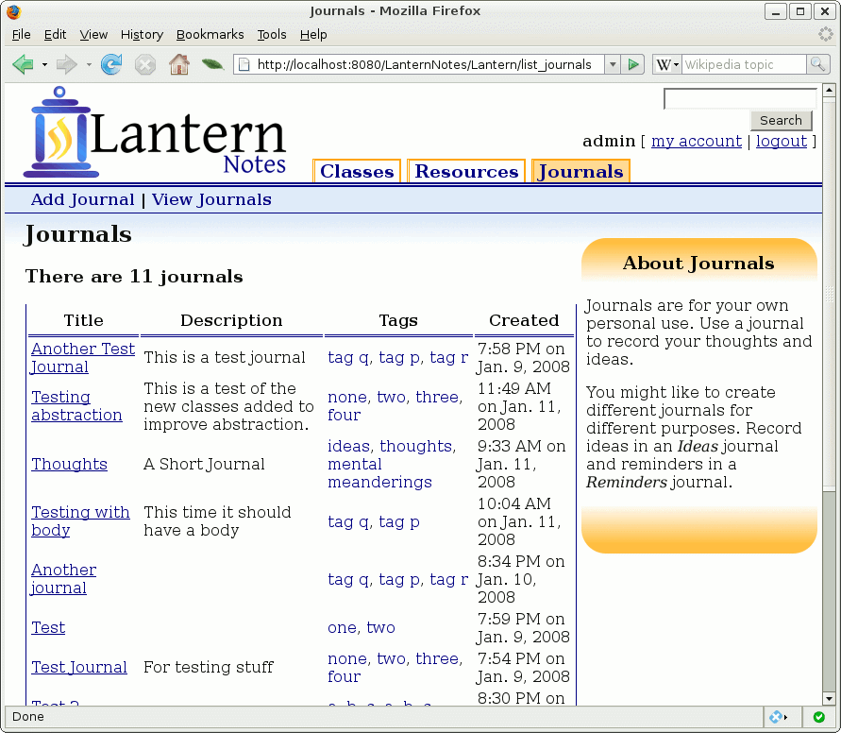
In the screenshot above, we can see that the user has created eleven journals.
To add a new journal, click Add Journal.

Add a Journal
Adding a journal is simple. Just give the journal a title, a description, and set some tags:
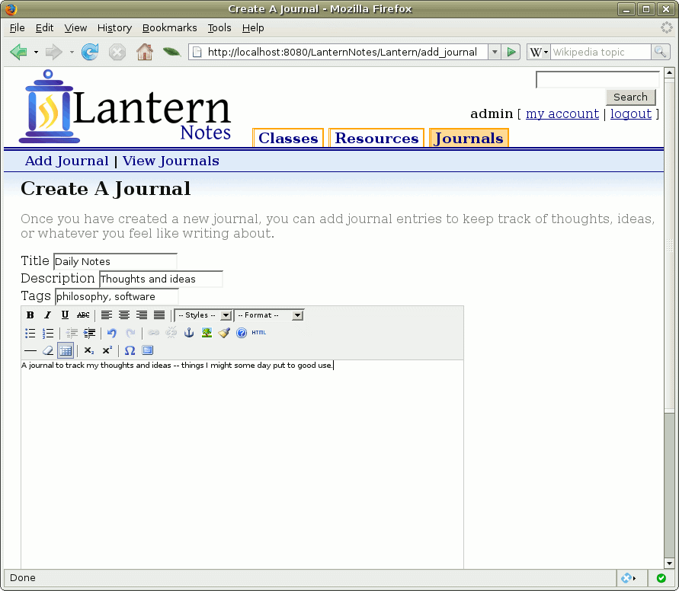
A journal also has a body, where a full text description of the journal can be added, too.
Once the journal has been added, it will also show up in the list of journals.

Listing of Journals with Our New Journal
The journal we just created is highlighted in orange in the picture below.
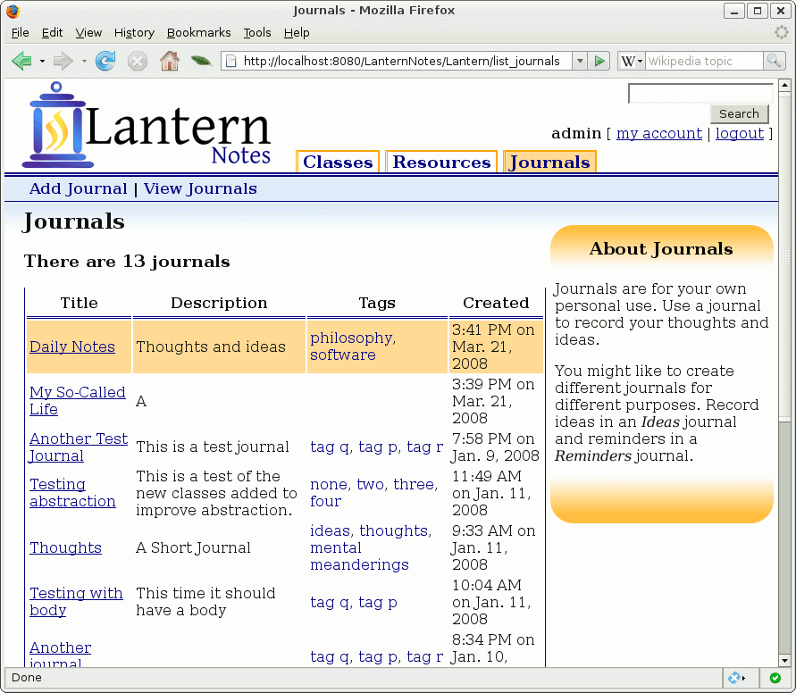
We can view this new journal by clicking on the title, Daily Notes.

Viewing a Journal
The first time we view a journal, it will have all of the information we entered. But so far there are no journal entries.
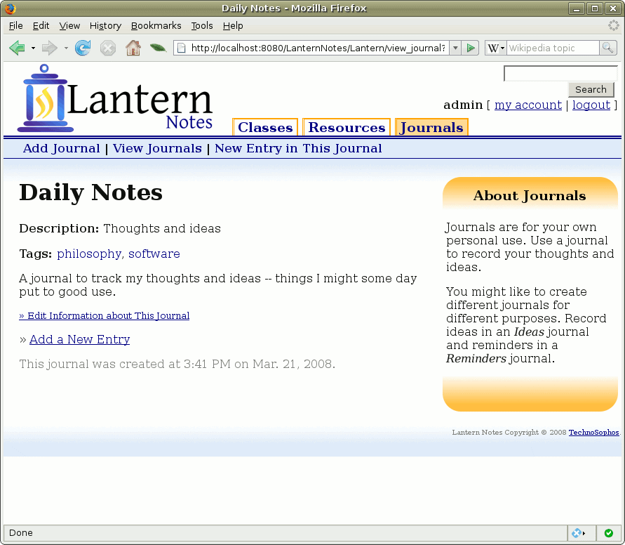
To add a new journal entry, we just click Add a New Entry.
This will bring up the journal editor, where we can add a new note.

The Journal Editor
The journal editor is similar in appearance to the other note editors.
Editors are kept as similar as possible in order to unify the interface. The editor is the most complex user interface, so uniformity was deemed particularly important for it.
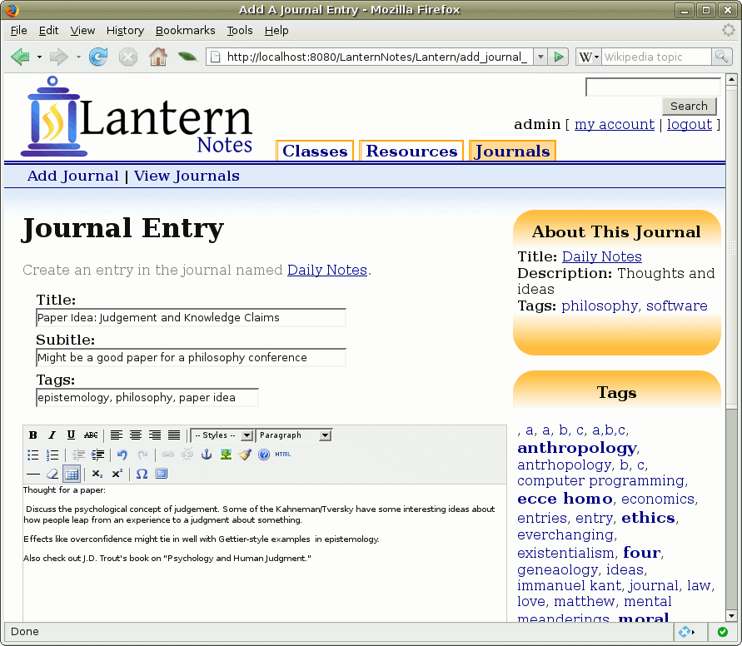
As with other note types, journal entries are free form. Users can structure entries however they want. Tables, special characters, external images, and hyperlinking are all supported, as are a variety of different styles.
In future versions, we may add the ability for users to store images and other non-text files in the database.
Once the journal entry has been saved, it will appear in the list of journal entries for our Daily Notes journal.

Viewing the Journal with Our New Journal Entry
If we view our journal again now that we have added an entry, it will look like this:
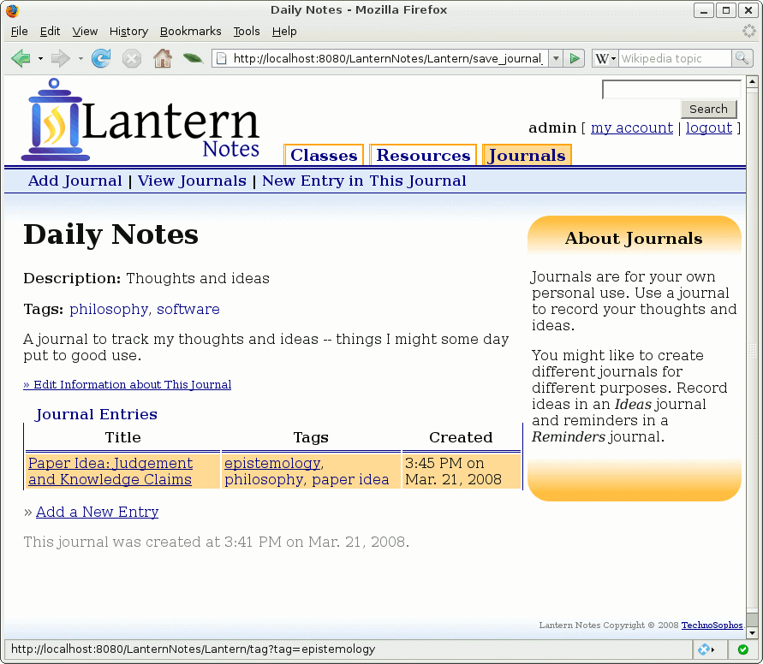
Our new entry is highlighted in orange in the screenshot above.
If we were to click on the title of this journal, Paper Idea: Judgement..., it would take us to the journal entry viewer and we could see our journal entry, or choose to edit it again.

Summary of Journals
The journals section is designed to help students keep track of their own thoughts. In many ways, it is intended as a tool to make a student more productive. But journals are flexible enough that they can be used for any sort of free-form writing that the student wants to do.
One could write a paper as a journal. One could also keep a personal diary, an address book, or just a set of random thoughts.

Searching and Finding
The last few screens we will look at have to do with Lantern Notes' searching capabilities.
There are two methods of locating information that we have employed. The first is through a taxonomy, in which the user categorizes her or his classes, resources, journals, and notes.
The taxonomy is implemented, as we have seen, in the form of tags. (Author names and Library of congress subject headings can also be navigated as a taxonomy, but they are considered auxiliary methods of browsing).
The second method of locating information is the traditional search. Lantern is backed by a very sophisticated search engine. It performs detailed analysis of the data and supports advanced filtering by tag, source, title, author, and other fields.

Navigating by Tag
Clicking on a tag will bring the user to a list of all items also marked with that tag.
Let's start from this screen:
This is the note we took on the book Code: version 2.0. When we created this note, we tagged it with three tags:
- computer programming
- law
- software
Each of those is now a link in the viewer.
If we click on the software tag, it will take us to all items with the tag software.

The Tag Browser
The tag browser lists all matching items, regardless of whether the match is a note, a journal entry, a journal, a resource, or a class:
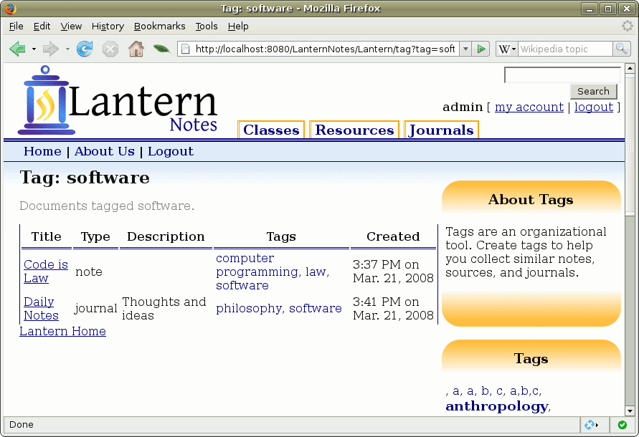
In the example above, there are two items tagged as software.
The first is a note, and the second is a journal (not a journal entry).
As students build up their own tag taxonomies, tag-based navigation can provide them with an intuitive method for locating things – Intuitive because the structure was “custom designed” by the user for the user.
Now let's look at searching.

Searching
A search box is located in the uppermost right corner of every page in Lantern Notes. At any point, a user can enter a query into that box and run a search.
When they click the Search button, the search engine will search the database.
In the case below, the user has entered the query tag:ethics kant.
This query will search for all documents that
- Have the tag ethics (tag:ethics)
- And contain the word kant somewhere in the item.
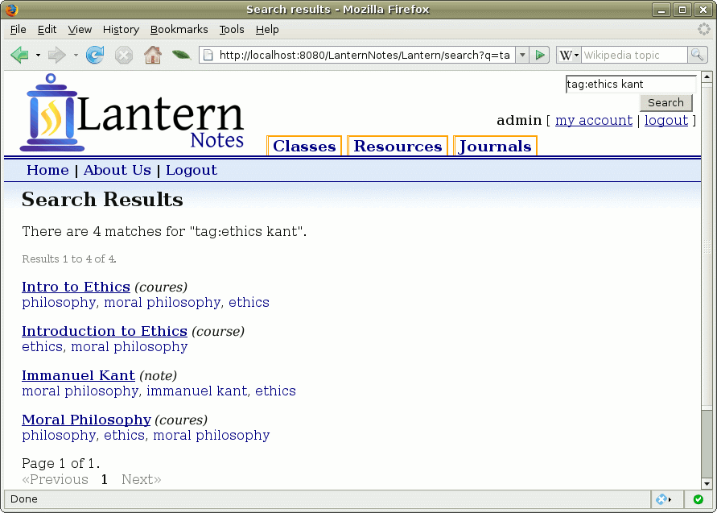
Four items were found to match. Three are courses, one is a note.
This illustrates how the search engine can search across types. It doesn't matter if the resulting entry is a class, resource, journal, journal entry or note... all will be searched.
However, if it is so desired, searches can be limited by types using the same keyword structure above. Here's an example:
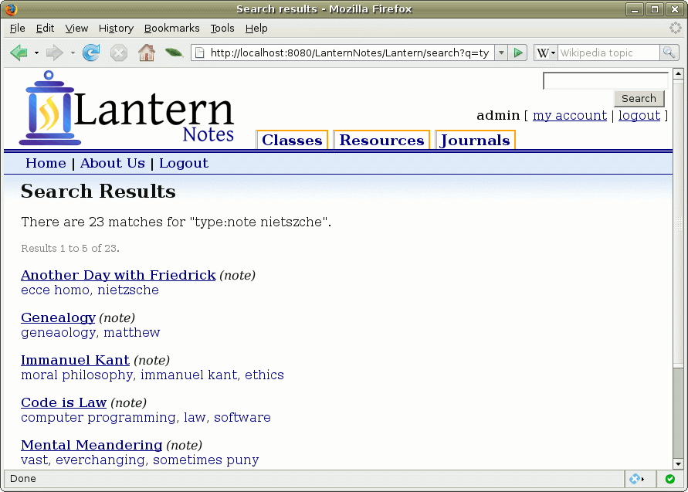
In this case, the search query is “type:note nietszche”. This will search for all notes that contain a reference to nietszche.

Search Conclusion
The searching technologies included with Lantern are designed to help students find the information they have put into Lantern.
Through taxonomies, they can organize and retrieve information using a technique that works for them.
Using the search engine, they can use a fine-grained query to find the exact item they are looking for. Or they can use broader queries to get a general idea of what they've done for a particular topic.

