# Link

<https://cloud.google.com/bigquery/docs/arima-single-time-series-forecasting-tutorial>

<https://cloud.google.com/blog/topics/developers-practitioners/how-build-demand-forecasting-models-bigquery-ml>

<https://cloud.google.com/blog/topics/developers-practitioners/how-build-demand-forecasting-models-bigquery-ml>

# Create Table and Set Bigquery scheduling to add new one

## Create new

CREATE TABLE SMART_TS_Forecast.n_daily_inident AS

SELECT date, CAST(count_incident AS INT64) as count_incident,'incident' as cate FROM `SMartDW.daily_incident` order by date

## Fill New on daily basis using Bigquery Scheduling

SELECT date, CAST(count_incident AS INT64) as count_incident,'incident' as cate FROM `SMartDW.daily_incident`   where date=(select max(date) from `SMartDW.daily_incident`   ) order by date

# Explore data

# query data over the last 30 days from SMART_TS_Forecast.n_daily_inident

SELECT

  date,

  count_incident

FROM

  `SMART_TS_Forecast.n_daily_inident`

WHERE

  date >= DATE_SUB(Date(date), INTERVAL 30 DAY) ORDER BY

  date DESC

# Create Model

CREATE OR REPLACE MODEL `SMART_TS_Forecast.model_daily_incident_forecast`

OPTIONS(

  model_type='ARIMA_PLUS',

         time_series_timestamp_col='date',

         time_series_data_col='count_incident',

         auto_arima = TRUE,

         data_frequency = 'AUTO_FREQUENCY',

         decompose_time_series = TRUE

         ) AS

SELECT

  date,

  count_incident

FROM

  `SMART_TS_Forecast.n_daily_inident`

Where date<='2024-01-31'

order by date

# Evaluate Model

#standardSQL

SELECT

 *

FROM

 ML.ARIMA_EVALUATE(MODEL `SMART_TS_Forecast.model_daily_incident_forecast`)

# Inspect the coefficients of your model

 SELECT * FROM

 ML.ARIMA_COEFFICIENTS(MODEL `SMART_TS_Forecast.model_daily_incident_forecast`)

# Use your model to forecast the time series & Explain and visualize the forecasting results

SELECT

 *

FROM

 ML.FORECAST(MODEL `SMART_TS_Forecast.model_daily_incident_forecast`,

             STRUCT(5 AS horizon, 0.9 AS confidence_level))

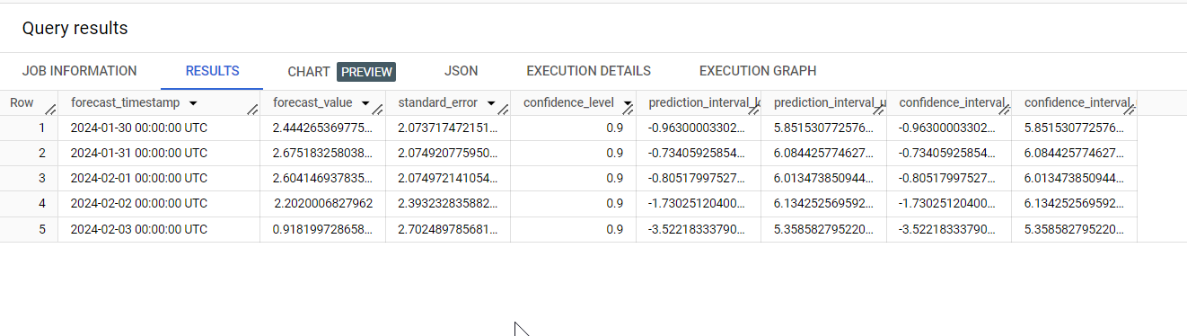

SELECT

 *

FROM

  ML.EXPLAIN_FORECAST(MODEL `SMART_TS_Forecast.model_daily_incident_forecast`,

             STRUCT(5 AS horizon, 0.9 AS confidence_level))