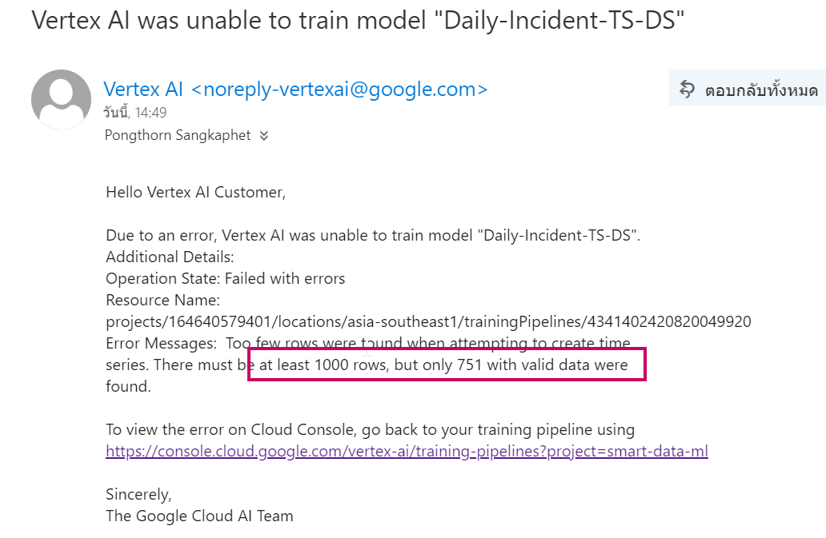

# Create Table and Set Bigquery scheduling to add new one

## Create new

CREATE TABLE SMART_TS_Forecast.n_daily_inident AS

SELECT date, CAST(count_incident AS INT64) as count_incident,'incident' as cate FROM `SMartDW.daily_incident` order by date

## Fill New on daily basis using Bigquery Scheduling

SELECT date, CAST(count_incident AS INT64) as count_incident,'incident' as cate FROM `SMartDW.daily_incident`   where date=(select max(date) from `SMartDW.daily_incident`   ) order by date

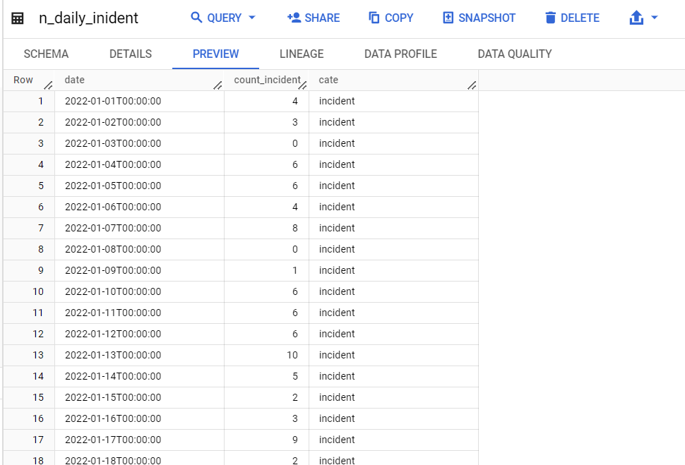

# Create DataSet : Daily-Incident-TS-DS

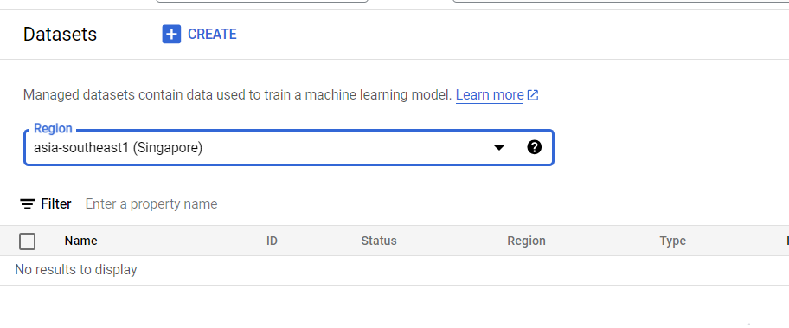

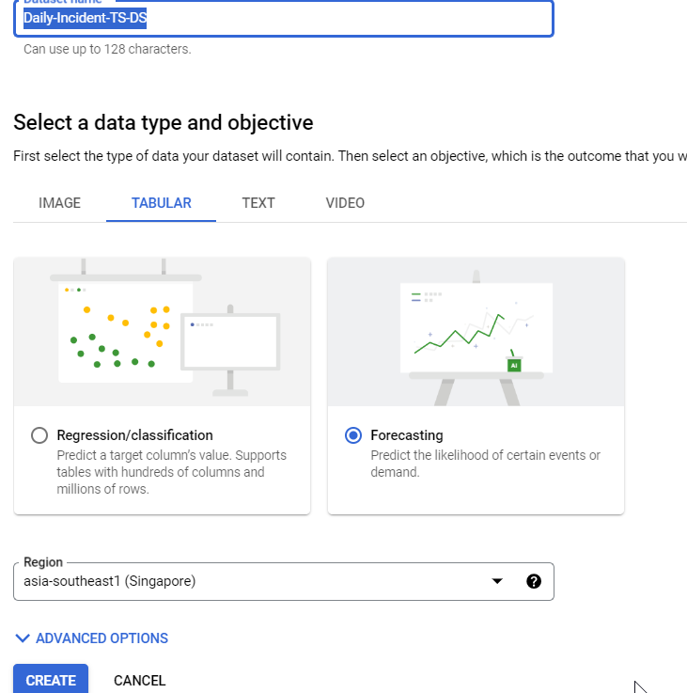

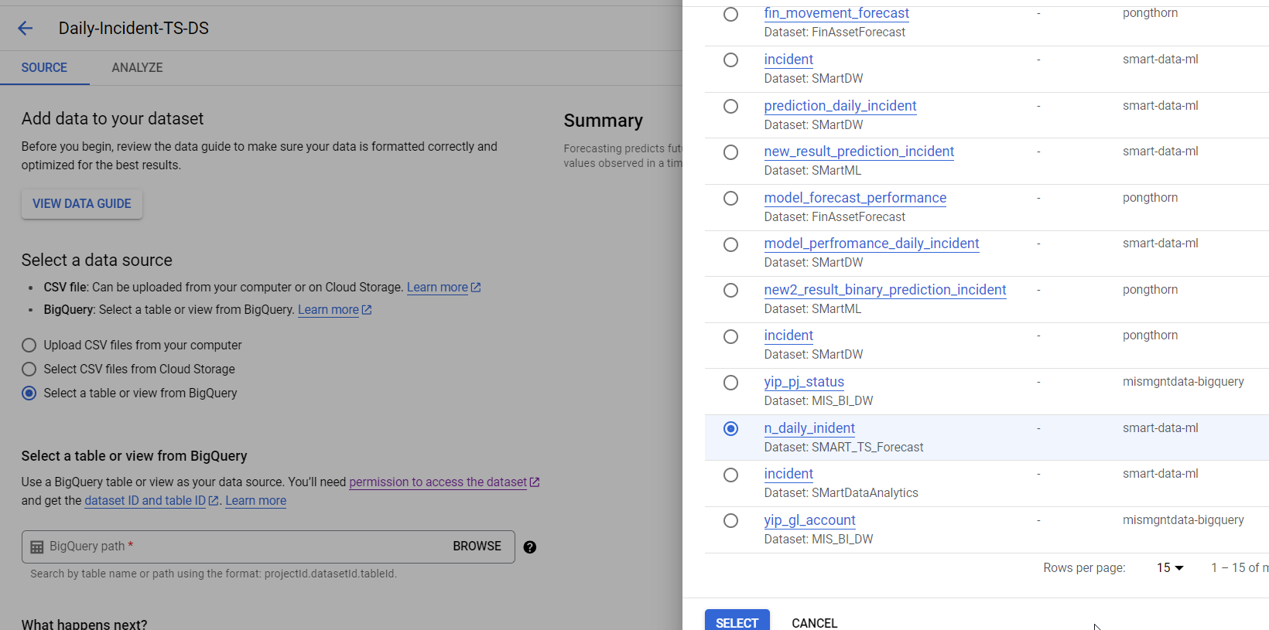

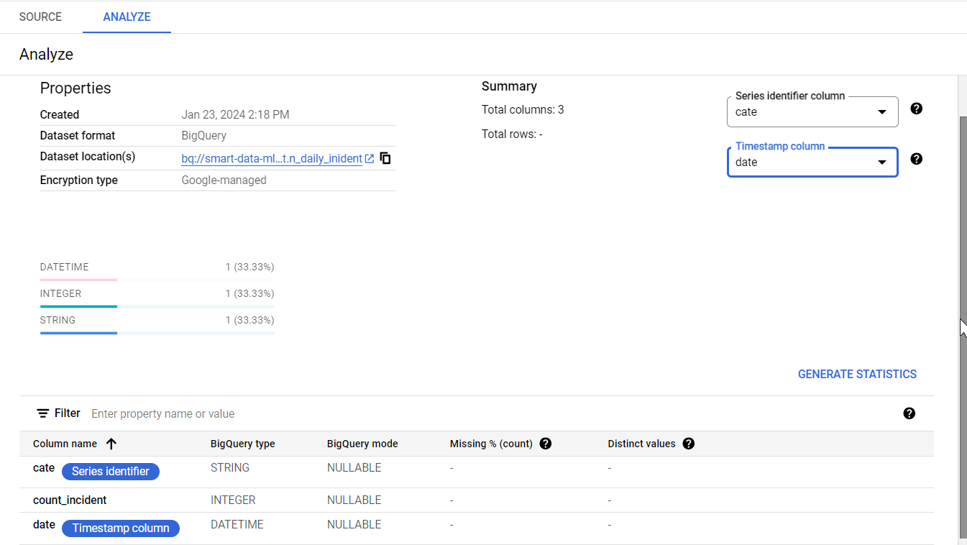

# Create Model

