# How to create New Table Merging

## Create view to retrieve data from particular table on PQ

, this step it allow you to perform data transformation

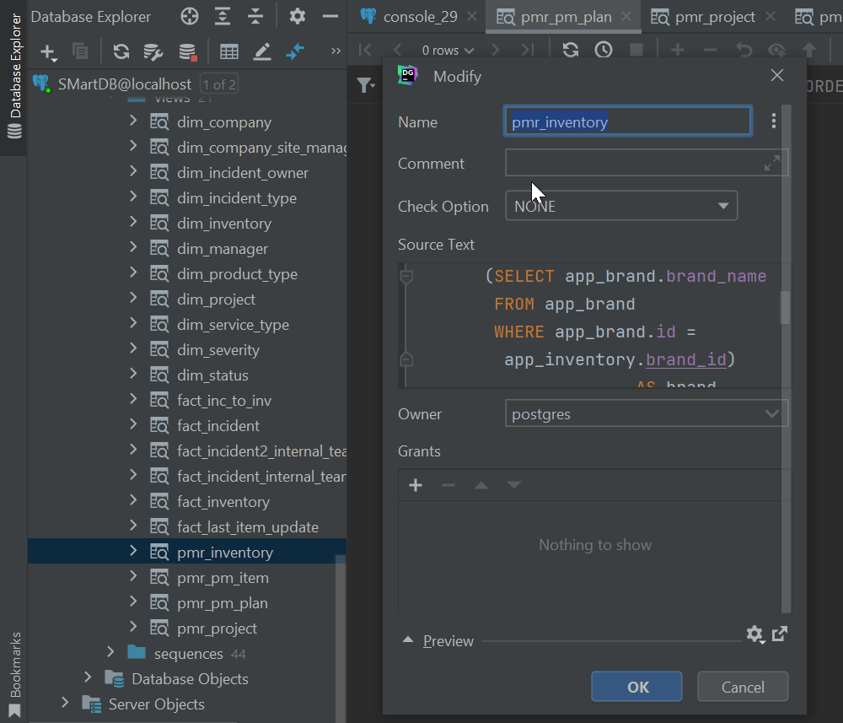

create view pmr_inventory  
 (inventory_id, serial_number, customer_warranty_start, customer_warranty_end, brand, model, product_type,  
 project_id, updated_at)  
as  
SELECT app_inventory.id AS inventory_id,  
 app_inventory.serial_number,  
 app_inventory.customer_warranty_start,  
 app_inventory.customer_warranty_end,  
 (SELECT app_brand.brand_name  
 FROM app_brand  
 WHERE app_brand.id = app_inventory.brand_id) AS brand,  
 (SELECT app_model.model_name  
 FROM app_model  
 WHERE app_model.id = app_inventory.model_id) AS model,  
 (SELECT app_product_type.productype_name  
 FROM app_product_type  
 WHERE app_product_type.id = app_inventory.product_type_id) AS product_type,  
 app_inventory.project_id,  
 app_inventory.updated_at  
FROM app_inventory  
WHERE app_inventory.is_dummy = false;  
  
alter table pmr_inventory  
 owner to postgres;

## CFG file Create last_import {view name}.cgf

this is in cfg_last_import folder , it is time stamp to update recent import (Time is UTC)

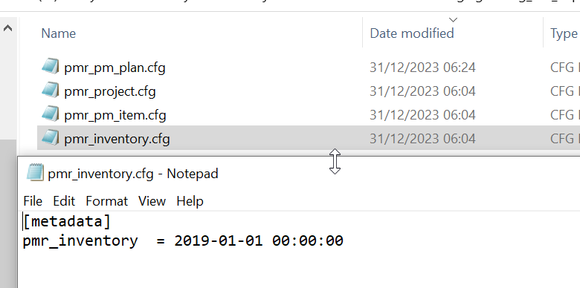

## Edit constantval in code file LoadPGToTempBQ.p

there are 4 parts

|  |  |  |
| --- | --- | --- |
|  |  | |
| tableContentID  Find in django_content_type table | |
|  | key_name  look for in view | |
|  | Sp_merge  Store procedure created on BigQuery to run Merge transaction  Name it like merge_{table name in main table onBQ}  Such as merge_inventory | |
|  | changed_field_mapping  changed_field_mapping=['planned_date','ended_pm_date',  'project_id','remark','team_lead_id']   * All column in view : 'planned_date' , 'ended_pm_date' , ,'remark' * including foreinkey ID : 'project_id' , ,'team_lead_id' * excluding custom column which is column that you create it in view on your own for data transformation : pm_period (it represent remark) ,team_lead(it represent team_lead_id) * exclude: key id and time stamp column : pm_id, update_at       It should be aligned with colums in view  {"remark": {"new": "3/3(Mar-LastPM)", "old": "3/3(LastPM)"}, "updated_at": {"new": "2023-12-30T14:06:51.615Z", "old": "2023-12-30T14:06:18.159Z"}} | |

## Create BQ table

### Temp_table

All column must be the same view in database

* include action filed
* exclude updated_At field
* Create table on smart-data-ml.SMartData_Temp

Use temp_inventory.txt in table_schema_script\inventory to create as below figure

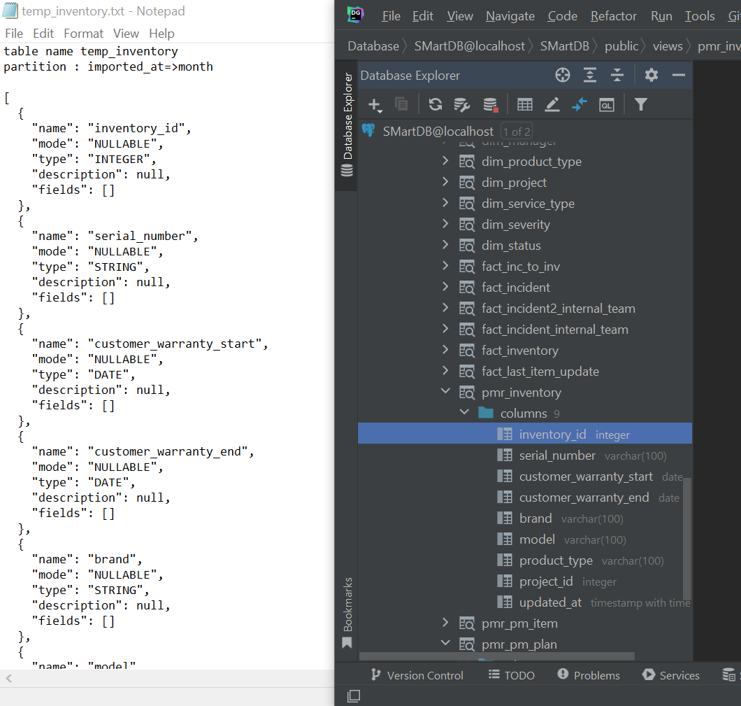

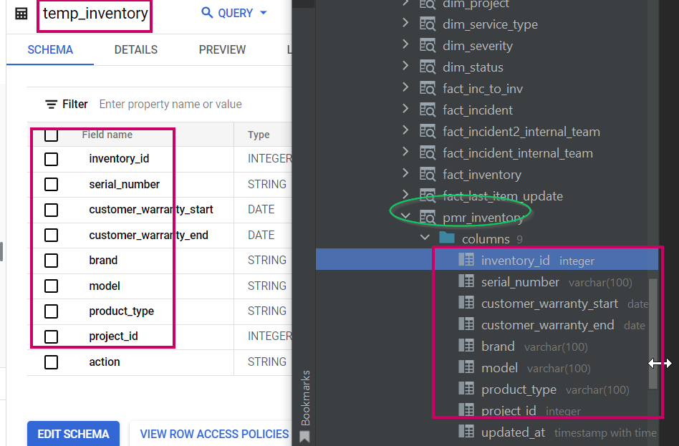

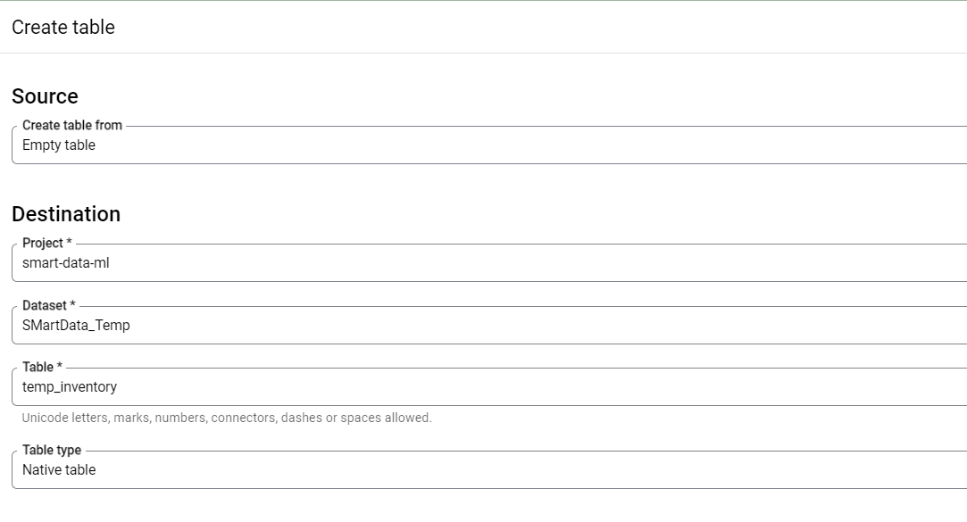

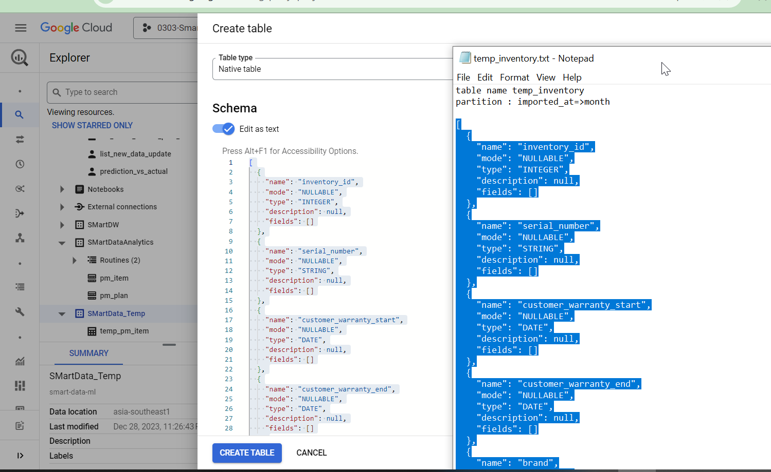

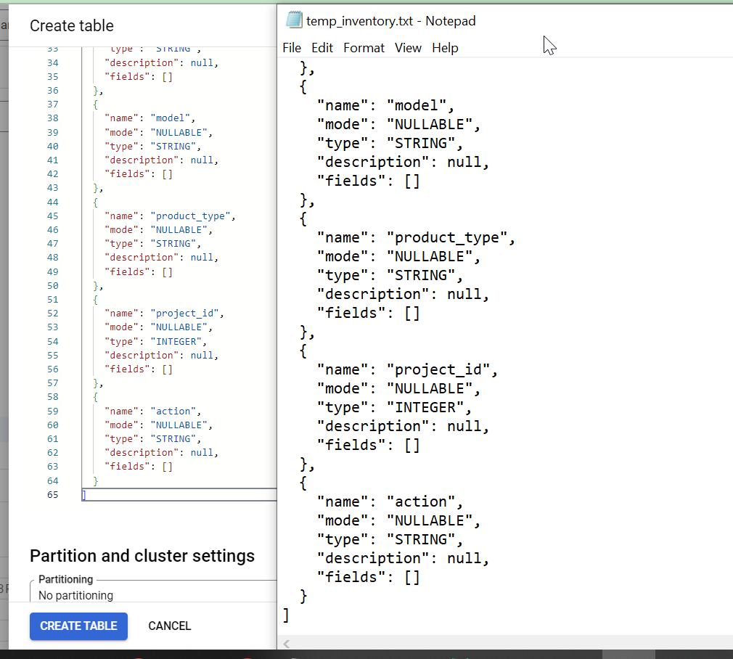

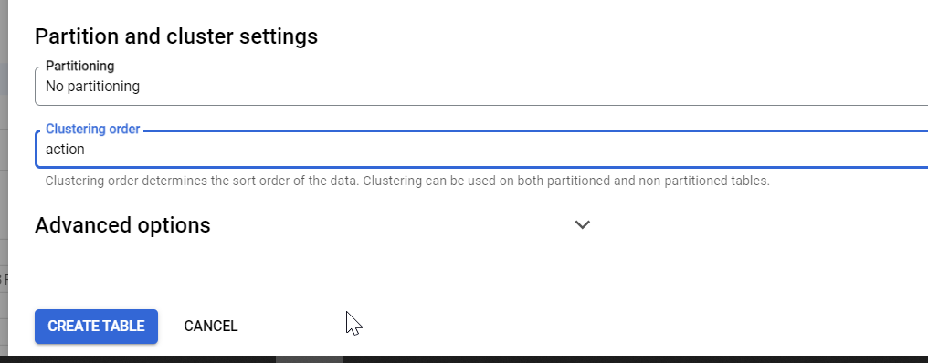

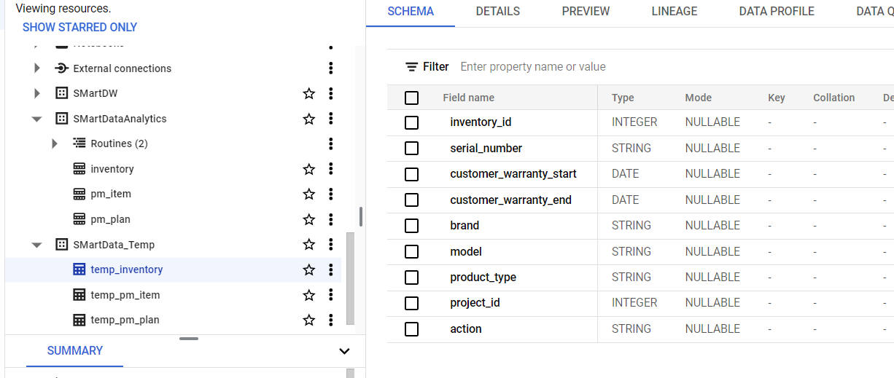

### Main Table

All column must be the same view in database

* include is_deleted and update_at filed
* exclude updated_At field

Create table on smart-data-ml.SMartDataAnalytics

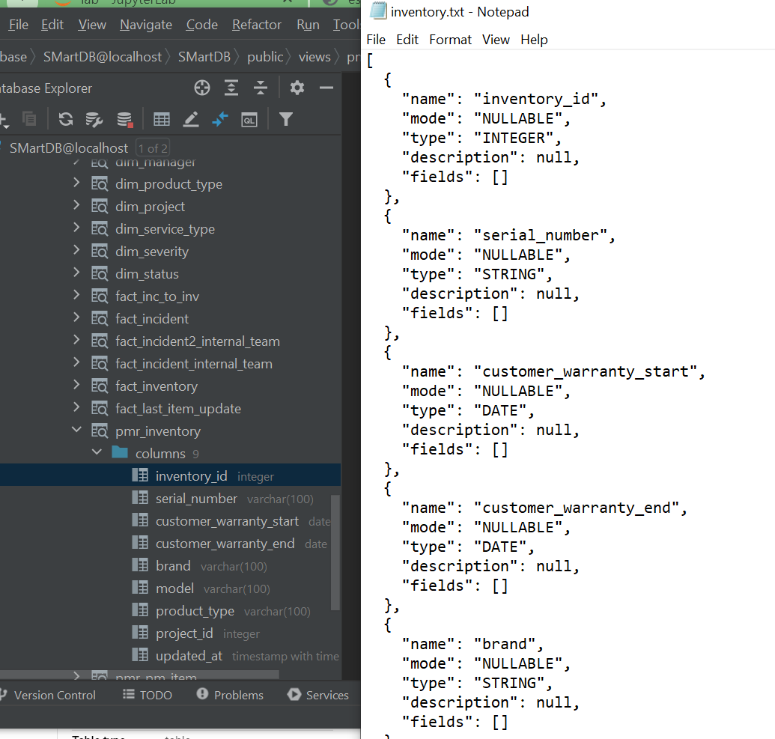

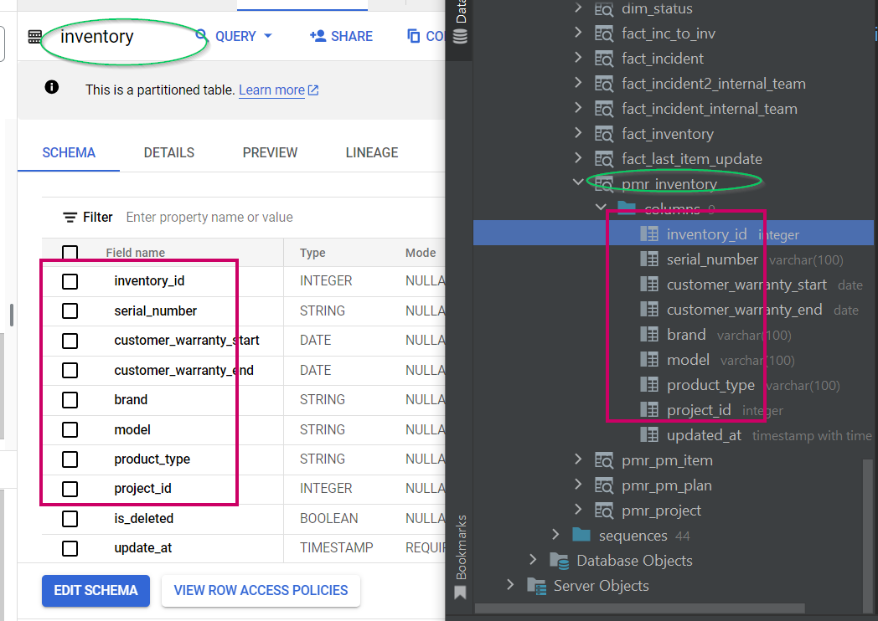

Use inventory.txt in table_schema_script\inventory to copy schemat to create as below figure

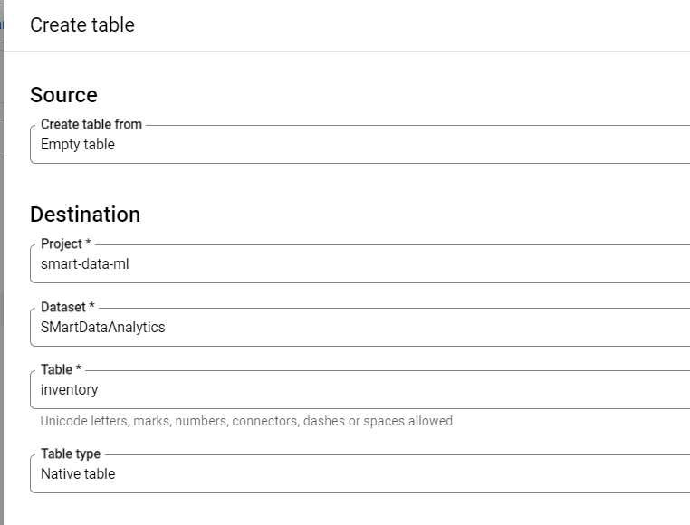

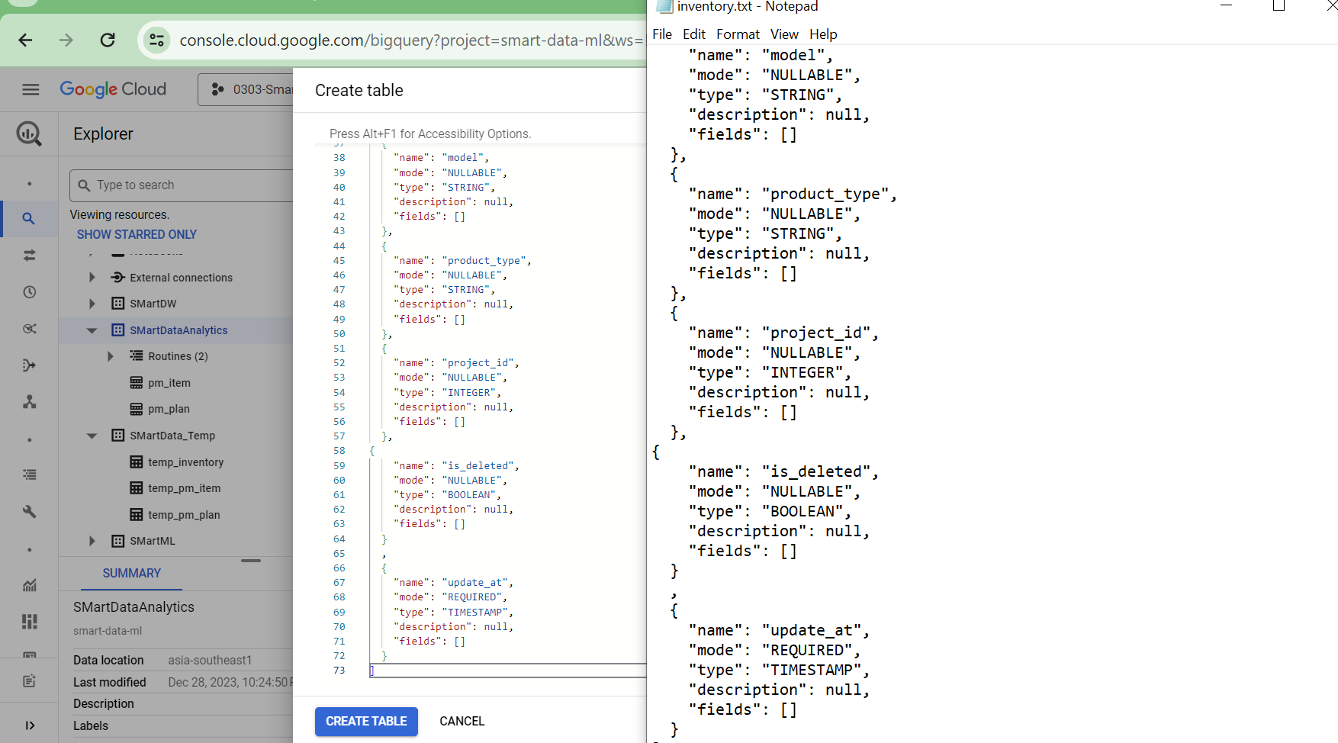

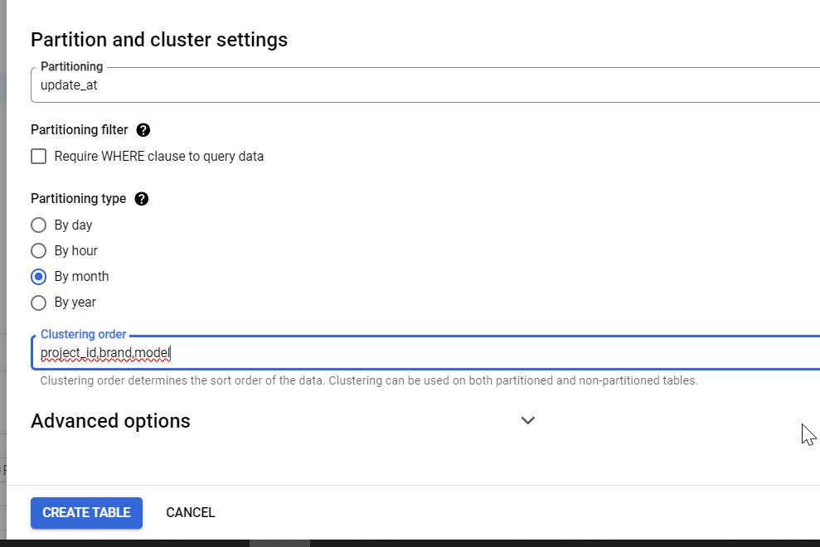

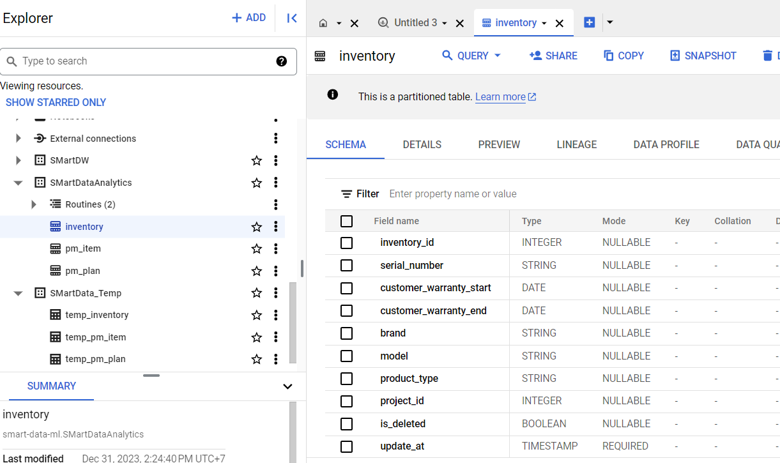

## Create Store Procedure ( Do it carefully and intentionally)

You can copy sp teamp and change field according to columns in table both main and temp table

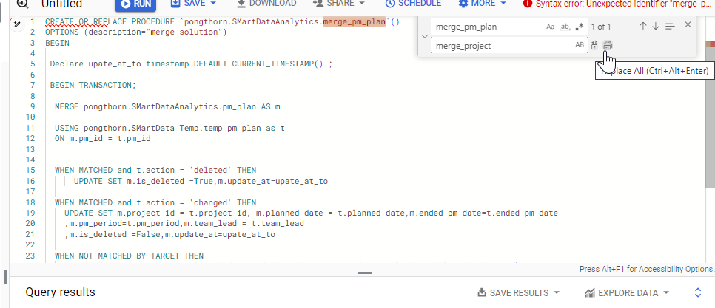

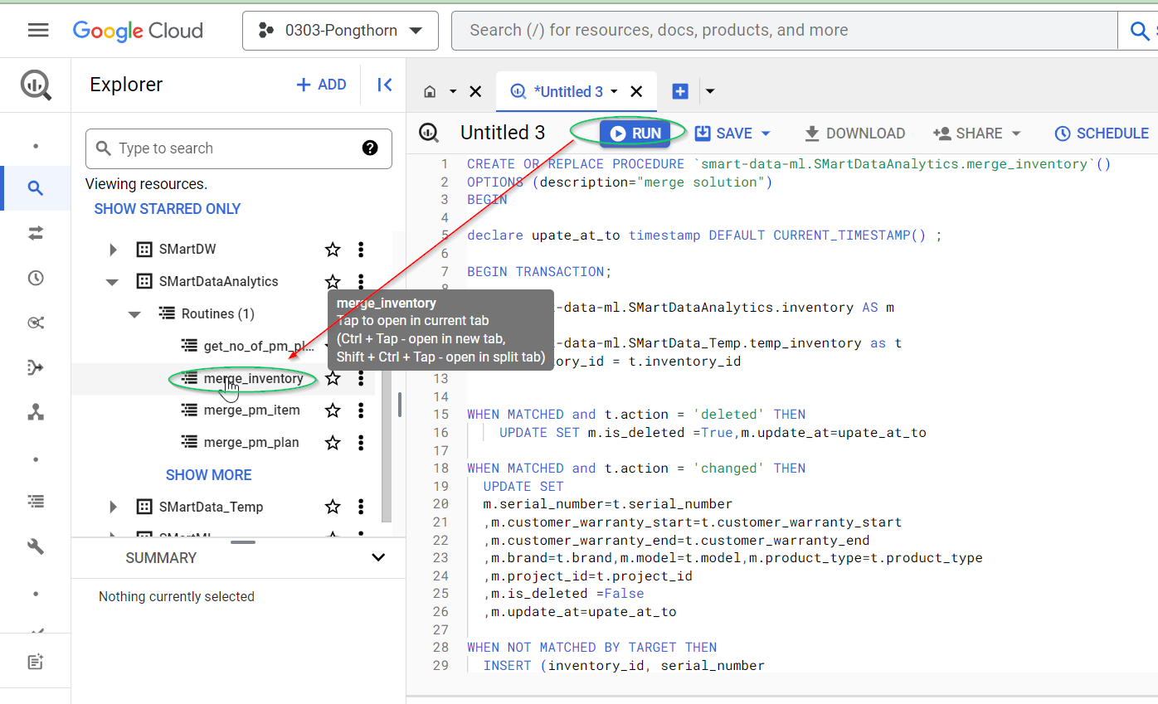

CREATE OR REPLACE PROCEDURE `smart-data-ml.SMartDataAnalytics.merge_inventory`()

OPTIONS (description="merge solution")

BEGIN

declare upate_at_to timestamp DEFAULT CURRENT_TIMESTAMP() ;

BEGIN TRANSACTION;

MERGE smart-data-ml.SMartDataAnalytics.inventory AS m

USING smart-data-ml.SMartData_Temp.temp_inventory as t

ON m.inventory_id = t.inventory_id

WHEN MATCHED and t.action = 'deleted' THEN

UPDATE SET m.is_deleted =True,m.update_at=upate_at_to

WHEN MATCHED and t.action = 'changed' THEN

UPDATE SET

m.serial_number=t.serial_number

,m.customer_warranty_start=t.customer_warranty_start

,m.customer_warranty_end=t.customer_warranty_end

,m.brand=t.brand,m.model=t.model,m.product_type=t.product_type

,m.project_id=t.project_id

,m.is_deleted =False

,m.update_at=upate_at_to

WHEN NOT MATCHED BY TARGET THEN

INSERT (inventory_id, serial_number

,customer_warranty_start, customer_warranty_end

, brand, model,product_type

,project_id

,is_deleted,update_at)

VALUES(t.inventory_id, t.serial_number

,t.customer_warranty_start, t.customer_warranty_end

, t.brand, t.model,t.product_type,

t.project_id

,False, upate_at_to)

;

truncate table smart-data-ml.SMartData_Temp.temp_inventory;

COMMIT TRANSACTION;

EXCEPTION WHEN ERROR THEN

select @@error.message,@@error.statement_text;

ROLLBACK TRANSACTION;

END;

# Frist Load OR ReLoad-All

## Truncate table

truncate table `pongthorn.SMartData_Temp.temp_inventory` ;

truncate table `pongthorn.SMartDataAnalytics.inventory`;

## Reset last uplate in cfg file

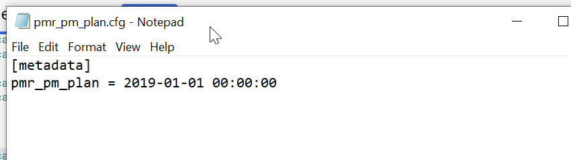

## Run script by passing view_name as argument

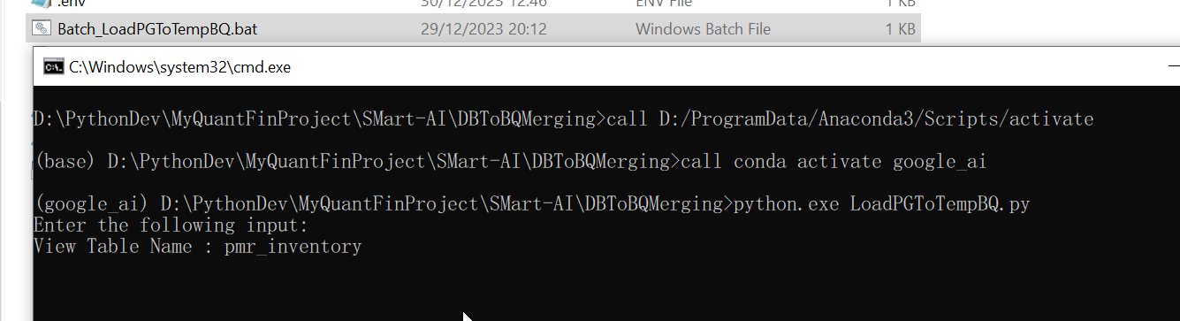

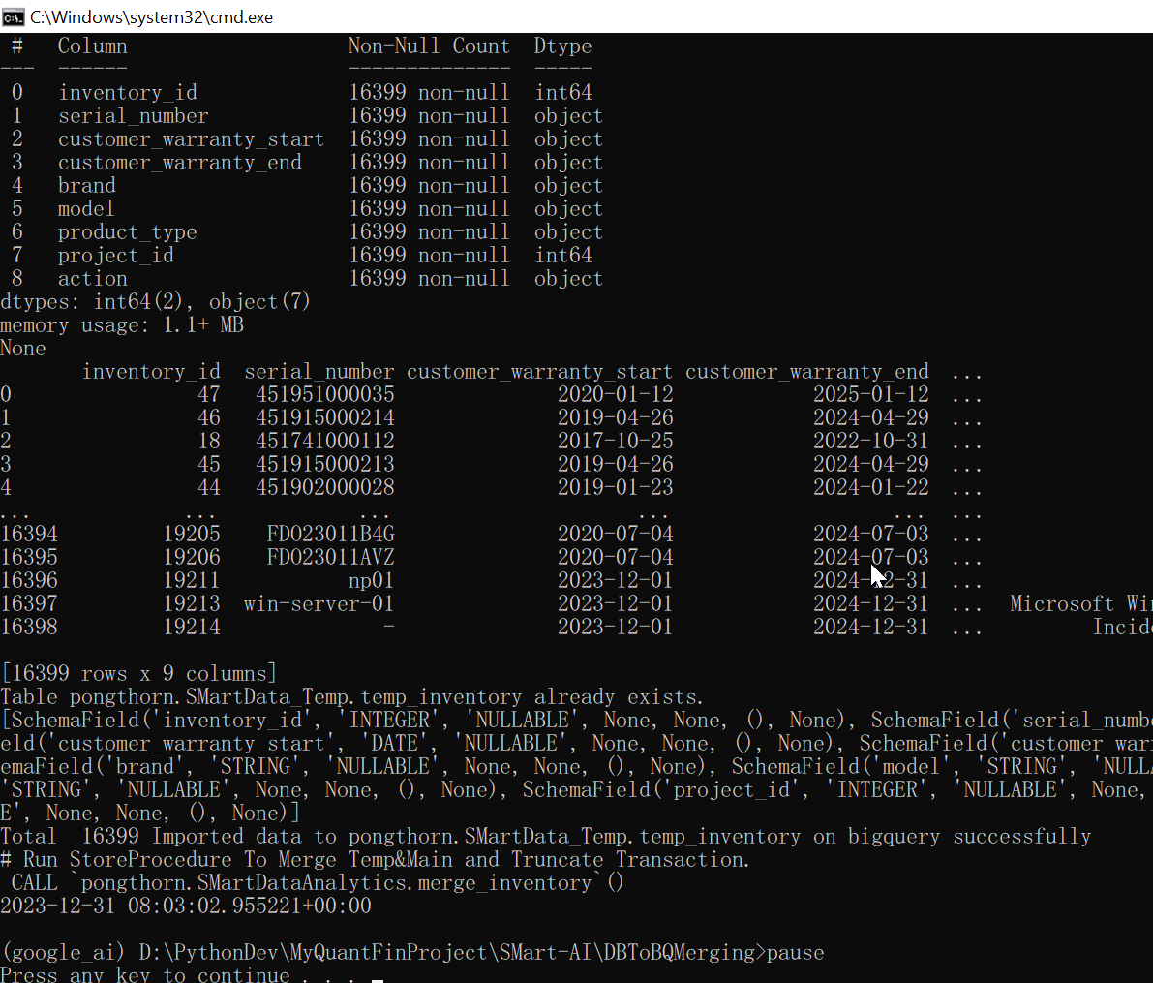

## Check result as the following items

### SP

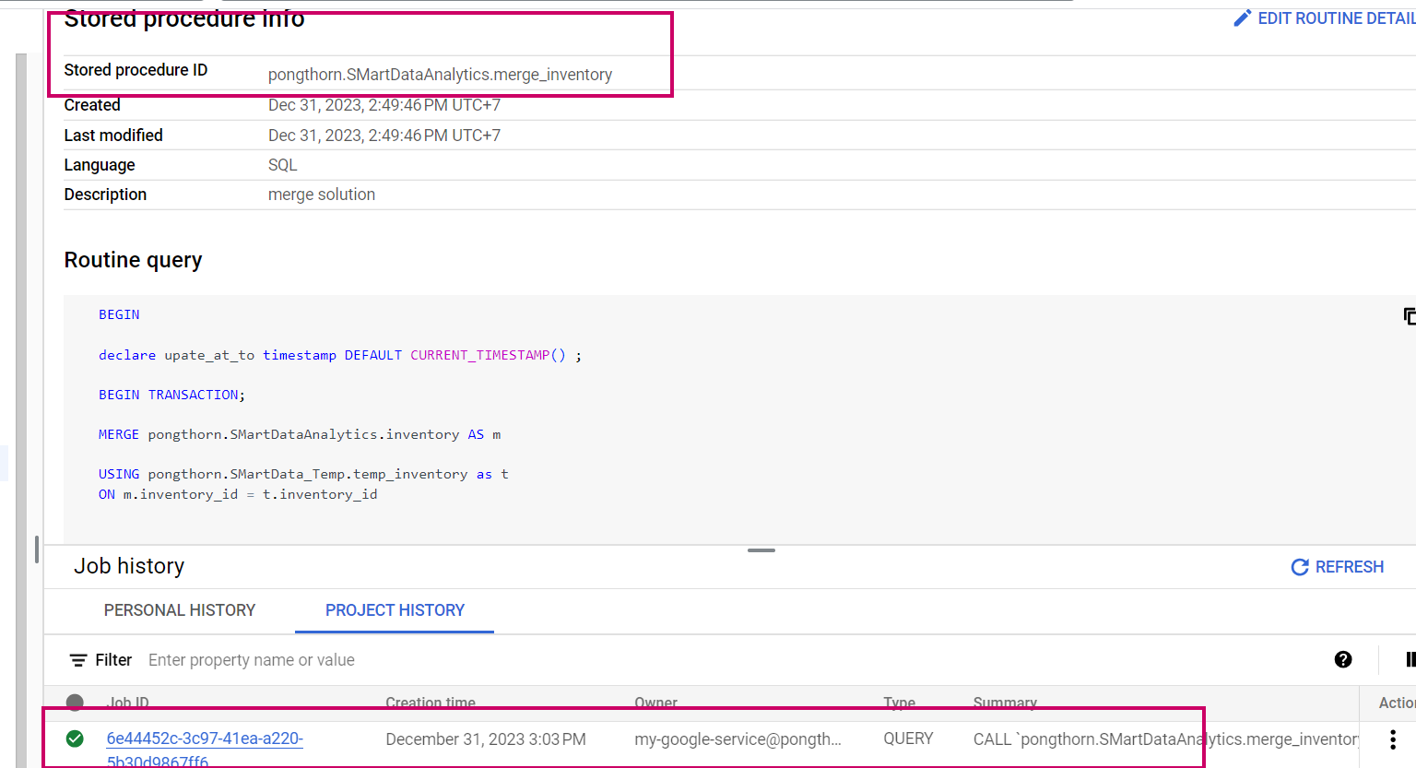

### Table result

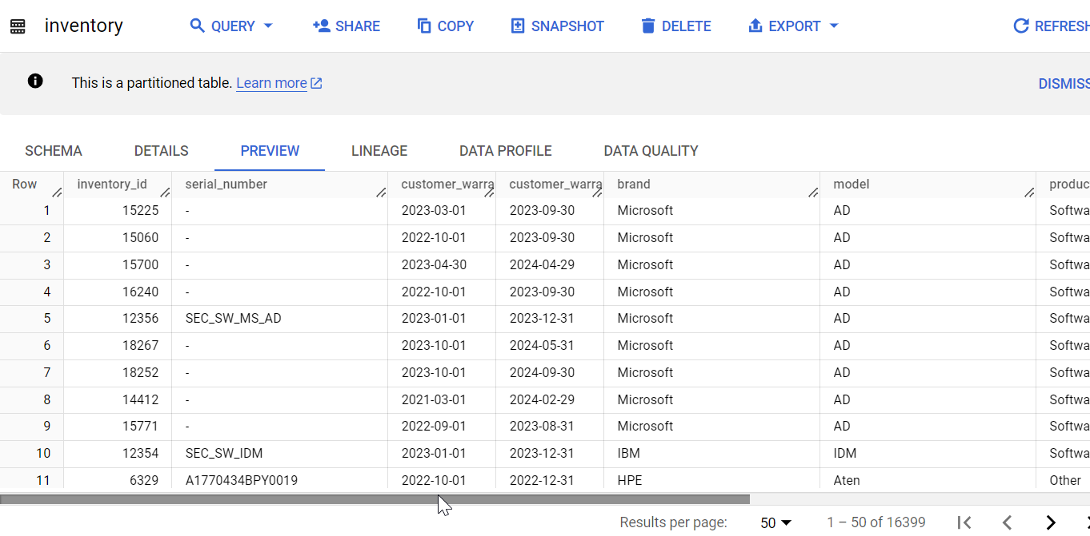

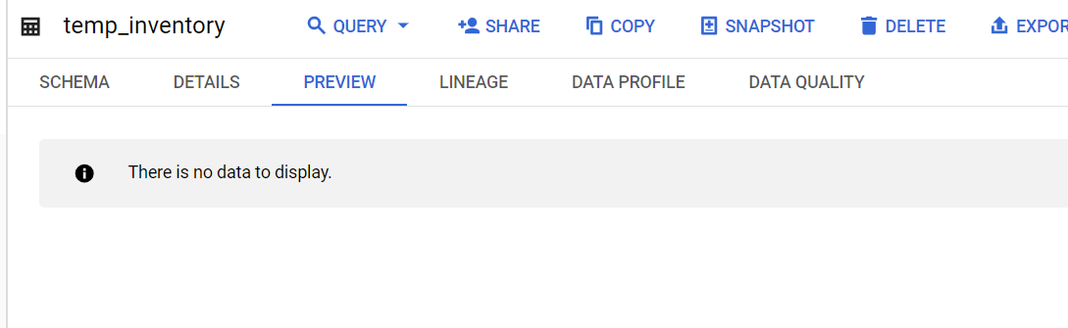

### Count total app_inventory in database = table inventoru in BQ

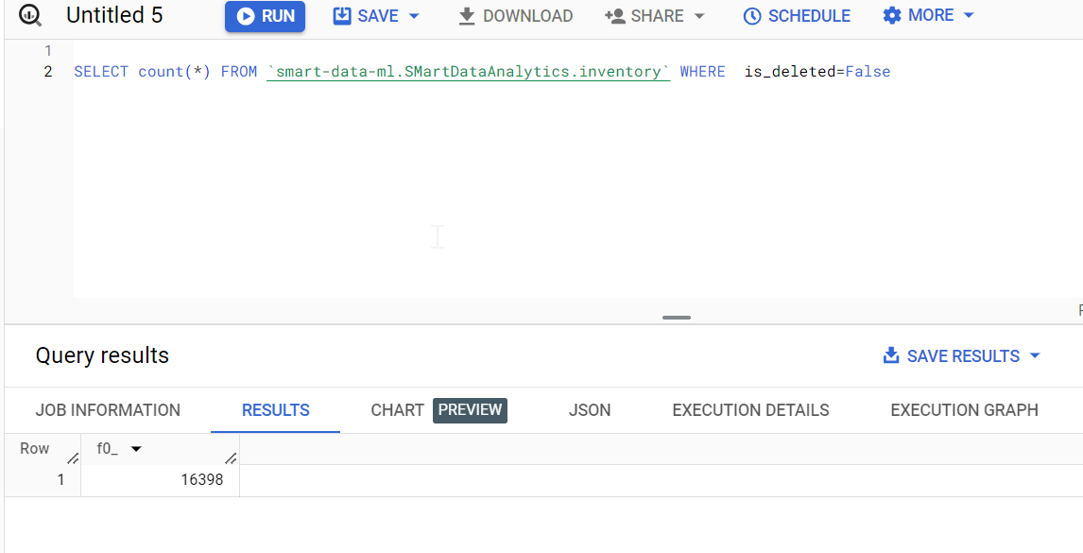

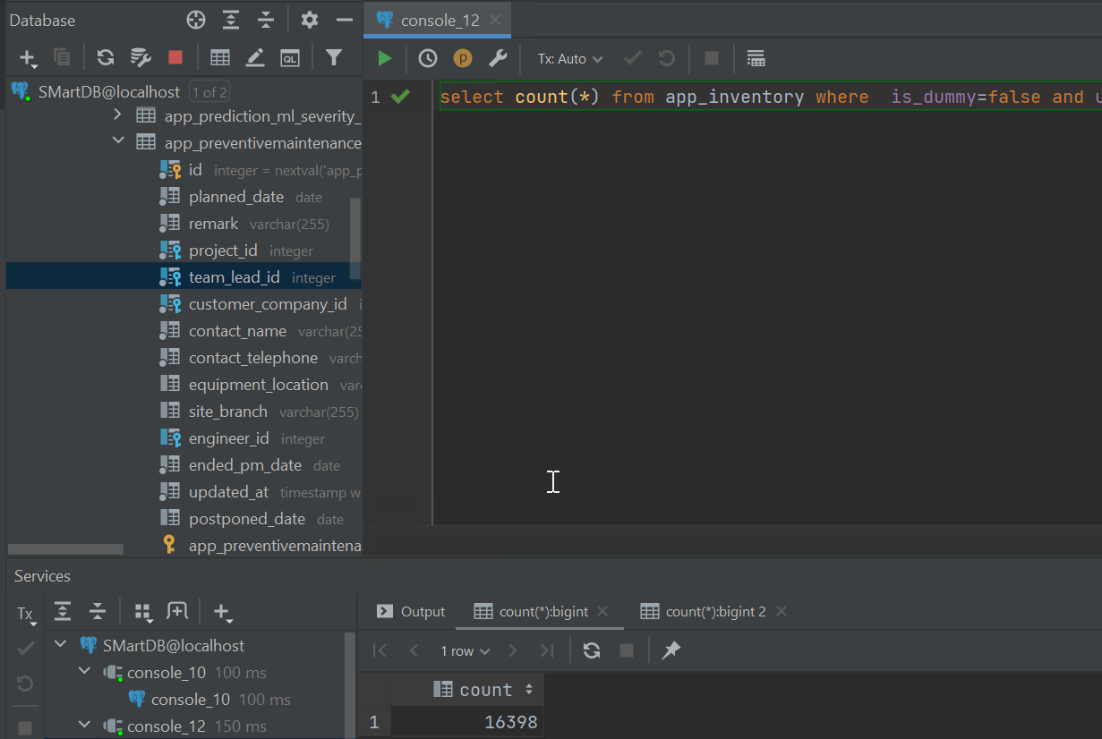

### Check timestpam update

Change from 2019-01-01 00:00:00 to 2023-12-31 08:12:24

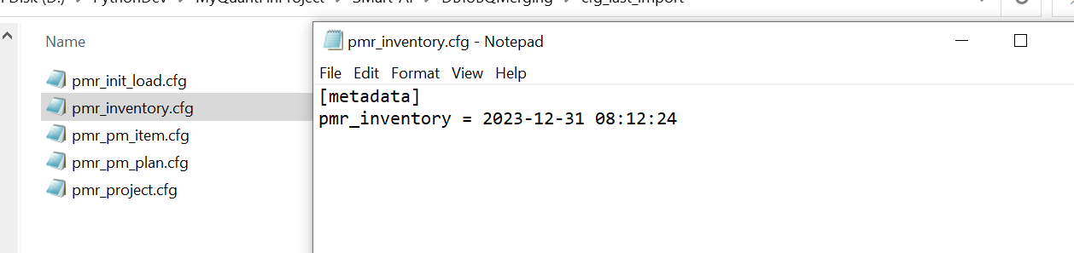

# All the things are ready to run

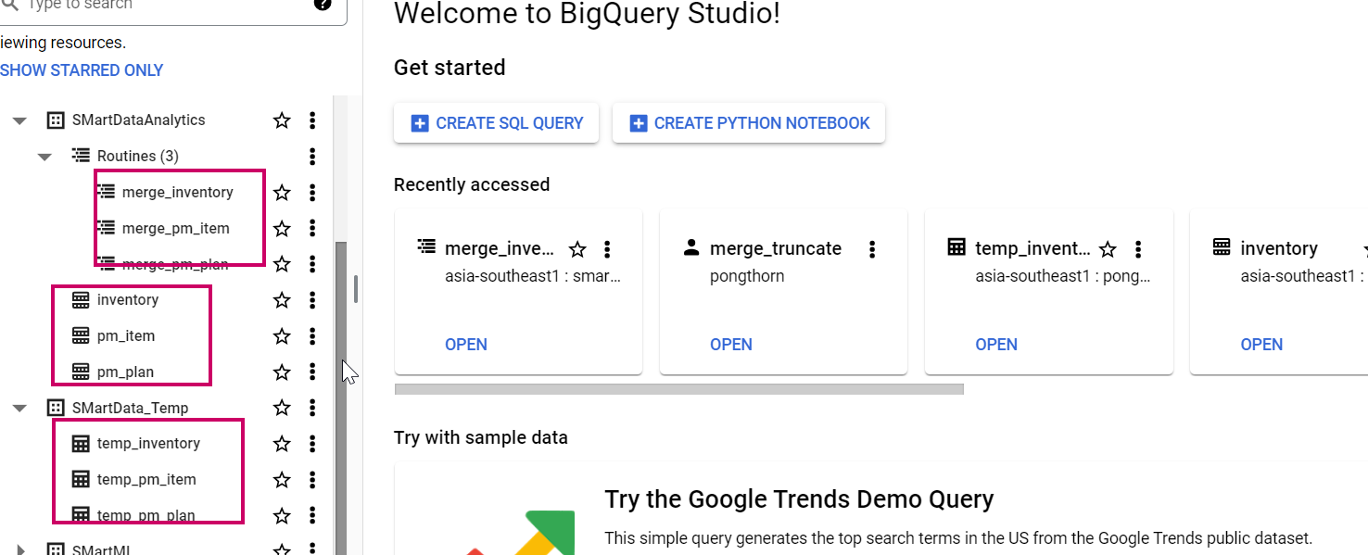

# Set Job to run

