Advanced Data Analysis Report
Global Superstore — Deep-Dive Business Analysis
AnalystLab Africa Data Analytics Internship — Week 3
Prepared by Oluwatosin Olusanya, Data Analyst — AnalystLab Africa Consulting

1. Sales & Profitability Trends Over Time
Year-over-year growth has been consistent and accelerating: sales grew 18.5% (2012), 27.2% (2013), and 26.3% (2014), with profit growth tracking closely or exceeding sales growth every year — a healthy sign that growth is not being bought through unprofitable discounting at the aggregate level, even though (as Section 3 shows) it is a serious problem within specific segments of the business.
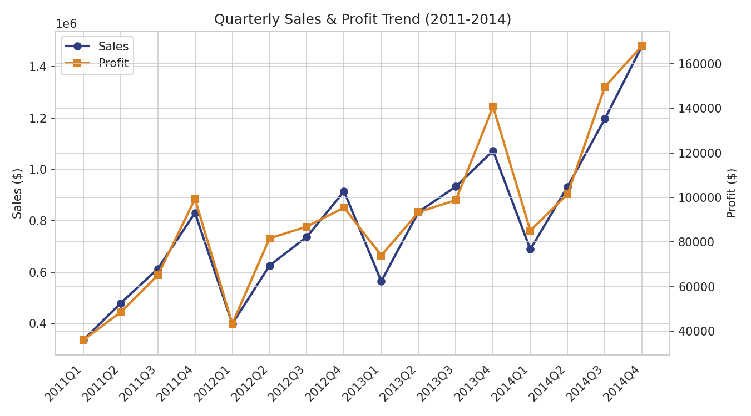
Figure 1: Quarterly sales and profit trend, 2011-2014.
The quarterly view shows Q4 (Oct-Dec) is consistently the strongest quarter every single year, and Q1 the weakest — a reliable seasonal pattern rather than a one-off. Profit tracks sales closely on this chart, meaning the business is not sacrificing margin to hit seasonal volume.
Month | Total Sales ($, all years combined)
January | 675,134
February | 543,739 (lowest)
March | 770,501
June | 1,269,717
September | 1,437,380
November | 1,551,277
December | 1,580,781 (highest)

2. Product Performance
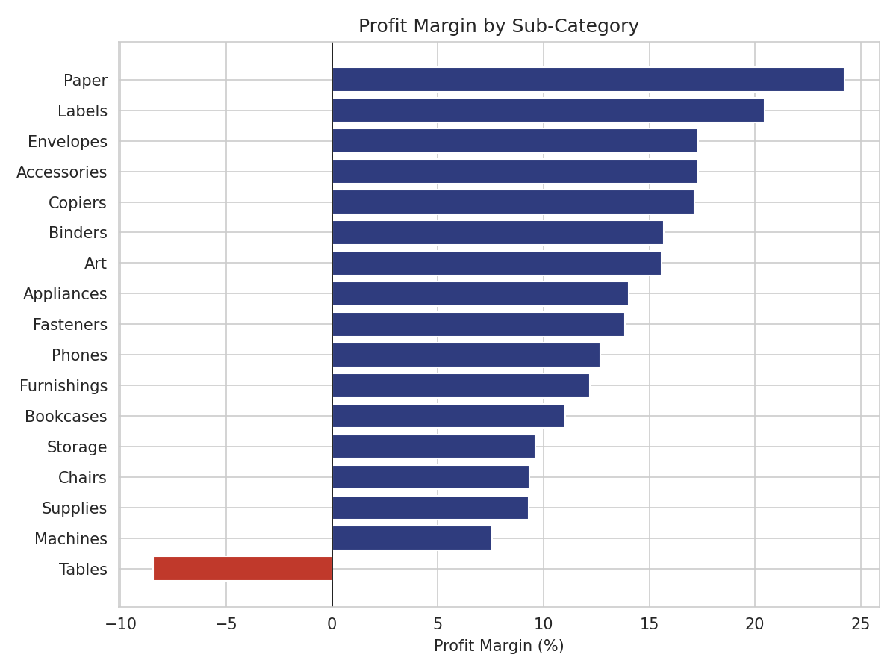
Figure 2: Profit margin by sub-category.
Tables is the only sub-category with a negative margin (-8.5%), confirming the Week 2 finding at a more precise level: $757,042 in sales produced a $64,083 loss. Machines is the weakest positive performer at 7.6% margin. Paper (24.2%) and Labels (20.4%) are the most efficient sub-categories, though both are low-volume.

Individual Loss-Making Products
Drilling below sub-category level surfaces specific products responsible for the losses, most of which are not in Tables at all:
Product | Sales | Profit
Cubify CubeX 3D Printer (Double Head) | $11,100 | -$8,880
Lexmark MX611dhe Laser Printer | $16,830 | -$4,590
Motorola Smart Phone, Cordless | $38,931 | -$4,447
Cubify CubeX 3D Printer (Triple Head) | $8,000 | -$3,840
Bevis Round Table, Adjustable Height | $5,655 | -$3,650
Notably, the two worst individual losses are 3D printers (Technology category) and a laser printer — not Furniture. This means the 'high sales, low profit' problem is broader than the Tables sub-category alone, and a product-level (not just sub-category-level) review is warranted.

3. Discount Impact — The Single Strongest Pattern in the Data
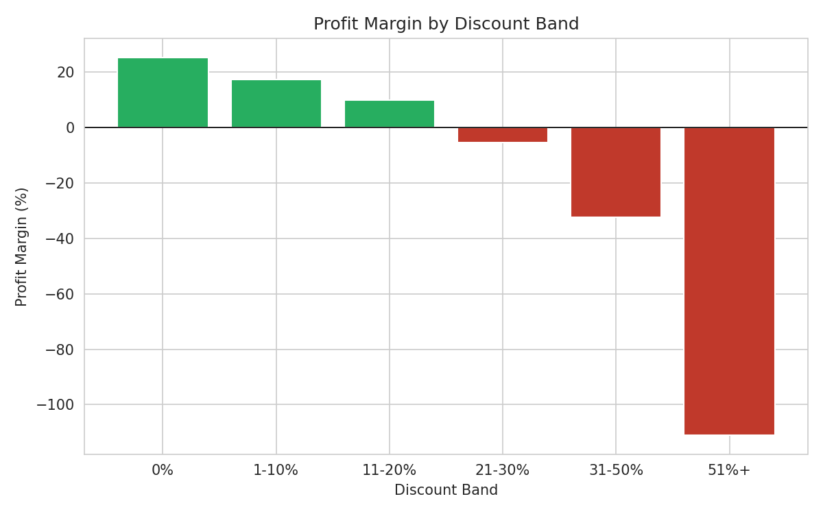
Figure 3: Profit margin by discount band.
This is the clearest relationship found in the entire analysis. Profit margin declines in a near-perfect staircase as discount increases: 25.3% margin with no discount, dropping to 17.2% (1-10% discount), 9.9% (11-20%), then turning negative at -5.5% (21-30%), -32.4% (31-50%), and a severe -111.0% (51%+ discount). The row-level correlation between discount and profit margin is -0.847 — a very strong relationship rarely seen this cleanly in real business data.
In dollar terms: orders with discounts above 20% collectively lost $814,683, while orders with no discount at all generated $1,770,695 in profit alone. Discounting above the 20% threshold is not a minor drag on margin — it is actively unprofitable business the company would be better off not writing.

4. Regional & Geographic Performance
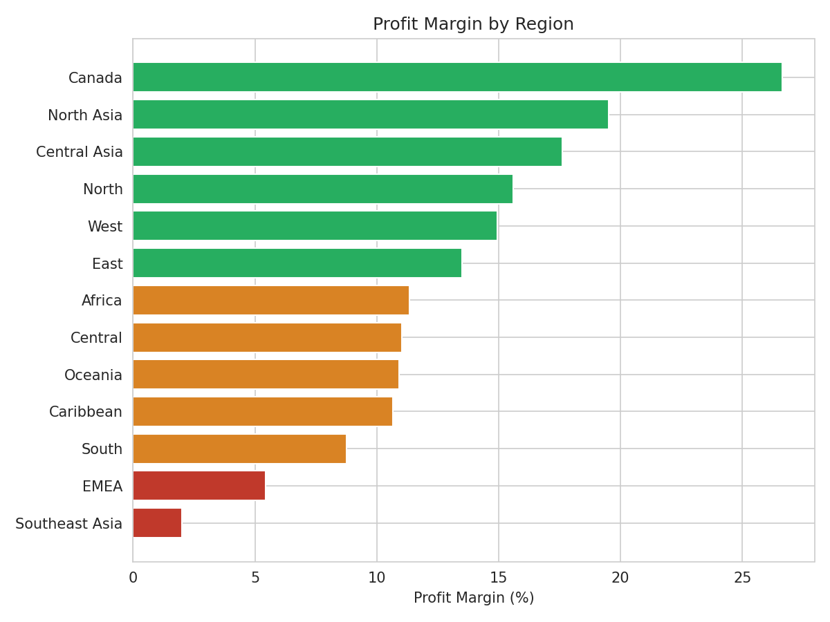
Figure 4: Profit margin by region.
Southeast Asia (2.0% margin) and EMEA (5.4% margin) remain the weakest regions, confirming Week 2's finding. Shipping cost as a percentage of sales is nearly uniform across all regions (10.9%-11.2%), and average shipping delay is similarly consistent (3.7-4.0 days) — ruling out logistics efficiency as the explanation. This points toward pricing and discounting practices, rather than operational cost structure, as the likely driver of regional margin gaps, directly connecting to the discount findings in Section 3.

5. Customer & Segment Analysis
Segment | Sales | Sales Share | Profit Margin | Customers
Consumer | $6,507,949 | 51.5% | 11.5% | 818
Corporate | $3,824,698 | 30.3% | 11.5% | 476
Home Office | $2,309,855 | 18.3% | 12.0% | 296
All three segments carry nearly identical profit margins (11.5%-12.0%), meaning the earlier discount pattern is likely spread evenly across segments rather than concentrated in one. With 1,590 total customers, the top 10 most profitable customers (led by Tamara Chand at $8,673 profit) each contribute more individual profit than many entire low-performing sub-categories — a small, identifiable group worth targeted retention attention.

6. Summary of Advanced Findings
- Growth is genuine and accelerating, not discount-fueled at the aggregate level — but discounting is a serious problem within specific orders.
- Q4 is a reliable, repeatable seasonal peak every year; Q1/February is reliably the weakest period.
- Loss-making products exist beyond the Tables sub-category, including Technology items like 3D printers and laser printers.
- Discount above 20% is the single strongest, cleanest negative driver of profitability found in the dataset (r = -0.847).
- Regional margin gaps are not explained by shipping cost or delivery speed, pointing instead toward discounting and pricing practices.

