HealthConnect Clinic — Advanced Analytics & Decision Support Report
Data Analytics Track | AnalystLab Africa Experience Lab — Week 6
Prepared by Oluwatosin Olusanya, Data Analyst — AnalystLab Africa

1. Week 5 → Week 6 Transition

Week 5 delivered five calculated KPIs, exploratory analysis across six candidate drivers, six supporting charts, five business insights, and four recommendations. The most important result was identifying two dominant, independent behavioural drivers of no-shows: booking lead time (26.6% at 0–3 days, rising to 63.9% at 30+ days) and prior no-show history (46.3% with no history, rising to 70.3% with 3+ prior no-shows). Appointment type, day of week, and time of day were confirmed as comparatively weak drivers (3–5 point spreads).
The main limitation carried into Week 6 was that these patterns were descriptive only — formal statistical testing to confirm they were not artefacts of chance, and an examination of whether the two drivers interact or simply add up, remained open work explicitly flagged in Section 8 of the Week 5 remaining-work list.
Week 6 work is relevant primarily to the Data Analytics track's own deliverable, with a completed integration point into the Project Management track (Section 8).
This week's focus: (1) statistically validate the two strongest Week 5 drivers, (2) determine whether they interact or combine additively, (3) refine the reminder-effectiveness finding by risk segment, and (4) translate the validated results into sharper, segment-targeted recommendations.

2. Data Preparation

The same dataset and exclusion rule from Week 5 was used for consistency: the 5,000-record HealthConnect Appointment Data.csv, with Cancelled outcomes (5.3%) excluded from no-show rate calculations, leaving 4,737 appointments with a definitive Attended/No-Show outcome. No new data preparation was required; this week's work is additional analysis on the same validated dataset, not a re-cleaning exercise.

3. Deepened & Validated Analysis

3.1 Booking Lead Time — Statistically Validated

The Week 5 lead-time pattern was tested formally with a chi-square test of independence (lead-time band × no-show outcome):
- χ² = 340.42, p < 0.001 (df = 4) — the relationship is highly statistically significant, not a descriptive artefact.
- Point-biserial correlation with raw booking_lead_days: r = 0.287, p < 0.001.
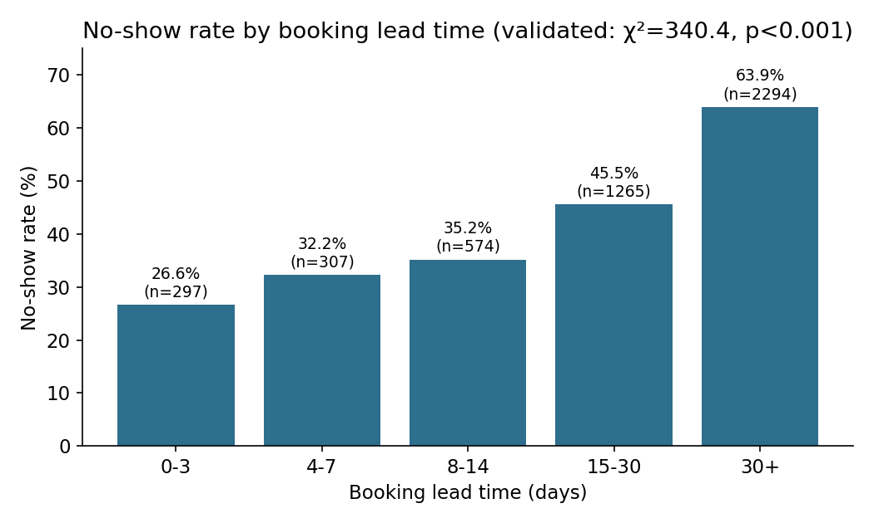
Figure 1: No-show rate by booking lead time, with formal significance test.

3.2 Prior No-Show History — Statistically Validated

The same test was applied to prior no-show history (band × no-show outcome):
- χ² = 72.36, p < 0.001 (df = 3) — also highly significant.
- Point-biserial correlation with raw previous_no_shows: r = 0.123, p < 0.001 (a real but weaker linear relationship than lead time; the band-level escalation in Figure 2 is the clearer signal).
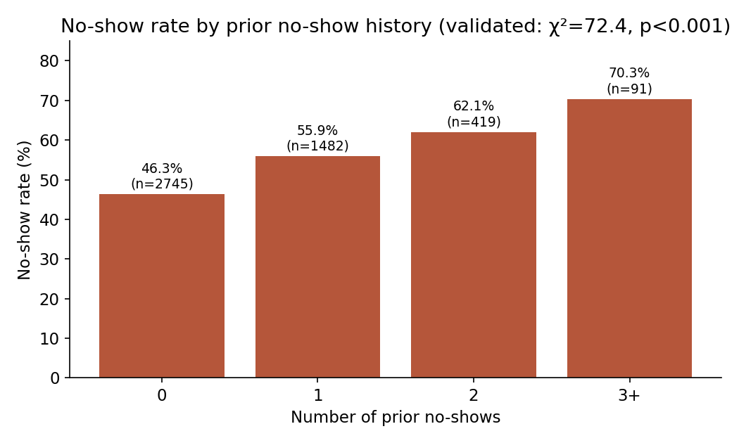
Figure 2: No-show rate by prior no-show count, with formal significance test.
Both Week 5 findings are now confirmed as statistically robust, not just descriptively large. Formal testing — flagged as open work in Week 5 — is complete.

3.3 New Analysis: Do the Two Drivers Interact?

Week 5 treated lead time and prior no-show history as separate, independent drivers but did not test whether patients with both risk factors are worse off than the two effects would separately predict. This was the main gap identified for Week 6 deepening.
Patients were split into four combined risk segments (short lead <15 days vs long lead 15+ days, crossed with no prior no-shows vs 1+ prior no-shows):
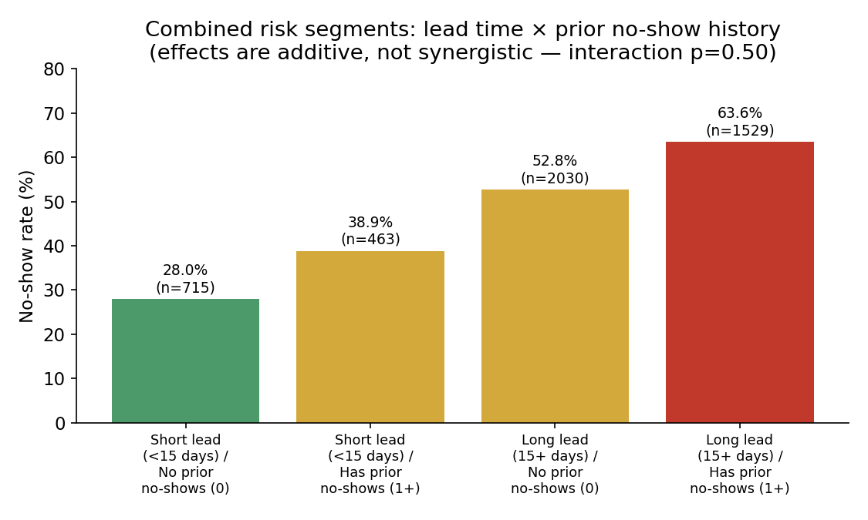
Figure 3: Combined risk segments — no-show rate rises steadily from 28.0% to 63.6% across the four segments.
To determine whether this rise reflects a true interaction (the two risk factors compounding each other) or simply additive, independent effects, a logistic regression was fitted with and without an interaction term (booking_lead_days × previous_no_shows), and the two models were compared with a likelihood-ratio test:
- Model without interaction: AUC = 0.679
- Model with interaction term: AUC = 0.679 (no meaningful improvement)
- Likelihood-ratio test on the interaction term: LR = 0.46, p = 0.50 not statistically significant
Finding: the two risk factors are additive, not synergistic. A patient with both a long lead time and prior no-show history is roughly as risky as the sum of the two individual effects would predict no extra "compounding penalty" exists beyond that. This is operationally useful: HealthConnect does not need a separate, more intensive protocol for patients with both risk factors — applying the lead-time and prior-history interventions together, independently, captures the combined risk correctly.

3.4 Refined Finding: Reminder Effectiveness by Risk Segment

Week 5 found reminders produced a modest ~4.7-point overall improvement (49.9% vs 54.6%). This was re-examined by risk segment to see whether reminders help everyone equally or are more valuable for some patients than others:
Risk segment | No-show rate — no reminder | No-show rate — reminder sent | Improvement
Long lead / Has prior no-shows (highest risk) | 67.1% | 62.2% | 4.9 pts
Long lead / No prior no-shows | 56.4% | 51.4% | 4.9 pts
Short lead / Has prior no-shows | 43.7% | 37.2% | 6.5 pts
Short lead / No prior no-shows (lowest risk) | 28.3% | 27.9% | 0.4 pts

Finding: reminders show almost no effect for the lowest-risk segment (0.4-point improvement) but a real effect for every segment carrying at least one risk factor (4.9–6.5 points). This refines the Week 5 recommendation: reminder resources are most efficiently targeted at patients with a long lead time and/or prior no-show history, rather than sent uniformly to all patients.

4. Validated & Refined KPIs Summary

KPI | Week 5 status | Week 6 status
Overall no-show rate (51.2%) | Calculated | Unchanged — confirmed baseline
No-show rate by lead time | Calculated, descriptive | Validated: χ²=340.4, p<0.001
Repeat no-show rate | Calculated, descriptive | Validated: χ²=72.4, p<0.001
Reminder effectiveness | Calculated (overall only) | Refined by risk segment — targeting insight added
Slot utilisation loss | Calculated | Unchanged this week — no new evidence to revise it

5. Business Insights (Week 6)

- Booking lead time and prior no-show history are both confirmed, statistically significant drivers of no-shows — the Week 5 findings were not chance patterns in a 5,000-row sample.
- The two drivers combine additively rather than synergistically: patients with both risk factors are exactly as risky as the two effects predict separately, with no evidence of an extra compounding penalty.
- Reminders are a poor use of resources for low-risk patients (near-zero effect) but a genuinely useful intervention for any patient carrying at least one risk factor (4.9–6.5 point improvement).
- The highest-risk segment — long lead time and prior no-show history — has a 63.6% no-show rate (n=1,529), more than double the lowest-risk segment's 28.0% (n=715), and represents the single largest, most identifiable target group for intervention.

6. Business Recommendations (Week 6)

- Formally adopt the lead-time and prior-history risk flags as validated (not just descriptive) triggers for HealthConnect's confirmation-call workflow, since both are now statistically confirmed rather than exploratory.
- Do not build a separate "combined risk" protocol — since the effects are additive, applying both interventions independently to any patient who qualifies for either is sufficient and simpler to implement operationally.
- Redirect reminder spend away from the lowest-risk segment (short lead, no prior no-shows), where reminders currently show almost no measurable benefit, toward the three higher-risk segments where each reminder delivers a real, quantifiable improvement.
- Prioritise the 1,529 patients in the highest-risk segment (long lead + prior no-shows) for the highest-touch intervention (phone confirmation), since this is the largest single high-impact group identified across all analysis to date.

7. Data Limitations

- This remains descriptive/associational analysis; the logistic regression AUC of 0.679 indicates lead time and prior history are meaningful but incomplete predictors — other unmeasured factors (e.g. patient-reported barriers) likely also matter.
- The interaction test rules out a specific form of compounding (multiplicative interaction in a logistic model); it does not rule out all possible non-linear relationships between the two variables.
- Distance to clinic and waiting time missingness (1.8% and 1.2% respectively) remain as documented in Week 5 and did not affect this week's analysis, which did not use those fields.
- The reminder-effectiveness-by-segment finding is observational: patients who receive reminders are not randomly assigned, so some of the observed improvement could reflect other differences between reminded and non-reminded patients rather than the reminder itself.

8. Cross-Track Contribution

Track collaborated with: Project Management.
Project dependency: PM required a validated analytical input to prioritise Week 6 integration controls and Week 7 testing/refinement preparation (Integration Register item DINT-006).
Information/output provided: The Week 5 HealthConnect analysis (Initial_HealthConnect_Analytics_Report), including the confirmed finding that booking lead time and prior no-show history are the two strongest behavioural drivers, with appointment type shown as comparatively weak.
Information/output received: PM's integration context, dependency and risk framing, and the Week 7 testing/refinement coordination requirements that this analysis now feeds into.
Integration activity completed: PM reviewed the Week 5 analysis against the HealthConnect objective and logged it in the Integration & Dependency Register (DINT-001, DINT-006) and Cross-Track Coordination log (CTR-001) as a completed Data Analytics → PM integration point, status "Completed – PM Integration."
What changed as a result: the Week 5 findings are now a documented, evidence-based input to PM's integration priorities and Week 7 testing preparation, rather than an isolated track deliverable. In return, this Week 6 report's validation and interaction analysis was scoped with PM's Week 7 testing/refinement requirements in mind, so the statistically confirmed drivers and segment targeting are ready to be cited as evidence in PM's readiness assessment.
Evidence: HealthConnect_Week6_PM_Integration_Tracker.xlsx (Integration Register rows DINT-001/DINT-006; Cross-Track Coordination row CTR-001) and HealthConnect_Week6_Project_Integration_Report.docx, Sections 3 and 5.

9. Week 7 Analytical Testing Requirements

- Test the validated risk-segment findings against a held-out slice of data (e.g. most recent month) to check the patterns generalise rather than being specific to this dataset snapshot.
- Formally evaluate the reminder-by-segment finding for confounding (e.g. do higher-risk patients simply get reminded less often for unrelated reasons?) using a more controlled comparison if additional fields become available.
- Coordinate with the Data Science track to confirm whether their model's feature importances corroborate the additive (non-interacting) relationship found here, since this affects whether their model should include an explicit interaction feature.
- Provide the finalised risk-segment definitions to Project Management for inclusion in the Week 7 testing/refinement readiness criteria.

