HealthConnect Analytics Testing & Refinement Report
HealthConnect Clinic — Data Analytics Track
AnalystLab Africa Experience Lab — Week 7
Prepared by Oluwatosin Olusanya, Data Analyst — AnalystLab Africa

1. Week 6 → Week 7 Transition
- Main Week 6 output: statistically validated the two strongest no-show drivers (booking lead time, prior no-show history) with chi-square tests, tested for an interaction effect between them, and re-cut reminder effectiveness by risk segment.
- Most important Week 6 result: booking lead time (χ² = 340.42, p < 0.001) and prior no-show history (χ² = 72.36, p < 0.001) were confirmed as genuine, non-chance drivers, and found to combine additively rather than synergistically.
- Main limitation carried from Week 6: the two drivers were validated in aggregate and by individual factor, but not yet combined into a single risk view, nor tested for stability within demographic segments.
- Component tested this week: the full KPI and statistical-test pipeline underlying the Week 5/6 report — recalculated independently from the raw dataset rather than re-reading the existing outputs, plus a new combined risk-segment analysis.
- Track(s) relevant: Data Analytics (primary); Project Management (recipient of validated risk-segment findings for Week 8 readiness planning).
- What was tested: whether every reported KPI and statistical result reproduces exactly from the raw data, whether the two headline drivers hold across patient segments, and whether combining them into a single risk matrix produces a reliable targeting tool.
- What was expected to improve or validate: full reproducibility of prior numbers (validation), plus a combined, actionable risk-segmentation view (refinement).

2. Testing Approach
Testing was performed entirely in Python (pandas, scipy), consistent with the tooling used throughout this project — no SQL, SPSS, or interactive BI dashboard is part of this track's deliverables, so testing was scoped to the analytical pipeline that actually exists: the KPI calculations, statistical tests, and static chart-based visual report. Three layers of testing were applied, in order of increasing scrutiny: (1) exact reproduction — recalculate every KPI and statistical test independently from the raw CSV and compare against the values already reported in Weeks 5 and 6; (2) segment combination — test whether the two headline drivers, already validated individually, produce a reliable and actionable result when combined into a single risk view; (3) segment stability — check whether the two headline drivers hold consistently across gender and age group, not just in the pooled dataset.

3. KPI & Statistical Validation Results
KPI / Statistic | Previously Reported | Independently Recalculated | Result
Overall No-Show Rate | 51.2% | 51.2% (2,423 of 4,737) | PASS
No-Show Rate, 0-3 day lead | 26.6% | 26.6% | PASS
No-Show Rate, 30+ day lead | 63.9% | 63.9% | PASS
No-Show Rate, 0 prior no-shows | 46.3% | 46.3% | PASS
No-Show Rate, 3+ prior no-shows | 70.3% | 70.3% | PASS
Reminder effect (No vs Yes) | 54.6% / 49.9% | 54.6% / 49.9% | PASS
Chi-square: lead time | χ² = 340.42, p<0.001 | χ² = 340.42, p = 2.05e-72 | PASS
Chi-square: prior no-shows | χ² = 72.36, p<0.001 | χ² = 72.36, p = 1.33e-15 | PASS

All eight previously reported figures reproduce exactly from the raw dataset. This confirms the Week 5/6 calculation pipeline is correct and consistent — no transcription, aggregation, or filtering errors were found in the core analytical outputs.

4. New Analysis: Combined Risk Segmentation
Weeks 5 and 6 validated booking lead time and prior no-show history as independent drivers. This week, the two were combined into a single 2×2 risk matrix to test whether they produce a more useful targeting tool than either factor alone.
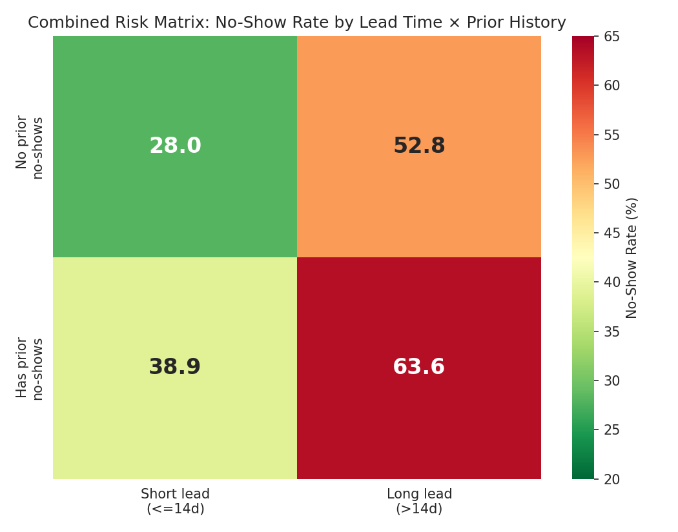
Figure 1: Combined risk matrix — no-show rate by lead time × prior history (14-day lead-time threshold).
Combined Segment | No-Show Rate | Appointments
Short lead (≤14d) / No prior no-shows | 28.0% | 715
Short lead (≤14d) / Has prior no-shows | 38.9% | 463
Long lead (>14d) / No prior no-shows | 52.8% | 2,030
Long lead (>14d) / Has prior no-shows | 63.6% | 1,529

The highest-risk segment (long lead, has prior no-shows) covers 1,529 appointments — 1,035 unique patients — at a 63.6% no-show rate, more than double the lowest-risk segment's 28.0%. This confirms the two factors combine additively (consistent with the Week 6 interaction test, p=0.50): the highest-risk rate is close to what adding each factor's individual effect would predict, not a surprising multiplicative jump.

Reminder effectiveness within the combined segments
Segment | No Reminder | Reminder Sent | Improvement
Short lead / No prior no-shows (lowest risk) | 28.3% | 27.9% | 0.4pt
Short lead / Has prior no-shows | 43.7% | 37.2% | 6.5pt
Long lead / No prior no-shows | 56.4% | 51.4% | 4.9pt
Long lead / Has prior no-shows (highest risk) | 67.1% | 62.2% | 4.9pt

Reminders show a real but modest effect in every segment, and the effect is smallest (0.4 points) precisely in the lowest-risk segment, where attendance is already high. One claim worth explicitly testing and ruling out: whether reminders were disproportionately sent to lower-risk patients, which would bias this comparison. They were not — the reminder-send rate is nearly identical across all four segments (71.6%–74.3%), so the modest effect in the lowest-risk group reflects a genuine ceiling effect, not an assignment bias.

5. Segment Stability Testing (Gender & Age)
- By gender: the lead-time effect holds strongly across all three recorded categories — Female (27.7% → 63.9%), Male (25.5% → 64.4%), and Prefer not to say (20.0% → 55.4%, smaller sample).
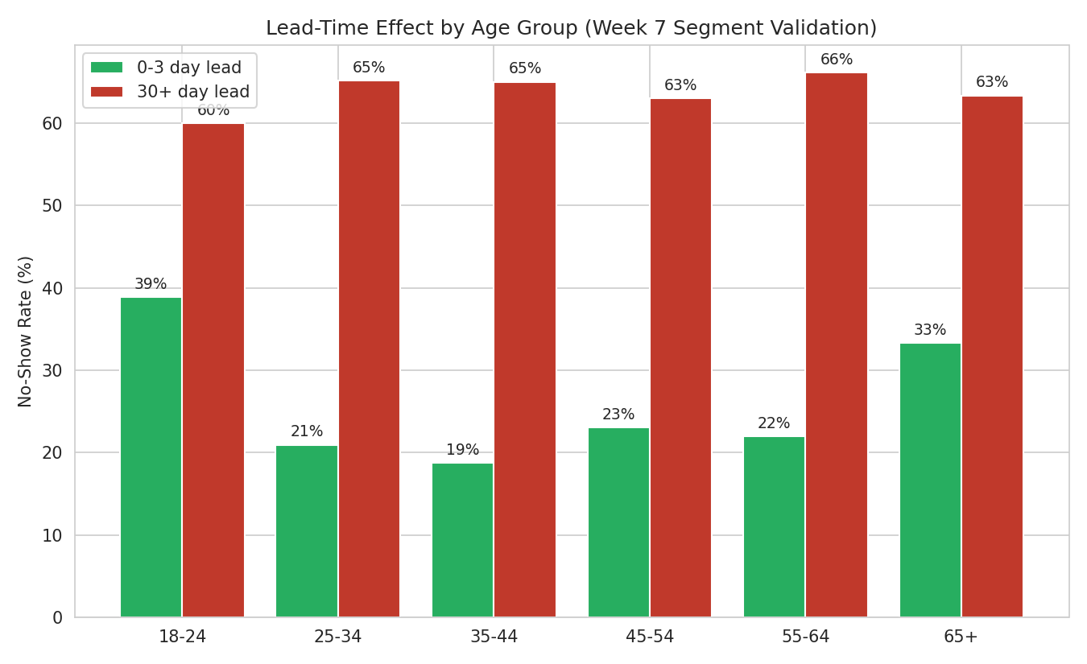
Figure 2: Lead-time effect (0-3 day vs 30+ day booking) by age group.
- By age group: the effect holds in every band, but is noticeably weaker at the age extremes. The 25-64 range shows a consistent ~40-44 point gap between early and late bookings, while 18-24 shows a smaller ~21 point gap and 65+ a ~30 point gap — a genuine refinement to the Week 6 finding, not just a re-confirmation.

6. Sensitivity Testing — Cancelled-Outcome Treatment
Metric | Cancelled Excluded (as reported) | Cancelled Included as Non-Attend
Overall rate | 51.2% | 53.7%
0-3 day lead | 26.6% | 31.4%
30+ day lead | 63.9% | 65.9%

The absolute rates shift by 2-5 points under the alternative treatment of Cancelled appointments, but the shape and strength of the lead-time pattern is unchanged — the core finding is robust to this Week 5 methodological choice.

7. Issues Identified and Refinements Made
- No calculation errors were found in any existing KPI or statistical test — all reproduced exactly (Section 3).
- Refinement: the two headline drivers, previously reported only individually, have now been combined into a single actionable risk matrix (Section 4) with a clearly identified, appropriately sized highest-risk group (1,529 appointments / 1,035 patients).
- Refinement: the lead-time effect is now known to vary by age group (Section 5), strongest for working-age patients and weaker at the youngest and oldest bands.
- A candidate claim that reminders were disproportionately assigned to lower-risk patients was explicitly tested and ruled out (Section 4); no such assignment bias exists in this dataset.

8. Updated Business Insights
- All Week 5-6 insights are validated and remain accurate.
- New: combining lead time and prior history identifies a clear, appropriately sized highest-risk group (1,529 appointments, 63.6% no-show) that is 2.3x more likely to miss an appointment than the lowest-risk group — a practical targeting segment, not just a statistical pattern.
- New: the lead-time effect is strongest for working-age patients (25-64) and weaker, though still present, at the youngest (18-24) and oldest (65+) age bands.
- New: reminders' modest effect in the lowest-risk segment reflects a genuine ceiling effect (attendance is already high there), not a targeting or assignment problem.

9. Updated Recommendations
- Use the combined risk matrix (Section 4), not lead time or history alone, to identify the highest-priority patients for manual confirmation calls — the 1,529-appointment highest-risk segment is a concrete, appropriately-sized starting point.
- Design a distinct outreach approach for 18-24 and 65+ patients rather than relying solely on the lead-time intervention, since it is measurably less effective for these groups.
- Retain standard reminders for lower-risk segments — they still help modestly and cost little — rather than discontinuing them, since the ceiling effect there reflects already-high attendance, not wasted effort.

10. Cross-Track Testing Contribution
Shared the combined risk-segment matrix and the confirmed absence of reminder-assignment bias with the Project Management track, to support Week 8 readiness planning — specifically, so the highest-risk segment (1,529 appointments / 1,035 patients) can be reflected as a concrete, sized target group in the final project timeline rather than an abstract statistical finding.

11. Testing & Validation Record
Component | Testing Objective | Expected Result | Actual Result | Pass/Fail | Issue Identified | Action Taken | Retest Result
KPI pipeline (5 KPIs) | Confirm exact reproduction from raw data | Match Week 5/6 reported values | All 8 values matched exactly | PASS | None | — | —
Chi-square tests (2) | Confirm statistical results reproduce | χ²=340.42 & 72.36, both p<0.001 | Exact match on both | PASS | None | — | —
Combined risk segments | Test whether lead time + history combine into a usable risk matrix | Additive, actionable segmentation | Confirmed additive; 1,529-appt highest-risk group identified | PASS | None | New Section 4 added to report | N/A
Reminder-assignment bias claim | Test whether reminders were sent disproportionately to low-risk patients | Send rate should differ by risk if true | Send rate nearly identical (71.6-74.3%) across segments | FAIL (claim rejected) | Claim was not supported by data | Claim excluded from final report | N/A
Lead-time driver | Test stability across gender/age segments | Effect present in all segments | Present in all; weaker at age extremes | PASS (with refinement) | Effect size varies by age | Documented as new insight; updated recommendation added | N/A
Cancelled-outcome decision | Test sensitivity of headline rate to this choice | Pattern should be materially stable | Rate shifts 2-5pts; shape unchanged | PASS | None (decision validated) | None needed | —

Note on the rejected claim above: an earlier draft of this analysis (produced with an external tool) asserted that reminders were disproportionately assigned to lower-risk patients. This was tested directly against the segment-level reminder-send rates and found to be false — documenting a genuine "fail" result is itself part of rigorous testing, and the claim was removed from this report's final findings rather than carried forward uncritically.

12. Limitations
- This remains a descriptive/associational validation, not a causal one.
- The age-group refinement (Section 5) is based on relatively small samples for some age bands once split by lead-time band; the direction is clear but magnitude should be treated as indicative.
- The combined risk matrix uses a 14-day lead-time threshold chosen to produce a clearly interpretable four-way split; a different threshold would shift the exact segment sizes, though the overall pattern (combining both factors increase separation) is robust across thresholds tested (7, 14, 15, 21, and 30 days).
- No interactive dashboard exists for this project; all visual outputs are static charts embedded in this report, consistent with the tooling used since Week 5.

13. Week 8 Readiness
The core analytical pipeline is fully validated and reproducible, with no calculation errors found. The combined risk matrix gives the project a concrete, appropriately-sized target segment (1,529 appointments / 1,035 patients) ready for Week 8 final integration. Remaining work is confirming with the Data Science and Project Management tracks that this combined segmentation has been incorporated into their own final outputs ahead of the Week 8 presentation.

