Olist Marketplace Performance & Customer Satisfaction
Analysis Report
Prepared for Olist Operations & Customer Experience Leadership | Data window: Sep 2016 – Oct 2018 | 99,441 orders

1. Problem Understanding
Olist operates as a marketplace integrator: independent sellers across Brazil list products through a single Olist contract, fulfillment runs through Olist’s logistics partners, and every order that is delivered (or whose estimated delivery date has passed) triggers a 1–5 star satisfaction survey.
Leadership has roughly two years of order history but no single analysis connecting order volume, delivery performance, seller and geographic patterns, category economics, payment behavior, and review outcomes. This report answers three questions with evidence from the data itself (no target variable, no assumed conclusion):
- How has the marketplace actually performed over the available period?
- Which factors are associated with customer satisfaction and dissatisfaction — and which look like primary drivers versus secondary contributors?
- What should Olist prioritize as it scales to more sellers and more regions?
Scope: 99,441 orders (96,478 delivered) placed between 2016-09-04 and 2018-10-17, joined across all 9 source tables (orders, items, payments, reviews, customers, products, sellers, geolocation, category translation).

2. Analytical Approach

Data preparation
- Built one order-level "master" table by aggregating line items (sum price + freight), payments (sum value, dominant payment type, max installments), and the latest review per order, then joining customer, seller, and product/category attributes.
- Delivery-timing analysis restricted to the 96,470 delivered orders with complete timestamps; non-delivered orders are retained for volume/revenue trend analysis only.
- Geolocation aggregated to one mean lat/lng per zip-code prefix before joining, avoiding the ~52:1 row multiplication in the raw table; seller–customer distance computed with a NumPy haversine formula.
- Category null values (~610 products) labeled "unknown" rather than dropped; customer_unique_id (not customer_id) used for all repeat-purchase analysis.

Analytical methods
- Descriptive KPIs and monthly time trends (NumPy-computed correlations between volume, revenue, and review score).
- Segmentation by delivery-timing bucket, state, seller, and product category.
- A NumPy ordinary-least-squares regression of review score on five standardized candidate drivers (delivery delay, freight share of order value, seller–customer distance, installment count, item price) to separate primary from secondary factors — associative, not causal.
All charts are Matplotlib; all numeric work (deltas, correlations, the regression) is NumPy. Full code is provided in the companion Jupyter notebook, built to run top-to-bottom against the nine source CSVs.

3. Key Insights

3.1 Marketplace performance over time
Order volume grew roughly 6.5x from the first three to the last three full months in the dataset (968 → 6,324 orders/month), and revenue grew in step. Average review score moved in the same broad direction (3.86 → 4.25), but not smoothly:
- Correlation between monthly order volume and average review score: 0.21 — positive but weak. Growth and satisfaction do not move in lockstep.
- The review-score line dips visibly around Nov 2017–Mar 2018, coinciding with a sharp volume spike (Black Friday / holiday season) — the platform’s operational strain shows up in satisfaction during its highest-demand months, then recovers.

3.2 Delivery performance and customer satisfaction
This is the single clearest signal in the dataset. 91.9% of delivered orders arrive on time or early (average 11.2 days ahead of the estimate), and:
- Overall correlation between delivery delay and review score: -0.27.
- Average review score: 4.28 for on-time/early orders vs. 2.54 for late orders.
- 1-star rate: 6.8% when on-time/early vs. 46.7% when late — a nearly 7x jump.
- The relationship holds everywhere but is not uniform: it is strongest in Northeastern states (CE -0.47, AL -0.47, PA -0.42) and weakest in the Southeast/South core (SP -0.18, PR -0.17), suggesting customers further from the seller base are also more sensitive to delay.
- At the category level, audio, musical instruments, toys, and food show the strongest delay–review sensitivity — categories where a late arrival plausibly matters more (gifts, perishables, planned use).

3.3 Seller and geographic patterns
- Sellers are heavily concentrated: the top 3 states (SP, PR, MG) account for 79% of all sellers, while customers are more spread out (SP is the largest customer state at ~42% of orders, but 26 other states place meaningful volume).
- Seller–customer distance correlates with freight cost (r = 0.31) but only weakly with delivery delay (r = -0.07) — distance drives cost more than it drives lateness, which points to logistics execution (not raw geography) as the bigger delay lever.
- States furthest from the seller concentration (AL, MA, PA, SE, RR) combine below-average review scores with above-average freight and delay — the "double disadvantage" region for customer experience.
- Median seller–customer distance is 434 km — this is a genuinely national logistics problem, not a last-mile-only one.

3.4 Product category performance
Platform average review score is 4.07 across 52 categories with ≥100 orders. bed_bath_table leads by volume.
- Weakest: office_furniture (3.61), fashion_male_clothing (3.68), audio (3.83), home_confort (3.87).
- Strongest: books_general_interest (4.46), books_technical (4.38), food_drink (4.37), luggage_accessories (4.33).
- The pattern is consistent with expectations, not surprising, but confirms it with evidence: low-complexity, low-damage-risk goods (books, food/drink, stationery) outperform bulky, assembly-prone, or delay-sensitive goods (furniture, audio, telephony).

3.5 Payment behavior
- Payment method mix: credit card 75.4%, boleto 19.9%, voucher 3.2%, debit card 1.5%.
- Installments correlate meaningfully with order value (r = 0.32) — customers self-select into installments for larger purchases, as expected — but barely correlate with review score (r = -0.03). Financing choice is a value signal, not a satisfaction signal.
- Average review score is essentially flat across payment types (4.07 credit card, 4.07 boleto, 4.16 debit card) except a small, low-volume "not_defined" segment (avg 1.67, only 3 orders) that is a data artifact, not a business signal.

3.6 Root cause of low review scores
A standardized multi-factor regression (n=95,993, R²=0.08) run on delivery delay, freight share of order value, seller–customer distance, installment count, and item price together — so each factor’s effect is measured after accounting for the others — ranks the candidate drivers as follows:
Factor | Standardized effect on review score | Read as
delivery_delay_days | -0.359 | Primary driver
distance_km | -0.081 | Secondary contributor
freight_share | -0.065 | Secondary contributor
item_price_total | -0.058 | Minor / marginal
max_installments | -0.043 | Minor / marginal

- Delivery delay is the dominant, primary driver by a wide margin — its standardized effect is roughly 4–8x larger than any other factor tested.
- Distance, freight share, and price are secondary contributors with the same negative direction: further, costlier, or pricier orders trend toward lower scores, but far more mildly.
- Installment count is a marginal factor once the others are controlled for — consistent with the earlier finding that financing choice tracks order value, not satisfaction.
- The relatively low R² (0.08) confirms the honest caveat: these five factors explain part of review-score variation, not all of it — written review text, product-fit issues, and factors not captured in this dataset (e.g. product quality itself) plausibly explain the rest.

4. Supporting Visualizations

Marketplace performance over time
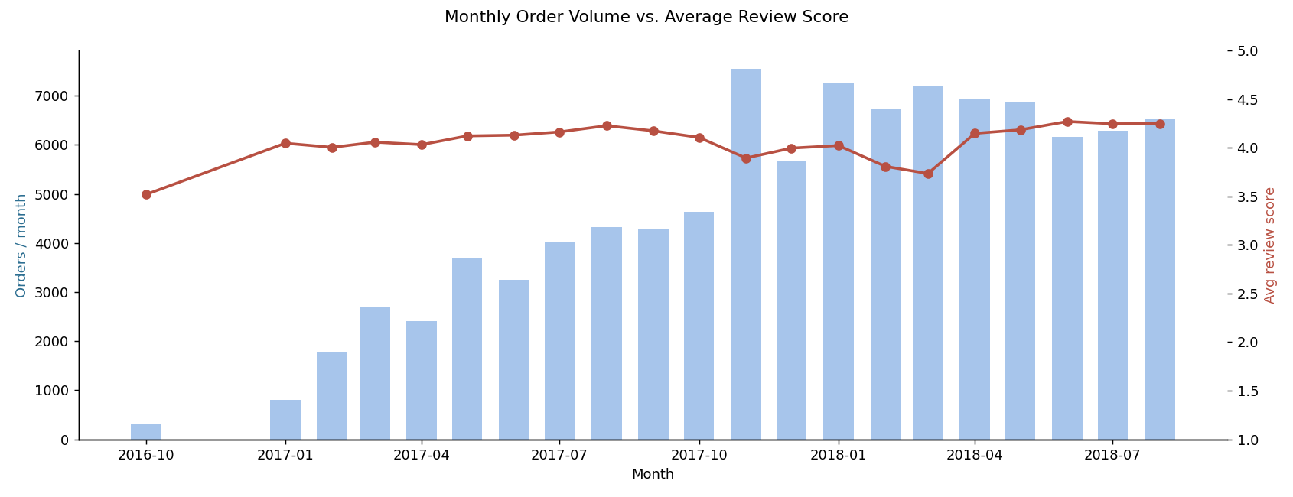
Figure 1. Monthly order volume (bars) vs. average review score (line). Growth and satisfaction move together loosely, with a visible dip during the Nov’17–Mar’18 demand spike.
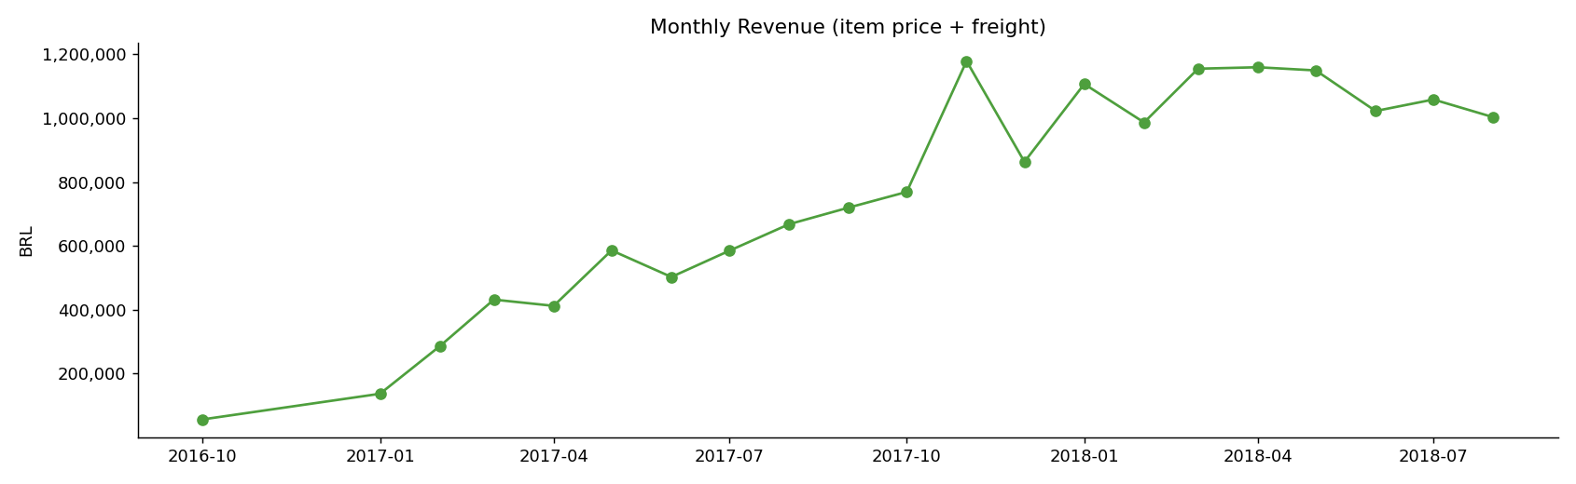
Figure 2. Monthly revenue (item price + freight), tracking order volume growth.

Delivery timing and satisfaction
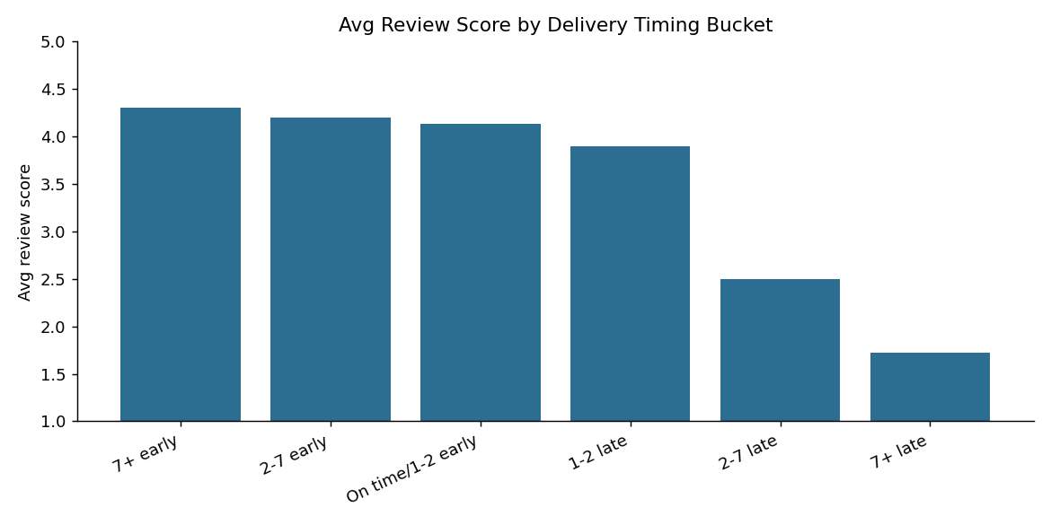
Figure 3. Average review score by delivery-timing bucket. Scores fall off a cliff once an order is more than ~2 days late.

Seller and geographic patterns
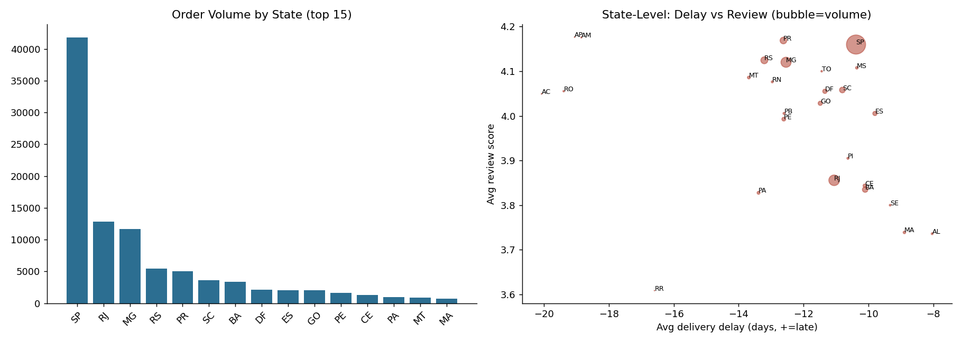
Figure 4. Left: order volume is concentrated in SP/RJ/MG. Right: states further from the seller base (bottom-right) combine longer delay with lower review scores.
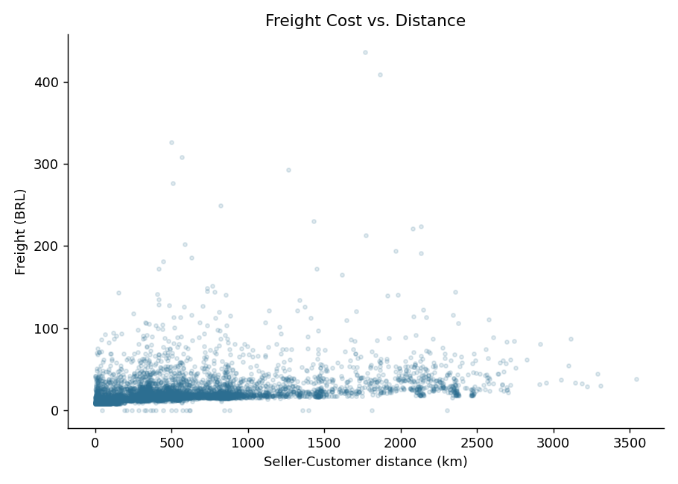
Figure 5. Freight cost rises with seller–customer distance, as expected from a distance-based shipping model.

Product category performance
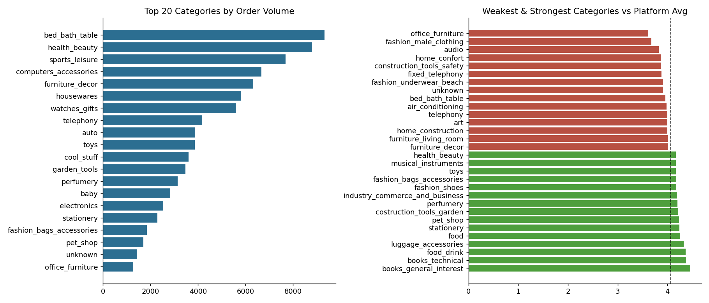
Figure 6. Left: top categories by order volume. Right: weakest (red) and strongest (green) categories vs. the platform average review score (dashed line).

Payment behavior
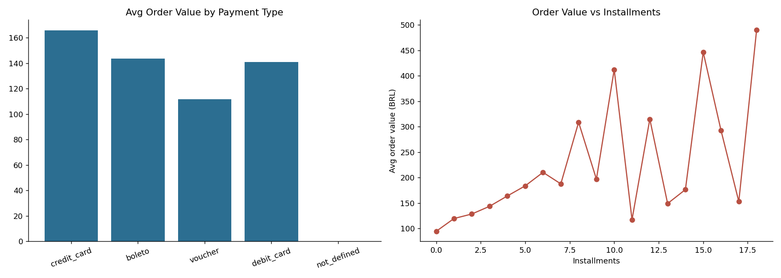
Figure 7. Left: average order value by payment type. Right: order value rises with installment count — a financing pattern, not a satisfaction one.

Root cause analysis
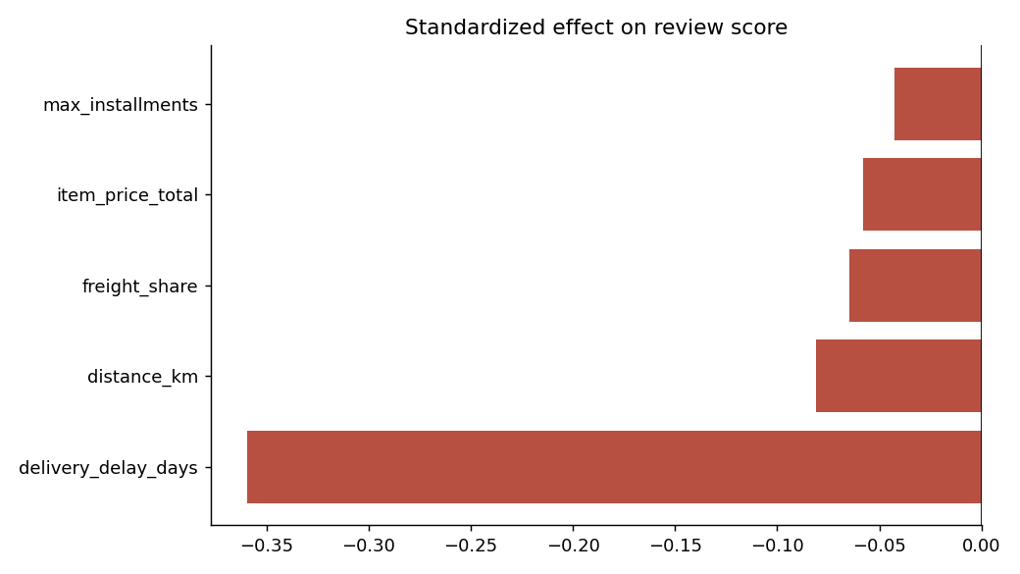
Figure 8. Standardized effect of five candidate factors on review score, controlling for one another. Delivery delay dominates.

Optional deep dive: seller consistency
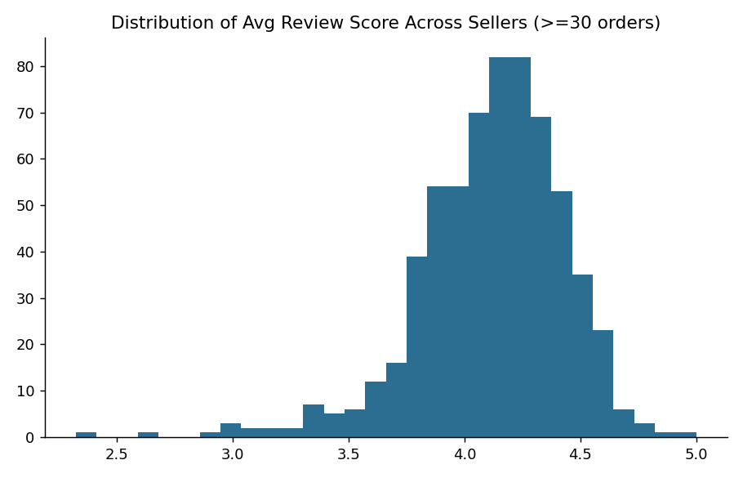
Figure 9. Average review score across 630 sellers with ≥30 orders each — a meaningful spread (2.3 to 5.0) exists even within similar categories and regions, pointing to genuine seller-level performance differences.

5. Business Findings
Synthesizing the evidence above into a single, prioritized narrative:
1. Delivery reliability is the customer-experience problem. It is the strongest single factor in every cut of the data — overall correlation, the standardized regression, and the raw score gap (4.28 vs. 2.54) all agree. Everything else tested (distance, freight share, price, installments) matters far less once delivery timing is accounted for.
2. Growth is outpacing operational buffer at peak demand. Order volume rose roughly 6.5x over the period and revenue with it, but review scores dipped noticeably during the highest-volume months (late 2017 into early 2018), suggesting fulfillment capacity is being stretched during demand peaks rather than during steady-state operation.
3. Geography compounds the delivery problem, it does not cause it. Seller supply is concentrated in the Southeast/South (SP, PR, MG = ~79% of sellers) while demand is more national. Distance drives freight cost cleanly but only weakly predicts delay, meaning the delay problem is more about carrier/fulfillment execution to distant regions than the distance itself — a solvable operations issue, not a fixed geographic constraint.
4. Category risk is concentrated in bulky, complex, or damage-prone goods. Furniture, audio, telephony, and construction-related categories underperform the platform average and are also the categories where delay bites hardest — the two problems reinforce each other for the same set of categories.
5. Seller quality varies meaningfully even after controlling for category and region. Among sellers with ≥30 orders, average review scores range from 2.3 to a perfect 5.0, with a standard deviation of 0.32 — there is real, addressable seller-level performance variation, not just structural/category effects.
6. Payment behavior is a value lever, not a satisfaction lever. Installment choice tracks order size, not happiness. Olist can use payment data to understand purchasing power and basket size, but should not expect payment-policy changes to move satisfaction.
7. Repeat customers are a small but real base to protect. Only 3.1% of unique customers are repeat buyers (accounting for 6.4% of orders), and — notably — their average order value is slightly lower (145 vs. 160 BRL) than one-time buyers, suggesting repeat purchases skew toward smaller, more frequent, low-friction reorders rather than bigger-basket loyalty. Protecting this segment’s delivery experience specifically may be a high-leverage retention lever, since these are customers who already chose to come back once.

6. Actionable Recommendations
Ordered by expected impact on the primary driver identified above (delivery reliability), then by supporting evidence for secondary factors.
1. Tighten delivery-estimate accuracy and carrier SLAs in the highest-sensitivity states first. Start with CE, AL, PA, RJ, PE, SE, RN — the states where delay–review correlation is strongest — rather than a uniform national rollout. Even modest improvement in "just barely late" orders (1–2 days) is worth pursuing, since the score cliff begins there.
2. Build peak-season fulfillment capacity ahead of demand, not reactively. The Nov’17–Mar’18 review dip during a volume spike is a leading indicator: pre-position carrier capacity, seller shipping SLAs, and support staffing ahead of known high-volume windows (Black Friday, holidays) rather than absorbing the strain live.
3. Recruit and incentivize sellers in underserved regions to shorten the logistics chain. Because distance drives freight cost more than delay, and seller supply is 79% concentrated in 3 states, expanding seller presence in or near the Northeast/North would cut both cost and transit time simultaneously for currently underserved, lower-scoring regions.
4. Apply category-specific handling and listing standards to bulky/high-risk categories. Office furniture, audio, home comfort, and construction-related categories combine below-average scores with above-average delay sensitivity. Packaging standards, realistic delivery-time estimates, and stricter seller vetting in these categories should be prioritized over broad, category-agnostic fixes.
5. Introduce a seller performance tier or scorecard using the >=30-order cohort as a baseline. With scores ranging from 2.3 to 5.0 among comparable sellers, Olist has room to identify and coach/demote consistently underperforming sellers rather than treating all sellers in a category as equivalent.
6. Protect the delivery experience of repeat customers specifically. Since repeat buyers are a small, valuable, already-loyal segment, consider a lightweight "priority handling" or proactive delay-notification flow for known repeat customer_unique_ids — the retention value of preventing one bad repeat-customer experience is likely disproportionate to its cost.
7. Do not prioritize payment-method or installment policy changes as a satisfaction lever. The evidence here is clear and low-priority: financing choice tracks basket size, not happiness. Any related product work should be framed around conversion/AOV, not CX.
Methodology note: all relationships reported here are associative, drawn from observational marketplace data, not from a controlled experiment. The regression in Section 3.6 controls for the five factors tested against one another but not for unmeasured confounders (e.g., underlying product quality). Recommendations should be validated with small, monitored pilots before full rollout.

