
College of Engineering and Information Technology
Department of Information Technology
Bachelor of Science in Information Technology (BSIT)
UAE Venture Guide: A Web Platform for Planning a Small Business in the UAE

Developed by:

Student Name(s), ID(s)
[], [],[], []

Supervised by:
[Dr. XXXXX ]

Project Report Submitted in Partial Fulfilment of the Requirements for the Degree of Bachelor of Science in Information Technology (BSIT)

[Semester-Year]

Undergraduate Capstone Project Declaration Form

Name of Students: , , , ,

Student IDs: , , , ,

Title of Project: UAE Venture Guide: A Web Platform for Planning a Small Business in the UAE

Program Name: Bachelor of Science in Information Technology (BSIT)

We sincerely declare that:
- The submitted project report is their own work and has been prepared as part of the requirements of the IT/IS/Cybersecurity Project course.
- All sources, references, ideas, figures, tables, and other materials obtained from external sources have been properly acknowledged and cited.
- The report does not contain plagiarism, including copying or presenting another person's work, ideas, text, images, code, or other materials as the students' own.
- The students have complied with the University's academic integrity and plagiarism policies and understand that violations may result in appropriate academic action.
- The use of generative AI tools in this project has been disclosed, and we take full responsibility for the accuracy, originality, and academic integrity of the submitted work.
- All project work and contributions are accurately represented, and no false, fabricated, or misleading information has been intentionally included in the report.
- The students accept responsibility for the originality and integrity of the submitted work and agree to provide clarification or supporting evidence if requested by the instructor, examiner, or University.

Student Name: ___________________________ Signature: ____________________________
Student Name: __________________________ Signature: ____________________________
Student Name: ___________________________ Signature: ____________________________
Student Name: ___________________________ Signature: ____________________________

Ethics Compliance Declaration Form

Students must declare whether the project involves activities that require ethical approval, including research involving human participants, interviews, surveys, personal or sensitive data, or other activities subject to ethical requirements.

Does this project require ethical approval?

☐ No
No further action is required.

☐ Yes
The students must obtain the relevant ethical approval before conducting the activity. Evidence of the ethical approval must be provided and attached to the project report as an appendix.

If Yes, provide the following information:
- Ethics Approval/Reference Number: __________________________
- Approving Committee/Institution: __________________________
- Date of Approval: __________________________
- Approval Document Attached: ☐ Yes ☐ No

Student Declaration:
We confirm that the information provided above is accurate and that, where ethical approval is required, the relevant approval has been obtained and supporting evidence is attached to this report.

Student Name: __________________________ Signature: _____________________________
Student Name: __________________________ Signature: _____________________________
Student Name: __________________________ Signature: _____________________________
Student Name: __________________________ Signature: _____________________________

Acknowledgment
We thank our project supervisor for clear guidance and honest feedback at every stage of this project.
We also thank the Department of Information Technology for the knowledge and support that made this work possible, and our families and friends for their patience and encouragement.

Abstract
Starting a small business in the UAE means following many steps across government and free-zone websites. First-time founders, especially students, often do not know the right order, the documents needed or the total cost. UAE Venture Guide is a web application that turns a business idea into a clear startup plan. The founder enters the idea, emirate, sector, budget and customers, and the system builds a roadmap of steps with costs in AED, a first-year budget, a document checklist and a list of risks, with steps and documents linked to official sources. The plan can be tracked, discussed with a built-in plan assistant, downloaded as a PDF, reviewed by a mentor and shared with funders. An administrator approves mentors and funders and keeps the official sources and fees up to date. The system was built with Next.js, JavaScript and MongoDB Atlas, using an Agile Scrum approach in one-week sprints. The roadmap planner and the assistant use the ChatGPT API when a key is set, and built-in rules otherwise. All 159 unit and database tests pass, and so does lint. The result is a working platform that brings planning, guidance and funding contacts into one place.
Keywords: startup planning, UAE, web application, mentorship, Next.js, MongoDB

List of Abbreviations

Abbreviation | Meaning
AED | United Arab Emirates dirham
AI | Artificial Intelligence
API | Application Programming Interface
CSRF | Cross-Site Request Forgery
ERD | Entity Relationship Diagram
FK | Foreign Key
FR | Functional Requirement
HS256 | Hash-based message authentication code with SHA-256
HTML | Hypertext Markup Language
HTTPS | Hypertext Transfer Protocol Secure
ID | Identifier
ISO/IEC | International Organization for Standardization / International Electrotechnical Commission
JSON | JavaScript Object Notation
JWT | JSON Web Token
MoSCoW | Must, Should, Could, Won’t (a way to rank requirements)
NFR | Non-Functional Requirement
PDF | Portable Document Format
PK | Primary Key
SME | Small and Medium-sized Enterprise
SMTP | Simple Mail Transfer Protocol
TC | Test Case
TLS | Transport Layer Security
TTL | Time to Live
UAE | United Arab Emirates
UML | Unified Modeling Language
WCAG | Web Content Accessibility Guidelines
XSS | Cross-Site Scripting
Table of Contents
Acknowledgment iv
Abstract v
List of Abbreviations vi
List of Figures x
List of Tables xi
Chapter One: Introduction 1
1.1 Background 1
1.2 Problem Statement 1
1.3 Motivation 1
1.4 Aim of the Project 1
1.5 Project Objectives 1
1.6 Project Scope 2
1.7 Project Contributions 2
1.8 Report Organisation 2
Chapter Two: Background and Related Work 3
2.1 Background and Key Concepts 3
2.2 Existing Technologies, Systems, or Solutions 3
2.3 Identified Gap 4
2.4 Summary 4
Chapter Three: Project Planning and Requirements 5
3.1 Project Methodology 5
3.1.1 How Scrum Is Applied 5
3.1.2 Development Life Cycle 5
3.1.3 Coding Standards 6
3.2 Stakeholder Analysis 6
3.3 Functional Requirements 7
3.3.1 Assumptions and Constraints 8
3.4 Non-Functional Requirements 8
3.5 Technical Requirements 9
3.6 Risk Analysis and Mitigation 9
3.7 Project Schedule 10
3.7.1 Development Roadmap 10
3.7.2 Milestones and Deliverables 10
3.7.3 Gantt Chart 11
3.8 Summary 11
Chapter Four: Project Analysis and Design 12
4.1 Analysis of the Existing System 12
4.2 Proposed Solution 12
4.3 System Architecture 12
4.4 System / Solution Design 13
4.4.1 Use-Case Diagram 13
4.4.2 Activity Diagram 14
4.4.3 Sequence Diagram 15
4.4.4 Class Diagram 16
4.4.5 Deployment Diagram 17
4.4.6 Security Design 17
4.5 Database Design 18
4.6 User Interface / User Experience Design 19
4.7 Design Justification 22
4.8 Summary 22
Chapter Five: Implementation and Development 23
5.1 Implementation Environment 23
5.2 Implementation Approach 23
5.3 Configuration and Development 23
5.3.1 Roadmap Planner 23
5.3.2 Plan Assistant 24
5.3.3 Access Control 24
5.3.4 Configuration 24
5.4 Integration 25
5.5 Implementation Challenges 25
5.6 Summary 25
Chapter Six: System Testing and Evaluation 26
6.1 Testing Strategy 26
6.2 Test Cases 26
6.3 Functional Testing 27
6.4 Performance Evaluation 27
6.5 Security Testing 28
6.6 Usability Evaluation 28
6.7 Results and Discussion 28
6.8 Summary 28
Chapter Seven: Entrepreneurship and Innovation 29
7.1 Project Innovation 29
7.2 Problem and Opportunity 29
7.3 Target Users and Customers 29
7.4 Value Proposition 29
7.5 Entrepreneurial Potential 29
7.6 Market Potential 29
7.7 Sustainability and Scalability 29
7.8 Future Commercialisation 29
Chapter Eight: Conclusion and Future Work 30
8.1 Summary of the Project 30
8.2 Achievement of Objectives 30
8.3 Main Contributions 30
8.4 Limitations 31
8.5 Future Work 31
8.6 Final Conclusion 31
References 32
Appendices 34
Appendix A: Source Code 34
Appendix B: Demo Accounts 34
Appendix C: Test Cases and Detailed Results 34
Appendix D: Use of Generative AI Tools 35

List of Figures
Figure 1: Gantt chart of the project schedule (Weeks 0 to 6) 11
Figure 2: System architecture 12
Figure 3: Use-case diagram 13
Figure 4: Activity diagram: creating a plan 14
Figure 5: Sequence diagram: guidance request and messaging 15
Figure 6: Class diagram 16
Figure 7: Deployment diagram 17
Figure 8: Entity relationship diagram 18
Figure 9: Wireframe: entrepreneur dashboard 20
Figure 10: Wireframe: plan workspace, budget tab 21
Figure 11: Wireframe: admin console, users page 21

List of Tables
Table 1: Existing solutions compared 3
Table 2: Scrum elements used in the project 5
Table 3: Project life cycle stages 5
Table 4: Stakeholders 6
Table 5: Functional requirements 7
Table 6: Non-functional requirements 8
Table 7: Technical requirements 9
Table 8: Risks and mitigation 9
Table 9: Development roadmap 10
Table 10: Milestones 10
Table 11: Data dictionary (main fields) 19
Table 12: Main screens 19
Table 13: Key design decisions 22
Table 14: Implementation environment 23
Table 15: Implementation challenges 25
Table 16: Test cases 26
Table 17: Requirements and their tests 27
Table 18: Automated test results 28
Table 19: Achievement of objectives 30
Table 20: Automated tests by area 34

Chapter One: Introduction

1.1 Background
A founder in the UAE can register a business on the mainland, through an emirate’s economic department, or in one of the many free zones, each with its own rules and fees [1]. A new company usually needs a trade name, a licence, an office or desk, residence visas and Emirates IDs for the owner and staff, a bank account and tax registration.
This information is published, but it is spread across many government and free-zone websites. Each site explains its own step and rarely shows the full journey or the total cost.

1.2 Problem Statement
First-time founders, such as university students, do not know which steps they need, in what order, which documents to prepare or what the first year will cost. They also find it hard to reach experienced mentors or interested funders. As a result, they lose time, miss steps or underestimate costs.

1.3 Motivation
Students and first-time founders often have business ideas but little experience of the setup process. A simple tool that shows the whole path in one place, with costs and official links, makes it easier to start. Linking founders with mentors and funders in the same tool helps them act on the plan.

1.4 Aim of the Project
The aim is to build a web application that helps first-time founders plan a small business in the UAE and connects them with mentors and funders.

1.5 Project Objectives
- Generate a startup roadmap with steps, costs in AED, documents and risks from a short intake form.
- Let the founder track tasks, budget and documents, and download the plan as a PDF.
- Provide a plan assistant that answers questions from the plan and official sources.
- Let founders request guidance from approved mentors and message them after acceptance.
- Let founders share a plan with approved funders, who can send interest and, once accepted, read the plan and message the owner.
- Give an administrator tools to approve users, manage official sources and fees, and hide unsuitable content.
- Protect accounts and plans with secure sign-in and access rules, tested automatically.

1.6 Project Scope
In scope: the project covers user accounts for four roles, the plan workspace (roadmap, tasks, budget, documents, risks, sources), the plan assistant, PDF reports, mentor requests and posts, plan sharing with funders, messaging, and the admin console.
Assumptions: the website is in English and shows amounts in AED, and demo data is used for testing and assessment (Section 3.3.1).

1.7 Project Contributions
- A working web application for the four roles.
- A roadmap planner, using built-in rules or the ChatGPT API, that marks each cost as official, demo or estimate.
- A clear access model that keeps business ideas private, apart from the administrator, until the owner says yes.
- A setup guide that lets others run and extend the system, and 159 automated tests that the team ran on their own computer.

1.8 Report Organisation
Chapter 2 reviews related work. Chapter 3 covers planning and requirements. Chapter 4 presents the design. Chapter 5 describes the implementation, and Chapter 6 covers the testing. Chapter 7 discusses the business potential, and Chapter 8 concludes.

Chapter Two: Background and Related Work
This chapter explains the key ideas, reviews existing tools and identifies the gap the project fills.

2.1 Background and Key Concepts
- Mainland and free zone. A mainland company is licensed by an emirate and can trade anywhere in the UAE. A free-zone company is licensed by a free-zone authority and follows that zone’s rules, including any limits on trading on the mainland [1].
- Startup roadmap. A startup roadmap is an ordered list of steps, grouped into phases, that takes a founder from idea to launch.
- Mentorship. Mentorship means experienced people giving advice to new founders, and it is widely recommended for them [2].
- Web application. A web application is software used in a browser. This project uses Next.js, a React framework [3], and MongoDB, a document database [4].

2.2 Existing Technologies, Systems, or Solutions
Table 1 compares the main existing solutions with what the project’s users need.
Table 1: Existing solutions compared
Solution | What it offers | Limitation for our users
UAE government portal (u.ae) [1] | Official information on starting a business | General information; no personal plan or cost total
Invest in Dubai [5] | Online company setup and licences in Dubai | One emirate only; no plan, budget or mentors
TAMM, Abu Dhabi [6] | Government services, including business licences | Abu Dhabi only; service portal, not a planner
Sheraa, Sharjah [7] | Startup programmes, events and mentoring | Selective programmes; no self-service plan
Khalifa Fund [8] | Funding and support for UAE SMEs | Funding focus; no step-by-step setup plan
Free-zone and economic department websites | Licence packages and fees for one authority | Covers one authority only; hard to compare
Business plan software (e.g. LivePlan) [9] | Templates for business plans and finances | Paid, not UAE-specific, no official fees
Mentoring networks (e.g. SCORE) [10] | Free advice from volunteer mentors | Not linked to a UAE plan; outside the UAE
Business setup consultants | Full service for a fee | Costly for students; no self-service tool

2.3 Identified Gap
No tool in Table 1 gives a UAE founder a personal plan with costs tied to official sources and links it to mentors and funders. UAE Venture Guide fills this gap in one free web application.

2.4 Summary
Existing sources are either official but scattered, or helpful but generic or costly. The project combines official UAE information, planning tools and a small community in one place.

Chapter Three: Project Planning and Requirements
This chapter presents the development method, the stakeholders, the requirements, the risks and the schedule.

3.1 Project Methodology
The project uses Agile: building the software in short cycles, with feedback after each one [11]. It follows Scrum, where work is done in fixed cycles called sprints [12]. Each sprint lasts one week and ends with a working, tested part of the website.
Agile suits this project because the mentor and funder features build on the founder’s plan, so each sprint adds one working layer, and a roadmap’s quality can only be judged by trying it. Waterfall was rejected because problems often appear only at the end [13].

3.1.1 How Scrum Is Applied
Table 2 shows how each Scrum role, artefact and event is used in this project.
Table 2: Scrum elements used in the project
Scrum element | How it is used
Product owner | One team member, who orders the backlog using the supervisor’s feedback
Scrum master | One team member, who keeps the sprints on track and removes blockers
Developers | All team members, who design, build and test each item
Product backlog | The ordered list of user stories on a GitHub Projects board
Sprint | One week, from Week 1 to Week 6
Sprint planning | Each week starts with a sprint goal and the backlog items chosen for it
Daily Scrum | A short daily check on progress and blockers
Sprint review | Shows the new features to the supervisor and updates the backlog
Retrospective | A short note on what went well and what to change

Each backlog item is a user story [14], for example: “As an entrepreneur, I want to describe my business idea, so that I get a personal startup roadmap.” An item is done when it works as described and passes the automated checks.

3.1.2 Development Life Cycle
Every sprint repeats the same cycle: plan, design, build, test, review and reflect. The whole project moves through the five stages in Table 3.
Table 3: Project life cycle stages
Stage | Main activities | Output
1. Planning (Week 0) | Requirements, technology choice, design, schedule | This chapter
2. Development (Weeks 1 to 6) | Six one-week sprints | A working part each week
3. Testing (Weeks 5 and 6) | Full automated testing | Test results
4. Release (end of Week 6) | Final version with demo data | Working system
5. Maintenance | Fixes, checking fees and sources, paid hosting | Improved versions

3.1.3 Coding Standards
- One language: all code is JavaScript. Input is checked with Zod. ESLint checks the code, and a Prettier settings file keeps the formatting consistent.
- Simple structure: pages in src/app, interface parts in src/components, shared logic in src/lib and database models in src/models.
- Clear names and short comments: names say what the code does, and comments explain why.
- Reuse: logic needed twice becomes one shared helper.

3.2 Stakeholder Analysis
The project’s stakeholders are the four groups who use the system, shown in Table 4.
Table 4: Stakeholders
Stakeholder | Role | Interests | Influence
Students (Entrepreneurs) | Create business plans, ask mentors for help and share plans with funders | A clear plan with correct costs; privacy for their idea | High
Mentors and volunteers | Answer guidance requests, message founders and write experience posts | An easy way to help; control over which requests they accept | Medium
Funders | Browse shared plans and send funding interest | Promising ideas; a way to contact the owner | Medium
Administrator | Approves users, manages official sources and fees, and hides unsuitable content | Simple tools and trustworthy content | High

3.3 Functional Requirements
The functional requirements in Table 5 describe what the system must do. Priorities follow the MoSCoW method [15]: Must, Should, Could or Won’t have. Must items are essential for the first release; Should items can move to later work.
Table 5: Functional requirements
ID | Requirement | Actor | Priority
FR-01 | A visitor can register as an entrepreneur, mentor or funder, then sign in and sign out. | Visitor | Must
FR-02 | Entrepreneurs are active at once; mentors and funders fill in a profile and wait for administrator approval. | System | Must
FR-03 | Each user sees a dashboard made for their role. | All users | Must
FR-04 | Users can change their name and password, and reset a forgotten password by email. | All users | Must
FR-05 | The entrepreneur creates a plan from a form: title, idea, emirate, sector, mainland or free-zone preference, budget, customers and team size. Later they can make a new version, try again after a failure, or delete it. | Entrepreneur | Must
FR-06 | The system builds a roadmap with phases, tasks, costs, a budget, documents and risks, and recommends a mainland or free-zone setup. | System | Must
FR-07 | Each cost is labelled official, demo or estimate, depending on its fee reference. | System | Must
FR-08 | The entrepreneur can add, edit and delete tasks and mark them as “to do”, “in progress” or “done”. | Entrepreneur | Must
FR-09 | The entrepreneur can add, edit and delete budget items and record what was paid; the system shows the first-year total, warns when it is over budget and draws charts. | Entrepreneur | Must
FR-10 | The entrepreneur can tick off documents in the checklist. | Entrepreneur | Must
FR-11 | The entrepreneur can ask the plan assistant questions, and the chat is saved. | Entrepreneur | Must
FR-12 | Each user has a daily limit of 5 roadmaps and 40 assistant messages. | System | Must
FR-13 | Anyone who may read a plan can download it as a PDF report. | All users | Must
FR-14 | Anyone can browse approved mentors (by expertise and emirate), read experience posts and search the official sources. | Anyone | Must
FR-15 | Entrepreneurs can send a guidance request to a mentor, optionally with a plan, and withdraw it while pending. | Entrepreneur | Must
FR-16 | Mentors can accept, decline or complete requests, and turn new requests on or off. | Mentor | Must
FR-17 | Mentors can publish experience posts with text, pictures and one chart. | Mentor | Must
FR-18 | Entrepreneurs can share a plan with funders as a pitch card and stop sharing at any time. | Entrepreneur | Must
FR-19 | Funders can browse pitch cards, filter them by sector and emirate, send interest with a message and withdraw it while pending. | Funder | Must
FR-20 | The plan owner can accept or decline interest; accepting lets the funder read the full plan. | Entrepreneur | Must
FR-21 | After acceptance, the two people can message each other on the website, up to 30 messages a minute each. | Entrepreneur, Mentor, Funder | Must
FR-22 | Users get an email when a request or interest is sent, accepted or declined, and when their account is approved or not approved. | System | Should
FR-23 | The administrator can approve, reject, suspend and reactivate accounts. | Administrator | Must
FR-24 | The administrator can manage official sources and fee references. | Administrator | Must
FR-25 | The administrator can hide posts and shared plans, and see daily AI usage (roadmaps and chat messages). | Administrator | Should

3.3.1 Assumptions and Constraints
- The website is in English only, and all amounts are in AED.
- The planner and assistant use the ChatGPT API when a key is set, and built-in rules otherwise; the demo runs without a key.
- Fee amounts in the demo data are samples marked “demo” until an administrator checks them against the official page.
- Testing with real people needs ethical approval first, so demo accounts are used for assessment.
- The system runs on free cloud plans for development and assessment.

3.4 Non-Functional Requirements
The non-functional requirements in Table 6 describe how well the system must work. Most areas come from the ISO/IEC 25010 quality model [16]. Usability and accessibility fall under its interaction capability, and privacy and accuracy are added for this project.
Table 6: Non-functional requirements
ID | Category | Requirement
NFR-01 | Security | Passwords are stored only as bcrypt hashes.
NFR-02 | Security | The server checks the user’s role and account status on every private page and API call.
NFR-03 | Security | All input is checked in the browser and again on the server.
NFR-04 | Security | After five wrong passwords in a row for one email, sign-in is blocked for 15 minutes.
NFR-05 | Privacy | A funder sees only the pitch card until the owner accepts; a conversation is visible only to its two people.
NFR-06 | Accuracy | A cost is marked official only when it comes from a fee reference checked by the administrator.
NFR-07 | Usability | The website uses plain English, shows clear error messages beside each field and works on phones, tablets and computers.
NFR-08 | Accessibility | Main tasks work with the keyboard alone, and pages follow the WCAG 2.1 AA guidelines [17].
NFR-09 | Reliability | A new plan and its roadmap are saved in one write operation, so a plan is never half-saved.
NFR-10 | Maintainability | The code has a clear folder structure, follows the coding standards and is checked with ESLint and the automated tests.
NFR-11 | Compatibility | The website works in current versions of Chrome, Edge, Firefox and Safari.

3.5 Technical Requirements
The system is one Next.js project with a MongoDB Atlas cloud database, so the team uses one language and one codebase, and nothing needs to be bought: even the optional ChatGPT API works on OpenAI’s free plan. Table 7 lists the technical requirements.
Table 7: Technical requirements
Item | Purpose
A computer that runs Node.js 24 | Developing and testing
Any device with a modern browser | Using the website
Next.js 16, React 19 and TanStack Query | Pages and server code in one project, and data loading in the browser
JavaScript, Zod | Programming language and input checks
Tailwind CSS 4, shadcn/ui | Styling and ready-made interface parts
MongoDB Atlas with Mongoose 9 | Cloud database and data models
bcryptjs and jose | Password hashing and signed session tokens (JWT)
Recharts, @react-pdf/renderer | Budget and post charts, and PDF reports
Nodemailer | Emails over SMTP
OpenAI API (optional) | ChatGPT (gpt-6-luna by default) writes roadmaps and answers when a key is set
Vercel (planned) | Hosting the live website
VS Code, Git and GitHub | Code editor and version control
ESLint, Vitest | Code checks, and unit and database tests

3.6 Risk Analysis and Mitigation
Each risk is scored as likelihood times impact, with Low counted as 1, Medium as 2 and High as 3. Table 8 lists the risks from the highest score to the lowest.
Table 8: Risks and mitigation
ID | Risk | Likelihood | Impact | Score | Mitigation
R-01 | The schedule is too tight | High | High | 9 | Must items first; Should items move to later sprints
R-02 | Fees are wrong or out of date | High | High | 9 | Costs are labelled official, demo or estimate; each fee records when it was checked
R-03 | The work grows beyond the plan | Medium | High | 6 | A fixed list of requirements; new ideas go to the backlog
R-04 | Account takeover by password guessing | Medium | High | 6 | A sign-in lockout and minimum password rules; bcrypt slows the cracking of a stolen database
R-05 | The AI writes a wrong fee or step | Medium | High | 6 | Only cited, checked fees count as official; plans say guidance only
R-06 | Limited experience with some tools | Medium | Medium | 4 | Official documentation and small practice programs
R-07 | Few real mentors and funders for testing | Medium | Medium | 4 | Demo accounts and sample data for every role
R-08 | Business ideas seen by the wrong people | Low | High | 3 | Server-side access checks, with database tests for plan and conversation access

3.7 Project Schedule
The project takes a planning week (Week 0) and six one-week sprints, as Tables 9 and 10 show.

3.7.1 Development Roadmap
Table 9: Development roadmap
Sprint | Week | Work | Deliverable
Planning | 0 | Requirements, design, schedule | Planning documents
Sprint 1 | 1 | Accounts, roles, dashboards, approval | Sign-up and dashboards
Sprint 2 | 2 | Sources and fees, intake form, roadmap planner | First roadmap
Sprint 3 | 3 | Tasks, budget, documents, assistant, ChatGPT | Plan workspace
Sprint 4 | 4 | Mentors: profiles, requests, messages, posts | Mentor features
Sprint 5 | 5 | Funders, sharing, PDF report, admin console | All features
Sprint 6 | 6 | Full testing, fixes, demo data, documents | Final release

3.7.2 Milestones and Deliverables
Table 10: Milestones
Milestone | Due | Meaning
M1: Planning complete | End of Week 0 | Requirements and design agreed
M2: Foundation ready | End of Week 1 | Accounts and dashboards work
M3: Core version | End of Week 3 | Roadmap, tasks, budget and assistant work
M4: Feature complete | End of Week 5 | Every Must requirement works
M5: Final release | End of Week 6 | Tested system and documents complete

The deliverables are the working system, the source code, a setup guide and this report.

3.7.3 Gantt Chart
Figure 1 shows the schedule as a Gantt chart. Diamonds mark the milestones.
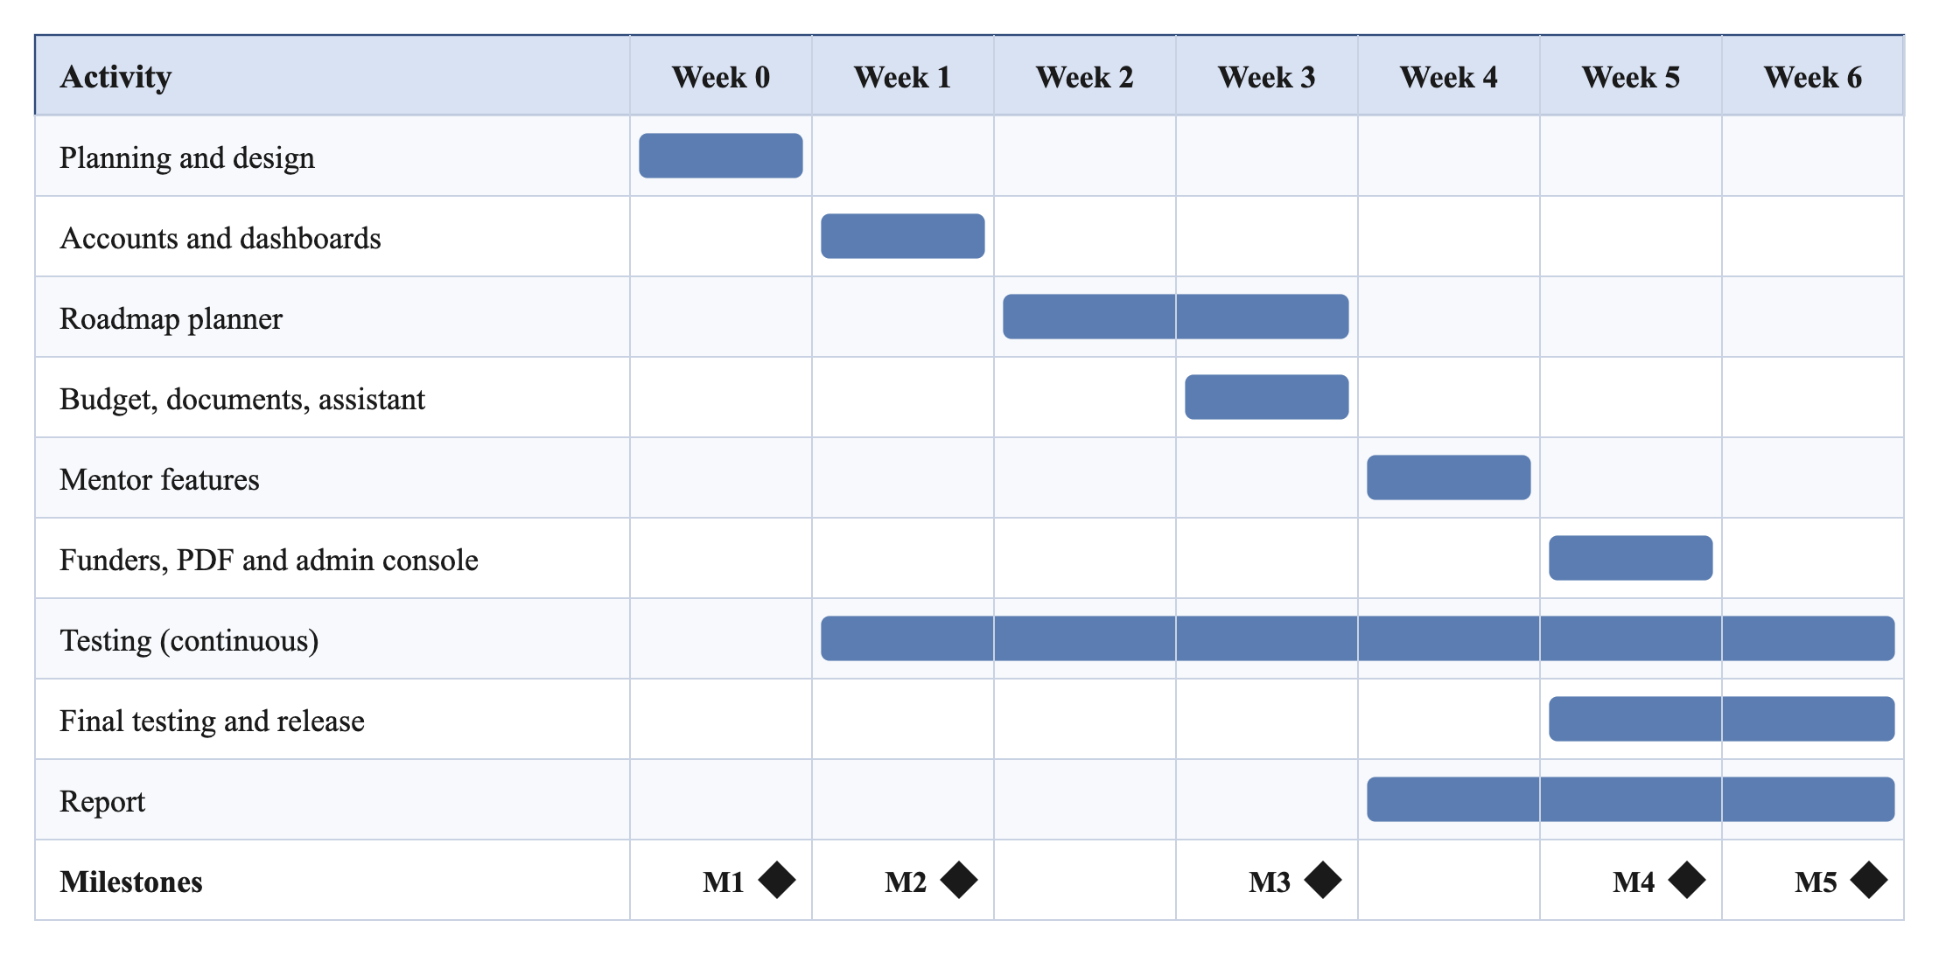
Figure 1: Gantt chart of the project schedule (Weeks 0 to 6)

3.8 Summary
The project uses Scrum: a planning week and six one-week sprints. It has four stakeholders, 25 functional and 11 non-functional requirements and five milestones. The top risks are the schedule and the fees.

Chapter Four: Project Analysis and Design
This chapter analyses the current situation, describes the proposed solution and presents its design.

4.1 Analysis of the Existing System
Today, a founder gathers information by hand from many websites. The main problems are:
- Steps, fees and documents are spread over many sites, with no total cost.
- There is no personal plan that adapts to the emirate, sector and budget.
- Finding a mentor or a funder depends on personal contacts.
- Paid consultants are too costly for most students.

4.2 Proposed Solution
UAE Venture Guide gives each founder a personal plan built from official sources, and a place to track it and get help. Mentors and funders join after the administrator approves them. A plan stays private, apart from the administrator, until a mentor accepts a request that has the plan attached, or the founder accepts a funder’s interest. Sharing a plan shows funders only a short pitch card.

4.3 System Architecture
The system has three tiers (Figure 2): the browser (presentation), the Next.js server (logic) and MongoDB Atlas (data). The server runs the pages, the API routes and the shared logic. The proxy checks the session cookie on requests for private pages, and every private API route checks the session itself.
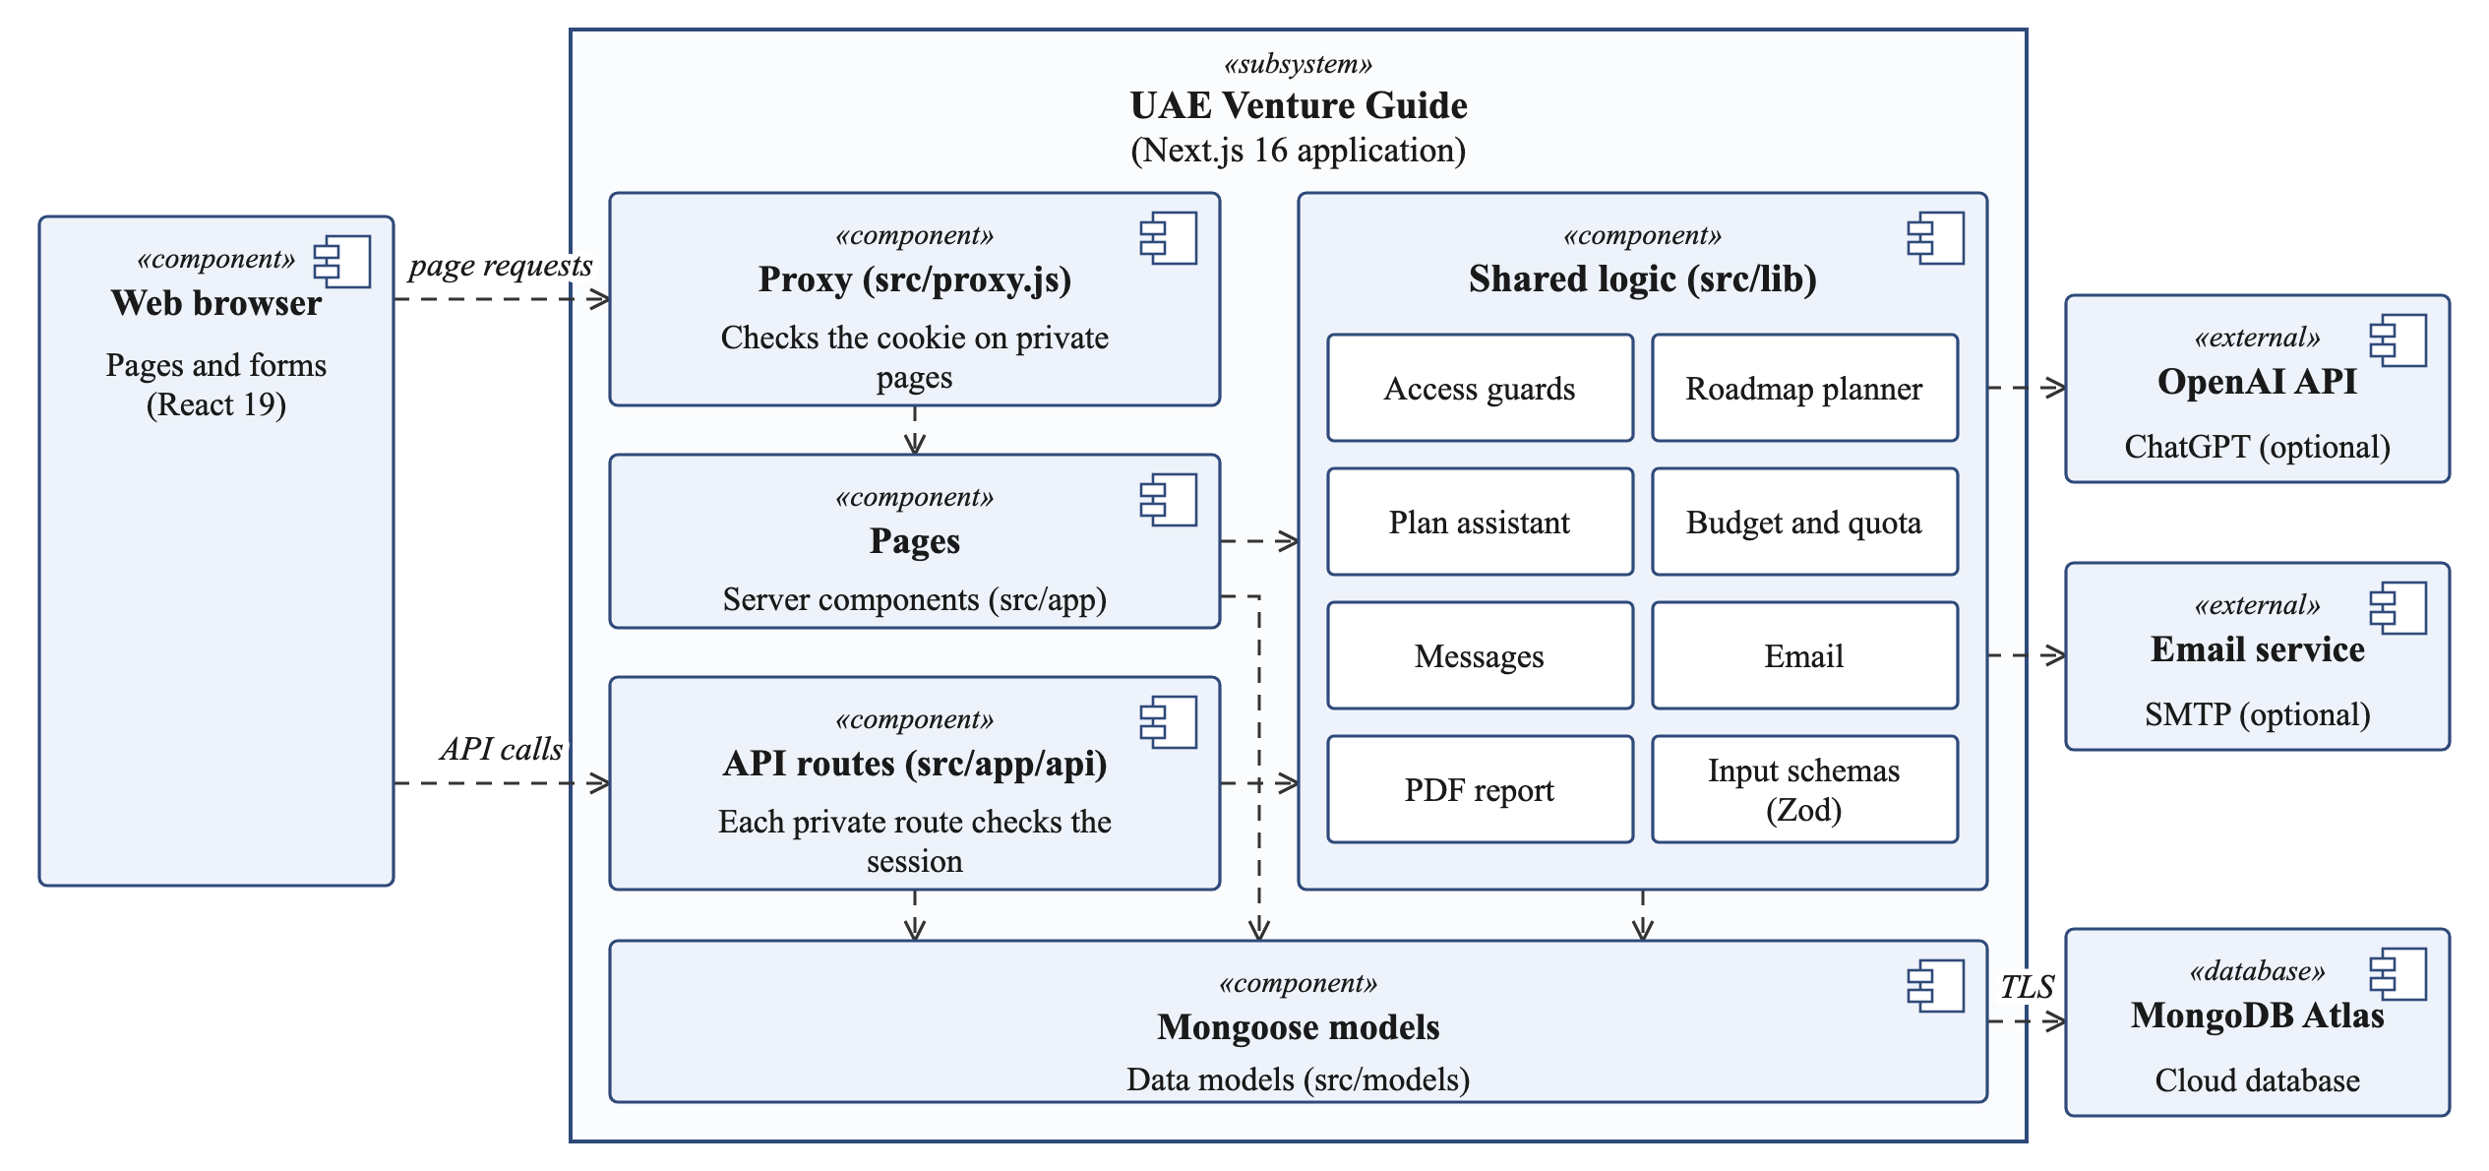
Figure 2: System architecture
- Private pages pass through the proxy, which sends anyone without a valid session to sign in.
- API calls go straight to the API routes, which check the session, role and input.
- Pages and API routes share the access rules in src/lib, and also use the models directly.
- Only the Mongoose models talk to the database, over an encrypted connection.
- With an OpenAI key, the planner and the assistant also call the OpenAI API (ChatGPT).

4.4 System / Solution Design

4.4.1 Use-Case Diagram
Figure 3 is a UML use-case diagram showing what each kind of user can do.
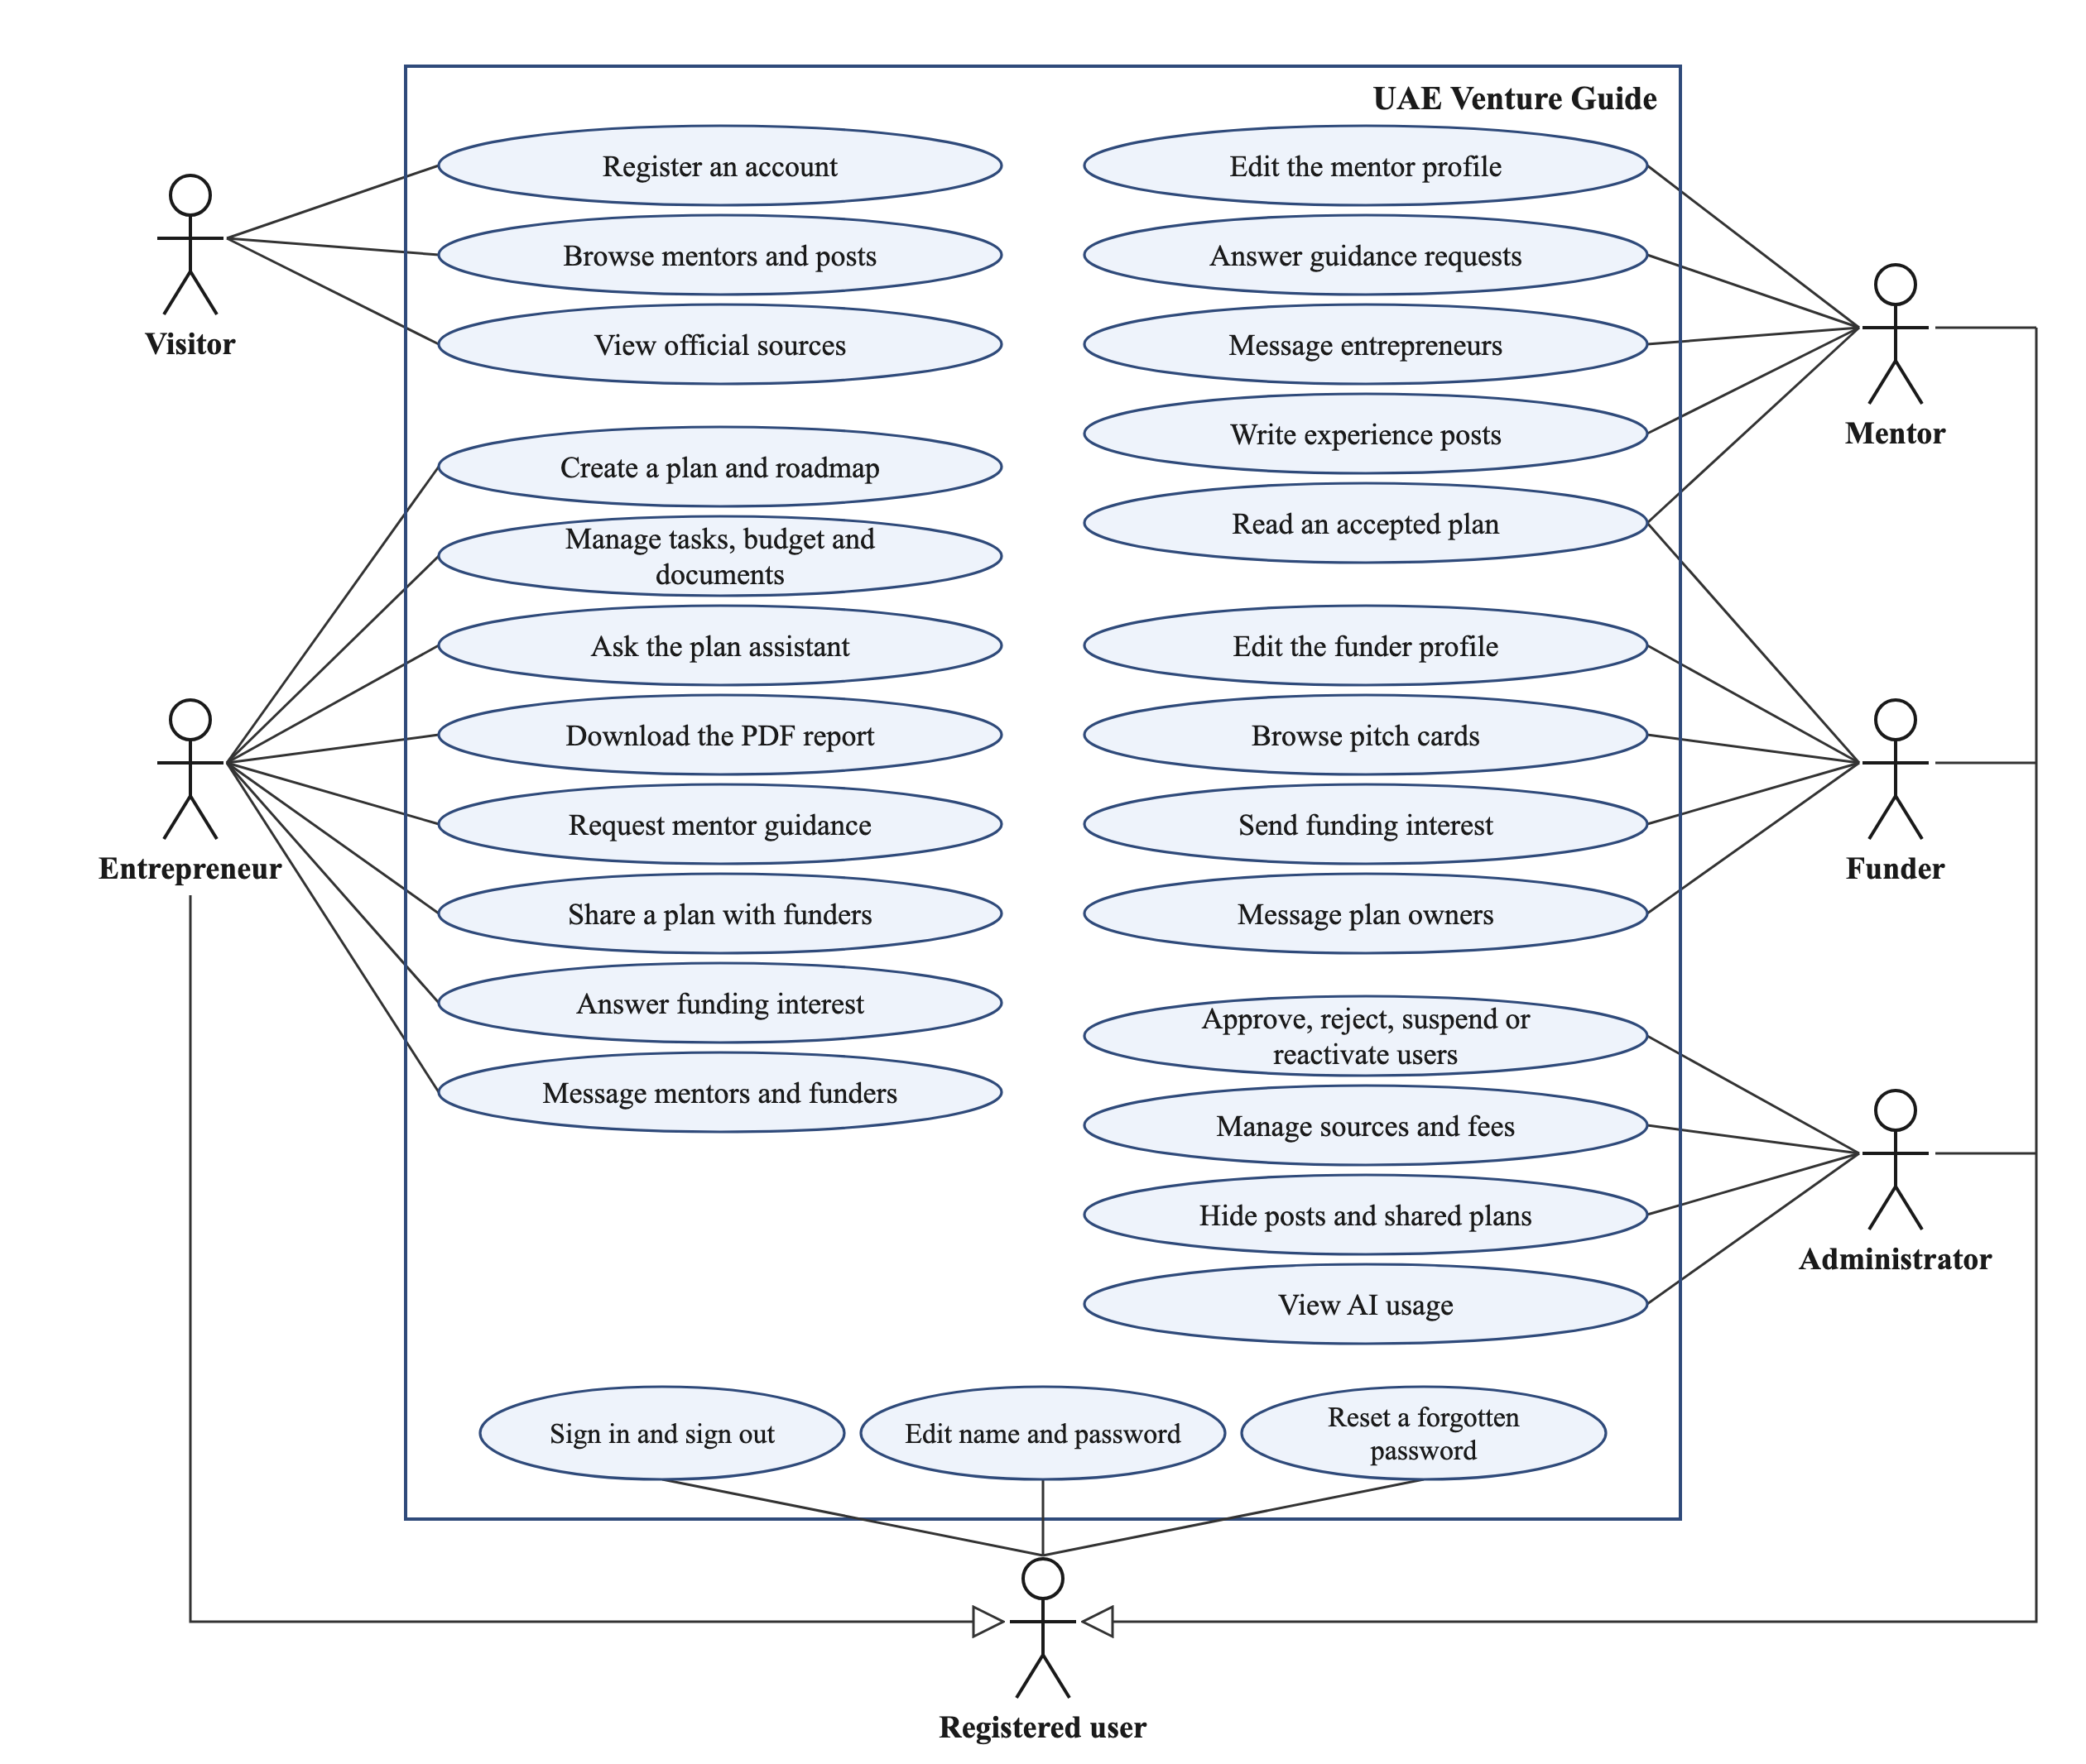
Figure 3: Use-case diagram
- A visitor can browse the public pages and register as an entrepreneur, mentor or funder; the administrator account comes from the seed script.
- The four roles are kinds of registered user, so each one signs in, edits its name and password, and resets a forgotten password in the same way.
- Until approved, mentors and funders can only fill in their profile and account settings.
- Messaging opens only after a request or an interest has been accepted.

4.4.2 Activity Diagram
Figure 4 shows how a plan is created, from the intake form to the saved roadmap. The plan and its roadmap are saved in one write operation, either as ready or as failed with a “Try again” button.
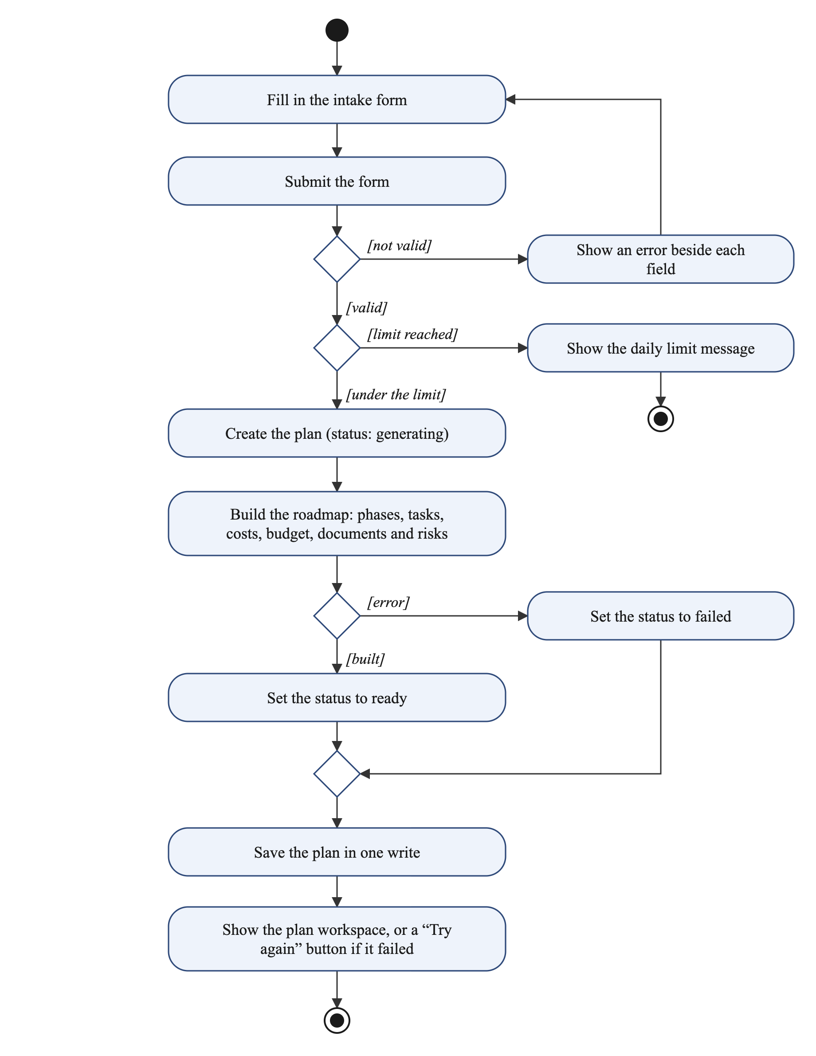
Figure 4: Activity diagram: creating a plan
- The form is checked in the browser and again on the server.
- The daily limit is checked and counted in one database update, before any work starts.
- If the roadmap cannot be built, the plan is still saved, marked as failed, and the owner can try again.

4.4.3 Sequence Diagram
Figure 5 shows a guidance request, from sending it to messaging after the mentor accepts.
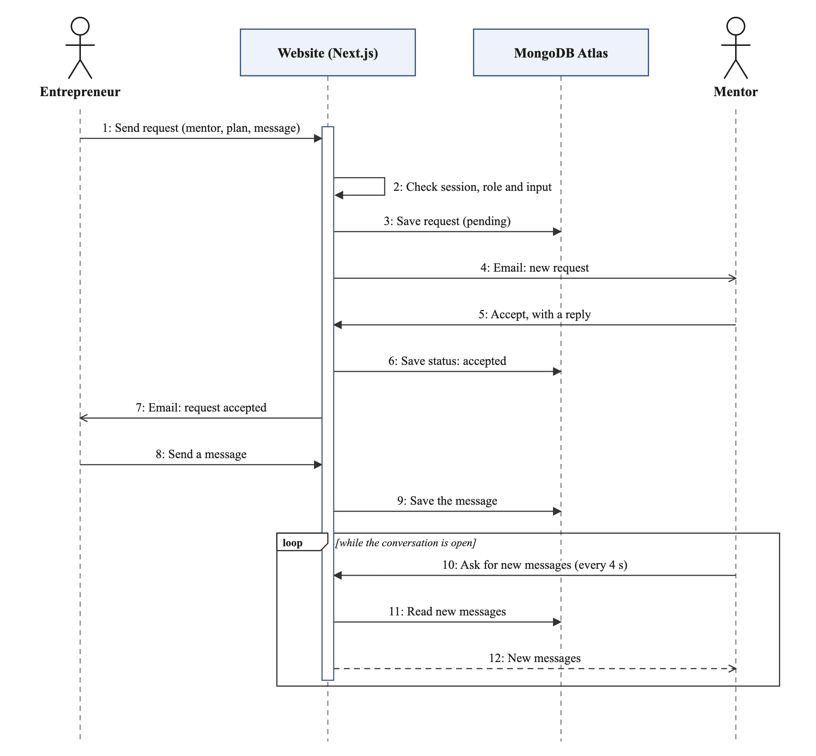
Figure 5: Sequence diagram: guidance request and messaging
- Steps 1 to 3: the request is checked and saved as pending.
- Steps 4 to 7: the mentor is emailed, accepts with a reply, the status is saved as accepted and the founder is emailed. The website shows the same status, so nothing is lost if an email fails.
- Steps 8 to 12: messages are saved, and the other person’s page asks for new ones every 4 seconds while it is open and in view.

4.4.4 Class Diagram
Figure 6 shows the main classes of the system with their key attributes. The operations shown are the main actions the API routes offer, such as accepting a request.
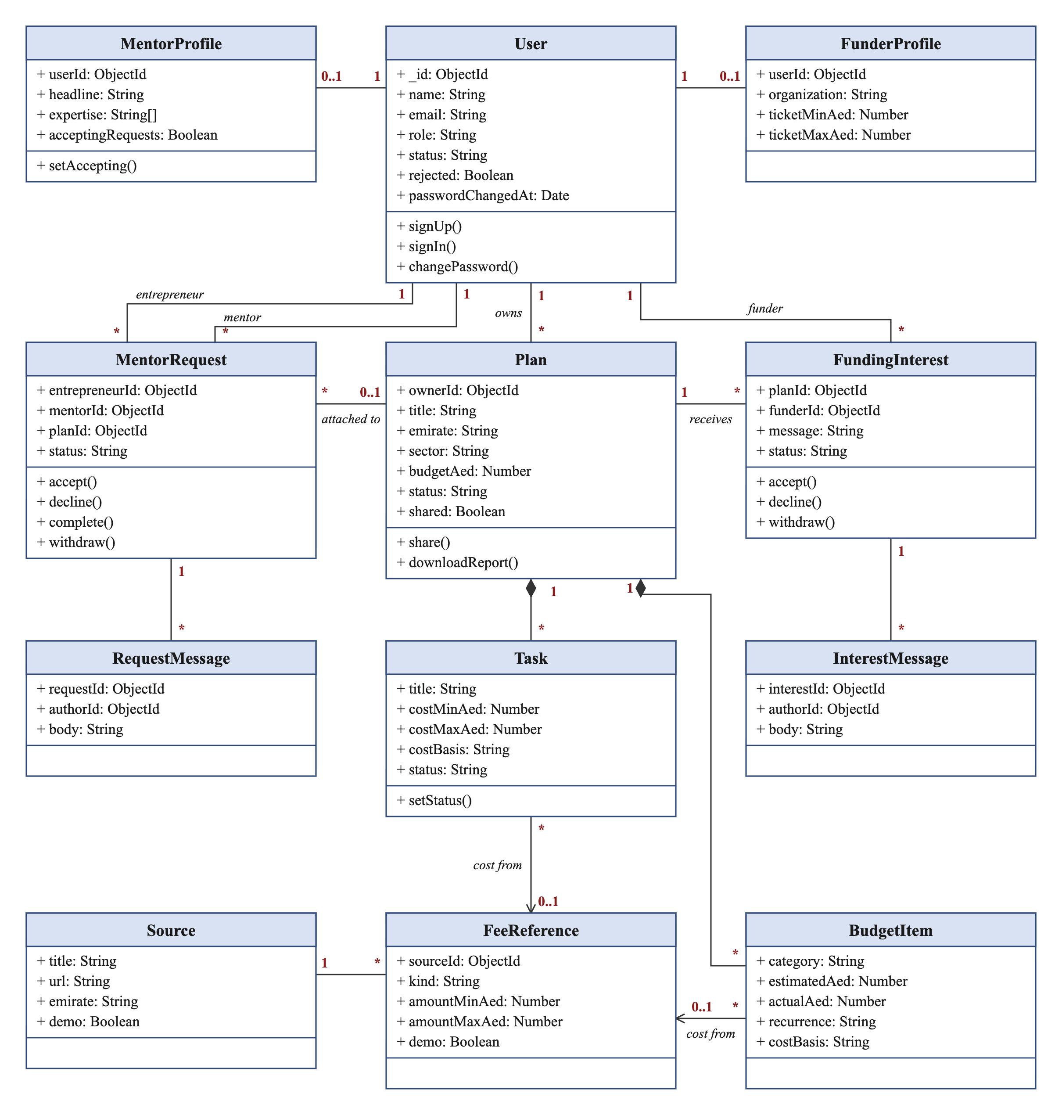
Figure 6: Class diagram
- The Plan class is central: one user owns it, and it contains its tasks and budget items.
- A MentorRequest links a founder to a mentor, optionally with a plan; a FundingInterest links a funder to a plan. Each has its own messages.
- A task or budget item may take its cost from one fee reference, and each fee reference comes from one official source.

4.4.5 Deployment Diagram
Figure 7 shows where each part of the system runs.
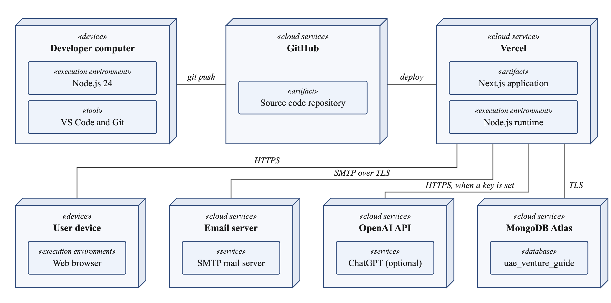
Figure 7: Deployment diagram
- Users reach the application over HTTPS from any modern browser.
- Code is pushed to GitHub and can then be deployed to Vercel.
- The application connects to MongoDB Atlas and to the email server over TLS, and, when a key is set, to the OpenAI API over HTTPS.

4.4.6 Security Design
- Passwords are hashed with bcrypt (cost 10) and never stored as plain text [18].
- After sign-in, the server issues a signed token (JWT, HS256) [19] in an httpOnly cookie that lasts 7 days.
- On every request, the server reloads the user from the database, so a suspension takes effect at once.
- Changing a password signs out the user’s other devices, and suspending an account signs it out everywhere.
- After five wrong passwords in a row, sign-in for that email is blocked for 15 minutes. Each try is counted before the password is checked, so tries sent together still stop at five.
- Every API input is checked with Zod. React escapes the text it shows, and posts drop raw HTML, accept only picture addresses that start with http(s) and remove unsafe links, to prevent XSS [20].
- Only a hash of each reset link is stored. A link works once and expires after one hour, a new one is emailed at most every five minutes, and a reset also ends a sign-in lock.

4.5 Database Design
MongoDB stores data as documents in collections. Figure 8, the entity relationship diagram (ERD), shows the collections and how they link. A plan keeps its phases, tasks, budget items, documents and risks inside one document, so the whole roadmap is saved in a single write operation. Table 11 describes the main fields of the main collections.
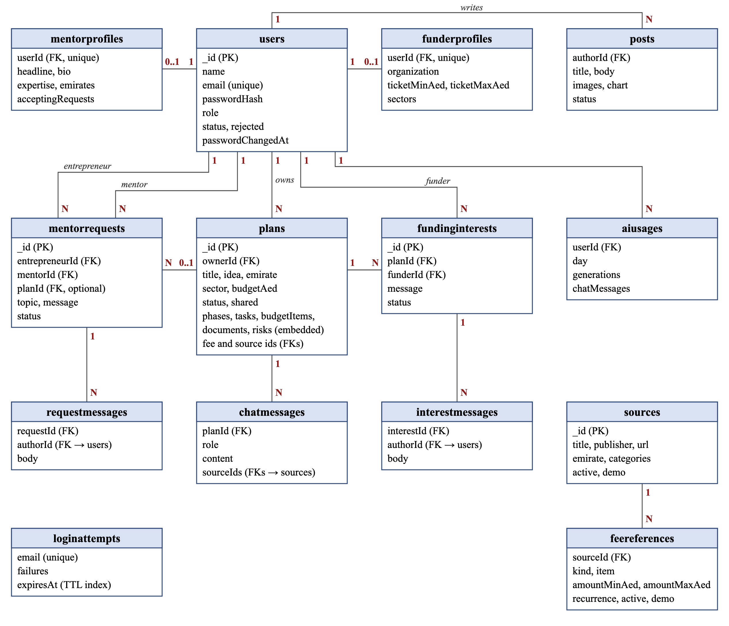
Figure 8: Entity relationship diagram
- Most links are one-to-many references by ID, such as a plan’s ownerId.
- Phases, tasks, budget items, documents and risks are embedded inside the plan document, not stored in separate collections.
- Unique indexes stop duplicates: one account per email, one interest per plan and funder, and one pending request per entrepreneur and mentor.
- MongoDB deletes a sign-in record when its 15 minutes run out (tries during a lock do not extend them), and usage records after 180 days.
Table 11: Data dictionary (main fields)
Collection | Field | Type | Rule or meaning
users | email | String | Required, unique, stored in lower case
users | passwordHash | String | The bcrypt hash of the password
users | role | String | One of: entrepreneur, mentor, funder or admin
users | status | String | One of: active, pending or suspended
users | rejected | Boolean | True when the administrator rejected the sign-up; shown as rejected, not suspended
users | passwordChangedAt | Date | Older sign-in tokens are refused
plans | ownerId | ObjectId | The entrepreneur who owns the plan (users)
plans | emirate, sector | String | Chosen from fixed lists
plans | budgetAed | Number | Budget in AED, 0 or more
plans | status | String | One of: generating, ready or failed
plans | shared, hiddenByAdmin | Boolean | Shared with funders; hidden by the administrator
plans | phases, tasks, budgetItems | Array | Embedded roadmap parts
plans.tasks, plans.budgetItems | costBasis | String | reference (official), demo or estimate; editing the amount makes it an estimate
plans.tasks, plans.budgetItems | feeReferenceId | ObjectId | The fee an official or demo cost comes from (feereferences)
mentorrequests | entrepreneurId, mentorId | ObjectId | The two people in the request (users)
mentorrequests | status | String | One of: pending, accepted, declined or completed
fundinginterests | planId, funderId | ObjectId | Unique pair: one interest per plan and funder
fundinginterests | status | String | One of: pending, accepted or declined
sources | url, emirate | String | Official page; no emirate means federal
feereferences | sourceId | ObjectId | The source the fee comes from (sources)
feereferences | amountMinAed, amountMaxAed | Number | Fee range in AED
feereferences | demo | Boolean | True for unchecked sample fees; the administrator clears it after checking
sources, feereferences | active | Boolean | Only active ones are used; a fee counts only while its source is active

4.6 User Interface / User Experience Design
The interface uses simple, consistent screens with plain language. Table 12 lists the main screens.
Table 12: Main screens
Screen | Purpose
Home page | Explains the service in three steps and the three roles people can sign up for
Sign-up and sign-in | Role picker, clear field errors and a loading overlay
Dashboard | A role-based summary with the next steps
Plan workspace | Tabs for overview, steps, budget, documents, risks and (for the owner) chat; a Download PDF button; links to sources and sharing; a guidance-only note on every page
Mentors and posts | Public mentor directory with filters, and experience posts
Discover (funders) | Pitch cards with sector and emirate filters
Conversations | Messages between founder and mentor, or owner and funder
Admin console | Overview, users, sources and fees, content, and AI usage (roadmaps and chat messages per day)

Every screen works on phones, tablets and computers. Menus become a side panel on small screens. Lists show loading skeletons. Actions show short messages (toasts), and risky actions ask for confirmation in a dialog.
Figures 9, 10 and 11 are wireframes of three main screens: the entrepreneur dashboard, the budget tab of a plan and the admin console.
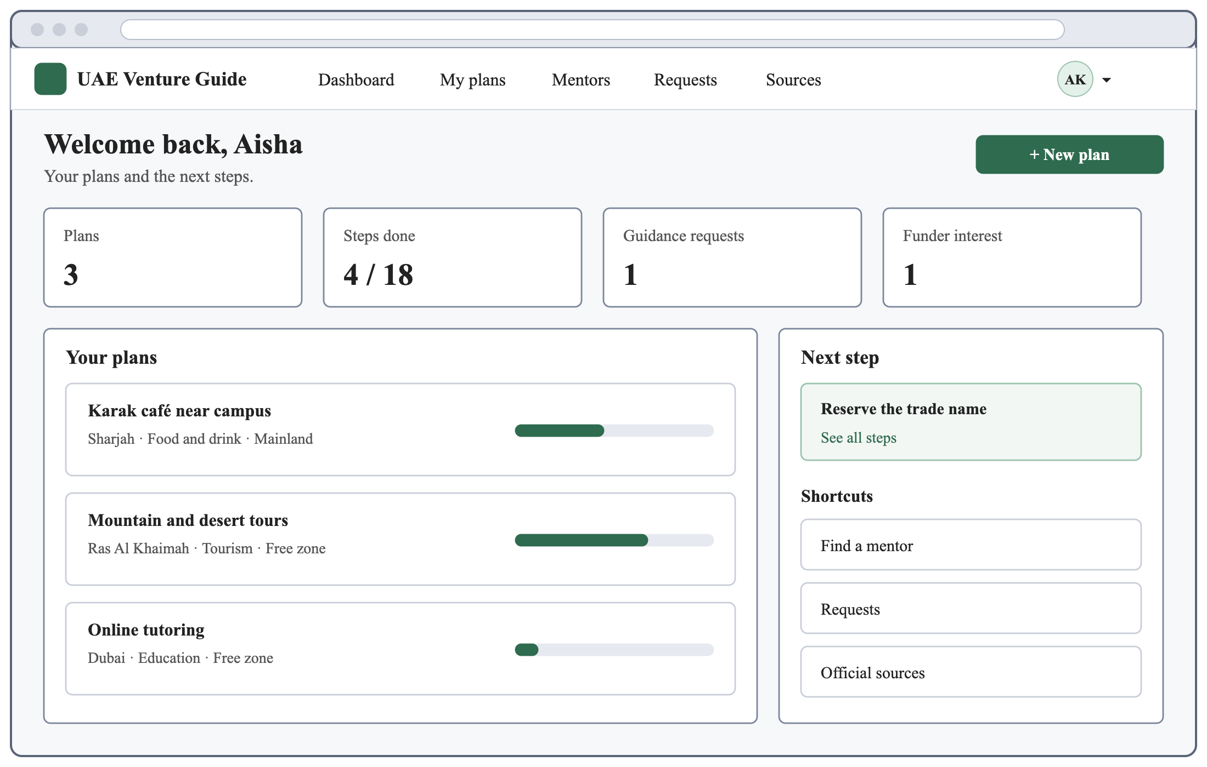
Figure 9: Wireframe: entrepreneur dashboard
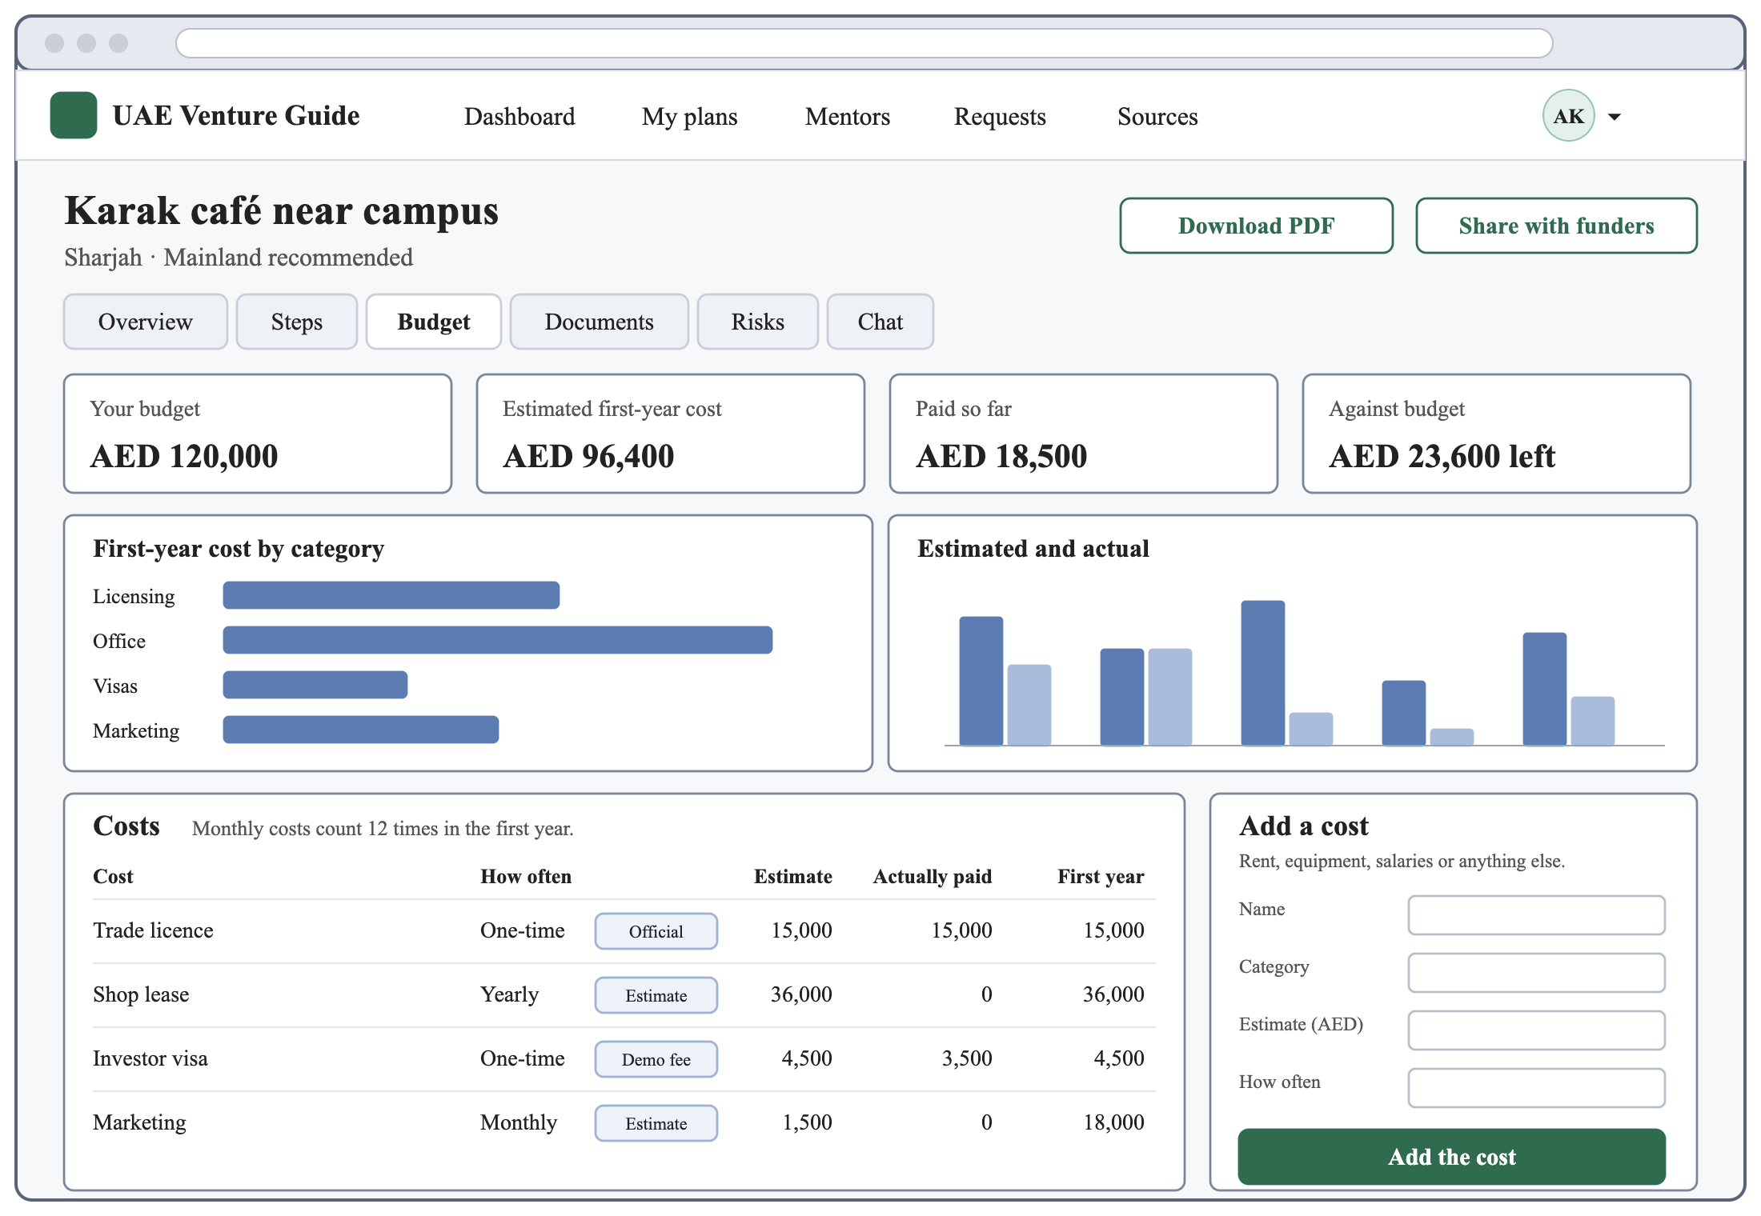
Figure 10: Wireframe: plan workspace, budget tab
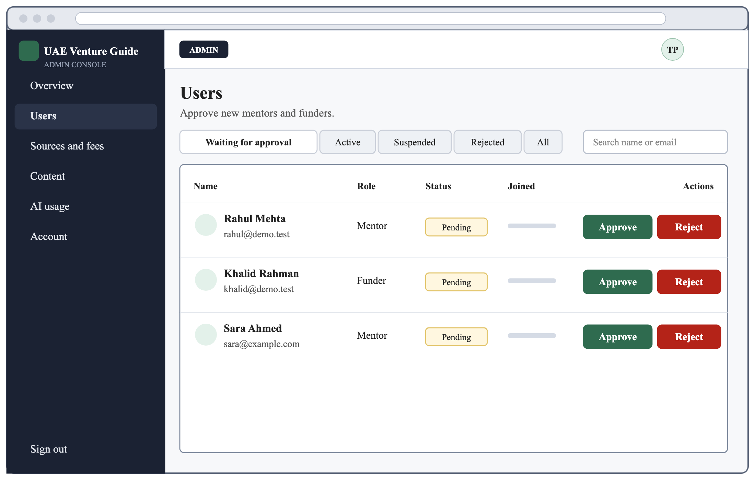
Figure 11: Wireframe: admin console, users page

4.7 Design Justification
Table 13 explains the key design decisions and the alternatives considered.
Table 13: Key design decisions
Decision | Reason | Alternative considered
Next.js for the front end and back end | One language and one project | Separate React and Express apps
MongoDB document database | A whole plan fits in one document | A relational database
Custom sign-in with bcrypt and JWT | Simple, free and fully explainable | A paid sign-in service
ChatGPT API when a key is set, built-in rules without one | The demo works without an OpenAI key, and AI roadmaps are checked against the given fees and sources before saving | An AI-only planner
Polling every 4 seconds for messages | Works on serverless hosting | WebSockets

4.8 Summary
The design uses one Next.js application, a MongoDB Atlas database and clear access rules. The diagrams show the roles, the main flows, the data model and where the system runs.

Chapter Five: Implementation and Development
This chapter explains how the design was built. Table 14 lists the tools and environment used.

5.1 Implementation Environment
Table 14: Implementation environment
Type | Used
Hardware | A laptop that runs Node.js 24
Operating system | windows
Language | JavaScript (Node.js 24)
Frameworks | Next.js 16, React 19, TanStack Query, Tailwind CSS 4
Database | MongoDB Atlas, through Mongoose
Tools | VS Code, Git, GitHub
Testing | Vitest
Cloud | MongoDB Atlas (database); OpenAI API (optional); designed for Vercel hosting

5.2 Implementation Approach
The system was built sprint by sprint in the order of Section 3.7.1. Each feature started with its data model, then its API route, then its page. The project folders are:
- src/app: pages for each role and the API routes.
- src/components: the interface parts, such as forms, tables and charts.
- src/lib: the shared logic, such as access guards, the roadmap planner, the assistant, the budget and the daily limits.
- src/models: the 14 Mongoose models.
- scripts: the seed script, which adds the demo data, including the administrator account.

5.3 Configuration and Development

5.3.1 Roadmap Planner
Without an OpenAI key, the planner builds a roadmap in a few steps:
- Load the active sources and fee references for the plan’s emirate, plus federal ones; a fee counts only while its source is also active.
- Choose the mainland or a free zone: the founder’s preference, or the mainland for walk-in sectors such as food and retail, and a free zone otherwise.
- Build five phases (Prepare, Licence and premises, Visas and identity, Bank and tax, Launch) from step templates.
- Give each step a cost: from a matching fee reference (official or demo), otherwise a template estimate.
- Add budget items, documents and risks, and then save the plan in one write operation.
- “New version” builds a fresh roadmap from the same answers as a new plan, numbered (version 2), (version 3) and so on; “Try again” rebuilds a failed plan. Both count against the daily limit.
When an OpenAI key is set, the same fees and sources, each with its ID, are sent to the ChatGPT API, which returns the roadmap as JSON in a fixed shape through its structured outputs feature [21]. Every part is checked before anything is saved: a cost is official only when it cites one of the fees given, and its amounts then come from the fee, never from the model. Unknown IDs are dropped, and the founder’s own choice of mainland or free zone always wins. A part that fails a check is fixed or dropped: a cost that cites no given fee, or a fee for the other licence type, becomes an estimate. Only if the call fails, or the answer has no summary or usable steps, is the plan saved as failed, and the founder can try again.

5.3.2 Plan Assistant
Without an OpenAI key, the assistant finds topic words in the question (such as cost, visa or documents), answers from the saved plan, and adds up to three active local or federal sources, found by a MongoDB text search when the question matches a topic. With a key, ChatGPT writes the answer from the plan’s facts and the same sources, and the answer appears on the page as it is written; if it stops part-way, nothing is saved. Only the plan’s owner can chat, once the roadmap is ready. The page shows the newest 200 messages and says that answers are guidance, not legal or financial advice. Each user can send 40 messages a day.

5.3.3 Access Control
One function decides who can read a plan: its owner, the administrator, a mentor whose request on that plan is accepted, or a funder whose interest is accepted while the plan is still shared and not hidden. Anyone else gets a “not found” page, so the system does not even reveal that the plan exists. Mentors and funders also lose access while the owner’s account is suspended, and a suspended user’s shared plans and posts are hidden from others.

5.3.4 Configuration
Settings are kept in environment variables outside the code: the database address (MONGODB_URI), the token secret (JWT_SECRET), the website address (APP_URL), the optional OpenAI key and model (OPENAI_API_KEY, OPENAI_MODEL), optional email settings, and the administrator’s email and password for the seed script (ADMIN_EMAIL, ADMIN_PASSWORD). Without the OpenAI key, the app runs in sample mode. A template file (.env.example) lists them with placeholder values and no secrets.

5.4 Integration
- Pages and API routes share the same models, session check and access rules, and the browser forms and API routes share the same Zod schemas.
- The OpenAI API is called from one file (src/lib/ai/openai.js), on the server only and with time limits; the key never reaches the browser.
- The database connection is created once and reused by every request.
- Emails go through Nodemailer. Without email settings, they are printed in the terminal, so the system still works.
- When the app is deployed, Vercel builds it first, so a version that does not build is never published.

5.5 Implementation Challenges
Table 15 lists the main challenges and how they were solved.
Table 15: Implementation challenges
Challenge | Solution
Keeping plans private | One shared access function, tested for every role
Live messages on serverless hosting | The page asks for new messages every 4 seconds while it is open and in view
A message saved a moment late | Each check looks back 30 seconds and skips the messages the page already has
Fair daily limits under many requests | One atomic database update does the check and the count in a single step
Costs that may not be official | Every cost carries an official, demo or estimate label
Trusting AI answers about fees | Every AI roadmap is checked before it is saved, and only cited fee references count as official
Logging out stolen sessions | Tokens made before a password change are refused

5.6 Summary
The system was built as planned in one Next.js project. The planner, the assistant, the access rules and the messaging are the core parts, and they share one set of models and checks.

Chapter Six: System Testing and Evaluation
This chapter explains how the system was tested and what the results show.

6.1 Testing Strategy
Testing has two levels:
- Unit tests (Vitest): check the rules on their own, such as budget totals and form checks.
- Database tests (Vitest with MongoDB): check the access rules, guidance requests, both kinds of conversation, the assistant, the daily limits, the sign-in lock, the roadmap planner and the ChatGPT path (with a stand-in for the API) on a real database. Each test file uses its own empty database.
The team ran all 159 unit and database tests on their own computer, and all of them pass. The code also passes lint and a production build.

6.2 Test Cases
Table 16 lists the main test cases with their expected and actual results.
Table 16: Test cases
ID | Objective | Input / condition | Expected result | Actual result | Status
TC-01 | A pending mentor cannot read a plan | A mentor who is not yet approved opens a plan | Access refused | Access refused | Pass
TC-02 | Refuse an admin sign-up | Sign-up data with the role admin | Refused, with a message on the role field | Refused | Pass
TC-03 | Refuse weak passwords | Passwords without a number, or too short | A clear message on the password field | Refused, with a password message | Pass
TC-04 | Block another user’s plan | A second entrepreneur opens the plan | Access refused | Access refused | Pass
TC-05 | Mentor access | Mentor before and after accepting | Can read the plan only while accepted | As expected | Pass
TC-06 | Funder access | Funder before and after acceptance; accepted funder of an unshared or hidden plan | Reads only after acceptance, never an unshared or hidden plan | As expected | Pass
TC-07 | Daily roadmap limit | Ten requests at the same time | Exactly five succeed | Five succeeded | Pass
TC-08 | Official cost label | Plan in an emirate with a fee reference | The matching cost uses that fee | Fee used | Pass
TC-09 | Budget total | Monthly item of AED 500 | AED 6,000 in the first year | AED 6,000 | Pass
TC-10 | Message after completion | Send in a completed request | Refused; read-only | Refused | Pass
TC-11 | Message rate limit | 31 messages in one minute | The last one is refused | Refused | Pass
TC-12 | Assistant sources | Ask about cost | Only active local or federal sources | As expected | Pass
TC-13 | Sign-in lock | Five wrong passwords, then the right one | Refused for 15 minutes | Refused | Pass
TC-14 | Funder chat closes | The owner stops sharing the plan | Refused; read-only | Refused | Pass
TC-15 | AI roadmap check | The AI cites a fee that was not given | Saved as an estimate | Estimate | Pass

6.3 Functional Testing
Table 17 maps the key requirements to the tests that check them; the others have no automated test yet.
Table 17: Requirements and their tests
Requirement | Checked by
FR-01, FR-02: sign-up rules and pending accounts | TC-01, TC-02, TC-03
FR-05, FR-08: plan and task forms | The form and progress tests
FR-06, FR-07: roadmap and cost labels | TC-08, TC-15 and the roadmap tests
FR-09: budget totals | TC-09 and the budget tests
FR-11, FR-12: assistant and daily limits | TC-07, TC-12 and the assistant tests
FR-15: guidance requests | The request tests
FR-16 (accept) and FR-21: mentor conversations | The request tests, TC-05, TC-10, TC-11
FR-18, FR-19: sharing and pitch cards | TC-14 and the funder conversation tests
FR-20: funder access after acceptance | TC-06
FR-22: email notifications | The request and approval tests
FR-23: approving and rejecting accounts | The approval tests
FR-24: fee references | The roadmap tests
FR-25: hiding shared plans | TC-06
NFR-02, NFR-03: status and input checks | The access, conversation and request tests
NFR-04: sign-in lock | TC-13
NFR-05: plan privacy | TC-04, TC-05, TC-06 and the conversation tests
NFR-06: official costs | TC-08, TC-15 and the roadmap tests
NFR-09: one write | The roadmap and AI tests

6.4 Performance Evaluation
No load tests were run. In a live test with an OpenAI key, ChatGPT wrote a roadmap in about 40 to 50 seconds, and a chat answer began within a few seconds. The design choices below aim to keep pages fast: pages are built on the server, so the browser downloads less code; database queries use indexes on the fields they search, such as plan owner, request status and source text; a roadmap is built from rules, or from one ChatGPT call that stops after 100 seconds, and is saved in one write operation; and messages are only checked, every 4 seconds, while a conversation is open.

6.5 Security Testing
- Authentication: password rules are covered by unit tests, and database tests check the sign-in lock (TC-13), including tries sent at the same moment.
- Authorisation: database tests check who may read a plan and who may see a mentor or funder conversation, for every role and for pending or suspended accounts.
- Input: invalid data and invalid IDs return clear errors, not crashes.
- XSS: React escapes the text it shows, and posts allow no raw HTML.
Known gaps: the site sends no extra security headers and uses no CSRF tokens. It relies on SameSite=Lax cookies, and sign-in and sign-up refuse forms sent from other websites.

6.6 Usability Evaluation
The screens are designed to the WCAG 2.1 AA guidelines [17]: form fields have visible labels, errors appear beside their fields, the keyboard focus is always visible, the form buttons and main page buttons, such as New plan and Download PDF, are 44 pixels tall, and the layout adapts to phone screens. Testing with real students and mentors needs ethical approval first, so it is planned as future work (Section 8.5).

6.7 Results and Discussion
Table 18 shows the results of the automated tests.
Table 18: Automated test results
Test level | Test files | Tests | Result
Unit tests | 7 | 63 | All passed
Database tests | 9 | 96 | All passed
Total | 16 | 159 | All passed

All 159 unit and database tests pass. They show that the core rules behind the main objectives work: founders get a roadmap with labelled costs; plans stay private (apart from the administrator) until the owner says yes; and pending accounts cannot read plans or conversations.

6.8 Summary
The unit and database tests confirm the core rules: cost labels, plan privacy, conversation rules and daily limits. User testing with real people remains to be run.

Chapter Seven: Entrepreneurship and Innovation
This chapter looks at UAE Venture Guide as a possible product.

7.1 Project Innovation
The project brings three things into one tool: a UAE-specific plan with labelled costs, a link from that plan to mentors and funders, and privacy rules that keep the idea hidden, apart from the administrator, until the owner agrees.

7.2 Problem and Opportunity
UAE startup information is spread over many websites, and consultants are costly. Students and first-time founders need a cheaper and simpler way to plan.

7.3 Target Users and Customers
The users are university students and first-time founders in the UAE, volunteer mentors, and small investors such as angel investors and accelerators. Universities and incubators are possible paying customers.

7.4 Value Proposition
Founders get a free plan from a short form, with costs tied to official sources and a direct path to advice and funding.

7.5 Entrepreneurial Potential
The platform can become a service for universities and incubators, offered as a licensed tool for their students.

7.6 Market Potential
Universities, incubators, free zones and banks all work with new founders and could use the tool to guide them.

7.7 Sustainability and Scalability
The cloud setup grows by moving to paid plans. New official sources and fees are added as data by the administrator, without changing the code.

7.8 Future Commercialisation
The service could offer a free plan for founders, paid features such as an AI assistant and expert reviews, and partner listings for free zones and service providers.

Chapter Eight: Conclusion and Future Work
This chapter sums up the project, its results and the next steps.

8.1 Summary of the Project
The project built UAE Venture Guide, a web application that helps first-time founders plan a small business in the UAE. It turns a short form into a roadmap with costs, a budget, documents and risks, and connects founders with mentors and funders under clear privacy rules.

8.2 Achievement of Objectives
Table 19 shows each objective, its status and the evidence for it.
Table 19: Achievement of objectives
Objective | Status | Evidence
Generate a roadmap with costs, documents and risks | Achieved | Roadmap tests, TC-08, TC-15
Track tasks, budget and documents; PDF report | Achieved | Budget tests, TC-09, task form and progress tests; no automated test for the document checklist or the PDF
Plan assistant from the plan and sources | Achieved (rules; ChatGPT with a key) | Assistant and AI tests, TC-12
Mentor requests and messaging | Achieved | TC-05, TC-10, TC-11
Sharing with funders and messaging | Achieved | TC-06, TC-14
Admin approval, sources and moderation | Achieved | Approval tests; roadmap tests (fee checks, hidden sources); TC-06 (hidden plans); no automated test for hiding posts
Secure sign-in and access rules, tested | Achieved | TC-01 to TC-06, TC-13

8.3 Main Contributions
- A working platform for four roles.
- A roadmap planner that shows where each cost comes from.
- A tested access model that protects business ideas.
- A setup guide, and 159 automated tests that the team ran on their own computer.

8.4 Limitations
- Without an OpenAI key, the planner and assistant use built-in rules, so answers are limited to known topics. The automated tests use a stand-in for the ChatGPT API, and the live path has so far been tried only on a demo plan.
- The demo fee amounts are samples and must be checked against the official pages before real use.
- There has been no testing with real users yet.

8.5 Future Work
- Review ChatGPT’s roadmaps and answers on more sample plans, and compare a larger model, which needs paid OpenAI credit.
- Run user testing with students and mentors after ethical approval.
- Move to paid cloud plans before real users join.
- Add security headers and an email check at sign-up.

8.6 Final Conclusion
UAE Venture Guide brings the steps, costs and official sources for starting a business in the UAE into one tested application. User testing is the next step to show how much it helps first-time founders. With checked fee data and the ChatGPT API switched on, it can grow into a public service.

References
- UAE Government, “Doing business,” The Official Portal of the UAE Government. [Online]. Available: https://u.ae/en/information-and-services/business/Doing-business. [Accessed: Oct. 12, 2026].
- D. F. Kuratko, Entrepreneurship: Theory, Process, Practice, 11th ed. Boston, MA: Cengage, 2020.
- Vercel, “Next.js Docs.” [Online]. Available: https://nextjs.org/docs. [Accessed: Oct. 12, 2026].
- MongoDB, Inc., “MongoDB Documentation.” [Online]. Available: https://www.mongodb.com/docs/. [Accessed: Oct. 12, 2026].
- Government of Dubai, “Invest in Dubai.” [Online]. Available: https://invest.dubai.ae. [Accessed: Oct. 12, 2026].
- Abu Dhabi Government, “TAMM: Abu Dhabi Government Services.” [Online]. Available: https://www.tamm.abudhabi. [Accessed: Oct. 12, 2026].
- Sharjah Entrepreneurship Center, “Sheraa.” [Online]. Available: https://sheraa.ae. [Accessed: Oct. 12, 2026].
- Khalifa Fund for Enterprise Development, “Khalifa Fund.” [Online]. Available: https://www.khalifafund.ae. [Accessed: Oct. 12, 2026].
- Palo Alto Software, “LivePlan.” [Online]. Available: https://www.liveplan.com. [Accessed: Oct. 12, 2026].
- SCORE Association, “SCORE.” [Online]. Available: https://www.score.org. [Accessed: Oct. 12, 2026].
- K. Beck et al., “Manifesto for Agile Software Development,” 2001. [Online]. Available: https://agilemanifesto.org/. [Accessed: Oct. 12, 2026].
- K. Schwaber and J. Sutherland, “The Scrum Guide,” Nov. 2020. [Online]. Available: https://scrumguides.org/scrum-guide.html. [Accessed: Oct. 12, 2026].
- W. W. Royce, “Managing the development of large software systems,” in Proc. IEEE WESCON, Aug. 1970, pp. 1–9.
- M. Cohn, User Stories Applied: For Agile Software Development. Boston, MA: Addison-Wesley, 2004.
- D. Clegg and R. Barker, CASE Method Fast-Track: A RAD Approach. Wokingham, U.K.: Addison-Wesley, 1994.
- Systems and Software Engineering — Systems and Software Quality Requirements and Evaluation (SQuaRE) — Product Quality Model, ISO/IEC 25010:2023, 2023.
- W3C, “Web Content Accessibility Guidelines (WCAG) 2.1,” W3C Recommendation, May 6, 2025. [Online]. Available: https://www.w3.org/TR/WCAG21/. [Accessed: Oct. 12, 2026].
- N. Provos and D. Mazières, “A future-adaptable password scheme,” in Proc. FREENIX Track: 1999 USENIX Annual Technical Conference, Monterey, CA, Jun. 1999, pp. 81–92.
- M. Jones, J. Bradley, and N. Sakimura, “JSON Web Token (JWT),” Internet Engineering Task Force, RFC 7519, May 2015. [Online]. Available: https://www.rfc-editor.org/info/rfc7519. [Accessed: Oct. 12, 2026].
- OWASP Foundation, “Cross Site Scripting Prevention Cheat Sheet,” OWASP Cheat Sheet Series. [Online]. Available: https://cheatsheetseries.owasp.org/cheatsheets/Cross_Site_Scripting_Prevention_Cheat_Sheet.html. [Accessed: Oct. 12, 2026].
- OpenAI, “Structured model outputs,” OpenAI API documentation. [Online]. Available: https://developers.openai.com/api/docs/guides/structured-outputs. [Accessed: Oct. 12, 2026].

Appendices

Appendix A: Source Code
The project’s GitHub repository, https://github.com/techproject181-blip/uae-venture-guide, holds the source code and setup guide. The README file explains how to install, seed the demo data and run the system.

Appendix B: Demo Accounts
The command “npm run seed” creates nine accounts: one administrator, two entrepreneurs, four mentors (one waiting for approval) and two funders (one waiting for approval). It also adds 13 sample sources, 15 sample fee references, two plans, three posts, two guidance requests and two funding interests. The administrator’s email comes from ADMIN_EMAIL, or from the seed script when it is not set, and its password from ADMIN_PASSWORD, or the demo password when it is not set. The other accounts share one demo password, given in the README.

Appendix C: Test Cases and Detailed Results
The test cases are listed in Section 6.2, and Table 18 sums up the results. The team ran the unit and database tests with Vitest on their own computer. Table 20 lists the automated tests by area.
Table 20: Automated tests by area
Area | Level | Tests
OpenAI client (requests and streamed answers) | Unit | 16
Checks on AI roadmaps | Unit | 20
Budget totals and progress | Unit | 12
Sign-up and password rules | Unit | 6
Plan form rules | Unit | 5
Theme colours | Unit | 3
Daily limit rule | Unit | 1
Roadmap planner and fees | Database | 26
Mentor conversations | Database | 18
Funder conversations | Database | 12
ChatGPT path (with a stand-in for the API) | Database | 10
Access rules | Database | 8
Sign-in lock and approval | Database | 8
Guidance requests | Database | 7
Plan assistant | Database | 4
Daily limits | Database | 3
Total |  | 159

Appendix D: Use of Generative AI
AI tools were used to help write parts of the test cases, The students reviewed, tested and edited all this work, and take full responsibility for it.

