Course Objectives
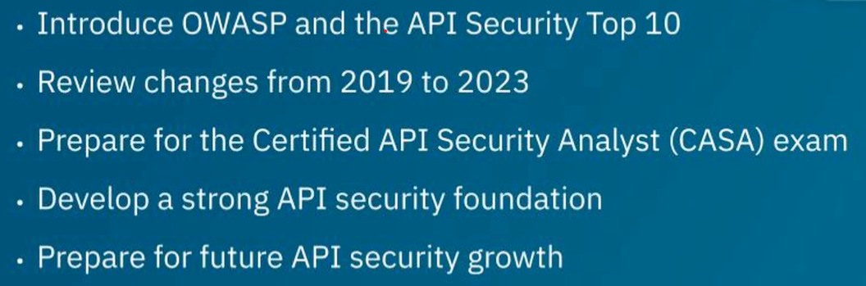

What is OWASP

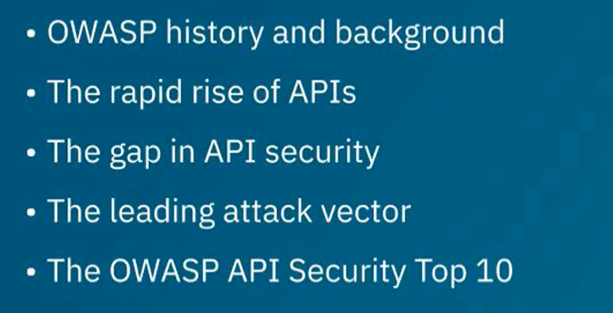

Newsworthy API Incidents

