Data Issues with Top 10

2019 VS 2023 Comparison
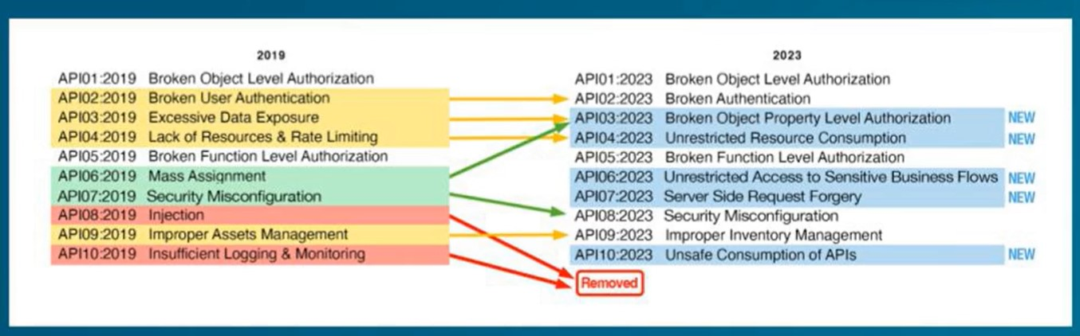

Risk Ratings
