1.Assumptions:
In first phase need to design for 50,000 daily active users - 5,000 orders per day - 500
Restaurants.
In further incremental phases it should support Target scale (12 months): - 5 million daily active users - 500,000 orders per day - 50,000 restaurants across 15 cities.
Peak traffic patterns: Apporx 60% orders will be at peak times either lunch or at dinner time and timings will be 12:00PM to 3:PM and 7:00PM to 10:30PM.
order lifecycle duration: 30 min from order placement to delivery
payment gateway: we should have the contract with payment gateway like razor pay etc..
Mobile-first user base.
2. High-Level Technical Design
I choose the layered architecture: client -> API layer -> Processing layer -> Data layer

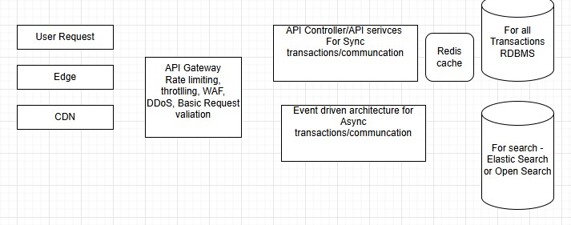
3. API Contract
/POST/Order/Create
{
Header: authorization: jwt token
Body: {
Idempoetency key
Orider id – UUID
customerId
Restaurant id
createTimeStamp
}

}
Like this I choose order lifecycle -> update, cancel and search.
HTTP method:
200 - sucess
4xx – data related
5xx – error related

4. Data Modeld
For OMS below are high level tables.
Customer
Order
Restaurant
Menu

I use below patterns while creating the Order.
Outbox pattern:
Order table update, then Outbox table update. This Outbox will be for further notification service using event driven architecture. So that data consistency will not come. But data will be eventual consistent.
I use saga pattern for transaction management in distributed systems. I choose choreography for event driven flows, for strong consistency one I choose orchestration pattern.
I choose consistency for critical transactions and eventual consistency where data consistency is not immediate.

For failure scenarios, I choose partial failure and degradation the system instead of completely down.
I choose retry mechanisms with exponential fallback and circuit breakers.
For scaling I choose:
Horizontal scaling of stateless services
Database sharding strategy: Shard by city_id or restaurant_id for geographic locality and I choose caching
Read replicas for query-heavy operations (order history, restaurant dashboards)
Event-driven architecture to decouple services — Order Service publishes
events; Notification, Analytics, and Billing services consume independently
Auto-scaling policies based on orders-per-second metrics during peak hours – I choose schedule-based auto scaling for peak hours.
Observability:
Metrics: p50, p75, p95, p99, 4xx, 5xx, throughput
Alerts: SLO and SLA
Logging: Splunk

