**Quick Sort**

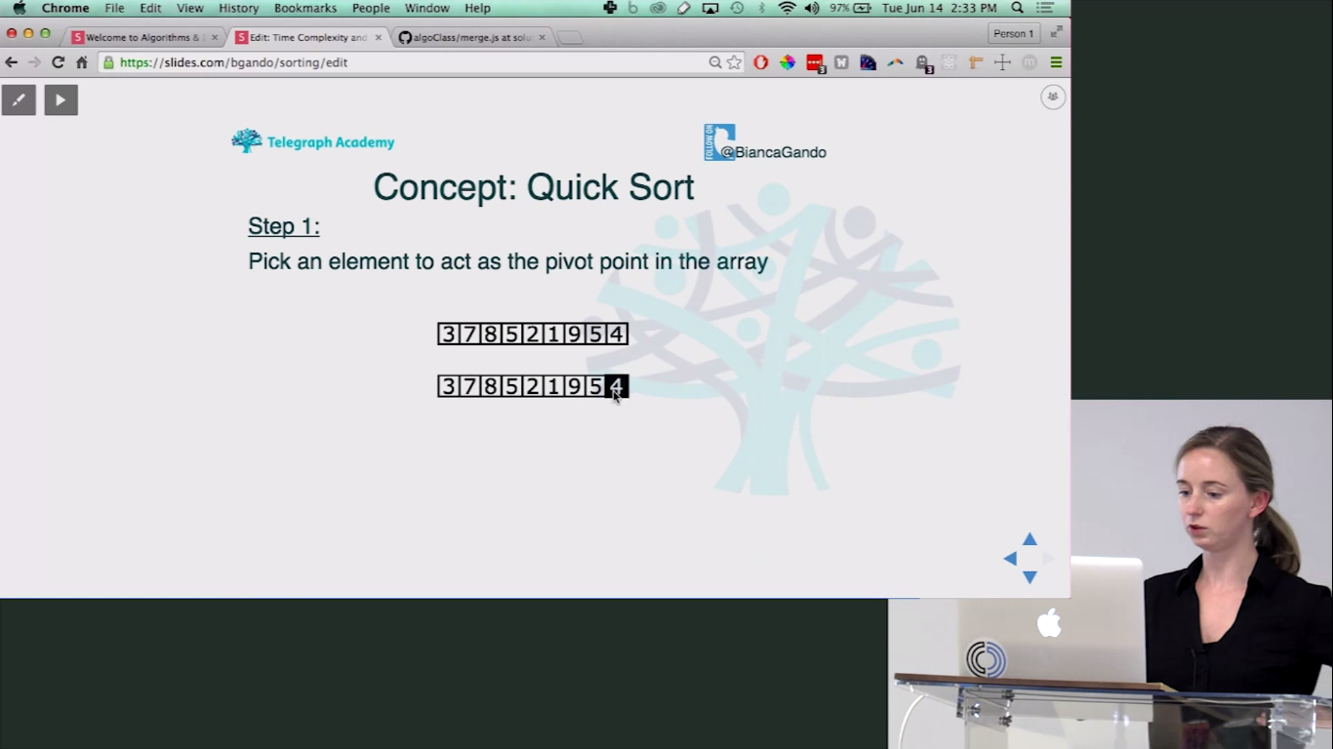

Swap all the larger elements to the right, and smaller elements to the left, one at a time.

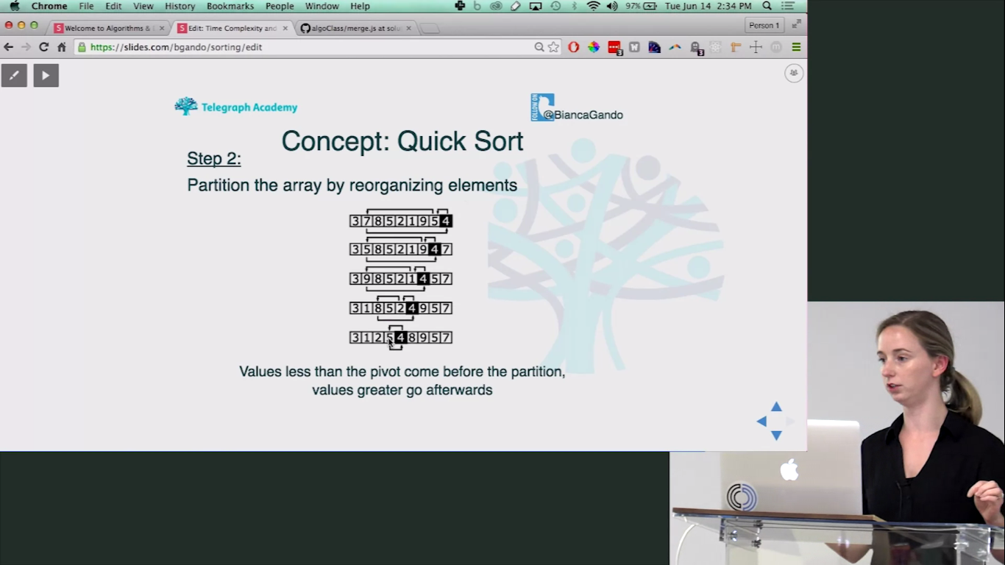

At a time all elements smaller to the pivot will be at left side, and larger to the pivot will be on right side. Like below:

|  |  |  |  |  |  |  |  |  |
| --- | --- | --- | --- | --- | --- | --- | --- | --- |
| 3 | 1 | 2 | 4 | 5 | 8 | 9 | 5 | 7 |

Once we find the final place for our pivot element 4, we recursively partition the right side and the left side.

Choose a pivot inside those and repeat finding the correct location of their pivot same as above.

