Step 1: Download the Jar

Step 2: Crete the folder and rename to lib

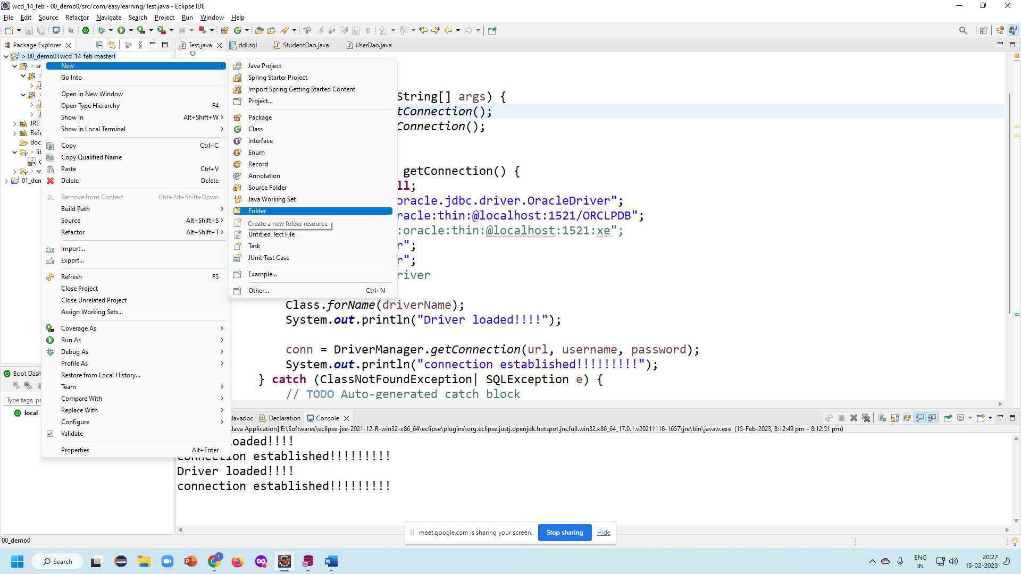

Step 3: copy the jar in the lib folder

Step 4: right click on project, go to properties

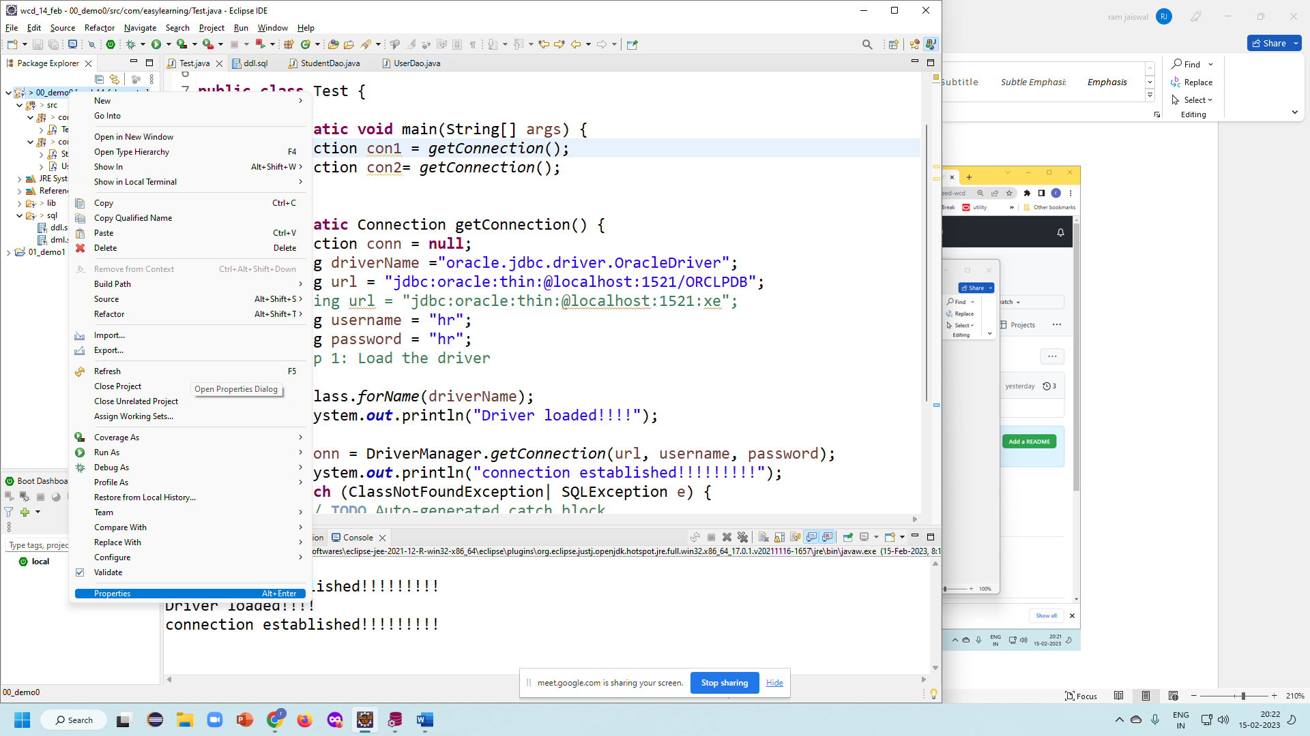

Step 5: click to java build path and then libraries tab

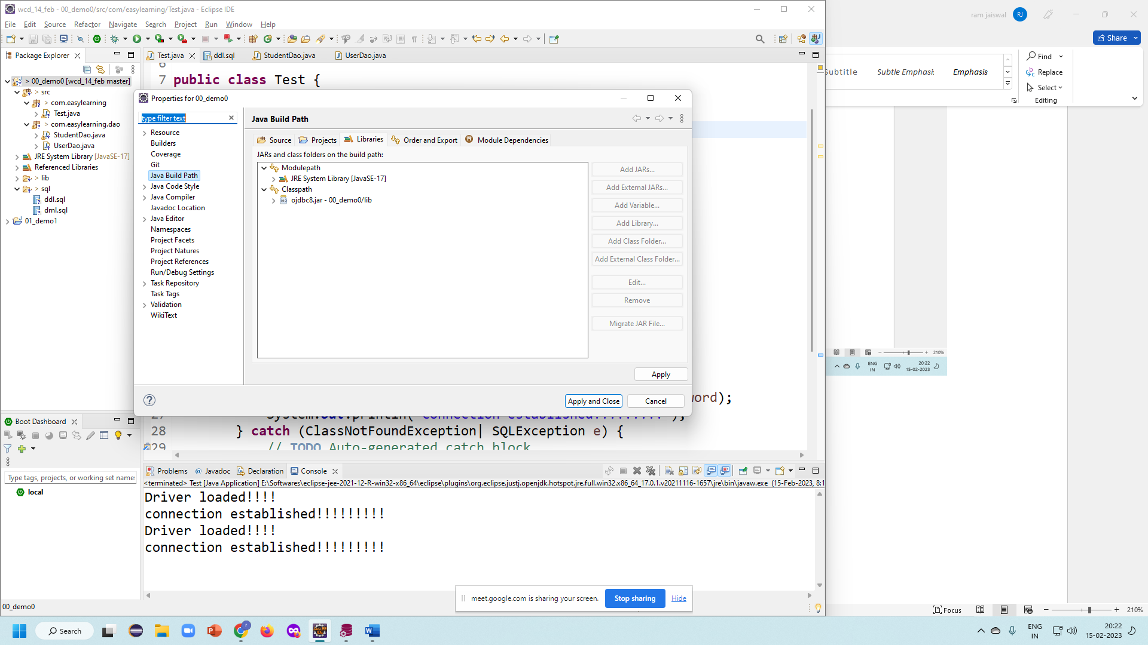

Click on the classpath

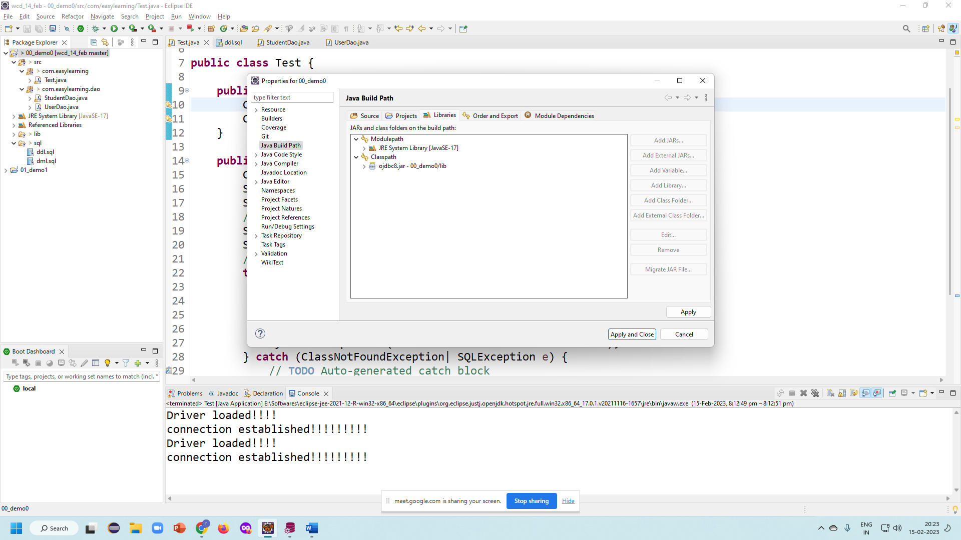

Click on Add jar button and select the jar in the lib folder.

