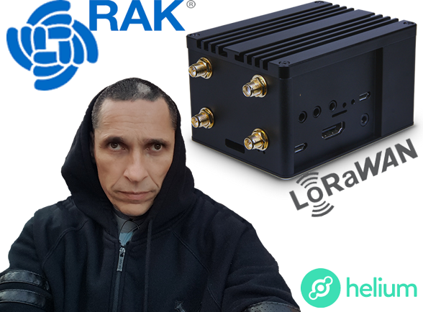

The Project:

DIY Helium Miner

The Box:

RAK RAK7243 Pilot LoRa Gateway Pro 4G Wireless LoRa RAK831

The Files:

Point, Click, Shoot...All The Files Are Here. There is NO NEED to go anywhere else. Kinda like The Wonka Factory.

