**A. · Or. Sudhir Sharma Dr. Mrs. M. Sharma**

MBB.S.MD MB B S

soNoGR A PHY & o 1G1TA L x - R A Y **Dr. Neetu Sharma**

GITALo pG **Dr.Apoorva Sharma**

D GITAL MAMMOGRAPHY • DI • • , MB BS OM.R E MB B S OMR E.

RAPHY t COLOUR DOPPLER

30,4D soNOG GY .30 ECHO CONSULTANT RADIOLOGIST & ULTRA SONOLOGIST

TtLE·RADIOLO

12 New Agrawal Nagar, Shmam Chambers, Near Morn! Saree, Agrasen Chouraha. s,poa·Sangeeta Main Road.Indore - 452 001 (MP.) • Phone 0731-4094488. 80039-21145

47

*II/SS Ktt LPA,\l,t SllARMA 26 Ye"rj'*

*27/Du/2020*

*USG PELVIS*

L1rin111") bladder is thin walled. No vesica l calcu lus. 13oth vesico-ureteric junctions

arc clear

Lterus 1s of nonnal size (antevencd - 7.1 x 3.9 x 3.2 crn). The myomctrium is homogenous. l·ndometrium is t hin (6.9 mm). Few ncbot hian cysts arc seen in cervical rt'gion. Pouch of dougla' is empl)'.

Both O\ ll ries are bu lky. t romal clements arc in (•rt>n sed. Peripherally nrronged J\I I' are seen. Good low resistance llow is noted ucross both t he m 11in ovarion & pa reocbymal arteries.

Rt O\ ar) -Volume - 10.8 cc. Lt O\ ary -Volu me- 11.2 cc.

**l\f**PRE 10'11:- Cen•icitis.

PCOS.

*Dr Sudhir Slrurmu*

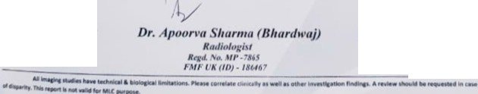

*St111Dr Rtu!io/"11/Jt*

\."'" *1111*

*Dr. eetu Slr arma*

*R111/lu/11gl>t*

'°'

*R'ltt UP. '861*

*IMf llA (/0)·17/f 'O*