1. turn over > allow only numbers an set max length 10
2. 2)event management ->when go direct to event location ,schedule, user role nothing show
3. Workshop start date is cut and validation message should show bellow start date also set max 200 llength for workshop description

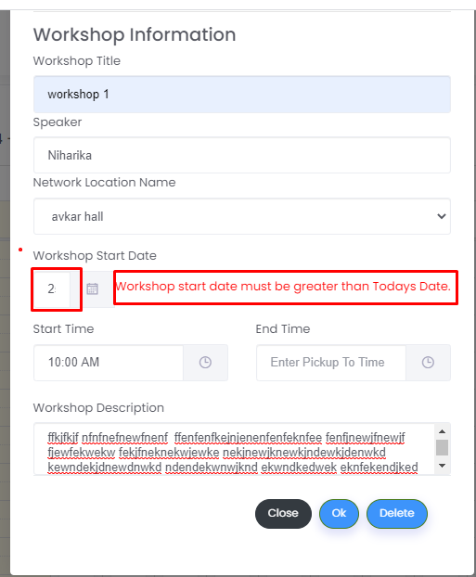

4)when add an meeting schedule screen does not show properly

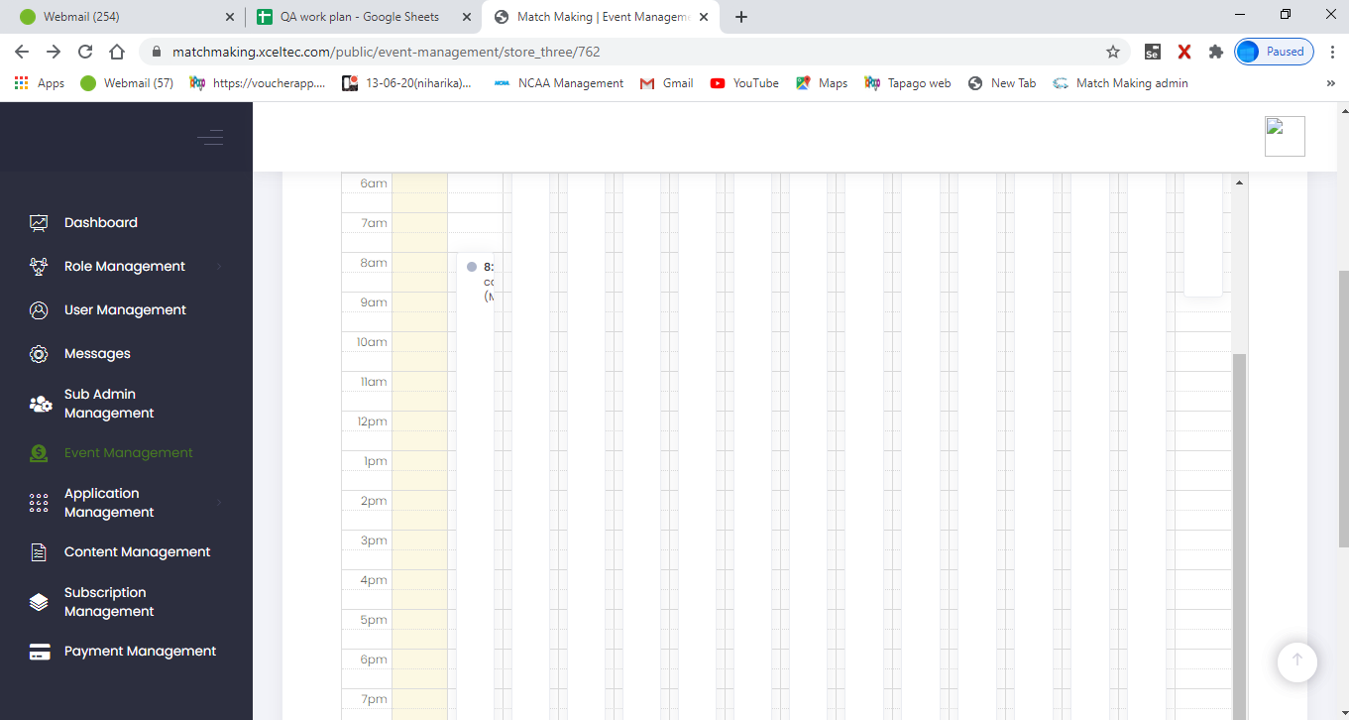

1. event management ->event location ->random tale ->set max length for table and allow only numbers
2. event management ->event location ->set max length for event location name
3. event management ->event schedule ->when try to make meeting which is already created it shows error………….it should give validation message “you can not make 2 meetings at same time”

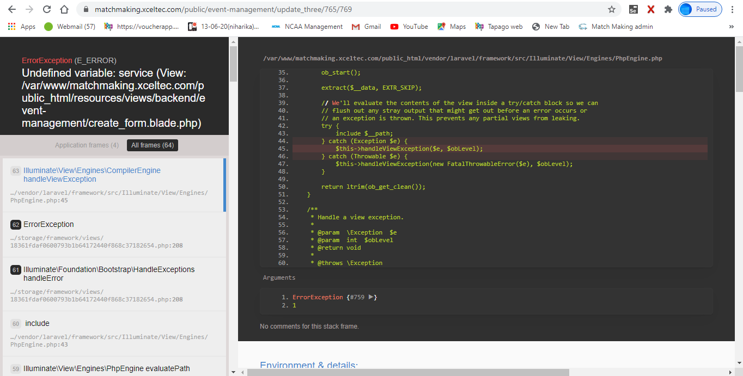

1. event management ->event schedule >when try to make presentation it shows error

9)event management >location > edit >added location shows multiple time

10)event management ->schedule >edit ->added meetings and workshop does not show

11)event management->user role ->when create 1 role and now click on add role ………previous user role’s data should be removed

12)user role ->should not allow to enter minus value in max group number , max privilege user ,max non privilege user , max force meetings

13) user role >privilege user/non privilege user ->edit >added data removed automatically for all fields

14 )suggestion >user role >privilege user -> privilege user will always get assign tale so no need of table type field

15)user role >non –privilege user >assign location fields should not open till select table type assign table for non privilege