Q1) How are inline and block elements different from each other?

Block element:
- A block element takes up the full width area available to it.
- By default, it always starts on a new line and stretches out to the left and right as far as it finds a space in the same line.
- The <div> element is a block-level element.
- By default for <div> the display is set to :
  - display: block;

Inline element:
- While an inline element does not start on a new line and only takes up as much width as necessary, according to the content of the element.
- This <span> element is an inline-level element.
- By default for <span> the display is set to:
  - display: inline;

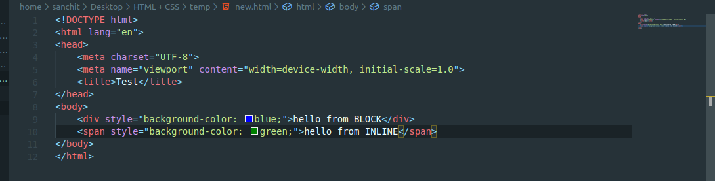

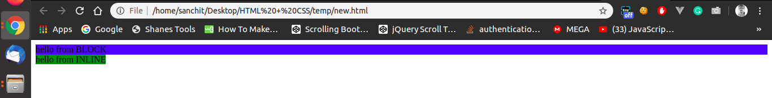

As we can see the blue area (block element) covers the full width, while the green area (inline element) only covers upto the length on the data.

Q2. Explain the difference between visibility:hidden and display:none

Both the display: none and visibilty: hidden makes the element hidden from the user’s perspective but both works differently.

Display: none;
- When we use display: none; for any element, the web page removes that element from the DOM i.e it doesn’t even keep any space for the particular element.

Visibility: hidden;
- In case of visibility: hidden; the web page doesn’t remove the element from DOM but keeps a space hidden from the user. Unlike the other case, The element still exist on the web page and has some space allocated to it although it is not visible to user.

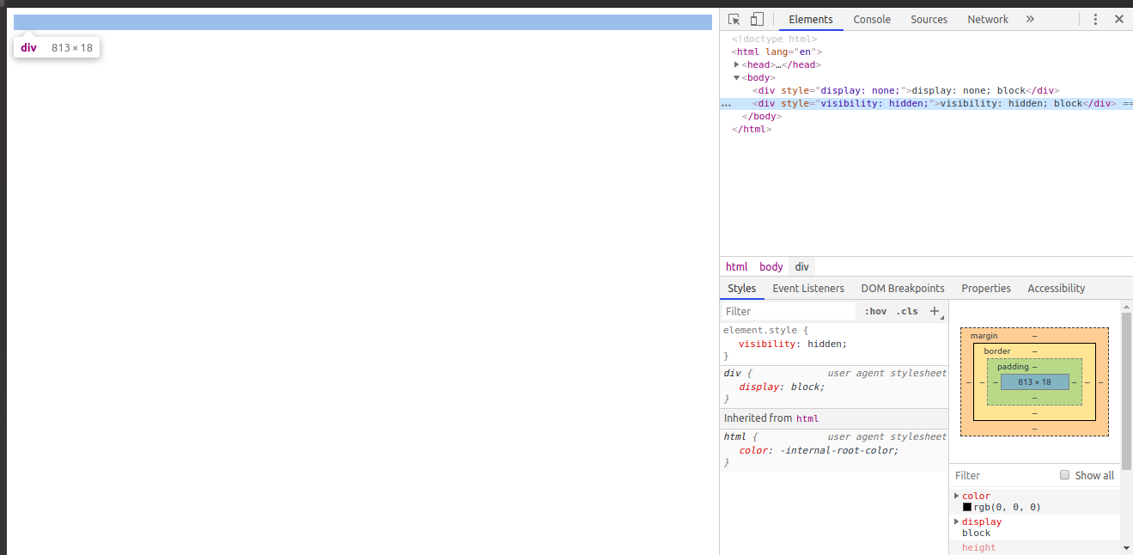
Since we have used visibility: hidden for the 2nd div, it still shows a space for that div while inspecting the source of the element as in the photo below.

Q3. Explain the clear and float properties.

- Float is a CSS positioning property.
- The CSS float property specifies how an element should float.
- Float is used for positioning and formatting content.
- Eg: Float provides a functionality to arrange the image with respect to the content surrounding it in a container.
- Float property can have value :
  - left: floats the image to the left
  - right: floats the image to the right
float: left;
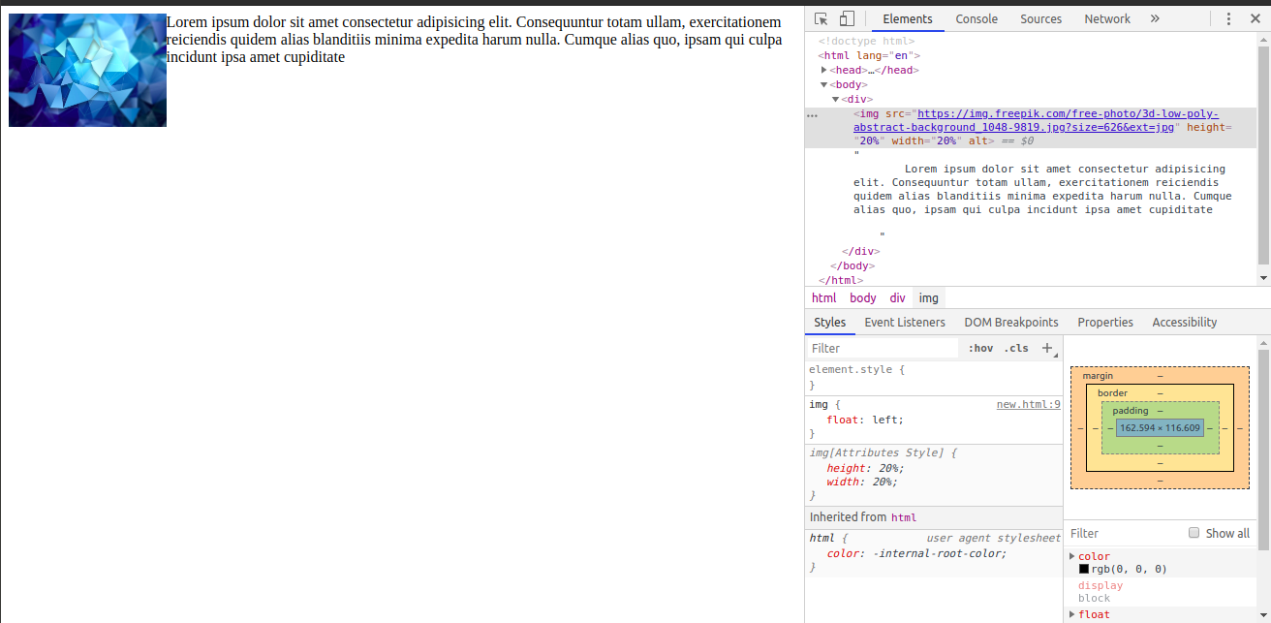

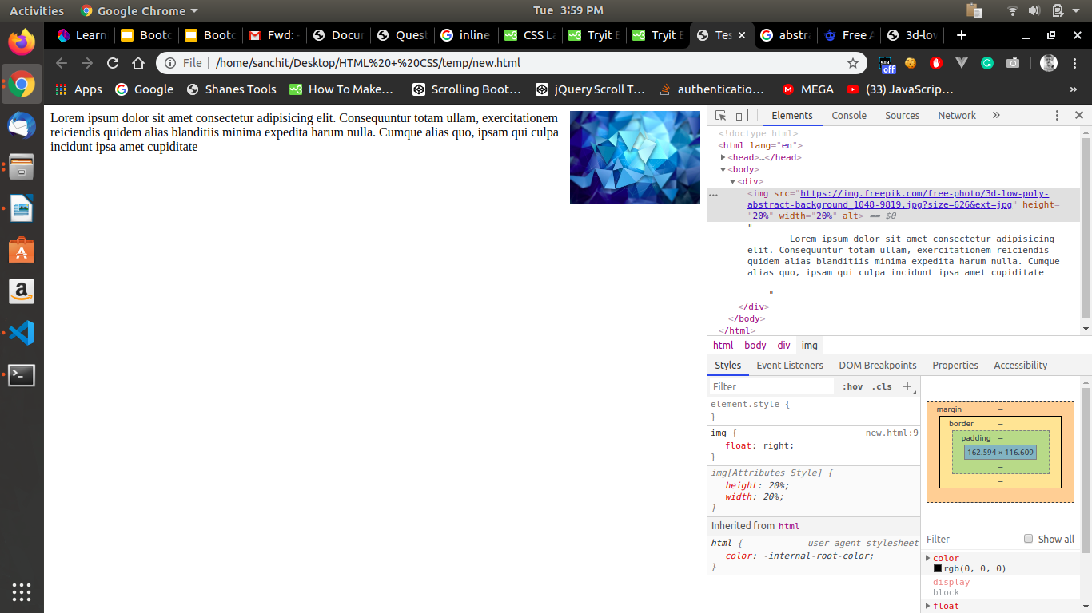
float: right;

CLEAR property
- The clear property specifies on which sides of an element floating elements are not allowed to float.
- We can specify to clear the floating of any element at the specified side. (either left or right) as specified using float.

Q4. explain difference between absolute, relative,fixed and static.

The position property specifies the type of positioning method used for an element.
Position property can have values like:
- relative
- absolute
- fixed
- static

relative
- An element with position: relative; is positioned relative to its normal position.
- When we set top, left, right, bottom properties on an element with position: relative, it will cause the element to be adjusted relative to its parent element.

Absolute
- An element with position: absolute; is positioned relative to the nearest positioned parent (instead of positioned relative to the viewport)
- If an absolute positioned element has no positioned ancestors, it uses the document body.

Fixed
- An element with position: fixed; is positioned relative to the viewport, which means it always stays in the same place even if the page is scrolled. The top, right, bottom, and left properties are used to position the element
static
- An element with position: static; is not positioned in any special way; it is always positioned according to the normal flow of the page.
- Static positioned elements are not affected by the top, bottom, left, and right properties.

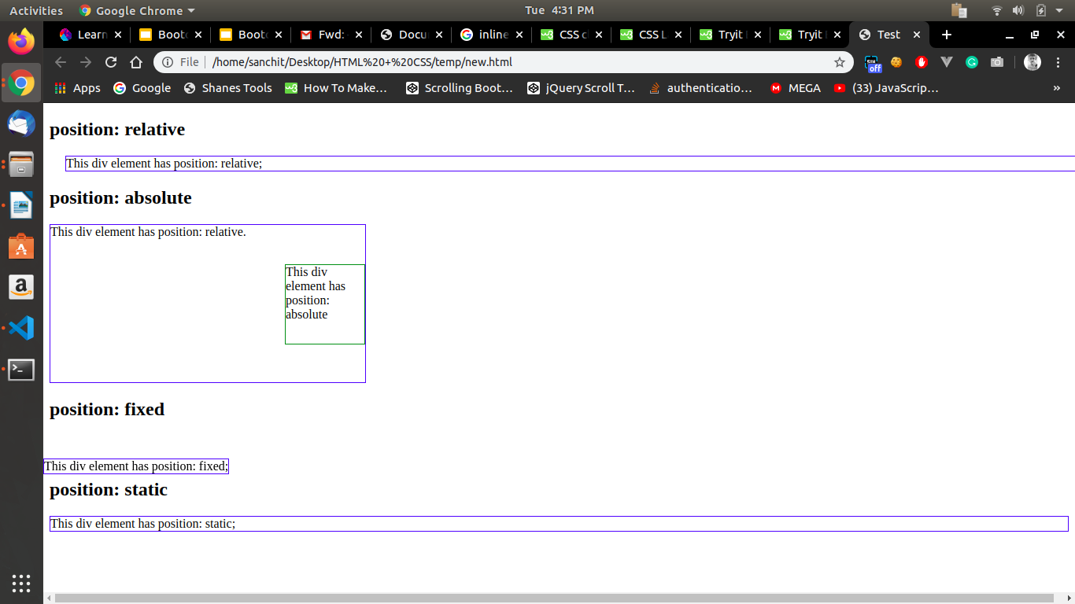

Q5. Write the HTML code to create a table in which there are 4 columns( ID , Employee Name, Designation, Department) and at least 6 rows. Also do some styling to it.

Refer to tables.html

Q6. Why do we use meta tags?

- Metadata is data (information) about data.
- The <meta> tag provides metadata about the HTML document. Metadata will not be displayed on the page, but will be understandable by the machine while interpreting the web page.
- Meta elements are typically used to specify page description, keywords, author of the document, last modified, and other metadata.
- HTML5 introduced a method to let web designers take control over the viewport, through the <meta> tag.
<meta name="viewport" content="width=device-width, initial-scale=1.0">

Q7. Explain box model.
The CSS box model is essentially a box that wraps around every HTML element. It consists of: margins, borders, padding, and the actual content. The image below illustrates the box model

- According to the above image, the blue area is the actual content and it specifies the actual size of the content in width and height.
- The content is surrounded by padding, which is the space between the element and the border of the element and can be adjusted manually.
- Border is used to surround the element with a defined boundary.
- Margin is the space between adjacent elements.

The box model allows us to add a border around elements, and to define space between elements.

Q8. What are the different types of CSS Selectors?
- CSS selectors are used to "find" (or select) the HTML elements you want to style.
- We can divide CSS selectors into five categories:
  - Simple selectors (select elements based on name, id, class)
  - Combinator selectors (select elements based on a specific relationship between them)
  - Pseudo-class selectors (select elements based on a certain state)
  - Pseudo-elements selectors (select and style a part of an element)
  - Attribute selectors (select elements based on an attribute or attribute value)

- The element selector selects HTML elements based on the element type. i.e. p here.
Eg: p{
text-align:center;
color:red;
}
- We can select the HTML elements based on id of the element.
Eg: #para1{
text-align:center;
color:red;
}
here #para1 is an id assigned to p tag. One id can be assigned to one element only.
- We can select the HTML elements based on class of the element.
Eg: .center{
text-align:center;
color:red;
}
here .center is the class name assigned to an element having class =center.

Q9. Define Doctype.
- A doctype or document type declaration is an instruction which tells the web browser about the markup language in which the current page is written.
- The Doctype is not an element or tag, it lets the browser know about the version of or standard of HTML or any other markup language that is being used in the document.
- The DOCTYPE for HTML5 is case-insensitive and can be written as shown below:
< !DOCTYPE html >

Q10. Explain 5 HTML5 semantic tags.
A semantic element clearly describes its meaning to both the browser and the developer.
HTML5 offers new semantic elements to define different parts of a web page:
- <header>
- <footer>
- <main>
- <section>
- <nav>
<header>
- The <header> element specifies a header for a document or section.
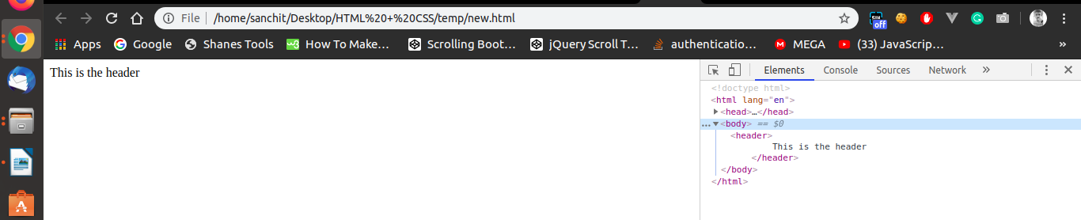
- We can have several <head> elements in one document.

<footer>
- The <footer> element specifies a footer for a document or section.
- A footer typically contains the author of the document, copyright information, links to terms of use, contact information, etc.
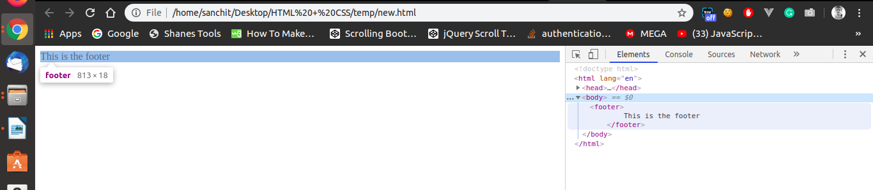

<main>
- The <main> tag specifies the main content of a document.
- The content inside the <main> element should be unique to the document. It should not contain any content that is repeated across documents such as sidebars, navigation links, copyright information, site logos, and search forms.
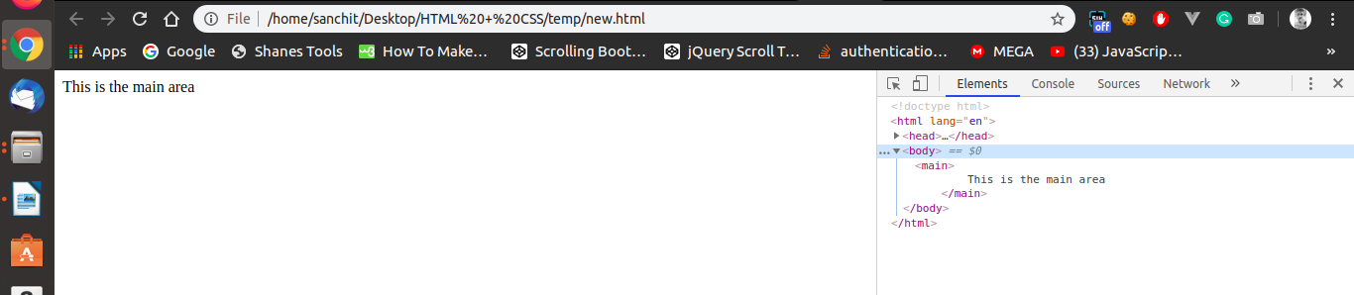
<section>
- The <section> element defines a section in a document.
- A home page could normally be split into sections for introduction, content, and contact information.

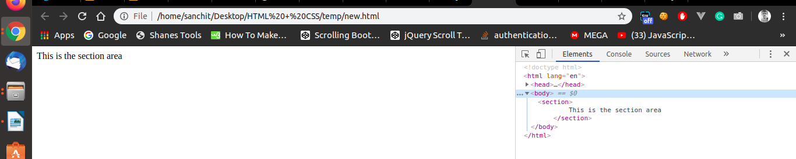
<nav>
- The <nav> element defines a set of navigation links.
- <nav> is used to define a navigation bar to navigate between multiple pages on the Website.
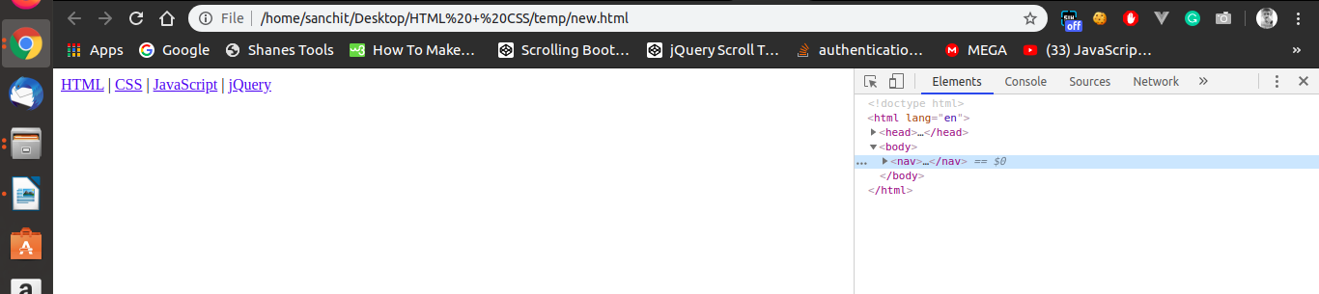

Q11. Create HTML for web-page.jpg(check resources, highest weightage for answers)
- Refer Question 11.html

Q12. Create HTML for form.png (check resources, highest weightage for answers)
- Refer Question 12.html

