Problem Statement: There can be multiple customers, who can place multiple orders on the site. Now a sales person can handle these orders will distribute into multiple sales persons (One order will be assign to one salesperson only). So a sales person can have multiple orders of multiple customers.

Q1) Create Database.

For creating a database, we made use of mysql and activated the mysql command line mode using :
$ sudo mysql

Command to create a database: CREATE DATABASE <db-name>

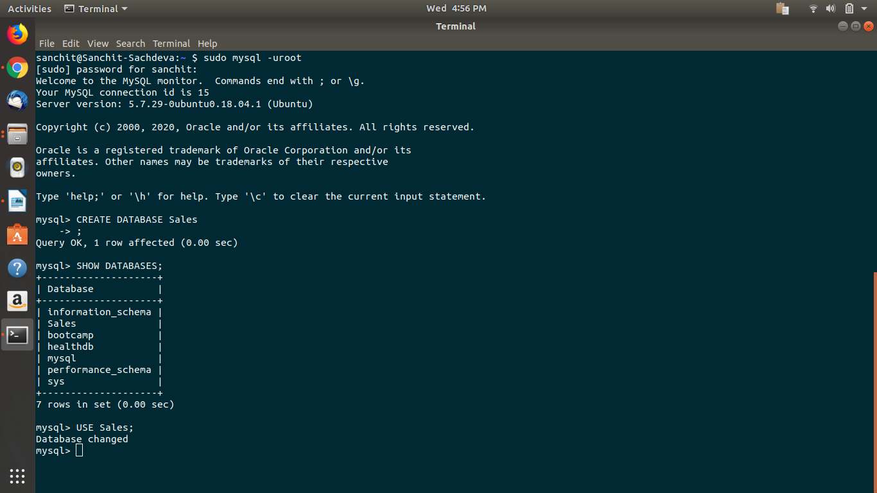

Q2) Create tables

For the given problem statement, we require 4 tables:
- Customers
- Orders
- SalesPerson

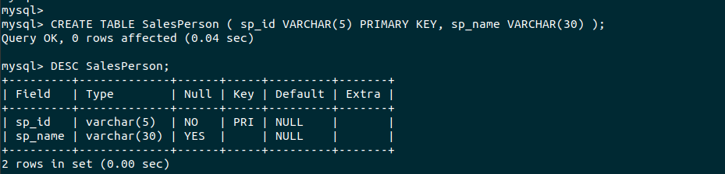
TABLE: SalesPerson

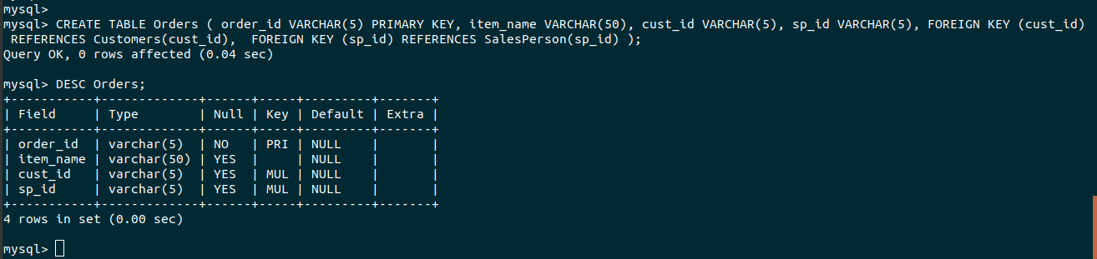
TABLE: Orders

TABLE: Customers
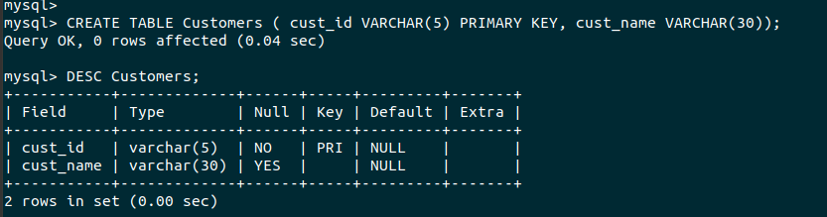

Q3) Design Schema

Schema is the basic structure of the table and its relationship with other tables.
For the given problem statement, we designed the Schema using appropriate PRIMARY KEY and FOREIGN KEY constraints in different tables.
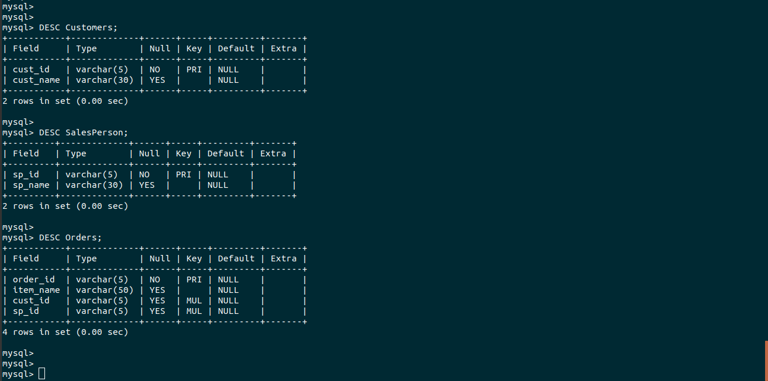

Q4) Insert sample data.

We will insert some arbitrary data in all the 3 created tables.

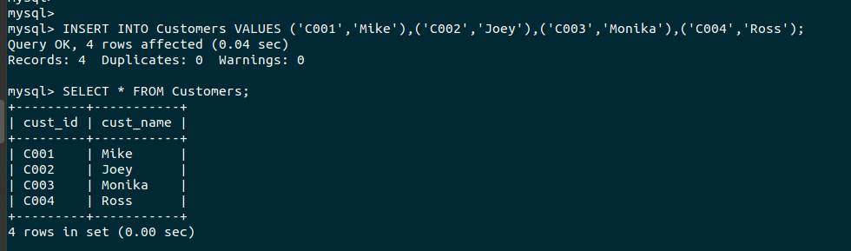
TABLE: Customers

TABLE: SalesPerson
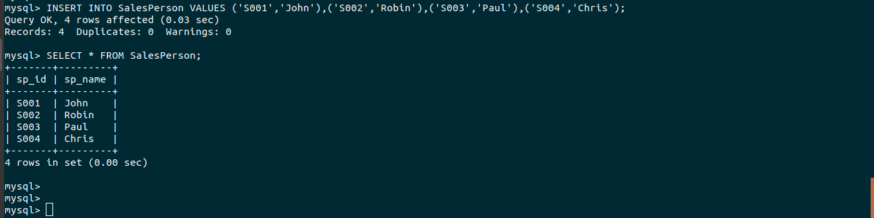

TABLE: Orders
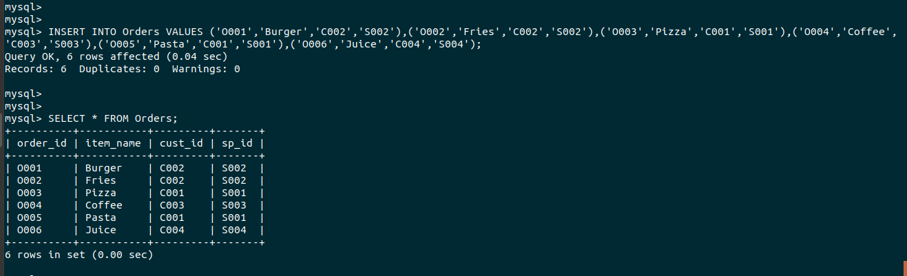

Q5) Find the sales person have multiple orders.

In this case, we have to use join over SalesPerson and Orders, so that we can find all those salesperson who handles multiple orders.

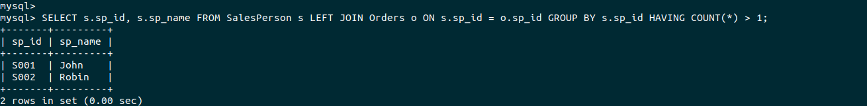

Q6) Find the all sales person details along with order details.

For this given problem, we have to join SalesPerson and Orders to get details of both the Tables i.e salesperson corressponding to all the orders in the Orders table.

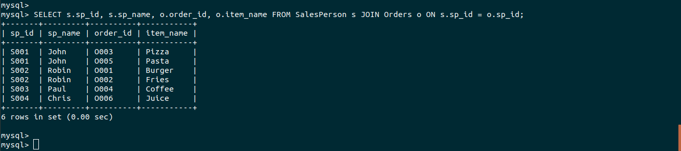

Q7) Create index.
Q8) How to show index on a table

combining both the question in one solution.
To create an index : CREATE INDEX <index-name> ON <table-name>(<column-name>)
To show all the index for any Table : SHOW INDEX FROM <table-name>
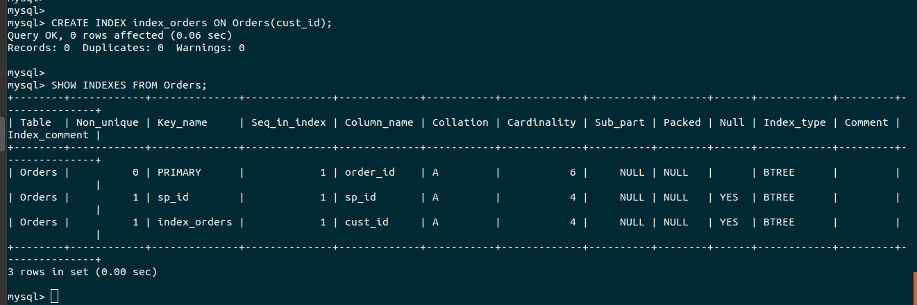
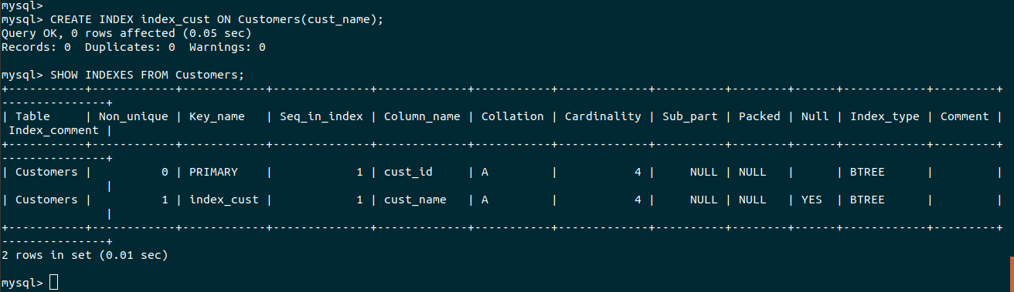
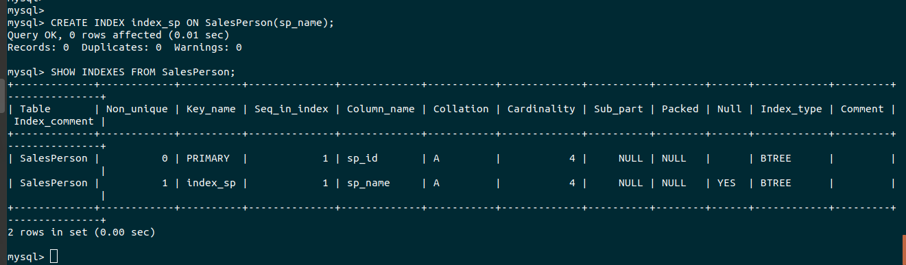
Q8) Find the order number, sale person name, along with the customer to whome that order belongs to.

For this we have to use 2 JOIN statements between -
- Orders and Salesperson
- Orders and Customers

