M.MOHAMED SHERIF
26/03/2026
DAY – 13 TASK
1. Create a box that takes up 80% of the screen width but no more than 600px.
- The box adjusts its size based on screen width (responsive).
- It will not grow beyond 600px even on large screens.
<!DOCTYPE html>
<html>
<head>
<style>
.box {
width: 80%;
max-width: 600px;
background: lightgray;
padding: 20px;
}
</style>
</head>
<body>
<div class="box">Responsive Box</div>
</body>
</html>

Output:
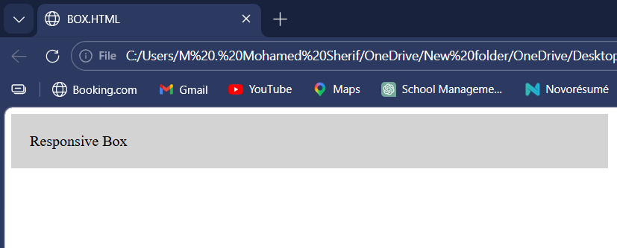
2. Set a paragraph’s font size to 1.5rem.
- The text size depends on the root (default browser size).
- It stays consistent across different devices.
<!DOCTYPE html>
<html>
<head>
<style>
p {
font-size: 1.5rem;
}
</style>
</head>
<body>
<p>This is a paragraph with scalable text.</p>
</body>
</html>
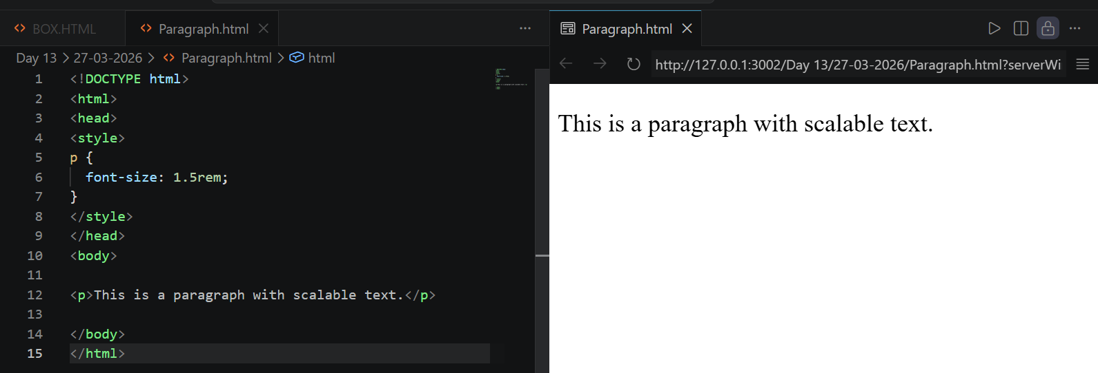
3. Use vw to make a heading that scales with screen size.
- The text size changes based on screen width.
- It becomes larger on big screens and smaller on small screens.
<!DOCTYPE html>
<html>
<head>
<style>
h1 {
font-size: 5vw;
}
</style>
</head>
<body>
<h1>Responsive Heading</h1>
</body>
</html>
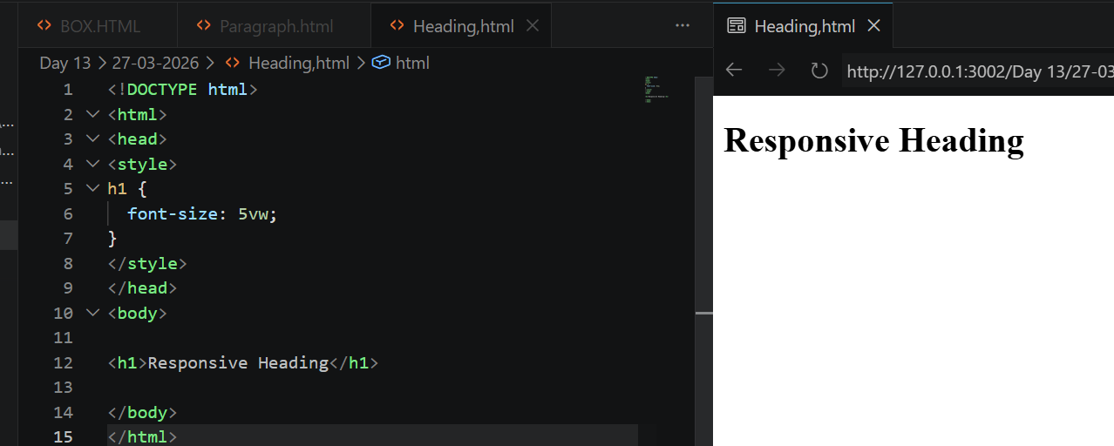
4. Write a media query that changes background color below 768px.
- Different styles are applied for smaller screens.
- Helps make the design mobile-friendly.
<!DOCTYPE html>
<html>
<head>
<style>
body {
background: white;
}
@media (max-width: 768px) {
body {
background: lightblue;
}
}
</style>
</head>
<body>
<p>Resize the screen to see background change.</p>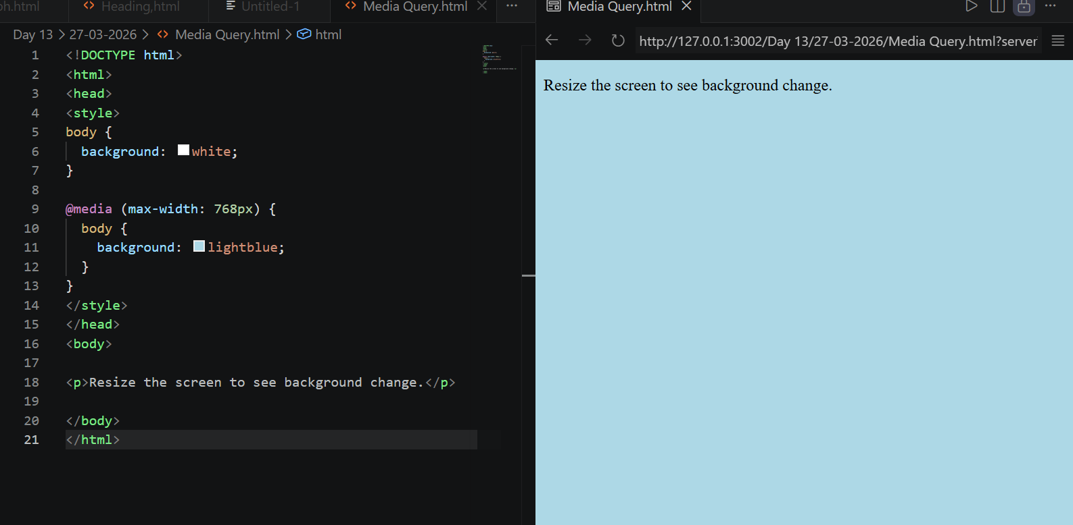
</body>
</html>

