Mohamad Sherif
30th April 2026
Day 33 - Bootstrap - Task
1. Task 1 — Setup a New Project
Definition:
Bootstrap is a CSS framework that helps to design responsive and mobile-first websites quickly using predefined classes.
Code:
<!DOCTYPE html>
<html>
<head>
<title>Bootstrap Setup</title>
<link href="https://cdn.jsdelivr.net/npm/bootstrap@5.3.0/dist/css/bootstrap.min.css" rel="stylesheet">
</head>
<body>
<div class="container">
<h1>Hello Bootstrap</h1>
<p>This is a simple Bootstrap container.</p>
</div>
</body>
</html>
Explanation:
Bootstrap is added using CDN. container class gives proper width, padding, and responsive layout.
Output:
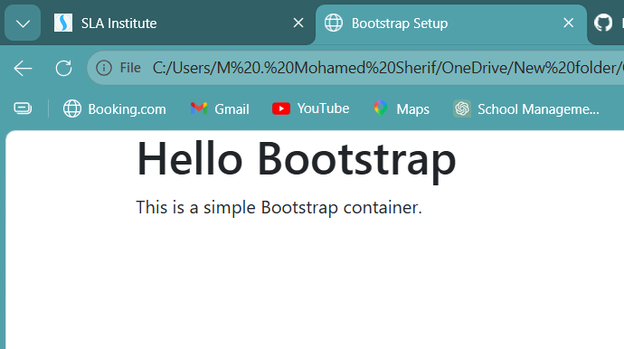

2. Task 2 — Typography & Spacing
Definition:
Bootstrap provides text utilities and spacing utilities to control layout and design.
Code:
<!DOCTYPE html>
<html>
<head>
<title>Typography & Spacing</title>
<link href="https://cdn.jsdelivr.net/npm/bootstrap@5.3.0/dist/css/bootstrap.min.css" rel="stylesheet">
</head>
<body>
<div class="container">
<h1 class="text-center text-primary">Welcome</h1>
<p class="text-center m-3">This is a paragraph using Bootstrap text utilities.</p>
<div class="p-4 bg-light">
<h3 class="text-success">Spacing Example</h3>
<p class="m-2">Padding and margin are applied using Bootstrap classes.</p>
</div>
</div>
</body>
</html>
Explanation:
text-center aligns text to center. text-primary and text-success add colors. m- and p- control margin and padding.
Output:
