M. MOHAMED SHERIF
06-04-2026
DAY 19 TASK

1. Write a function to add two numbers
A function is a reusable block of code that performs a specific task. In this case, the function takes two numbers as input and returns their sum.
function addNumbers(a, b) {
return a + b;
}
console.log(addNumbers(5, 3));
Output:
8
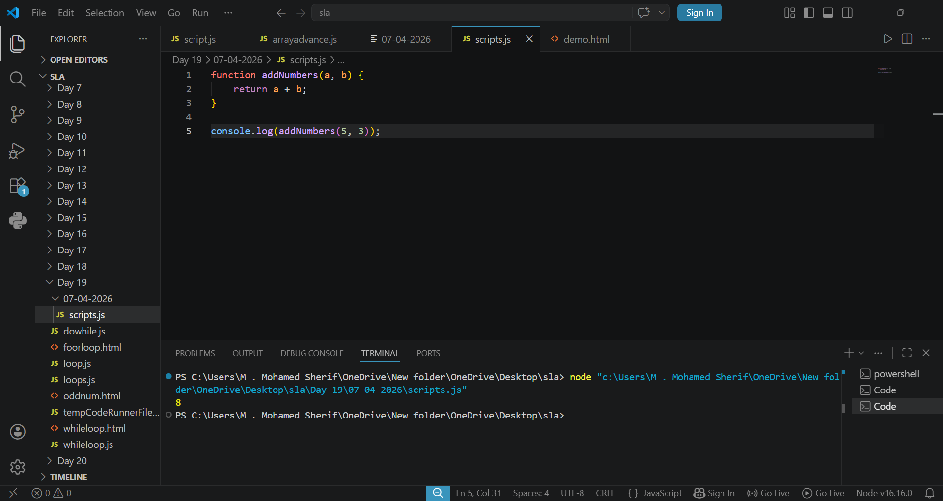
2. Write a function expression to multiply two numbers
A function expression is when a function is assigned to a variable. It allows storing functions in variables and using them later.
const multiplyNumbers = function(a, b) {
return a * b;
};
console.log(multiplyNumbers(4, 2));
Output:
72
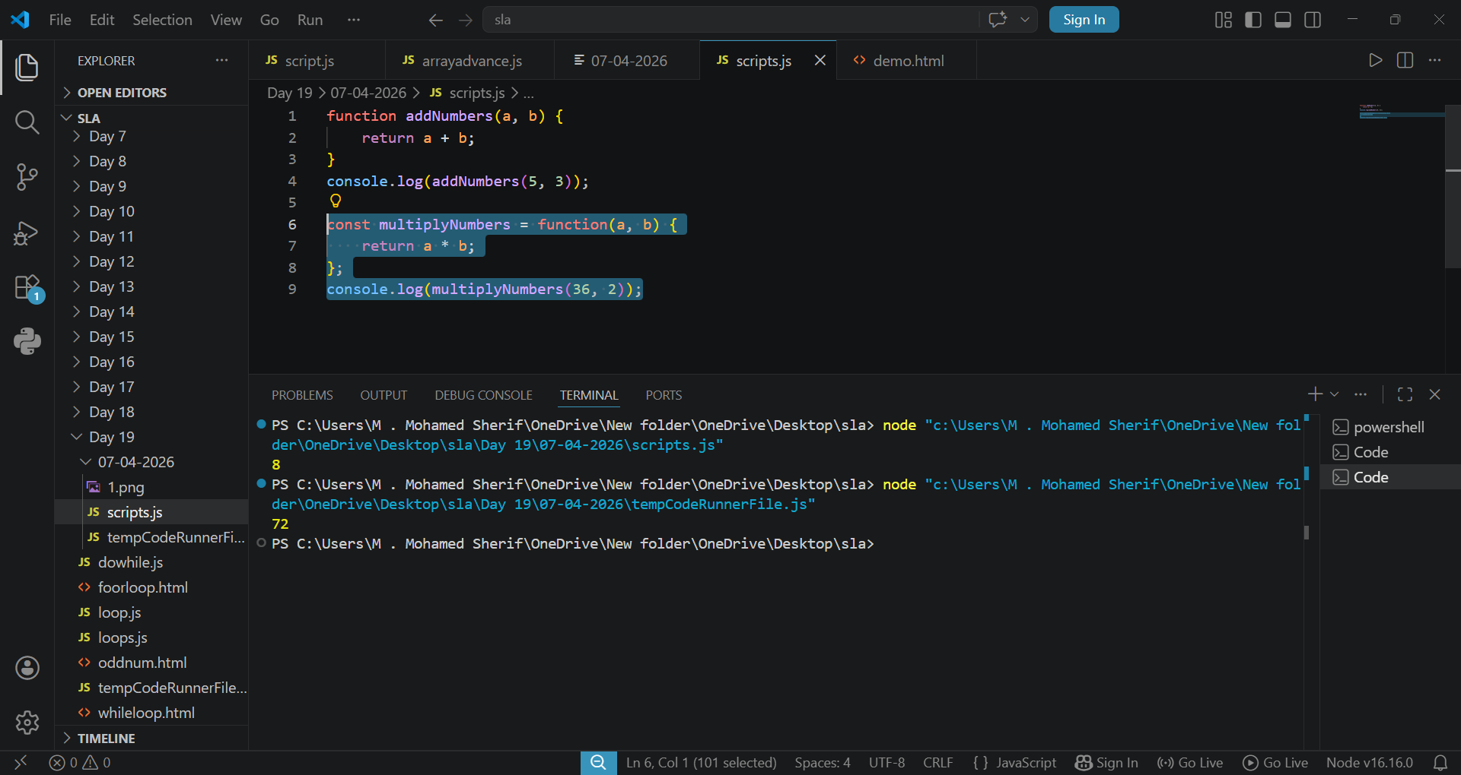

3. Write an arrow function to subtract two numbers
An arrow function is a shorter syntax for writing functions in JavaScript. It is commonly used for simple operations.
const subtractNumbers = (a, b) => {
return a - b;
};
console.log(subtractNumbers(10, 4));
Output:
44
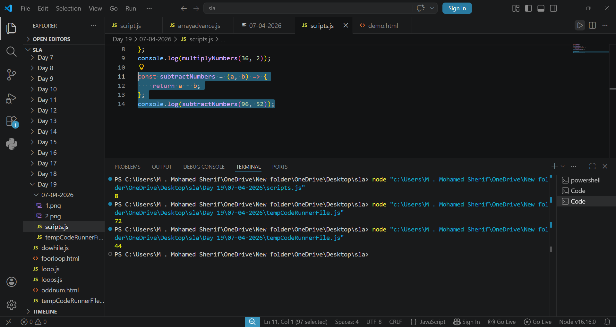

4. Write a function with parameters and return a value
Functions can accept parameters (inputs) and return a value after processing. This helps in making functions dynamic and reusable.
function greetUser(name) {
return "Hello " + name;
}
console.log(greetUser("Mohamed"));
Output:
Hello Mohamed
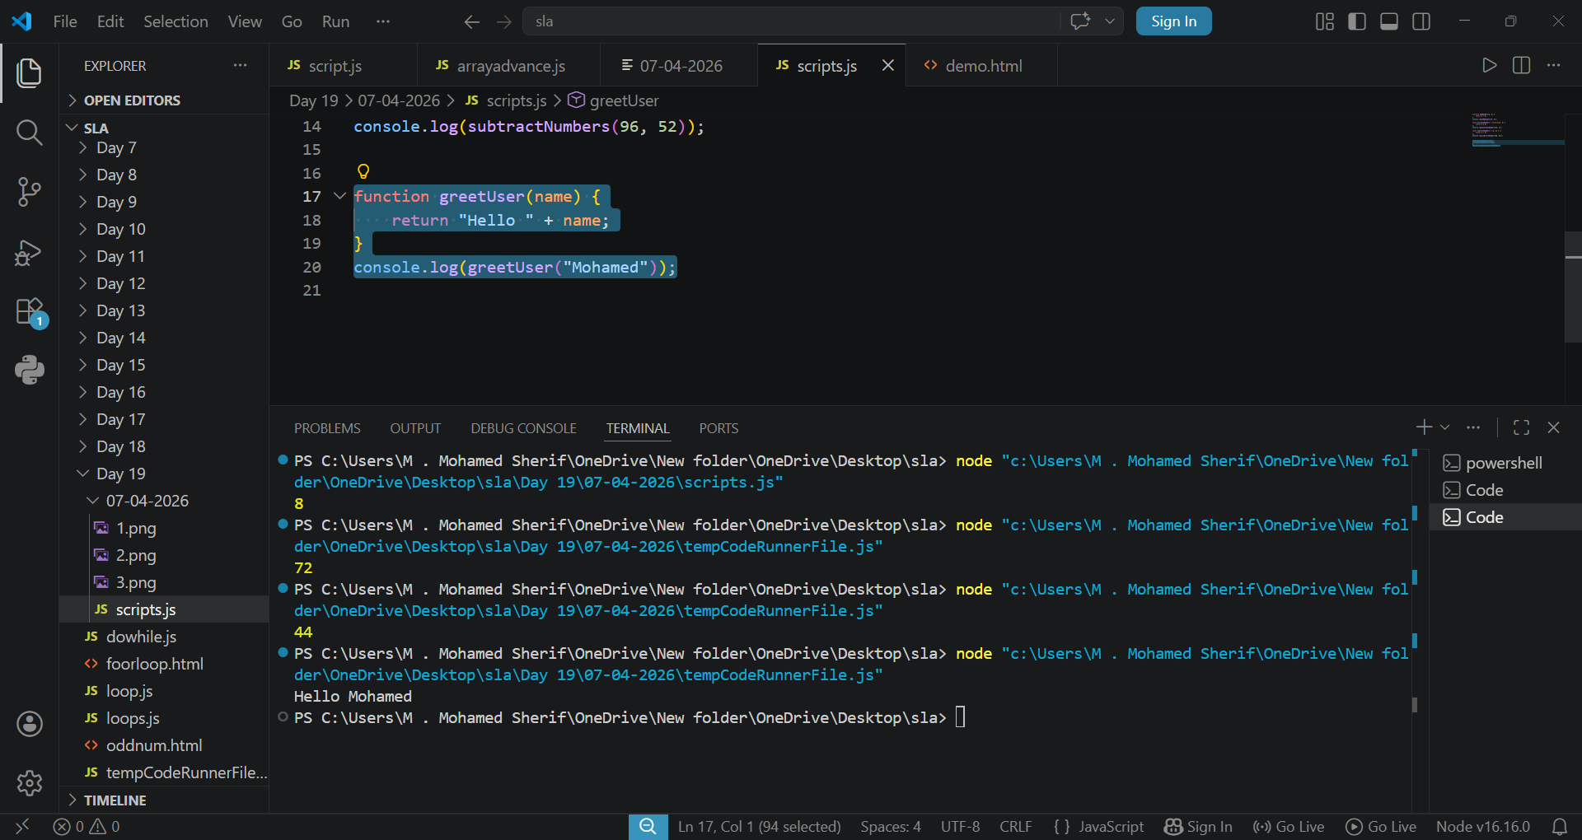

5. Demonstrate global vs local scope
Scope determines where a variable can be accessed. Global scope variables can be accessed anywhere, while local scope variables can only be accessed within the function they are declared in.
let globalVar = "I am global";
function showScope() {
let localVar = "I am local";
console.log(globalVar);
console.log(localVar);
}
showScope();
console.log(globalVar);
Output:
I am global
I am local
I am global

