Day 25 Task
M. MOHAMED SHERIF
15th April 2026

1. Rewrite code with let and const:
Explanation: In modern JavaScript, 'let' and 'const' are used instead of 'var'. 'let' is used when the value can change, and 'const' is used when the value should not be reassigned.
Code:
let name = 'Rohit';
const age = 21;
name = 'Sharif';
console.log(name, age);
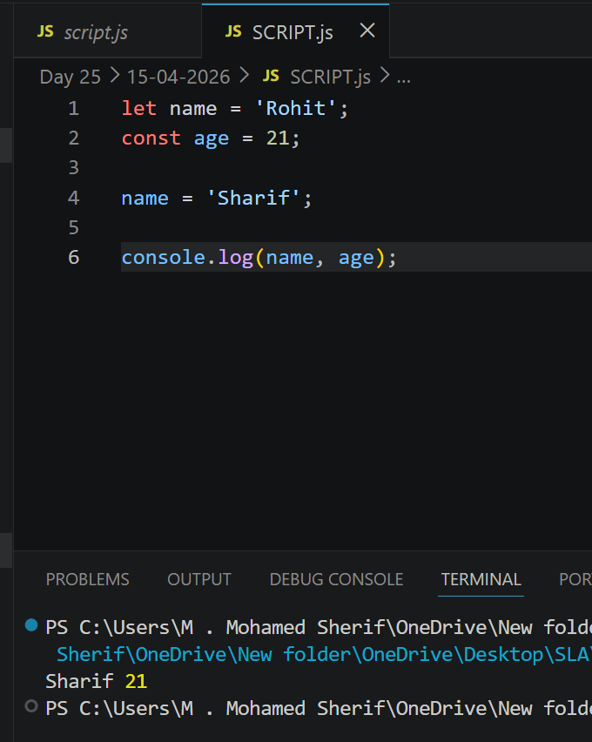
2. Use template literals with variables:
Explanation: Template literals use backticks (`) and allow embedding variables using ${}.
Code:
let user = 'Rohit';
let message = `Hello, ${user}! Welcome to JavaScript.`;
console.log(message);
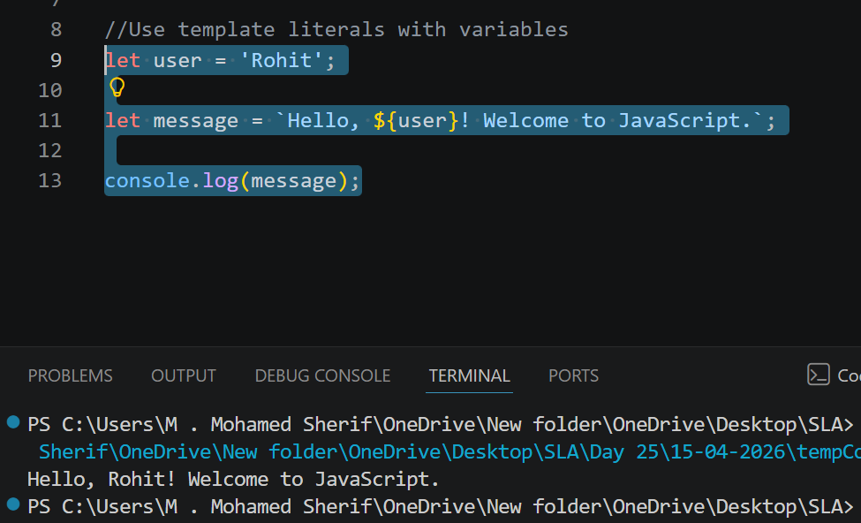
3. Create a function with default parameter values:
Explanation: Default parameters allow assigning default values if no argument is passed.
Code:
function greet(name = 'Guest') {
return `Hello, ${name}!`;
}
console.log(greet());
console.log(greet('Rohit'));

