M. Mohamad Sherif
29th April 2026
Day 32 - JS - Task
1. Write promise code using async/await
Definition:
A Promise in JavaScript is used to handle asynchronous operations. async/await makes it easier to write and read asynchronous code.
Code:
function getData() {
return new Promise((resolve, reject) => {
setTimeout(() => {
resolve("Data received successfully");
}, 2000);
});
}
async function fetchData() {
try {
let result = await getData();
console.log(result);
} catch (error) {
console.log("Error:", error);
}
}
fetchData();
Explanation:
getData returns a promise. async allows using await. await waits for the promise to complete. try-catch handles errors.

Output:
Data received successfully
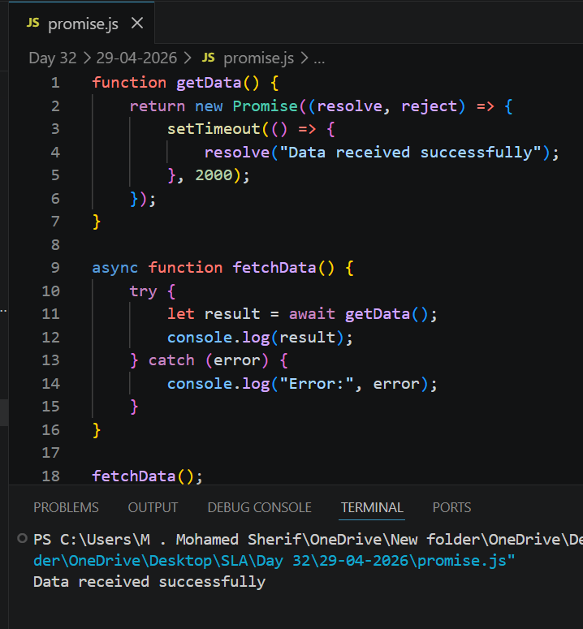
2. Save and Remove a value in localStorage
Definition:
localStorage stores data permanently in the browser until removed manually.
Code:
// Simple object to simulate storage
let storage = {};

// Save
storage.username = "Sharif";
console.log("Saved:", storage.username);

// Remove
delete storage.username;
console.log("After removal:", storage.username);
Explanation:
setItem saves data, getItem retrieves it, removeItem deletes it. Data persists after refresh.
Output:
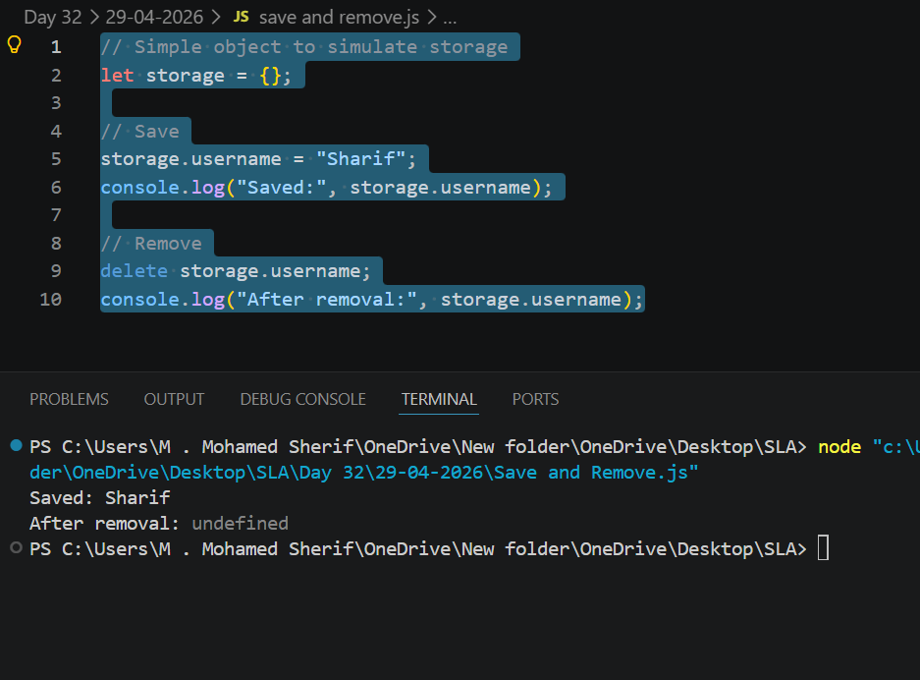

3. Save and Remove a value in sessionStorage
Definition:
sessionStorage stores data temporarily and clears when the browser tab is closed.
Code:
let sessionStorage = {};
// Save
sessionStorage.setItem = function(key, value) {
this[key] = value;
};
sessionStorage.getItem = function(key) {
return this[key];
};
sessionStorage.removeItem = function(key) {
delete this[key];
};
// Usage
sessionStorage.setItem("user", "Sherif");
console.log("Saved:", sessionStorage.getItem("user"));
sessionStorage.removeItem("user");
console.log("After removal:", sessionStorage.getItem("user"));
Explanation:
Works like localStorage but data is temporary and cleared after session ends.
Output:
