M. MOHAMED SHERIF
Day 9 - SQL - Task
-- 1. Create a table sales (id, product, amount)
CREATE TABLE sales (
id INT PRIMARY KEY,
product VARCHAR(50),
amount DECIMAL(10,2)
);

-- Insert sample data
INSERT INTO sales VALUES
(1, 'Laptop', 50000),
(2, 'Mobile', 30000),
(3, 'Tablet', 30000),
(4, 'Monitor', 20000),
(5, 'Keyboard', 10000);

-- 2. Use ROW_NUMBER() to rank sales by amount
SELECT
id,
product,
amount,
ROW_NUMBER() OVER (
ORDER BY amount DESC
) AS row_num
FROM sales;
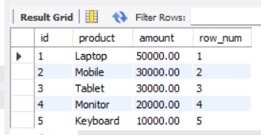

-- 3. Use RANK() to assign ranks with ties
SELECT
id,
product,
amount,
RANK() OVER (
ORDER BY amount DESC
) AS rank_num
FROM sales;

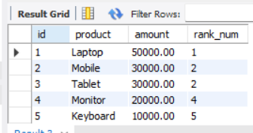

-- 4. Use DENSE_RANK() to avoid gaps in ranking
SELECT
id,
product,
amount,
DENSE_RANK() OVER (
ORDER BY amount DESC
) AS dense_rank_num
FROM sales;
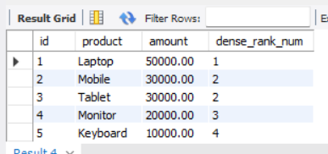

-- 5. Use SUM() OVER() to calculate running totals
SELECT
id,
product,
amount,
SUM(amount) OVER (
ORDER BY id
) AS running_total
FROM sales;
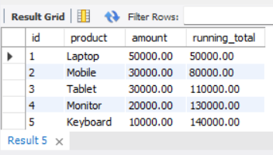

-- 6. Create a CTE to fetch sales above average
WITH avg_sales AS (
SELECT AVG(amount) AS avg_amount
FROM sales
)
SELECT
s.id,
s.product,
s.amount
FROM sales s
JOIN avg_sales a
ON s.amount > a.avg_amount;
