M. Mohamed Sherif
5th May 2026
Day 35 - Bootstrap Tasks
Task 1: Build a responsive navbar with a collapsible toggle for mobile.
This task involves creating a navigation bar that adjusts for different screen sizes using Bootstrap.
Code:
<!DOCTYPE html>
<html>
<head>
<title>Navbar</title>
<link href="https://cdn.jsdelivr.net/npm/bootstrap@5.3.0/dist/css/bootstrap.min.css" rel="stylesheet">
</head>
<body>
<nav class="navbar navbar-expand-lg bg-black navbar-dark">
<div class="container-fluid">
<a class="navbar-brand text-warning" href="#">MySite</a>
<!-- Toggle Button -->
<button class="navbar-toggler" type="button" data-bs-toggle="collapse" data-bs-target="#menu">
<span class="navbar-toggler-icon"></span>
</button>
<!-- Menu -->
<div class="collapse navbar-collapse" id="menu">
<ul class="navbar-nav ms-auto">
<li class="nav-item"><a class="nav-link text-warning" href="#">Home</a></li>
<li class="nav-item"><a class="nav-link text-warning" href="#">About</a></li>
<li class="nav-item"><a class="nav-link text-warning" href="#">Contact</a></li>
</ul>
</div>
</div>
</nav>
<script src="https://cdn.jsdelivr.net/npm/bootstrap@5.3.0/dist/js/bootstrap.bundle.min.js"></script>
</body>
</html>
Explanation:
This code creates a responsive navbar. The toggle button appears on small screens and expands the menu.
Output: 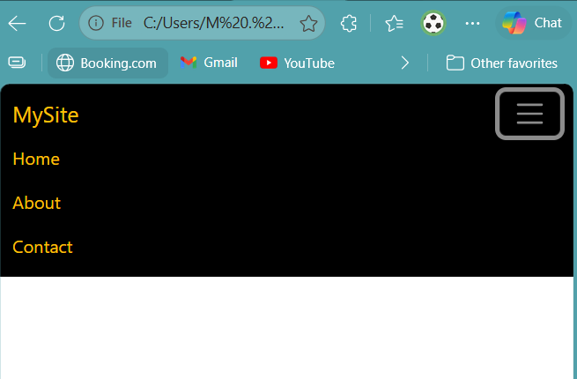
Task 2: Create buttons and alert box.
This task demonstrates Bootstrap button styles and alert components.
Code:
<!DOCTYPE html>
<html>
<head>
<title>Buttons & Alert</title>
<!-- Bootstrap CSS -->
<link href="https://cdn.jsdelivr.net/npm/bootstrap@5.3.0/dist/css/bootstrap.min.css" rel="stylesheet">
</head>
<body class="p-4">
<!-- Buttons -->
<button class="btn btn-primary">Primary</button>
<button class="btn btn-success">Success</button>
<button class="btn btn-outline-danger">Outline Danger</button>
<br><br>
<!-- Alert -->
<div class="alert alert-warning alert-dismissible fade show" role="alert">
This is a warning alert!
<button type="button" class="btn-close" data-bs-dismiss="alert"></button>
</div>
<!-- ✅ IMPORTANT: Bootstrap JS (required for click to work) -->
<script src="https://cdn.jsdelivr.net/npm/bootstrap@5.3.0/dist/js/bootstrap.bundle.min.js"></script>
</body>
</html>
Output:
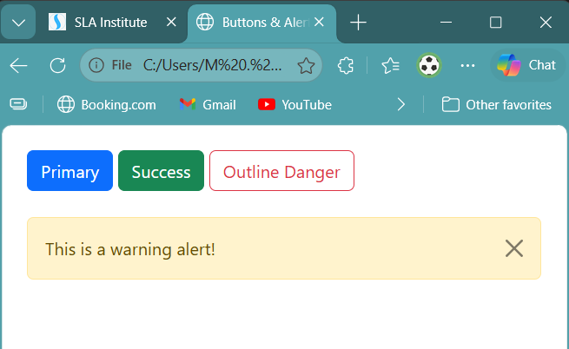

Task 3: Create a contact form.
This task builds a simple form using Bootstrap form classes.
Code:
<!DOCTYPE html>
<html>
<head>
<title>Royal Contact Form</title>
<!-- Bootstrap CSS -->
<link href="https://cdn.jsdelivr.net/npm/bootstrap@5.3.0/dist/css/bootstrap.min.css" rel="stylesheet">
</head>
<!-- Dark Navy Background -->
<body class="bg-dark text-warning p-4">
<div class="container">
<h2 class="text-center mb-4">Contact Form</h2>
<!-- Form -->
<form onsubmit="return showMessage()">
<div class="mb-3">
<label class="form-label">Name</label>
<input type="text" class="form-control" required>
</div>
<div class="mb-3">
<label class="form-label">Email</label>
<input type="email" class="form-control" required>
</div>
<div class="mb-3">
<label class="form-label">Message</label>
<textarea class="form-control" rows="3" required></textarea>
</div>
<!-- Grey Button with Black Text -->
<button type="submit" class="btn btn-secondary text-dark">Submit</button>
</form>
</div>
<!-- Popup -->
<script>
function showMessage() {
alert("Form submitted successfully!");
return false;
}
</script>
</body>
</html>
Explanation:
Form-control class styles input fields. Labels describe each input.
Output:
