M. Mohamed Sherif
1st May 2026
Day 34 - Bootstrap - Task
1. Task 1 — 3 Column Responsive Layout
Definition:
Bootstrap Grid System is used to create responsive layouts using rows and columns. It divides the page into 12 columns.
Code:
<!DOCTYPE html>
<html>
<head>
<title>3 Column Layout</title>
<link href="https://cdn.jsdelivr.net/npm/bootstrap@5.3.0/dist/css/bootstrap.min.css" rel="stylesheet">
</head>
<body>
<div class="container">
<div class="row">
<div class="col-lg-4 col-12 bg-primary text-white p-3">
Column 1
</div>
<div class="col-lg-4 col-12 bg-success text-white p-3">
Column 2
</div>
<div class="col-lg-4 col-12 bg-danger text-white p-3">
Column 3
</div>
</div>
</div>
</body>
</html>

Explanation:
row creates a row. col-lg-4 creates 3 equal columns on large screens. col-12 makes columns full width on small screens.
Output:
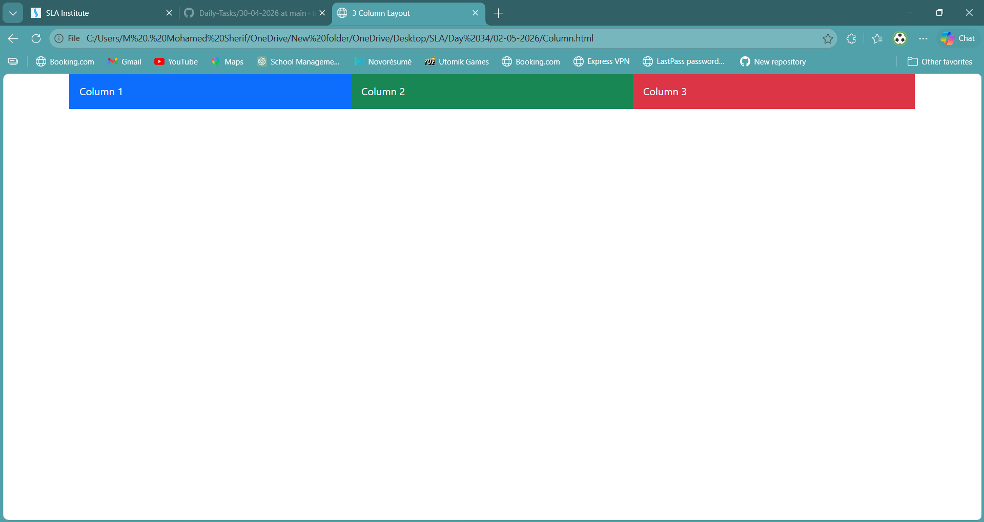
2. Task 2 — Nested Columns
Definition:
Bootstrap allows nesting rows inside columns to create complex layouts.
Code:
<!DOCTYPE html>
<html>
<head>
<title>Nested Columns</title>
<link href="https://cdn.jsdelivr.net/npm/bootstrap@5.3.0/dist/css/bootstrap.min.css" rel="stylesheet">
</head>
<body>
<div class="container mt-4">
<div class="row">
<div class="col-lg-6 p-3" style="background-color: #fff7ed;">
<h5>Parent Column</h5>
<div class="row mt-3">
<div class="col-6 p-2" style="background-color: #fde2e4;">
Sub Column 1
</div>
<div class="col-6 p-2" style="background-color: #e9d5ff;">
Sub Column 2
</div>
</div>
</div>
<div class="col-lg-6 p-3 text-dark" style="background-color: #fcd34d;">
Another Column
</div>
</div>
</div>
</body>
</html>
Explanation:
Nested row is created inside a column. Inside that, two sub-columns are created using col-6.
Output: 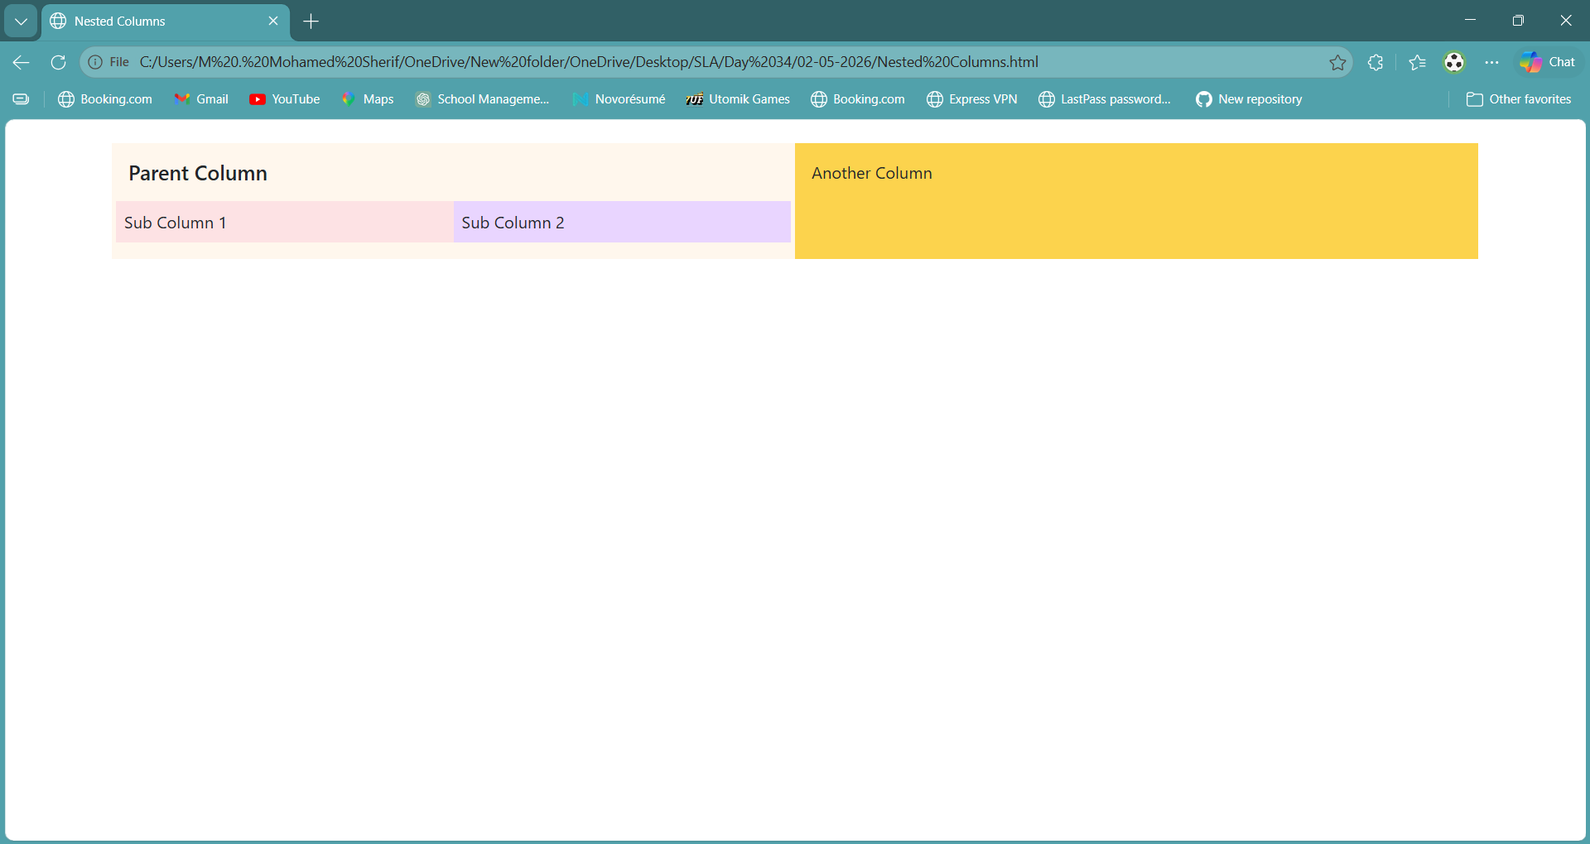
3. Task 3 — Responsive Navbar
Definition:
Navbar is used for navigation. Bootstrap provides responsive navbar which collapses on small screens.
Code:
<!DOCTYPE html>
<html lang="en">
<head>
<meta charset="UTF-8">
<meta name="viewport" content="width=device-width, initial-scale=1.0">
<title>Navbar Example</title>
<link href="https://cdn.jsdelivr.net/npm/bootstrap@5.3.3/dist/css/bootstrap.min.css" rel="stylesheet">
<script src="https://cdn.jsdelivr.net/npm/bootstrap@5.3.3/dist/js/bootstrap.bundle.min.js"></script>
</head>
<body>
<div class="container">
<nav class="navbar navbar-expand-sm bg-dark navbar-dark">
<div class="container-fluid">
<a class="navbar-brand" href="#">My Website</a>
<button class="navbar-toggler" type="button" data-bs-toggle="collapse" data-bs-target="#nav1">
<span class="navbar-toggler-icon"></span>
</button>
<div class="collapse navbar-collapse" id="nav1">
<ul class="navbar-nav">
<li class="nav-item">
<a class="nav-link" href="#">Home</a>
</li>
<li class="nav-item">
<a class="nav-link" href="#">About</a>
</li>
<li class="nav-item dropdown">
<a class="nav-link dropdown-toggle" href="#" role="button" data-bs-toggle="dropdown">
Services
</a>
<ul class="dropdown-menu">
<li><a class="dropdown-item" href="#">Service 1</a></li>
<li><a class="dropdown-item" href="#">Service 2</a></li>
</ul>
</li>
</ul>
</div>
</div>
</nav>
</div>
</body>
</html>

Explanation:
navbar-expand-lg shows full menu on large screens. navbar-toggler creates hamburger menu. collapse hides menu on small screens.
Output:
