M. Mohamed Sherif
17 April 2026
27th Day Task
Task 1: Filter a List of Names Using Textbox and UL
This program demonstrates how to filter a list of names dynamically as the user types in a textbox. The list updates in real time using JavaScript.
Code:
<!DOCTYPE html>
<html>
<head>
<title>Filter Names</title>
</head>
<body>
<h3>Filter Names</h3>
<input type="text" id="searchBox" placeholder="Type a name..." onkeyup="filterNames()">
<ul id="nameList">
<li>Arun</li>
<li>Bala</li>
<li>Charan</li>
<li>Divya</li>
<li>Elan</li>
</ul>
<script>
function filterNames() {
let input = document.getElementById("searchBox").value.toLowerCase();
let ul = document.getElementById("nameList");
let li = ul.getElementsByTagName("li");
for (let i = 0; i < li.length; i++) {
let text = li[i].textContent.toLowerCase();
if (text.includes(input)) {
li[i].style.display = "";
} else {
li[i].style.display = "none";
}
}
}
</script>
</body>
</html>
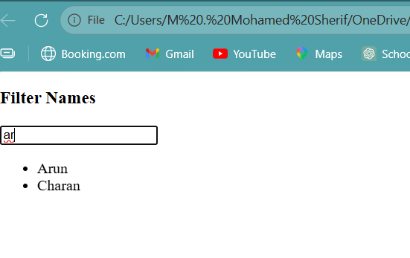
Task 2: Display Movie Cards Using JavaScript
This program displays a list of movie cards with movie names and images dynamically using JavaScript.
Code:
<!DOCTYPE html>
<html>
<head>
<title>Movie Cards</title>
</head>
<body>
<h3>Movie List</h3>
<div id="movieContainer"></div>
<script>
const movies = [
{ name: "Inception", image: "https://via.placeholder.com/150" },
{ name: "Avatar", image: "https://via.placeholder.com/150" },
{ name: "Titanic", image: "https://via.placeholder.com/150" }
];
const container = document.getElementById("movieContainer");
movies.forEach(movie => {
let card = document.createElement("div");
let img = document.createElement("img");
img.src = movie.image;
let title = document.createElement("p");
title.textContent = movie.name;
card.appendChild(img);
card.appendChild(title);
container.appendChild(card);
});
</script>
</body>
</html>

