MOHAMED SHERIF
Date: 10/04/2026
23rd Day Task
Task 1: Change text of an element using getElementById
<!DOCTYPE html>
<html>
<head>
<title>Task 1</title>
<style>
body {
background-color: #FFD700;
font-family: Arial;
text-align: center;
}
.box {
background-color: white;
margin: 100px auto;
padding: 20px;
width: 300px;
border-radius: 10px;
}
button {
padding: 10px;
margin-top: 10px;
}
</style>
</head>
<body>

<div class="box">
<h2>Change Text</h2>
<p id="demo">Original Text: Hello World</p>
<button onclick="changeText()">Change</button>
</div>

<script>
function changeText() {
document.getElementById("demo").innerText = "New Text: Text Changed Successfully!";
}
</script>

</body>
</html>

Explanation:
getElementById() selects the element and innerText changes the text.

Output:
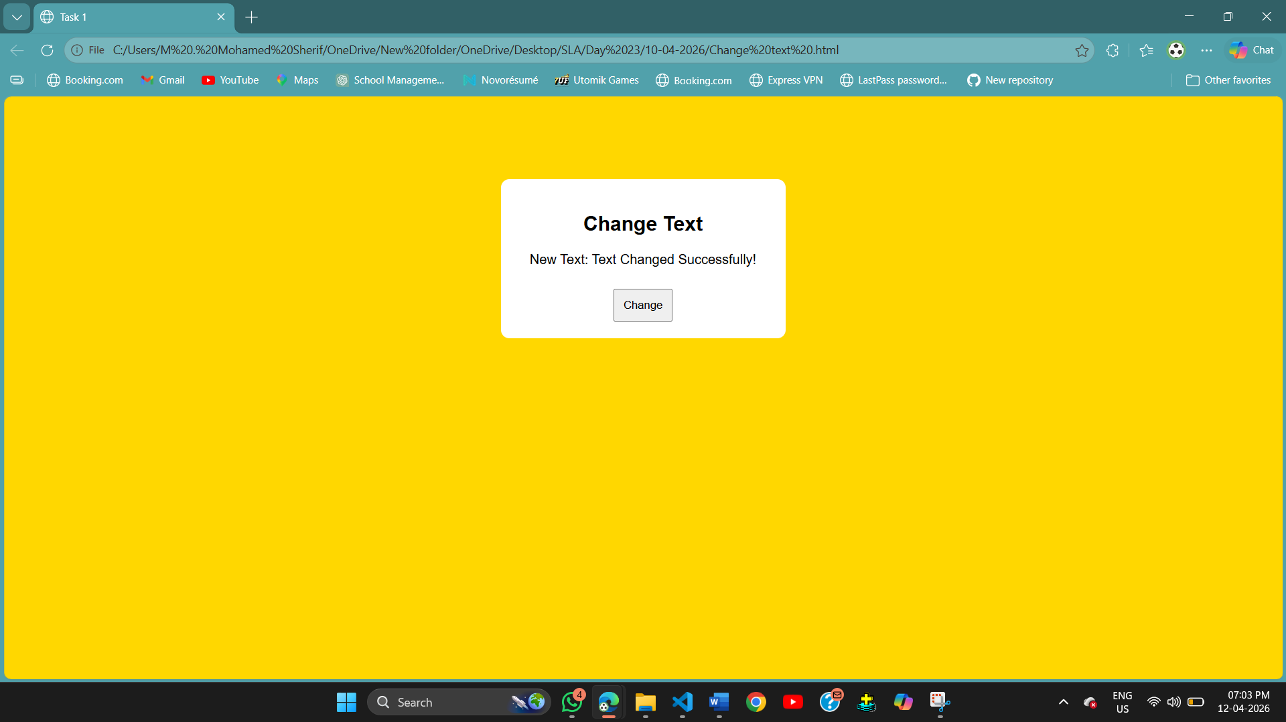
Task 2: Select an element and change its style
<!DOCTYPE html>
<html>
<head>
<title>Task 2</title>
<style>
body {
background-color: #3DDC84;
font-family: Arial;
text-align: center;
}
.box {
background-color: white;
margin: 100px auto;
padding: 20px;
width: 300px;
border-radius: 10px;
}
button {
padding: 10px;
margin-top: 10px;
}
</style>
</head>
<body>

<div class="box">
<h2>Change Style</h2>
<p id="text">Original Style: Normal Text</p>
<button onclick="changeStyle()">Change</button>
</div>

<script>
function changeStyle() {
let el = document.getElementById("text");
el.innerText = "New Style: Color Changed!";
el.style.color = "blue";
el.style.fontWeight = "bold";
}
</script>

</body>
</html>

Explanation:
Element is selected and style is changed using .style property.
Output: 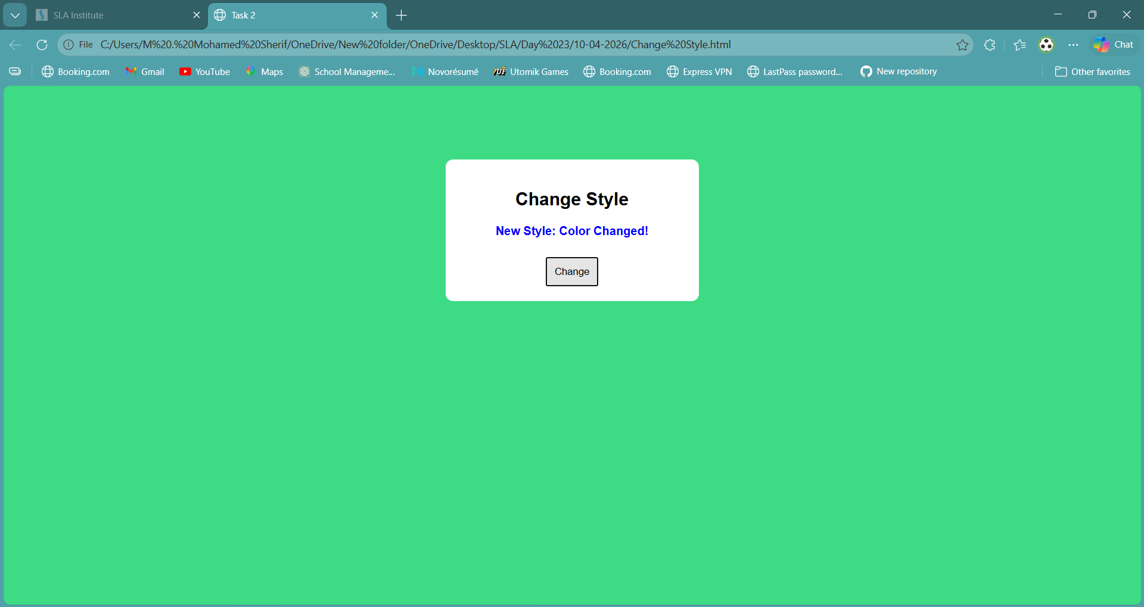
Task 3: Change content of a paragraph
<!DOCTYPE html>
<html>
<head>
<title>Task 3</title>
<style>
body {
background-color: #121212;
font-family: Arial;
text-align: center;
color: white;
}
.box {
background-color: #1e1e1e;
margin: 100px auto;
padding: 20px;
width: 300px;
border-radius: 10px;
}
button {
padding: 10px;
margin-top: 10px;
}
</style>
</head>
<body>

<div class="box">
<h2>Change Content</h2>
<p id="para">Old Content: Welcome User</p>
<button onclick="changeContent()">Change</button>
</div>

<script>
function changeContent() {
document.getElementById("para").innerHTML = "<b>New Content: Content Updated!</b>";
}
</script>

</body>
</html>

Explanation:
innerHTML changes the content inside the paragraph.
Output:
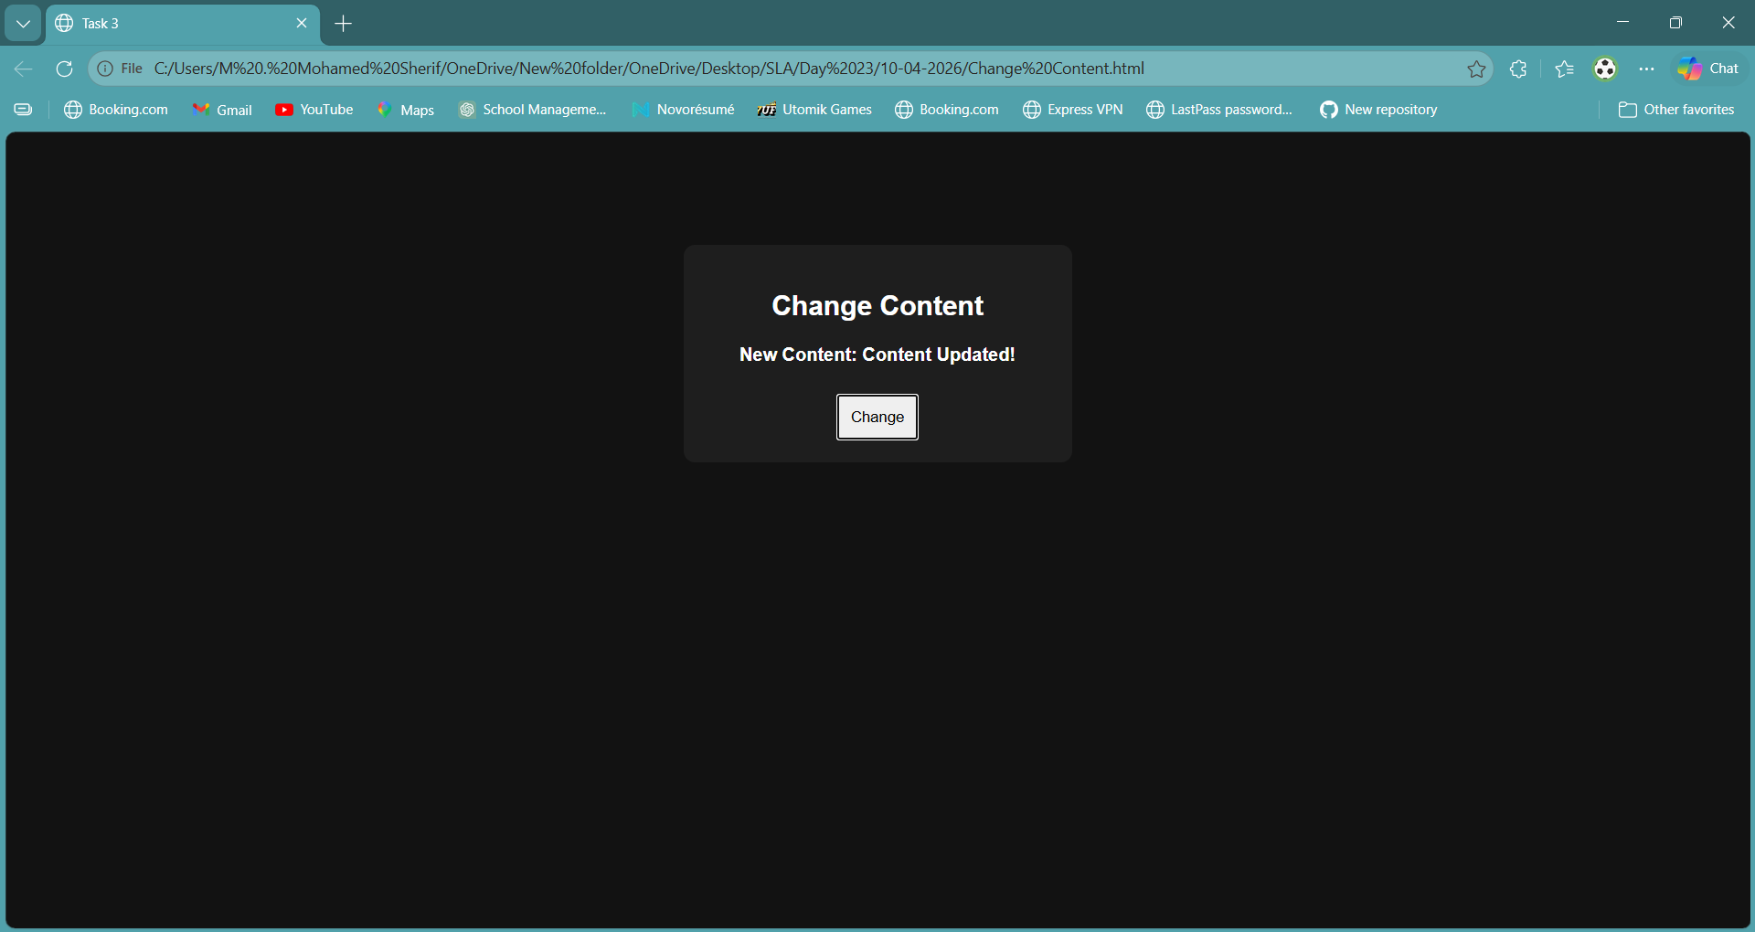

Task 4: Change color and font size of text
<!DOCTYPE html>
<html>
<head>
<title>Task 4</title>
<style>
body {
background-color: #6A0DAD;
font-family: Arial;
text-align: center;
color: white;
}
.box {
background-color: white;
color: black;
margin: 100px auto;
padding: 20px;
width: 300px;
border-radius: 10px;
}
button {
padding: 10px;
margin-top: 10px;
}
</style>
</head>
<body>

<div class="box">
<h2>Change Color & Size</h2>
<p id="styleText">Original: Normal Size Text</p>
<button onclick="changeDesign()">Change</button>
</div>

<script>
function changeDesign() {
let el = document.getElementById("styleText");
el.innerText = "New: Bigger & Colored Text!";
el.style.color = "red";
el.style.fontSize = "28px";
}
</script>

</body>
</html>

Explanation:
Using style, we change color and font size of text.

Output:
