M MOHAMED SHERIF
Date: 09/04/2026
22nd Day Task
Task 1: Create an object with name, age, and method sayHello()
let person = {
name: "Mohamed Sherif",
age: 21,
sayHello: function() {
return "Hello, my name is " + this.name;
}
};
console.log(person.sayHello());
Explanation:
An object stores data as key-value pairs. name and age are properties, and sayHello() is a method. 'this' refers to the current object.
Output:
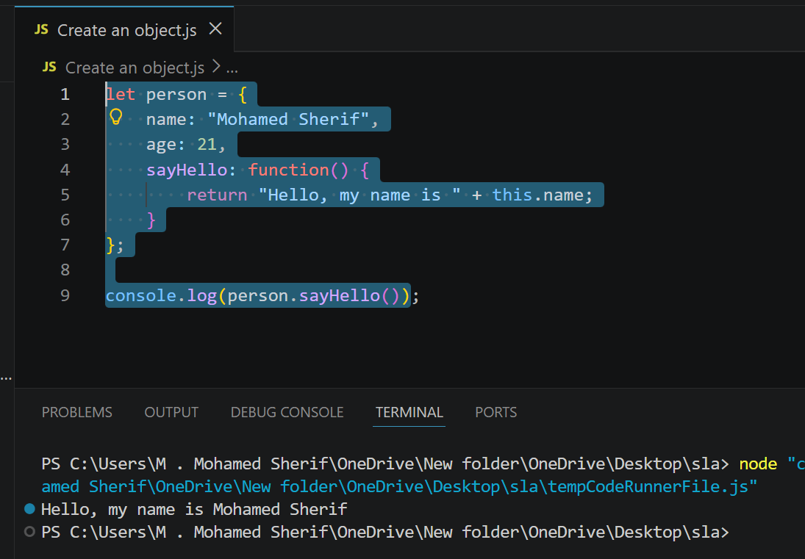
Task 2: Access and modify object properties
console.log(person.name);
person.age = 22;
console.log(person.age);
Explanation:
Properties are accessed using dot notation. We can modify values by assigning new values to them.
Output:
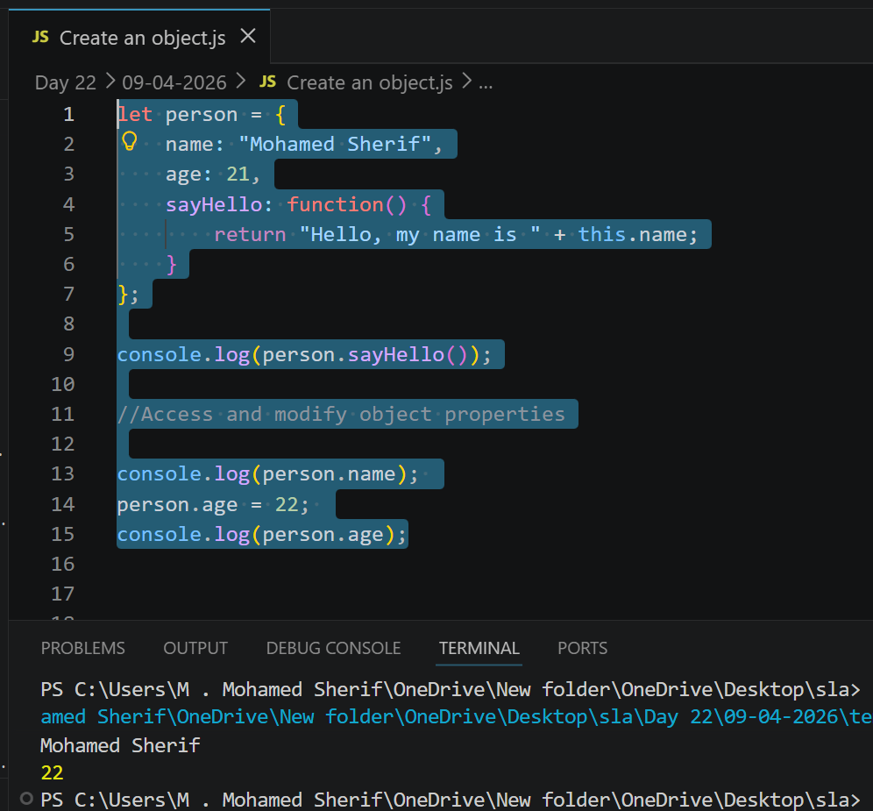
Task 3: Call an object method
person.sayHello();
Explanation:
A method is called using parentheses. It executes the function inside the object.
Output: 