M. Mohamed Sherif
13th April 2026
Day 24 Task
1. Add a Button Click Event
Explanation:
A button click event is used to perform an action when the user clicks a button.
Code:
<!DOCTYPE html>
<html>
<head>
<title>Button Click Event</title>
</head>
<body>
<button id="myButton">Click Me</button>
<script>
document.getElementById("myButton").addEventListener("click", function() {
alert("Button was clicked!");
});
</script>
</body>
</html>
Output:
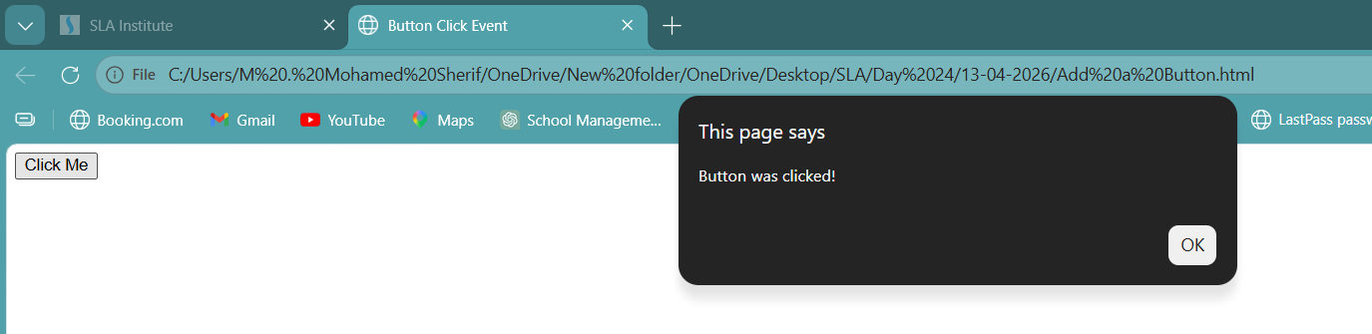

2. Show Input Value When Typing
Explanation:
This program displays the value entered by the user in real-time as they type.
Code:
<!DOCTYPE html>
<html>
<head>
<title>Show Input Value</title>
</head>
<body>
<input type="text" id="inputBox" placeholder="Type something...">
<p id="output"></p>
<script>
document.getElementById("inputBox").addEventListener("input", function() {
document.getElementById("output").textContent = this.value;
});
</script>
</body>
</html>
Output:
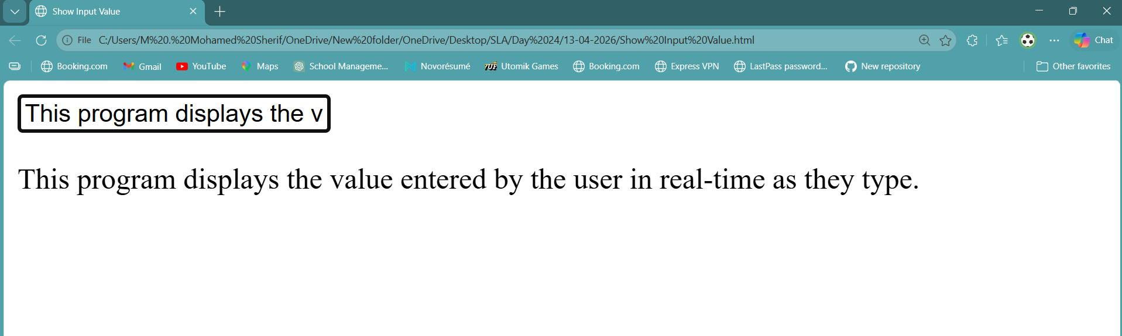
3. Add Event Listener to a Button
Explanation:
An event listener is used to attach an event (like click) to an element using JavaScript.
Code:
<!DOCTYPE html>
<html>
<head>
<title>Event Listener Example</title>
</head>
<body>
<button id="btn">Click Here</button>
<p id="message"></p>
<script>
let button = document.getElementById("btn");
button.addEventListener("click", function() {
document.getElementById("message").textContent = "Event Listener Triggered!";
});
</script>
</body>
</html>
Output:
