M. Mohamed Sherif
22nd April 2026
Day 29 - JavaScript Task
1. Show synchronous vs asynchronous execution
Synchronous execution runs code line by line, waiting for each step to finish. Asynchronous execution allows certain tasks to run later without blocking the program flow.
// Synchronous
console.log("Inning before strategic timeout");
function resumeTheGame() {
console.log("Game resuming after 3 seconds");
}
resumeTheGame();
console.log("Innings after strategic timeout");
// Asynchronous
console.log("Inning before strategic timeout");
setTimeout(() => {
console.log("Game resuming after 3 seconds");
}, 3000);
console.log("Innings after strategic timeout");
In synchronous code, the function runs immediately. In asynchronous code, setTimeout delays execution while other lines run first.
Output: 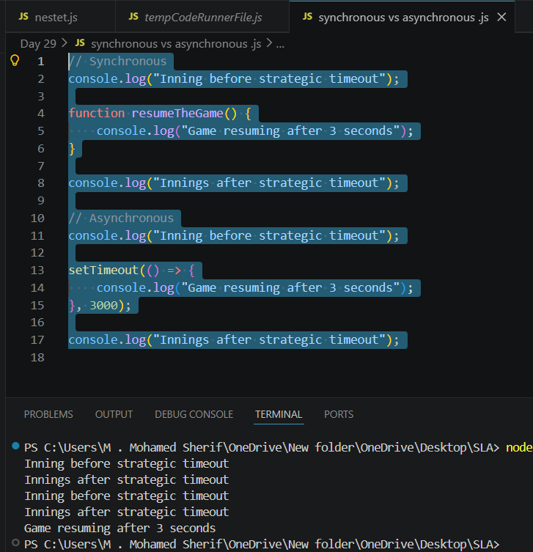
2. Print a message after 2 seconds
setTimeout() executes code after a specified delay, useful for timed events.
console.log("Game paused... taking a short 2-second break!");
setTimeout(() => {
console.log("Game resumed! Let's continue playing!");
}, 2000);
First message prints immediately. After 2 seconds, the second message appears.
Output:
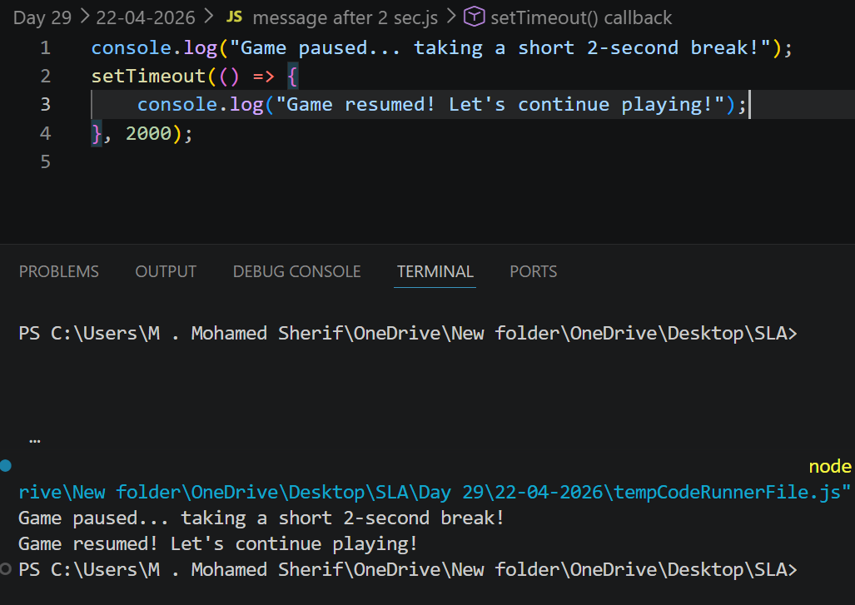

3. Print a counter every 1 second
setInterval() repeatedly runs code at fixed intervals until stopped.
let count = 0;
let intervalId = setInterval(() => {
count++;
console.log(count);
clearInterval(intervalId);
if (count > 10) {
}
}, 1000);
The counter increases every second. Once it exceeds 10, the interval stops.

Output:
