M. Mohamed Sherif
16th April 2026
Day 26 Task

1. Extract values from an array/object using destructuring:
Explanation: Destructuring allows extracting values from arrays or objects into variables easily.
Array Example:
let numbers = [10, 20, 30];
let [a, b, c] = numbers;
console.log(a);
console.log(b);
console.log(c);
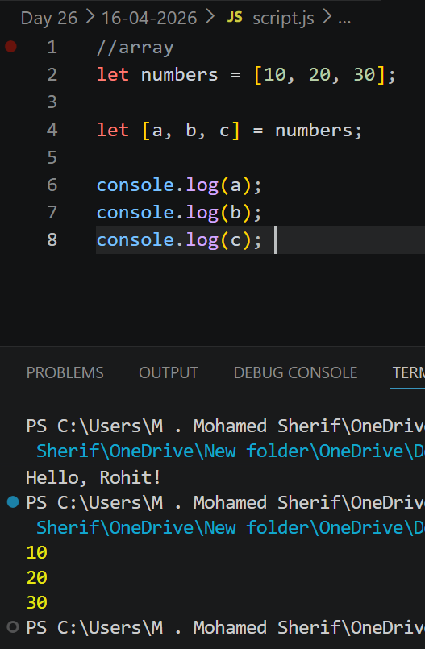
Object Example:
let person = { name: 'Sherif', age: 21 };
let { name, age } = person;
console.log(name);
console.log(age);
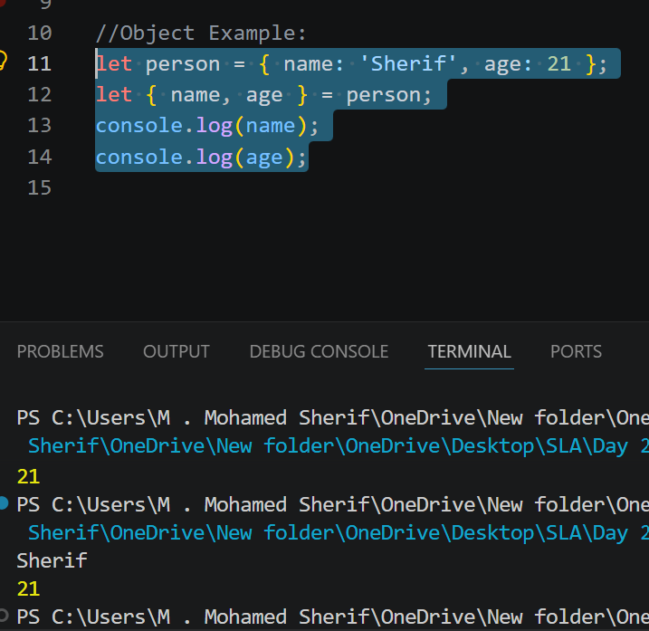
2. Copy an array using spread operator:
Explanation: The spread operator (...) is used to copy or expand array elements.
Code:
let original = [1, 2, 3];
let copy = [...original];
console.log(copy);
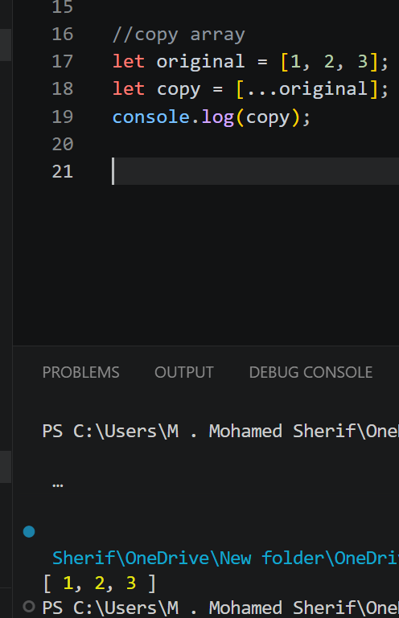
3. Write a function using rest operator:
Explanation: The rest operator (...) allows a function to accept multiple arguments as an array.
Code:
function sum(...numbers) {
let total = 0;
for (let num of numbers) {
total += num;
}
return total;
}
console.log(sum(1, 2, 3));
console.log(sum(10, 20, 30));
