M. Mohamed sherif
18-03-2026
Day - 7 - Task
1. Difference between <ul> and <ol>
<ul> | <ol>
Unordered list (bullets) | Ordered list (numbers)
Order not important | Order is important
- <ul> uses bullet points.
- <ol> uses numbers or letters.
- Use <ul> when order is not needed, <ol> when order is important.
<html>
<body>
<ul>
<li>Milk</li>
<li>Bread</li>
</ul>
<ol>
<li>Step 1</li>
<li>Step 2</li>
</ol>
</body>
</html>
Output:
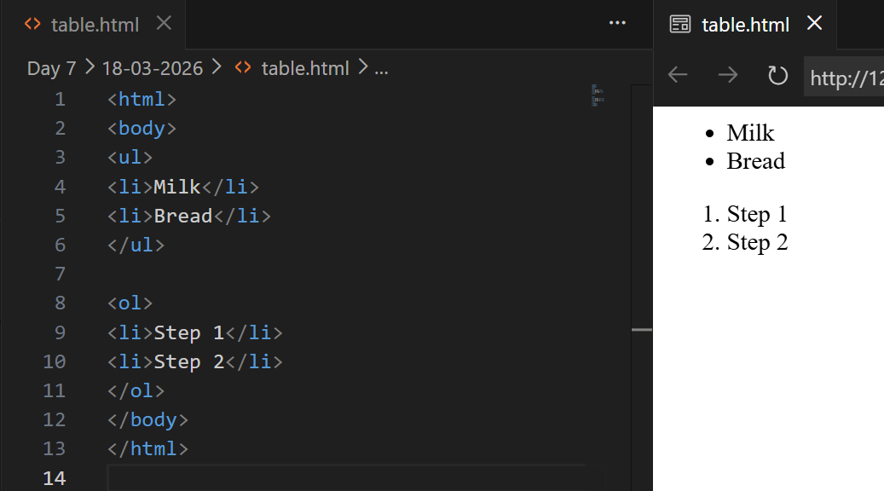
2. Using <li> and Nested Lists
- <li> defines each list item.
- <li> is used inside <ul> or <ol>.
- Nested list means list inside another list.
<html>
<body>
<ul>
<li>Fruits
<ul>
<li>Apple</li>
<li>Banana</li>
</ul>
</li>
</ul>
</body>
</html>
Output:
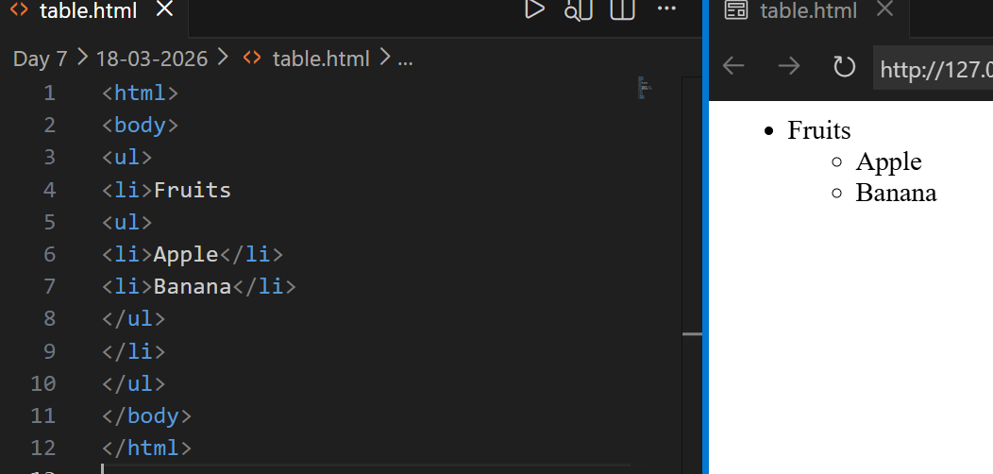
3. Structure of Tables
- <table> creates a table.
- <tr> creates rows.
- <td> creates columns (data cells).
<html>
<body>
<table border="1">
<tr>
<td>Name</td>
<td>Age</td>
</tr>
</table>
</body>
</html>
Output:
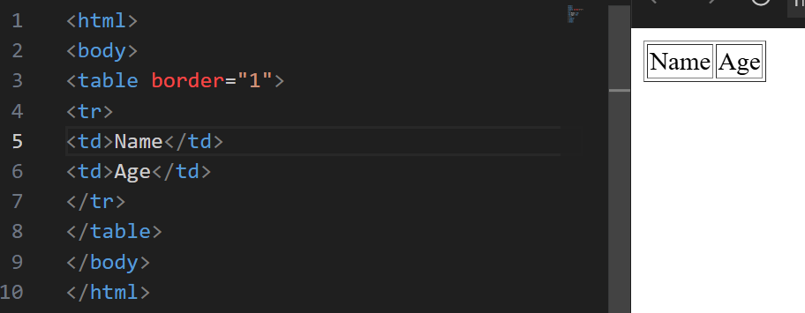
4. Using <th> and Difference between <td> and <th>
<td> | <th>
Normal data cell | Header cell
Not bold | Bold and centered
- <th> is used for headings.
- <td> is used for normal data.
- <th> text is bold by default.
<html>
<body>
<table border="1">
<tr>
<th>Name</th>
<th>Age</th>
</tr>
<tr>
<td>John</td>
<td>20</td>
</tr>
</table>
</body>
</html>
OUTPUT:
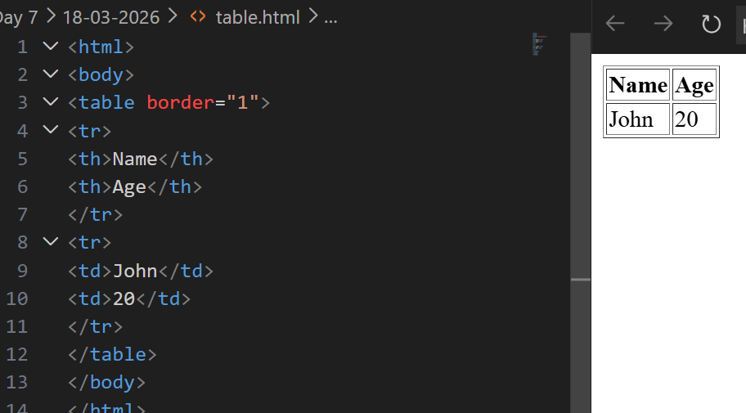
5. Table Attributes and CSS Styling
- colspan merges columns.
- rowspan merges rows.
- CSS is used for border, spacing, and padding.
<html>
<body>
<table border="1">
<tr>
<th colspan="2">Details</th>
</tr>
<tr>
<td rowspan="2">Name</td>
<td>John</td>
</tr>
<tr>
<td>Doe</td>
</tr>
</table>
</body>
</html>

OUTPUT:
