M. MOHAMED SHERIF
21st April 2026
28th Day Task – JavaScript
1. Write Concise Arrow Functions
// Normal Function
function add(a, b) {
return a + b;
}
// Arrow Function
const addArrow = (a, b) => a + b;
console.log(addArrow(5, 3));
Explanation:
- function add(a, b): creates a function with two inputs.
- return a + b: adds the numbers and gives result.
- const addArrow = (a, b) => a + b: shorter way using arrow function.
- => replaces 'function' keyword.
- console.log(addArrow(5, 3)): calls function and prints result (8).
Output:
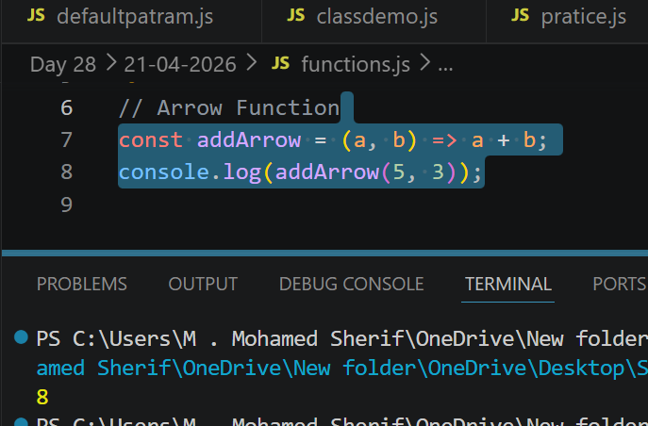
2. Create a Simple Class with Constructor and Method
class Person {
constructor(name, age) {
this.name = name;
this.age = age;
}
display() {
console.log("Name: " + this.name);
console.log("Age: " + this.age);
}
}
let person1 = new Person("Sherif", 21);
person1.display();
Explanation:
- class Person: creates a class.
- constructor(name, age): runs when object is created.
- this.name and this.age: store values inside object.
- display(): method to show data.
- console.log(): prints values.
- new Person("Sherif", 21): creates object.
- person1.display(): calls method and prints output.
Output: 