M. MOHAMED SHARIF
24 April 2026
DAY 30 – JS TASK
Question 1: Create a Project for Online Shopping. Add Products to the Cart and the Count should increase as the Products are added to the Cart.
Definition:
An online shopping cart system allows users to add products and keeps track of the number of items selected. It updates dynamically using JavaScript.
<!DOCTYPE html>
<html>
<head>
<title>Giant Online Mart</title>
<style>
body { font-family: Arial; margin: 0; background: linear-gradient(135deg, #ffecd2, #fcb69f); text-align: center; }
header { background: linear-gradient(to right, #6a11cb, #2575fc); color: #fff8e1; padding: 15px; position: relative; }
.cart { position: absolute; right: 20px; top: 20px; background: #ff7043; color: white; padding: 6px 12px; border-radius: 20px; }
ul { display: flex; justify-content: center; list-style-type: none; gap: 30px; padding: 20px; }
li { background: white; padding: 15px; border-radius: 10px; width: 150px; }
button { margin-top: 10px; padding: 8px; background: green; color: white; border: none; border-radius: 5px; }
footer { background: linear-gradient(to right, #ff9966, #ff5e62); color: #fffde7; padding: 10px; position: fixed; bottom: 0; width: 100%; }
</style>
</head>
<body>
<header><h1>Giant Online Mart</h1><div class="cart">Cart (<span id="cart-count">0</span>)</div></header>
<ul>
<li>Good Day Biscuit<button onclick="addToCart()">Add</button></li>
<li>Hide & Seek<button onclick="addToCart()">Add</button></li>
<li>Parle-G<button onclick="addToCart()">Add</button></li>
</ul>
<footer>Created by Mohammed Sharif</footer>
<script>
let cartCount = 0;
function addToCart() {
cartCount++;
document.getElementById("cart-count").textContent = cartCount;
}
</script>
</body>
</html>
Explanation:
This project displays products and allows users to add items to the cart. Each time the button is clicked, the cart count increases using JavaScript.
Output:
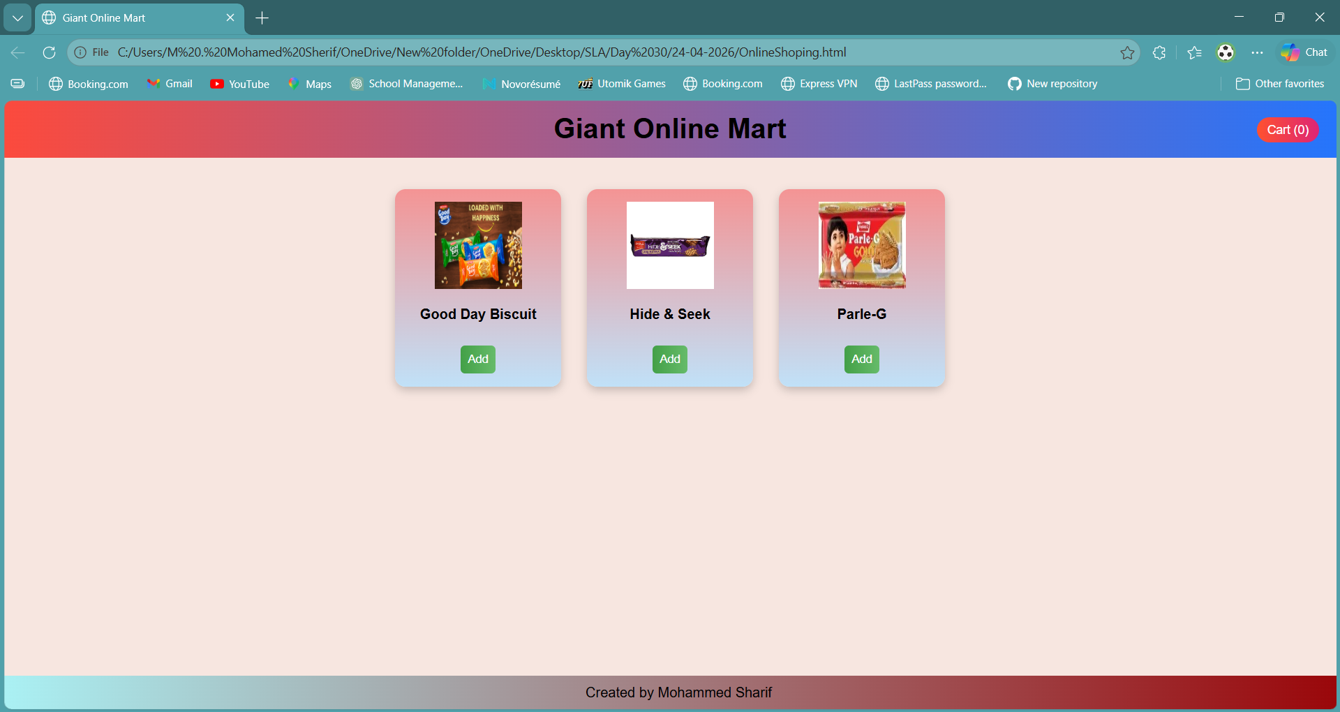
Question 2: Write a function that accepts a callback.
Definition:
A callback function is a function passed as an argument to another function and executed later.
function onlineShopping(userName, nextStep) {
console.log("Welcome to Sharif's Shopping Cart, " + userName);
nextStep();
}
function showOffer() {
console.log("Special Offer: Get 10% discount on your purchase!");
}
onlineShopping("Mohammed Sharif", showOffer);
Explanation:
The function onlineShopping accepts another function as a parameter (nextStep). After displaying the welcome message, it calls the nextStep function, which shows the offer.
Output:
