MOHAMED SHERIF. M
17/03/2026

Day 5 Task
- Learn the purpose of <form> in HTML. Create a basic form structure with action and method.
The <form> tag is used to:
- Collect user input (data).
- Send that data to another page or server
A <form> is like a container that holds:
- Text fields (name, email)
- Password box
- Radio buttons
- Checkboxes
- Submit button
All these inputs are grouped inside <form>.
Form for stud reg
<!DOCTYPE html>
<html lang="en">
<head>
<meta charset="UTF-8">
<meta name="viewport" content="width=device-width, initial-scale=1.0">
<title>Student Registration</title>
<style>
body {
font-family: Arial;
background: linear-gradient(to right, #a8e063, #56ab2f);
}
.container {
width: 400px;
margin: 50px auto;
background: white;
padding: 20px;
border-radius: 10px;
box-shadow: 0 0 10px gray;
}
h1 {
text-align: center;
color: green;
}

label {
font-weight: bold;
}
input, select, textarea {
width: 100%;
padding: 8px;
margin-top: 5px;
margin-bottom: 15px;
border-radius: 5px;
border: 1px solid gray;
}
input[type="radio"], input[type="checkbox"] {
width: auto;
}
.btn {
background: green;
color: white;
border: none;
padding: 10px;
cursor: pointer;
}
.btn:hover {
background: darkgreen;
}
fieldset {
border: 2px solid green;
margin-bottom: 15px;
}
legend {
color: green;
font-weight: bold;
}
</style>
</head>
<body>
<div class="container">
<form action="stdreg.html" method="POST">
<h1>Student Registration</h1>
<fieldset>
<legend>Personal Details</legend>
<label for="name">Student Name:</label>
<input id="name" type="text" placeholder="Enter your name" required>
<label for="pwd">Password:</label>
<input id="pwd" type="password" minlength="3" maxlength="8" required>
<label for="email">Email:</label>
<input id="email" type="email" placeholder="Enter email" required>
<label>Gender:</label><br>
<input type="radio" name="gender" required> Male
<input type="radio" name="gender"> Female
<br><br>
<label>Age:</label>
<input type="number" min="4" max="25" required>
</fieldset>
<fieldset>
<legend>Contact Details</legend>
<label>Mobile Number:</label>
<input type="tel" pattern="[0-9]{10}" placeholder="10-digit number" required>
<label>Address:</label>
<textarea rows="3" placeholder="Enter address"></textarea>
</fieldset>
<fieldset>
<legend>Course Details</legend>
<label>Select Course:</label>
<select>
<option>--Select--</option>
<option>BCA</option>
<option>MCA</option>
<option>B.Sc</option>
<option>B.Tech</option>
</select>
<label>Skills:</label><br>
<input type="checkbox"> HTML
<input type="checkbox"> CSS
<input type="checkbox"> JavaScript
</fieldset>
<input type="submit" value="Register" class="btn">
<input type="reset" value="Clear" class="btn">
</form>
</div>
</body>
</html>

Registration page
<!DOCTYPE html>
<html lang="en">
<head>
<meta charset="UTF-8">
<meta name="viewport" content="width=device-width, initial-scale=1.0">
<title>Success</title>
<style>
body {
background-color: #e0f7fa;
text-align: center;
font-family: Arial, sans-serif;
}
h1 {
margin-top: 200px;
color: green;
border: 2px solid green;
display: inline-block;
padding: 20px;
border-radius: 10px;
background-color: white;
}
</style>
</head>
<body>
<h1>✔ Student Registration is Completed</h1>
</body>
</html>
Output:
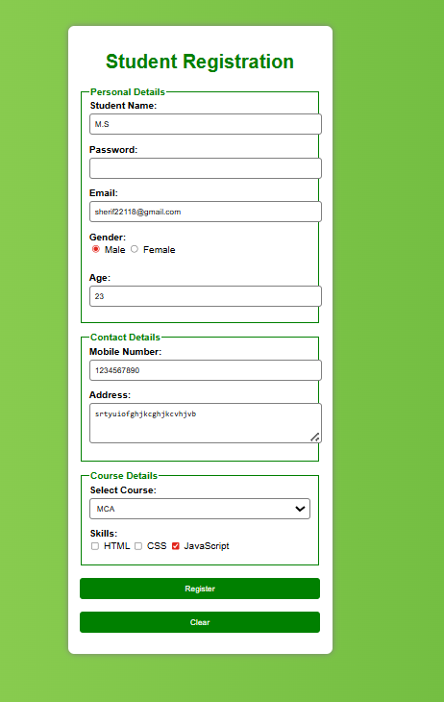

––

Practice using <input type="text">, <input type="password">, and <input type="email">. Create a login form.

<input type="text">
→ Used to enter normal text (username)
<input type="email">
→ Accepts only valid email format (like abc@gmail.com)
<input type="password">
→ Hides characters (security purpose)
required
→ User must fill before submitting
placeholder
→ Shows hint inside the box
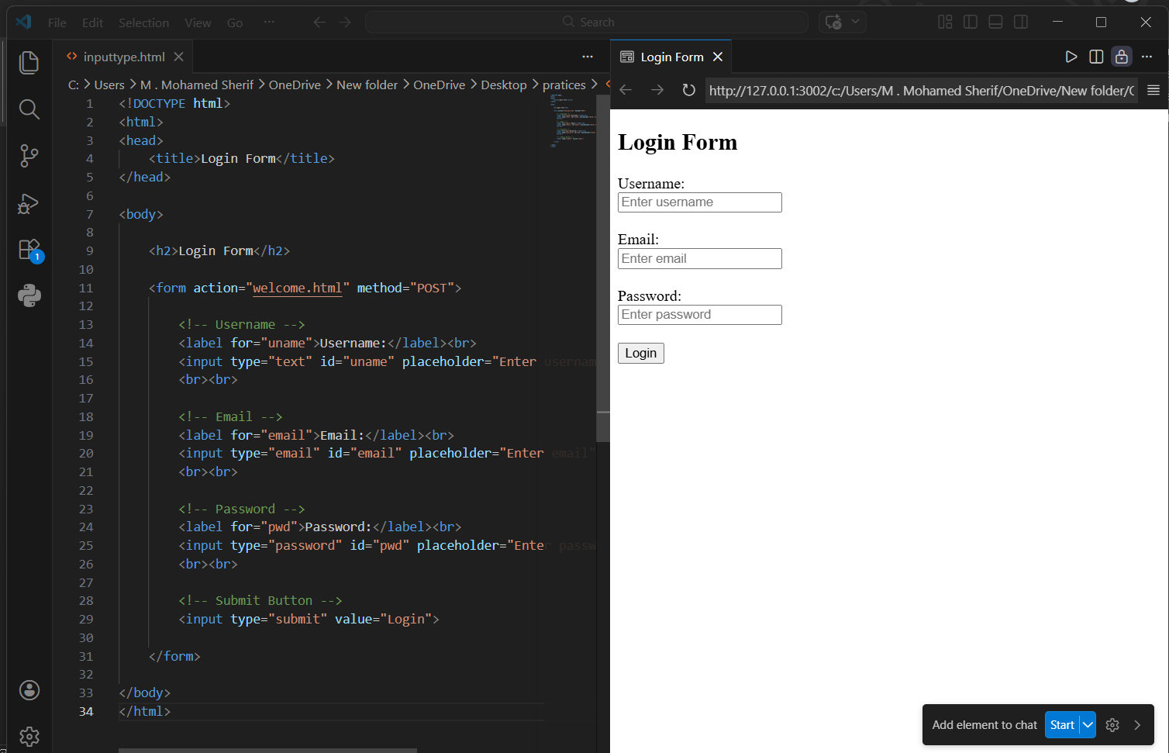

Use checkboxes for multiple choices, radio buttons for single choice, and number fields for numeric input.
1. Checkboxes (Multiple Choice)
Used when user can select more than one option
Example: Skills
- HTML
- CSS
- JavaScript
<input type="checkbox"> HTML
<input type="checkbox"> CSS
<input type="checkbox"> JavaScript

2. Radio Buttons (Single Choice)
- Used when user can select only one option
- Important: Same name is required
Example: Gender
<input type="radio" name="gender"> Male
<input type="radio" name="gender"> Female
3. Number Field (Numeric Input)
- Used to enter only numbers
<input type="number" min="1" max="100">
min → minimum value
max → maximum value
Type | Use | Selection
Checkbox | Multiple options | Many
Radio | One option only | One
Number | Numeric input only | Numbers

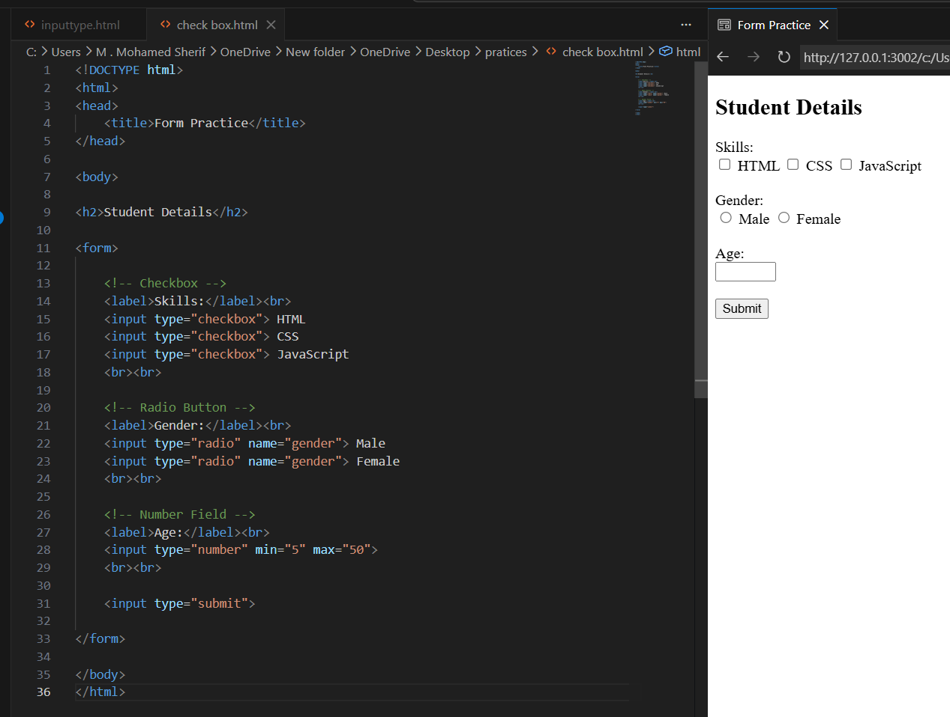

Learn <label> for accessibility and placeholder for hints. Connect labels with inputs using for and id.
1. What is <label>?
- <label> is used to describe an input field
It helps:
- Users understand what to enter
- Accessibility (screen readers)
- Clicking label focuses input
Example
<label>Name:</label>
<input type="text">
Connect <label> with <input> (Important)
We use:
- for (in label)
- id (in input)
Both must be same
Example
<label for="name">Name:</label>
<input type="text" id="name">
What is placeholder?
- placeholder gives a hint inside the input box
Example
<input type="text" placeholder="Enter your name">
Feature | Purpose
<label> | Describes input
for + id | Connects label & input
placeholder | Gives hint

Use required to make fields mandatory. Practice building a signup form where name, email, and password are required.

What is required?
- required makes a field mandatory
- User cannot submit form without filling it

Code for signup form:
<!DOCTYPE html>
<html>
<head>
<title>Signup Form</title>
</head>
<body style="font-family: Arial; text-align: center; margin-top: 50px;">
<h2>Signup Form</h2>
<form action="welcome.html" method="POST">
<label for="name">Name:</label><br>
<input type="text" id="name" placeholder="Enter your name" required>
<br><br>
<label for="email">Email:</label><br>
<input type="email" id="email" placeholder="Enter your email" required>
<br><br>
<label for="pwd">Password:</label><br>
<input type="password" id="pwd" placeholder="Enter password" required>
<br><br>
<input type="submit" value="Signup">
</form>
</body>
</html>
Output:
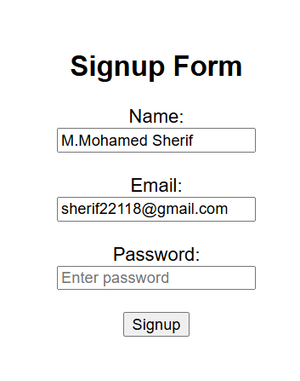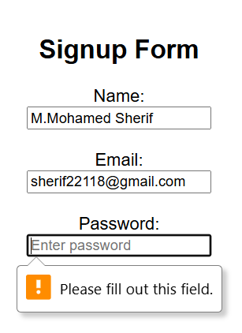

Explore built-in HTML5 validation (email format, number range, required). Test submitting forms with incorrect data.
HTML5 Built-in Validation – Notes
- HTML5 provides automatic validation without JavaScript. The browser itself checks user input before submitting the form.
1. Email Validation
Using:
<input type="email">
Purpose:
- Accepts only valid email format (example: abc@gmail.com)
- If invalid → browser shows error message
Example:
<input type="email" required>
Test cases:
- abc → invalid
- abc@ → invalid
- abc@gmail.com → valid
2. Number Range Validation
Using:
<input type="number" min="10" max="50">
Purpose:
- Restricts input between a minimum and maximum value
Example:
<input type="number" min="18" max="60" required>
Test cases:
- 10 → invalid (less than 18)
- 70 → invalid (greater than 60)
- 25 → valid
3. Required Field Validation
Using:
<input type="text" required>
Purpose:
- Prevents form submission if field is empty
Test case:
- Empty field → form will not submit
- Filled field → form submits

Build a registration form with text, email, password, gender (radio), hobbies (checkbox), age (number), and submit button. Include labels, placeholders, and validation.
<!DOCTYPE html>
<html>
<head>
<title>Registration Form</title>
</head>
<body style="font-family: Arial; margin: 40px;">
<h2>Registration Form</h2>
<form action="welcome.html" method="POST">
<label for="name">Full Name:</label><br>
<input type="text" id="name" placeholder="Enter your name" required>
<br><br>
<label for="email">Email:</label><br>
<input type="email" id="email" placeholder="Enter your email" required>
<br><br>
<label for="pwd">Password:</label><br>
<input type="password" id="pwd" placeholder="Enter password" minlength="4" maxlength="10" required>
<br><br>
<label>Gender:</label><br>
<input type="radio" id="male" name="gender" required>
<label for="male">Male</label>
<input type="radio" id="female" name="gender">
<label for="female">Female</label>
<br><br>
<label>Hobbies:</label><br>
<input type="checkbox" id="h1">
<label for="h1">Reading</label>

<input type="checkbox" id="h2">
<label for="h2">Sports</label>
<input type="checkbox" id="h3">
<label for="h3">Music</label>
<br><br>
<label for="age">Age:</label><br>
<input type="number" id="age" placeholder="Enter age" min="10" max="60" required>
<br><br>
<input type="submit" value="Register">
</form>
</body>
</html>
