M. MOHAMED SHERIF
07/04/2026
20th Day Task
1. Use push, pop, shift, unshift on an array.
Push:
Adds one or more elements to the end of an array.
Pop:
Removes the last element from an array.
Unshift:
Adds one or more elements to the beginning of an array.
Shift:
Removes the first element from an array.
Code:
let fruits = ["Apple", "Banana"];
console.log("Original Array:", fruits);
//push (add at end)
fruits.push("Mango");
console.log("After push:", fruits);
// pop (remove from end)
fruits.pop();
console.log("After pop:", fruits);
// unshift (add at beginning)
fruits.unshift("Orange");
console.log("After unshift:", fruits);
// shift (remove from beginning)
fruits.shift();
console.log("After shift:", fruits);
Output:
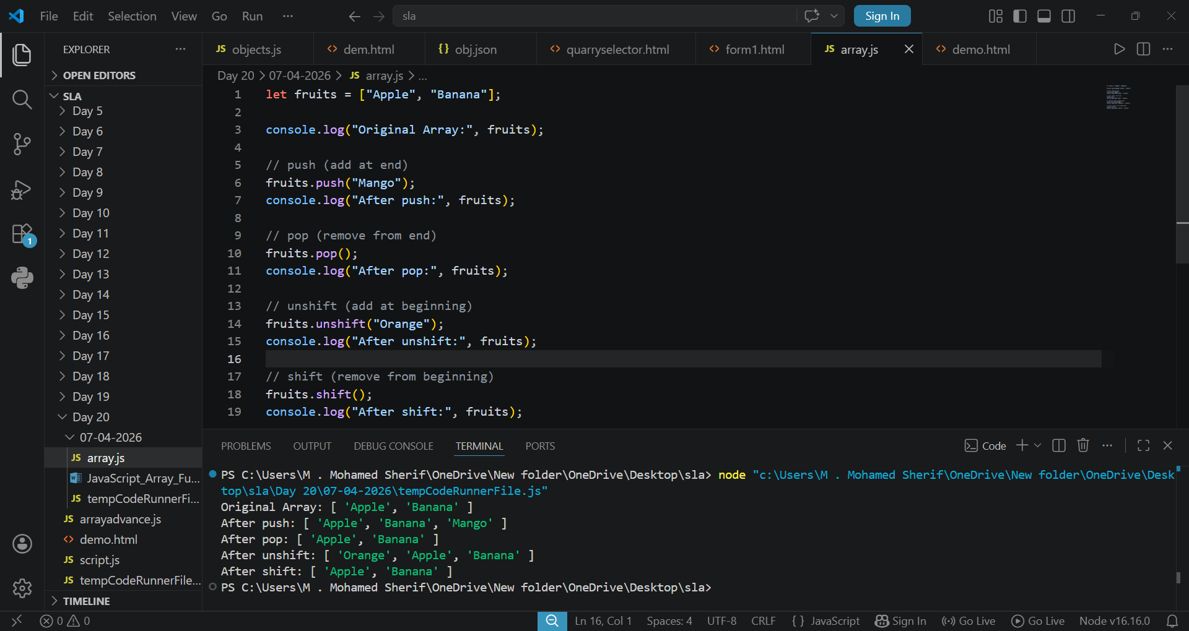

2. Print all elements of an array using for loop.
Definition:
A for loop is used to repeat a block of code a specific number of times. It is commonly used to iterate through arrays.
Code:
let numbers = [10, 20, 30, 40, 50];
for (let i = 0; i < numbers.length; i++) {
console.log(numbers[i]);
}
output:
