M. MOHAMED SHERIF
20-07-2026
Day 1 Python Task
- get 10 information from user then print it on screen
student = input("Enter your name: ")
Qualification = input("Enter your Qualification: ")
place = input("Enter your place: ")
Mobile_number = int(input("Enter your Mobile number: "))
age = int(input("Enter your Age: "))
tenth_percentage = float(input("Enter your 10th percentage: "))
twelfth_percentage = float(input("Enter your 12th percentage: "))
cgp = float(input("Enter your CGPA: "))
height = int(input("Enter your height (cm): "))
weight = int(input("Enter your weight (kg): "))
print(student)
print(Qualification)
print(place)
print(Mobile_number)
print(age)
print(tenth_percentage)
print(twelfth_percentage)
print(cgp)
print(height)
print(weight)
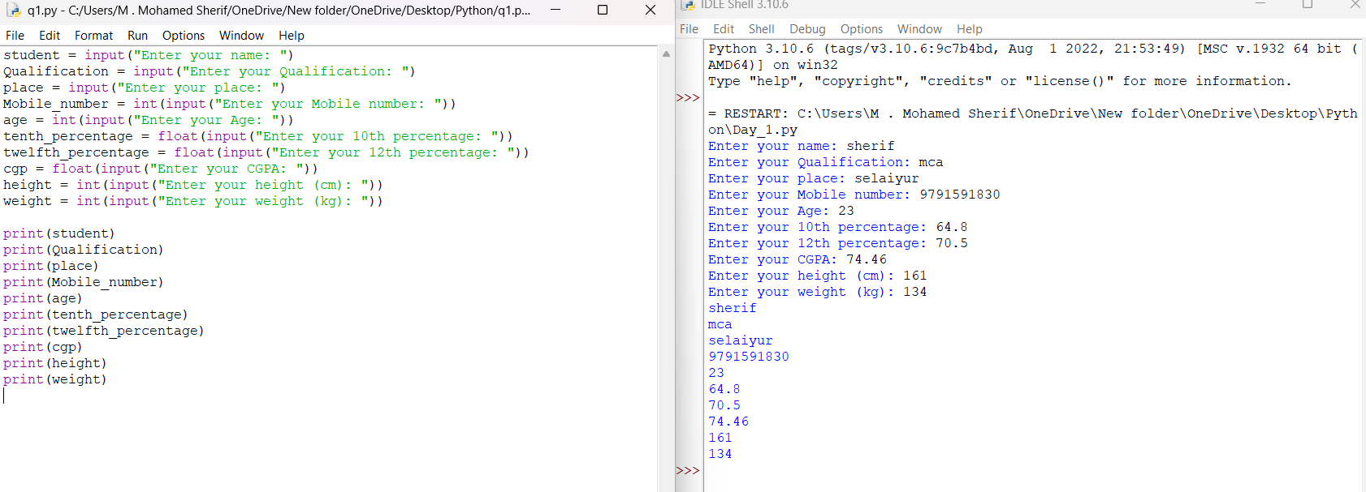

- get three subjects marks then find the average

sub1=int(input("Enter your mark"))
sub2=int(input("Enter your mark"))
sub3=int(input("Enter your mark"))

add=sub1+sub2+sub3/3

print("average",add)
