Smart Energy Monitoring and Control System
Project Summary

Project Overview
The Smart Energy Monitoring and Control System is an IoT-based solution designed to monitor electrical parameters in real time and provide remote data visualization.
The system uses an ESP32 microcontroller to collect voltage and current measurements, calculate electrical power and energy consumption, display the information locally on an LCD, and upload the data to the cloud through Wi-Fi.

Main Features
- Real-time Voltage Monitoring
  - ZMPT101B voltage sensor measures AC voltage
- Current Monitoring
  - ACS712-20A current sensor measures load current
- Power Calculation
  - The ESP32 calculates apparent power from voltage and current
- Energy Monitoring
  - Energy consumption is calculated in kWh over time
- Load Control
  - A 5 V relay controlled through a BC547 transistor allows the electrical load to be switched ON/OFF
- Local Display
  - A 16×2 I2C LCD displays Voltage, Current, Power, and Energy
- IoT Connectivity
  - The ESP32 connects to Wi-Fi and sends sensor data to ThingSpeak
- Cloud Monitoring
  - ThingSpeak provides graphical monitoring of Voltage, Current, Power, and Energy

System Architecture

Signal Processing Flow
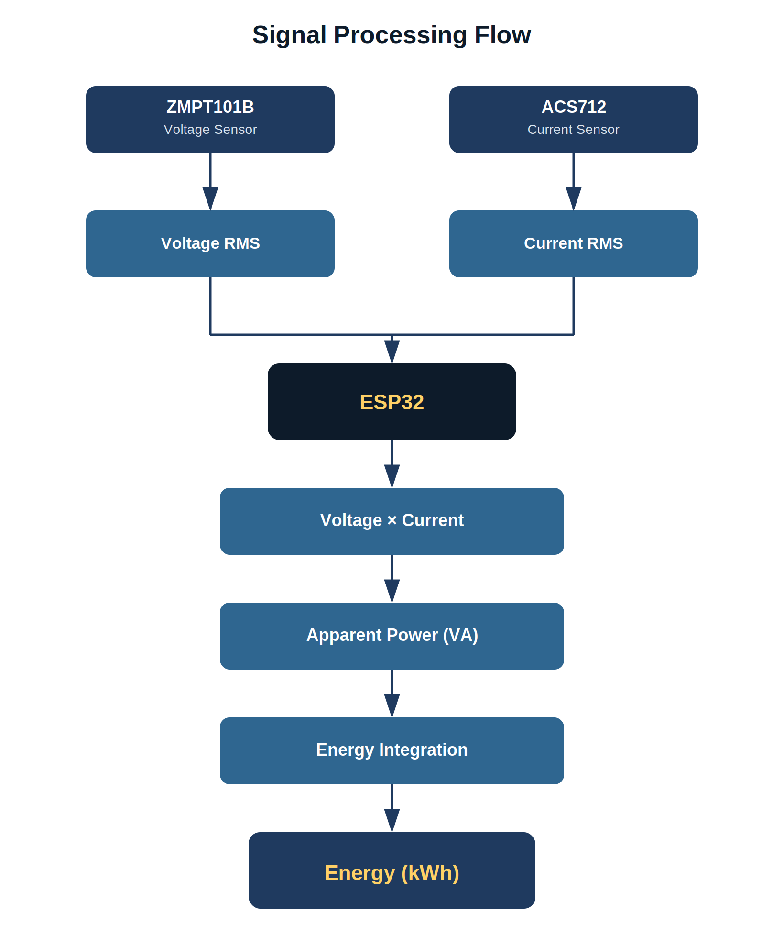
Figure 1 — Sensor data flow from acquisition to energy calculation

System Block Diagram
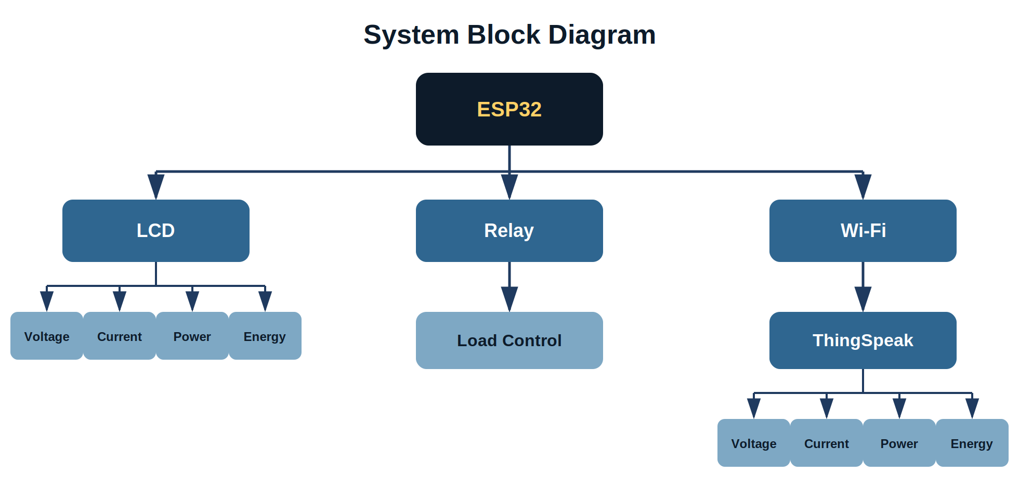
Figure 2 — ESP32 interfacing with the display, load control, and cloud platform

Hardware Used
Component | Purpose
ESP32 | Main controller + Wi-Fi
ZMPT101B | AC voltage measurement
ACS712-20A | AC current measurement
5 V Relay | Load control
BC547 | Relay driver
16×2 I2C LCD | Local display
5 V DC supply | Low-voltage electronics
ThingSpeak | Cloud monitoring
Electrical load | Demonstration / test load

Current Project Status
Hardware and software integration has been successfully demonstrated:
✓ Voltage sensing | ✓ Current sensing
✓ Relay control | ✓ LCD display
✓ Power calculation | ✓ Energy calculation
✓ ESP32 Wi-Fi | ✓ ThingSpeak upload
✓ Cloud graphs
The system has successfully transmitted live measurements from the ESP32 to ThingSpeak, where the parameters are displayed as graphs.

Example Output
Parameter | Observed Range
Voltage | ~240–265 V
Current | ~0.09–0.12 A
Power | ~20–32 VA
Energy | Increasing steadily (kWh)
Wi-Fi | Connected
Relay | ON
Cloud | Data uploaded successfully

Client Benefits
- Real-time electrical monitoring
- Local display of electrical parameters
- Remote monitoring through the Internet
- Historical data visualization
- Load ON/OFF control
- Energy-consumption tracking
- A foundation for future smart-home / industrial energy-management features

Future Enhancements
- Mobile application / dashboard
- Automatic overload protection
- Energy-cost calculation
- Daily / monthly energy reports
- Remote relay control
- Alerts for abnormal voltage/current
- Multiple-load monitoring
- More accurate true-power and power-factor measurement
Technical note: The present prototype calculates V × I as apparent power (VA). For billing-grade real-power measurement in watts and precise energy accounting for non-resistive loads, synchronized voltage/current waveform measurement and power-factor correction would be added.

One-line Client Explanation
“This project is an IoT-based smart energy monitoring and control system that measures voltage, current, power and energy using an ESP32, displays the information locally, controls the connected load through a relay, and provides real-time cloud monitoring through ThingSpeak.”

