**ASSIGNMENT – 6**

DATE – 23/03/2023

**QUESTION:**

Standard Number Access Control List(ACL)

**OUTPUT:**

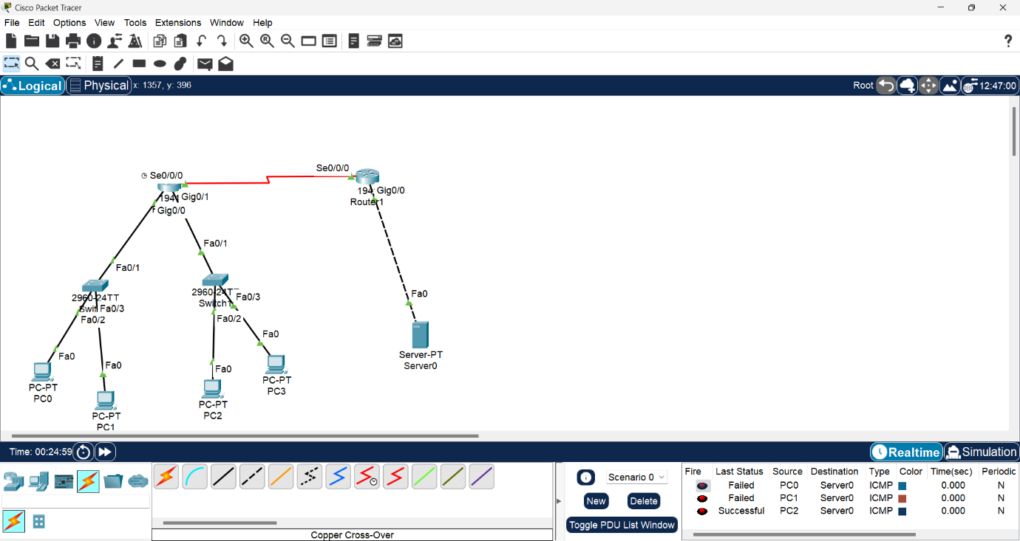

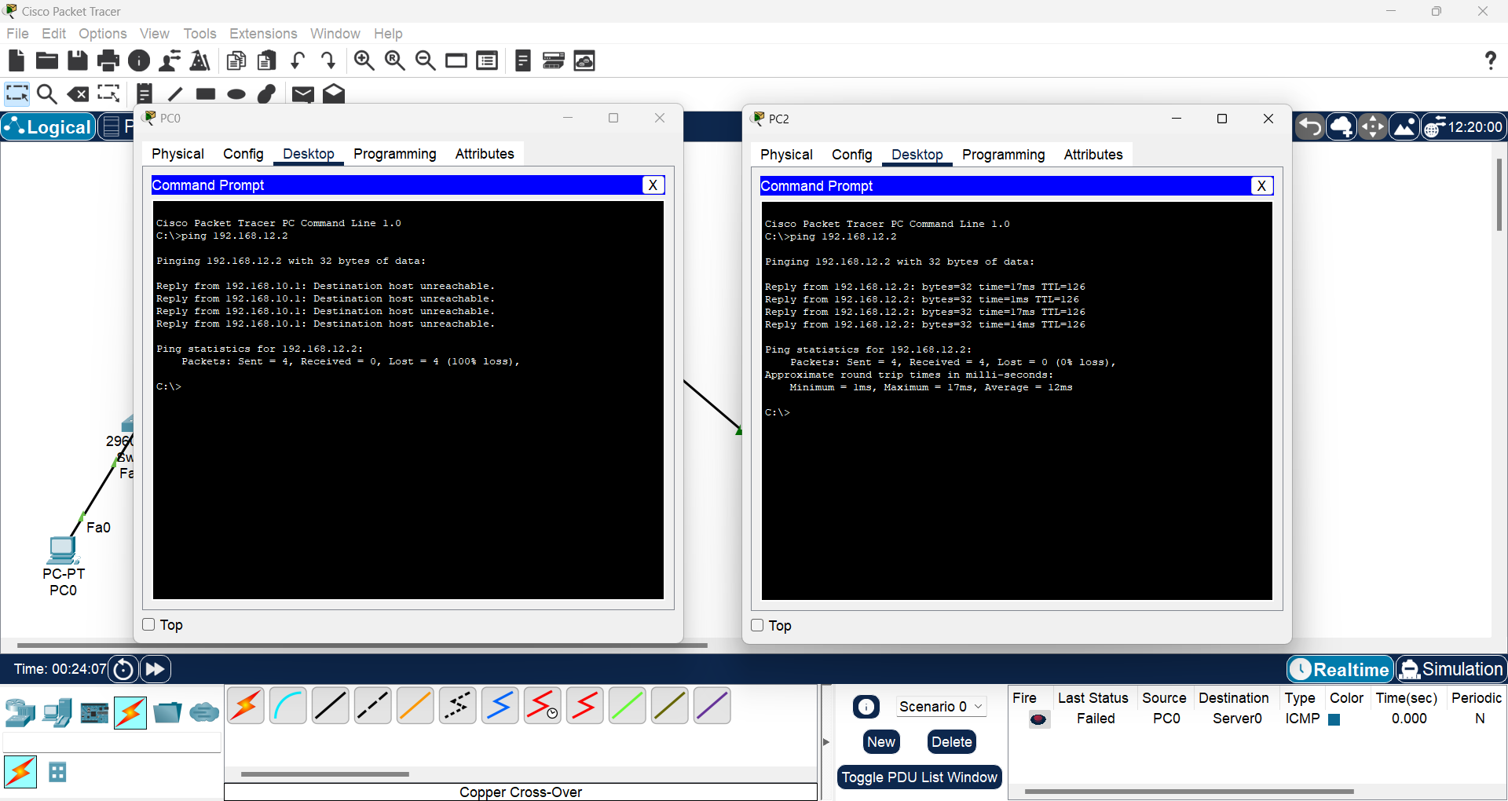

**CODE:**

**router0(DCE)**

> en

# config

(config)# interface gi 0/0

(config-if)# ip address 192.168.10.1 255.255.255.0

(config-if)# no shutdown

(config-if)# exit

(config)# interface gi 0/1

(config-if)# ip address 192.168.11.1 255.255.255.0

(config-if)# no shutdown

(config-if)# exit

(config)# interface se 0/0/0

(config-if)# ip address 10.0.0.1 255.0.0.0

(config-if)# clock rate 64000

(config-if)# no shutdown

(config-if)# exit

(config)# router eigrp 2

(config-router)# network 192.168.10.0

(config-router)# network 10.0.0.0

(config-router)# exit

(config)# router eigrp 2

(config-router)# network 192.168.11.0

(config-router)# network 10.0.0.0

(config-router)# exit

**router1(DCE)**

> en

# config

(config)# interface gi 0/0

(config-if)# ip address 192.168.12.1 255.255.255.0

(config-if)# no shutdown

(config-if)# exit

(config)# interface se 0/0/0

(config-if)# ip address 10.0.0.2 255.0.0.0

(config-if)# clock rate 64000

(config-if)# no shutdown

(config-if)# exit

(config)# router eigrp 2

(config-router)# network 192.168.12.0

(config-router)# network 10.0.0.0

(config-router)# exit

**FOR ACL:**

**router0(DCE):**

(config)# access-list 2 deny 192.168.10.0 0.0.0.255

(config)# access-list 2 permit any

(config)# interface se 0/0/0

(config-if)# ip access-group 2 out

**pc0**

IPv4 Address: 192.168.10.2

Subnet Mask: 255.255.255.0

Default Gateway: 192.168.10.1

**pc1**

IPv4 Address: 192.168.10.3

Subnet Mask: 255.255.255.0

Default Gateway: 192.168.10.1

**pc3**

IPv4 Address: 192.168.11.2

Subnet Mask: 255.255.255.0

Default Gateway: 192.168.11.1

**pc4**

IPv4 Address: 192.168.11.3

Subnet Mask: 255.255.255.0

Default Gateway: 192.168.11.1

**server0**

IPv4 Address: 192.168.12.2

Subnet Mask: 255.255.255.0

Default Gateway: 192.168.12.1

**QUESTION:**

Extended Number Access Control List(ACL)

**OUTPUT:**

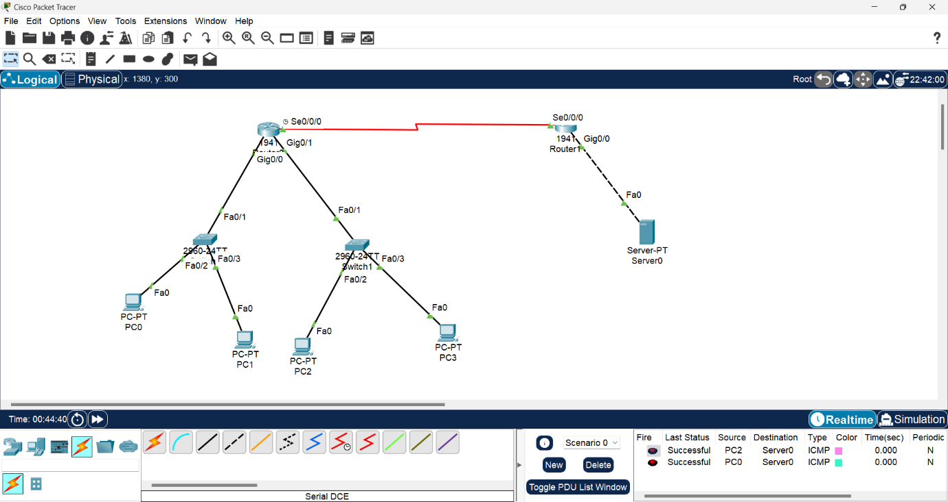

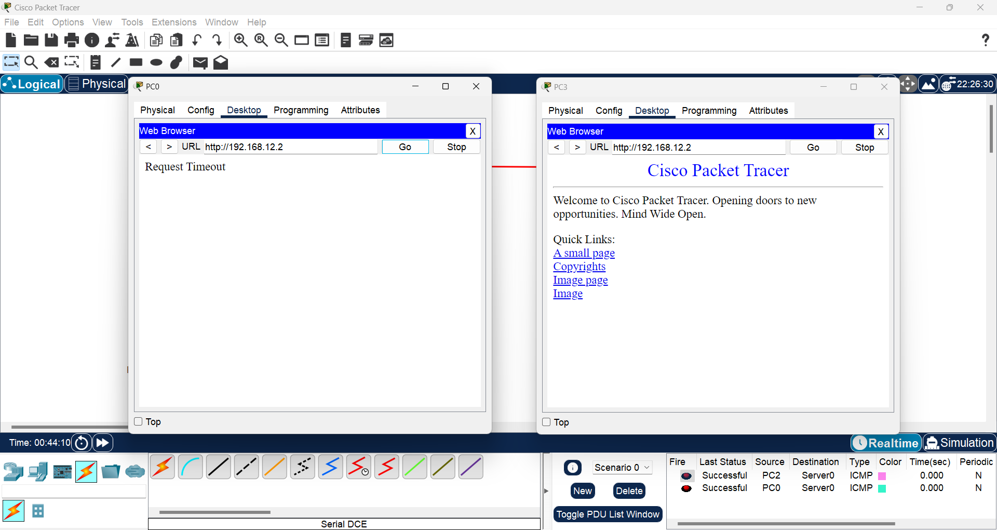

**CODE:**

**router0(DCE)**

> en

# config

(config)# interface gi 0/0

(config-if)# ip address 192.168.10.1 255.255.255.0

(config-if)# no shutdown

(config-if)# exit

(config)# interface gi 0/1

(config-if)# ip address 192.168.11.1 255.255.255.0

(config-if)# no shutdown

(config-if)# exit

(config)# interface se 0/0/0

(config-if)# ip address 10.0.0.1 255.0.0.0

(config-if)# clock rate 64000

(config-if)# no shutdown

(config-if)# exit

(config)# router eigrp 2

(config-router)# network 192.168.10.0

(config-router)# network 10.0.0.0

(config-router)# exit

(config)# router eigrp 2

(config-router)# network 192.168.11.0

(config-router)# network 10.0.0.0

(config-router)# exit

**router1(DCE)**

> en

# config

(config)# interface gi 0/0

(config-if)# ip address 192.168.12.1 255.255.255.0

(config-if)# no shutdown

(config-if)# exit

(config)# interface se 0/0/0

(config-if)# ip address 10.0.0.2 255.0.0.0

(config-if)# clock rate 64000

(config-if)# no shutdown

(config-if)# exit

(config)# router eigrp 2

(config-router)# network 192.168.12.0

(config-router)# network 10.0.0.0

(config-router)# exit

**FOR ACL:**

**router0(DCE):**

(config)# access-list 115 deny tcp 192.168.10.0 0.0.0.255 192.168.12.2 0.0.0.0

eq 80

(config)# access-list 115 permit ip any any

(config)# interface gi 0/0

(config-if)# ip access-group 115 out

**pc0**

IPv4 Address: 192.168.10.2

Subnet Mask: 255.255.255.0

Default Gateway: 192.168.10.1

**pc1**

IPv4 Address: 192.168.10.3

Subnet Mask: 255.255.255.0

Default Gateway: 192.168.10.1

**pc3**

IPv4 Address: 192.168.11.2

Subnet Mask: 255.255.255.0

Default Gateway: 192.168.11.1

**pc4**

IPv4 Address: 192.168.11.3

Subnet Mask: 255.255.255.0

Default Gateway: 192.168.11.1

**server0**

IPv4 Address: 192.168.12.2

Subnet Mask: 255.255.255.0

Default Gateway: 192.168.12.1