**ASSIGNMENT – 2**

DATE – 09/02/2023

**QUESTION:**

rip2 routing protocol

**OUTPUT:**

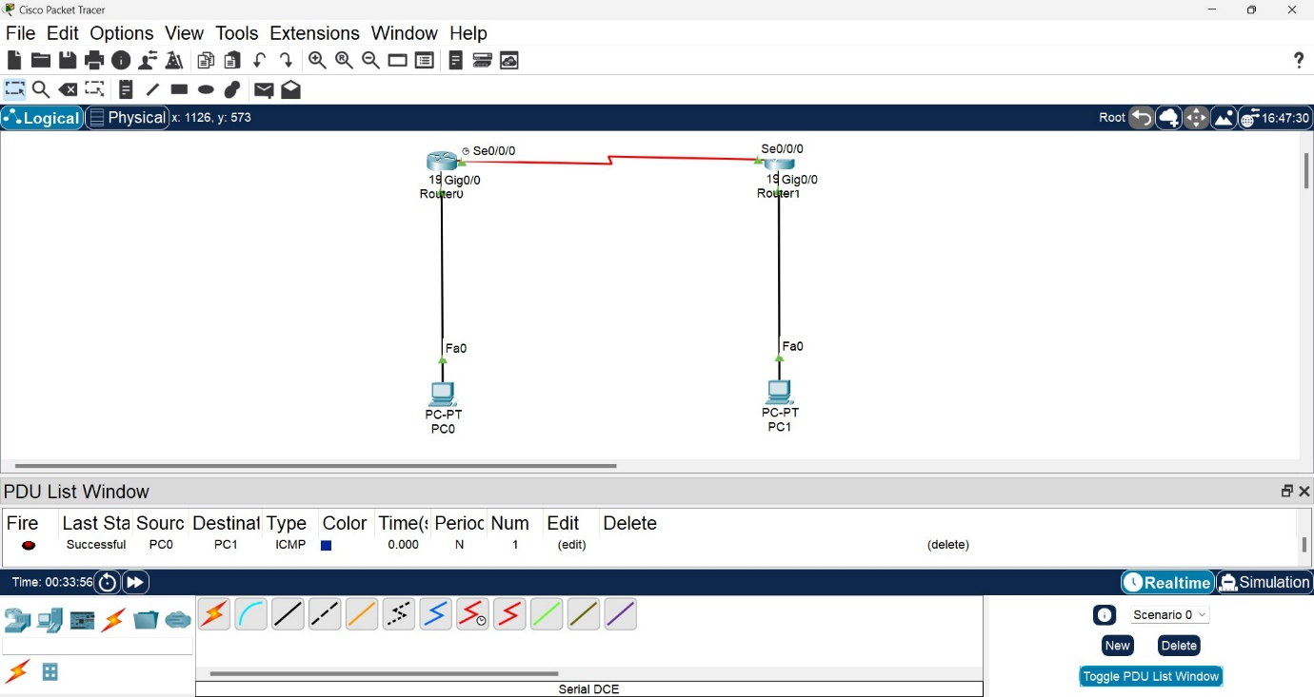

**CODE:**

**router1(DTE)**

> en

# config

(config)# interface gi 0/0

(config-if)# ip address 192.168.10.1 255.255.255.0

(config-if)# no shutdown

(config-if)# exit

(config)# interface se 0/0/0

(config-if)# ip address 10.0.0.1 255.0.0.0

(config-if)# no shutdown

(config-if)# exit

(config)# router rip

(config-router)# network 192.168.10.0

(config-router)# network 10.0.0.0

(config-router)# version 2

**router2(DCE)**

> en

# config

(config)# interface gi 0/0

(config-if)# ip address 192.168.11.1 255.255.255.0

(config-if)# no shutdown

(config-if)# exit

(config)# interface se 0/0/0

(config-if)# ip address 10.0.0.2 255.0.0.0

(config-if)# clock rate 64000

(config-if)# no shutdown

(config-if)# exit

(config)# router rip

(config-router)# network 192.168.11.0

(config-router)# network 10.0.0.0

(config-router)# version 2

**pc1**

IPv4 Address: 192.168.10.2

Subnet Mask: 255.255.255.0

Default Gateway: 192.168.10.1

**pc2**

IPv4 Address: 192.168.11.2

Subnet Mask: 255.255.255.0

Default Gateway: 192.168.11.1

**QUESTION:**

eigrp routing protocol

**OUTPUT:**

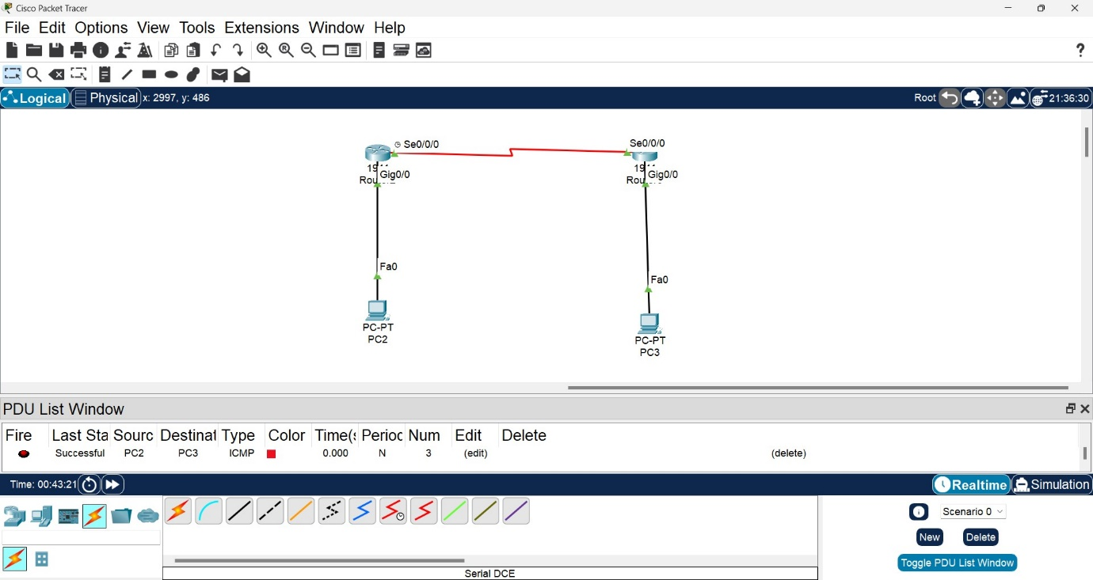

**CODE:**

**router1(DTE)**

> en

# config

(config)# interface gi 0/0

(config-if)# ip address 192.168.10.1 255.255.255.0

(config-if)# no shutdown

(config-if)# exit

(config)# interface se 0/0/0

(config-if)# ip address 10.0.0.1 255.0.0.0

(config-if)# no shutdown

(config-if)# exit

(config)# router eigrp 2

(config-router)# network 192.168.10.0

(config-router)# network 10.0.0.0

**router2(DCE)**

> en

# config

(config)# interface gi 0/0

(config-if)# ip address 192.168.11.1 255.255.255.0

(config-if)# no shutdown

(config-if)# exit

(config)# interface se 0/0/0

(config-if)# ip address 10.0.0.2 255.0.0.0

(config-if)# clock rate 64000

(config-if)# no shutdown

(config-if)# exit

(config)# router eigrp 2

(config-router)# network 192.168.11.0

(config-router)# network 10.0.0.0

**pc1**

IPv4 Address: 192.168.10.2

Subnet Mask: 255.255.255.0

Default Gateway: 192.168.10.1

**pc2**

IPv4 Address: 192.168.11.2

Subnet Mask: 255.255.255.0

Default Gateway: 192.168.11.1