ASSIGNMENT – 8

DATE – 06/03/2023

**QUESTION:**

Virtual Local Area Network (VLAN)

**OUTPUT:**

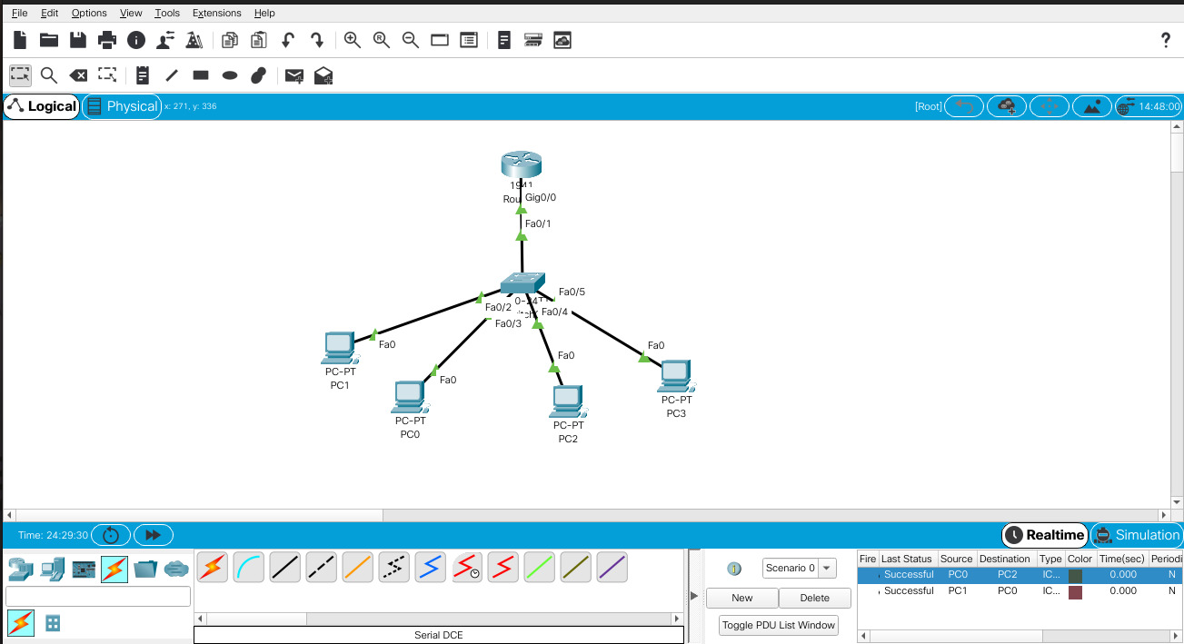

**CODE:**

**switch0**

> en

# vlan database

#(vlan) vlan 2 name CSE

#(vlan) vlan 3 name IT

# exit

# config terminal

# interface range 0/2 – 3

# switchport mode access

# switchport access vlan 2

# exit

# interface range 0/4 – 5

# switchport mode access

# switchport access vlan 3

**router0**

> en

# config terminal

# interface gi 0/0

# no shutdown

# interface gi 0/0.1

# encapsulation dot1q 2

# ip address 192.168.10.1 255.255.255.0

# exit

# interface gi 0/0.2

# encapsulation dot1q 3

# ip address 192.168.11.1 255.255.255.0

**For inter VLAN:**

**swtich0**

>en

# config terminal

# interface fa 0/1

#switchport mode trunk

**Configurations**

**pc0**

IPv4 Address: 192.168.10.2

Subnet Mask: 255.255.255.0

Default Gateway: 192.168.10.1

**pc1**

IPv4 Address: 192.168.10.3

Subnet Mask: 255.255.255.0

Default Gateway: 192.168.10.1

**pc2**

IPv4 Address: 192.168.11.2

Subnet Mask: 255.255.255.0

Default Gateway: 192.168.11.1

**pc3**

IPv4 Address: 192.168.11.3

Subnet Mask: 255.255.255.0

Default Gateway: 192.168.11.1