# **BOBITNKR525519**

# **SOFTWARE ENGINEERING 2 PROJECT REPORT**

The contact tracing app is designed to work in a hospital and help the health workers trace contacts. When a user (medical practitioner/contact tracer) opens the web based app they will be met with a registration page that will require their credentials and on registration they will be able to access the information that is fed in the system. On the home page a tree like follow up list will be presented with names of the people that have tested positive and those they have had contact with a date will be submitted for easy analysis of the spread of the disease the parent patient(patient zero) will be at the top and the rest will follow. To use the one will need basic computer skills and data can only be accessed by an ICT expert to avoid the data being altered. Below is an entity diagram that shows how the web app will flow.

Access

Login

Register

USER

Patient details

Admin

Updates

Database

Below are screenshots of how the web application pages should look like;

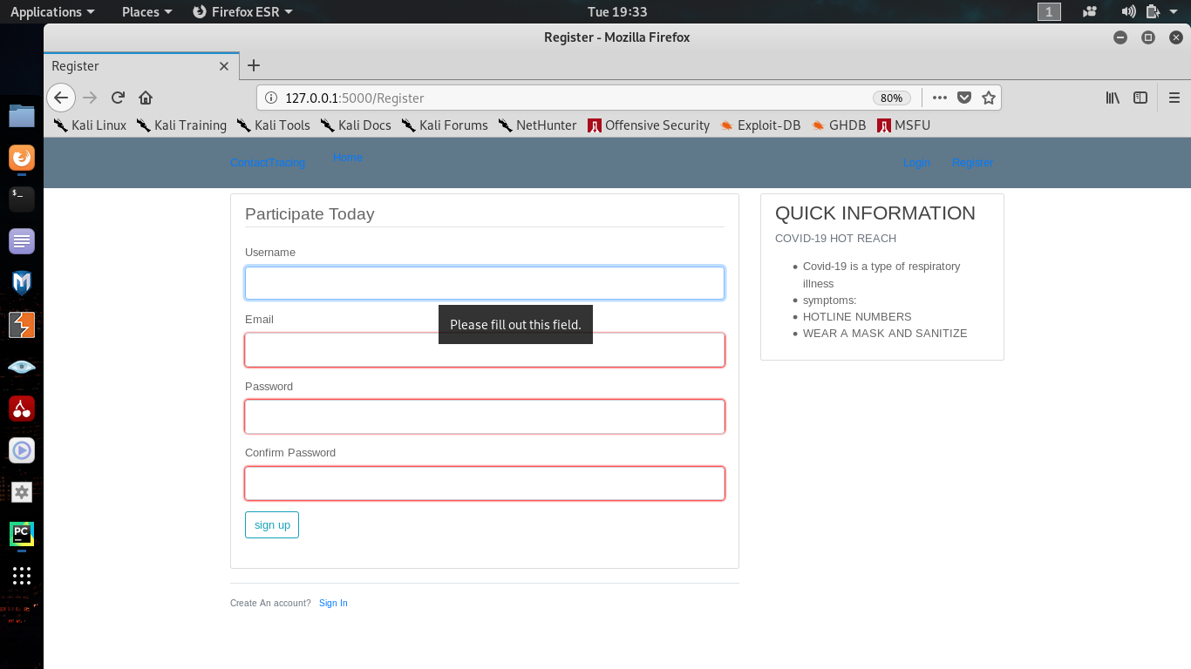

Under this page the user is presented with the register form where a username, email and password is needed.

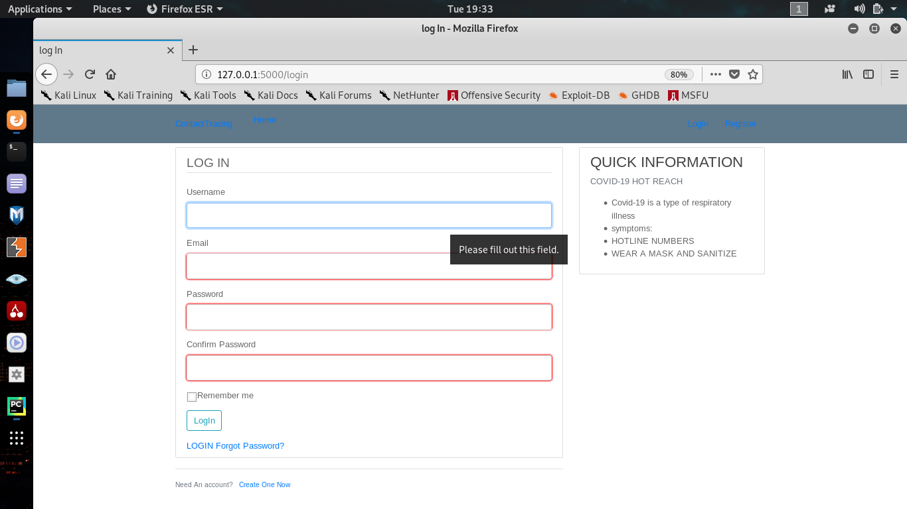

Above is a log in page showing details needed to access the contact tracing information. Once they are logged in the page below is presented

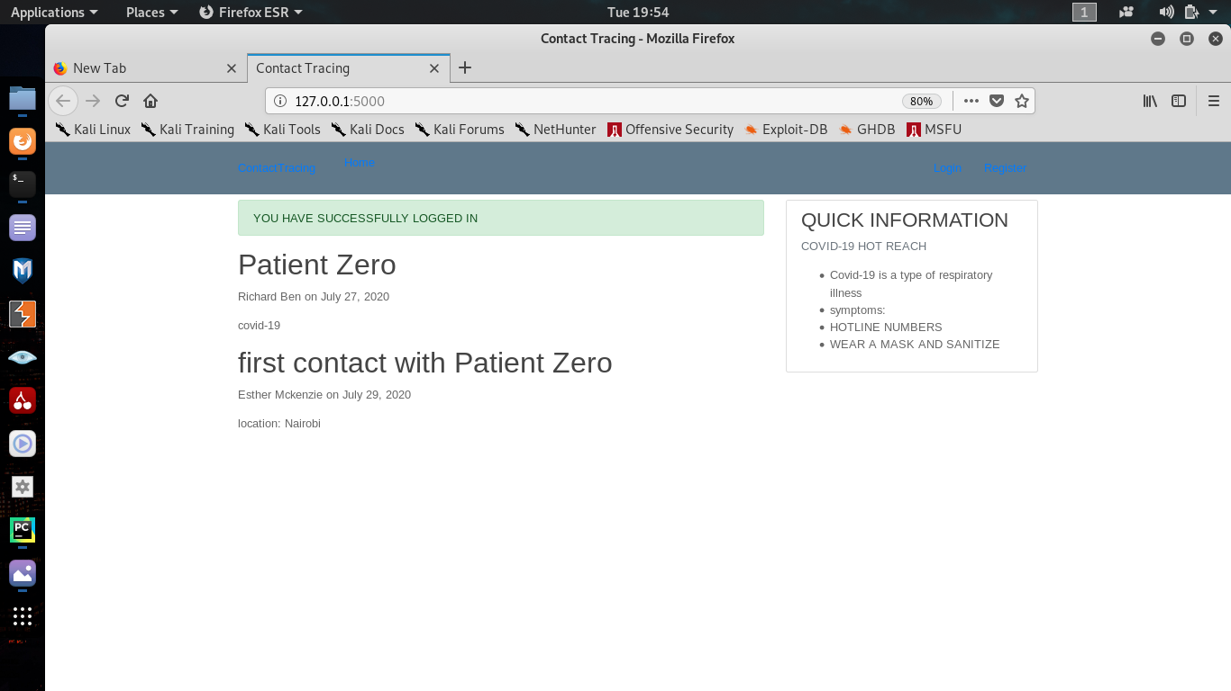

The web applications code project is linked here:

https://github.com/techspu/TechFundi_bobitnkr525519#techfundi_bobitnkr525519