NEPOPS — DIGITAL MARKETING
MONTHLY MANAGEMENT REPORT
Field | Detail
Period | September 2026
Area | Marketing — NEPOPS
Responsible supervisor | Prerana Subedi
Clients / projects | Pensiones México · MÉVIAL
Purpose of the report | To report what was done, what results were achieved, how the area evolved compared with the previous month, what is currently in progress, and the objectives for the following month.

Figures marked “calc.” are calculated from the reported figures.

Executive summary
- Volume fell again at Pensiones México: messages 4,489 → 3,769 (-16.0%), assigned 40 → 22 (-45.0%), closures 8 → 3 (-62.5%).
- Spend fell 12.9% ($49,520 → $43,146.05, calc.), while impressions fell 19.7% and reach 18.6%. Cost per 1,000 impressions rose from $48.21 to $52.29 (+8.5%, calc.).
- Cost per message held roughly flat ($11.03 → $11.45, +3.8%), but cost per assigned rose 58.4% ($1,238 → $1,961) and cost per closure 132.3% ($6,190 → $14,382), all calc.
- Conversion weakened at both downstream stages: message → assigned 0.89% → 0.58% and assigned → closure 20.0% → 13.6% (calc.). In August only the first stage had declined.
- Campaign results diverged: PAM (+3.0%) and Pensionate (+10.2%) were the only campaigns to increase messages, and both lowered their cost per message. Barcco (-30.9%) and Retiro Vertical (-30.2%) had the largest declines.
- August's volume objective was met: at least 40% of July's messages (~2,400) was required; September's 3,769 equal 62.2% of July (calc.).
- Mid-month reset: from 15 September, campaigns were returned as far as possible to their July geographic and creative configuration. The team observed a significant improvement in message volume afterwards; this has not yet been quantified.
- Operational issues: GHL configuration (seven Meta business portfolios could not be managed in one sub-account and were split into four advisor sub-accounts); the PAM page, which sat in a personal portfolio, was transferred to a business portfolio with a new ad account.
- New campaign: Prosperar launched in Guadalajara on 21 September (62 messages, $1,040.32).
- MÉVIAL: the campaign stayed active without changes. Landing page views fell to 2,922 (-18.3%) at a higher cost per view (€0.070 → €0.103). Of 2,096 users who started the diagnostic, 2 reached step 2 and none completed it.

1. What did we do during September?
Activity indicator | September 2026
Campaigns active / launched | 8 in total: 7 at Pensiones México (Pensión 360, Pensionate, Nosotros, Retiro Vertical, Barcco, PAM and Prosperar) + 1 MÉVIAL campaign.
Videos / Reels | 14 in total: 12 for Pensiones México (1 organic) and 2 promotional videos prepared for MÉVIAL.
Posts and designs | 7 paid posts, 5 carousels and 45 organic posts.
Other actions | GHL sub-account setup per advisor; new business portfolio and ad account for PAM; restructuring rounds on 4, 15, 21 and 28–29 Sep; Retiro Vertical verification and relaunch; Barcco switched to WhatsApp Business (WABA) on 29 Sep.

Detail of the work carried out
- Pensiones México — campaign restructuring. Geographic expansion on 4 Sep, a return to the July configuration on 15 Sep, age range raised to 60–65+ and location refinement on 21 Sep, new Reels on 25 Sep, and new campaigns and ad-set changes on 28–29 Sep.
- New campaign. Prosperar launched in Guadalajara on 21 Sep (one circle, one Reel, one post).
- GHL implementation. Sub-accounts reorganized into four, one per advisor's Facebook account and business page. Technical help from Andres and Lorgio for a long-term solution.
- Content production. 12 videos for Pensiones México, 2 promotional videos for MÉVIAL, 7 paid posts, 5 carousels and 45 organic posts. Advisor Reels were introduced in Retiro Vertical, Barcco and PAM.
- Monitoring. The Mexico campaigns are analyzed daily, with new promotional and organic material produced alongside.

2. Clients / projects

A. Pensiones México

What did we do during September?
Date | Main action
4 Sep | Geographic expansion. Pensión 360: whole CDMX in one set (25 miles). Pensionate: CD Juárez 3 circles; Chihuahua expanded from 10 to 12 miles. Nosotros: both halves of CDMX. PAM: new campaign with 3 new Monterrey circles, same materials. Barcco: 3 Monterrey circles. Retiro Vertical: beneficiary verified using Rocio's ID and the paused campaign relaunched.
15 Sep | Return to the July configuration. Barcco relaunched with the July setup, budget reduced from $300 to $250/day, 2 ad sets (Monterrey halves, $150 / $100), AI post variations, age 58–65+. PAM: new ad account in a new business portfolio inside Pablo's account (same Facebook page), July ad structure, Monterrey $100 + Border $100, age 58–65+. Pensionate: July setup (Chihuahua + CD Juárez, $200, one ad set), age 57–65+, June Reel and July post. Retiro Vertical: 3 campaigns (Mérida, Campeche, Cancún; $250/3 ≈ $83 per city), age 57–65+, July Reel. Pensión 360: 2 ad sets covering CDMX halves ($300), one including Toluca, age 57–65+. Nosotros: July Reel and post, whole CDMX, no Toluca.
21 Sep | Age raised to 60–65+ across all campaigns, plus location refinement. Retiro Vertical: Mérida (Umán, Komchén, Chablekal, Conkal, Tixkokob), Cancún (Playa del Carmen), Campeche (Samulá, Lerma, China). Nosotros: two ad sets (upper and lower halves). Pensionate: CD Juárez 4 circles. Barcco: two halves of Monterrey (2 + 4 circles). PAM: more bubbles (Border + Monterrey). Prosperar launched in Guadalajara.
25 Sep | Retiro Vertical: Reel replaced with advisor Rocio's Reel in all 3 cities. Pensión 360: Reel updated with a CDMX Reel.
28 Sep | Pensión 360: new campaign testing two Reel angles (CDMX-specific video vs. the earlier mother–daughter Reel), 2 ad sets (20 miles). Retiro Vertical: new campaign with Mérida and Cancún (8 miles) ad sets; Campeche removed; Rocio's Reel. Barcco: 1 ad set covering all of Monterrey, 2 Reels (1 advisor, 1 from July).
29 Sep | Barcco switched to WhatsApp Business (WABA). PAM: 2 ad sets, Monterrey $150 + Matamoros $50 (Reynosa and Río Bravo removed), advisor Reel only. Nosotros: 1 ad set ($250), one large bubble, CDMX Reel.

Problems during the month
- GHL account configuration. Seven different Meta business portfolios for the same client were being integrated into one sub-account, which became unmanageable. The setup was split into four sub-accounts, one per advisor (each advisor's Facebook account has its own business page).
- PAM page in a personal portfolio. Advisor Jose Luis had created the PAM page in his personal portfolio rather than a business portfolio, so it could not be connected to his sub-account. Resolved by gaining access to the page, creating a new business portfolio inside Pablo's account and assigning the page to Jose Luis, as requested by Mariano.
- Message and lead drop. The campaigns were already struggling to generate messages and qualified leads in August. Optimization continued throughout September, with the major reset on 15 Sep.

Results and comparison with August
Indicator | August | September | Change
Paid reach | 358,211 | 291,478 | -18.6%
Paid impressions | 1,027,101 | 825,175 | -19.7%
Messages | 4,489 | 3,769 | -16.0%
Assigned | 40 | 22 | -45.0%
Closures (sales) | 8 | 3 | -62.5%
Spend (calc., all campaigns) | $49,520 | $43,146.05 | -12.9%

Reach, impressions, messages, assigned and closures are the monthly summary figures. Total reach is the sum of each campaign's reach, not unique people. September spend is the sum of the seven campaigns' reported spend.

Reach and impressions by campaign
Campaign | Reach Aug. | Reach Sep. | Chg. | Impr. Aug. | Impr. Sep. | Chg.
Pensión 360 | 86,839 | 72,687 | -16.3% | 205,374 | 156,898 | -23.6%
Pensionate | 46,274 | 36,102 | -22.0% | 161,203 | 140,325 | -13.0%
Nosotros | 43,438 | 37,092 | -14.6% | 124,702 | 101,761 | -18.4%
Retiro Vertical | 54,775 | 42,979 | -21.5% | 147,511 | 126,204 | -14.4%
Barcco | 66,874 | 45,628 | -31.8% | 189,405 | 133,888 | -29.3%
PAM | 60,011 | 56,990 | -5.0% | 198,906 | 169,107 | -15.0%
Prosperar (new, from 21 Sep) | — | 4,266* | — | — | 8,502* | —

PAM combines its two ad accounts from 15 Sep (reach 31,742 + 25,248; impressions 80,553 + 88,554; calc.). *Prosperar was reported as reach 8,502 and impressions 4,266; since reach cannot exceed impressions, the two values are shown swapped and should be confirmed.
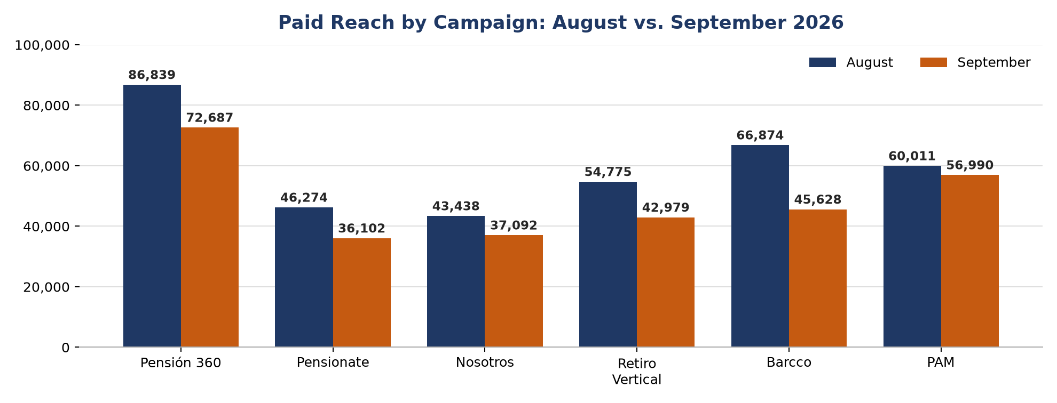
Chart 1. Paid reach by campaign: August vs. September 2026 (continuing campaigns).

Spend by campaign
Campaign | Daily budget (Sep.) | August | September | Change
Pensión 360 | $300 | $9,068 | $7,979.41 | -12.0%
Pensionate | $200 | $6,973 | $6,067.73 | -13.0%
Nosotros | $250 | $7,782 | $7,553.59 | -2.9%
Retiro Vertical | $250 | $7,448 | $7,181.41 | -3.6%
Barcco | $250 | $8,980 | $7,323.59 | -18.4%
PAM | $200 | $9,269 | $6,000 | -35.3%
Prosperar (new, from 21 Sep) | $100 | — | $1,040.32 | —
TOTAL | $1,550/day | $49,520 | $43,146.05 | -12.9%

Daily budgets as reported. Some budgets changed during the month (e.g. Barcco from $300 to $250/day on 15 Sep), so a monthly budget and budget utilization are not calculated.

Messages and cost per message by campaign
Campaign | Msgs Aug. | Msgs Sep. | Change | % of Sep. | Cost/msg Aug. | Cost/msg Sep.
Pensión 360 | 1,178 | 1,025 | -13.0% | 26.2% | $7.70 | $7.78
PAM | 735 | 757 | +3.0% | 19.4% | $12.61 | $7.93
Pensionate | 522 | 575 | +10.2% | 14.7% | $13.36 | $10.55
Barcco | 811 | 560 | -30.9% | 14.3% | $11.07 | $13.08
Nosotros | 611 | 492 | -19.5% | 12.6% | $12.74 | $15.35
Retiro Vertical | 632 | 441 | -30.2% | 11.3% | $11.78 | $16.28
Prosperar (new) | — | 62 | — | 1.6% | — | $16.78
TOTAL (campaign data) | 4,489 | 3,912 | -12.9% | 100.0% | $11.03 | $11.03

Cost per message and shares are calc. The campaign-level messages add up to 3,912 (3,850 without Prosperar), versus 3,769 in the monthly summary; the summary figure is used for the headline results and conversion rates.
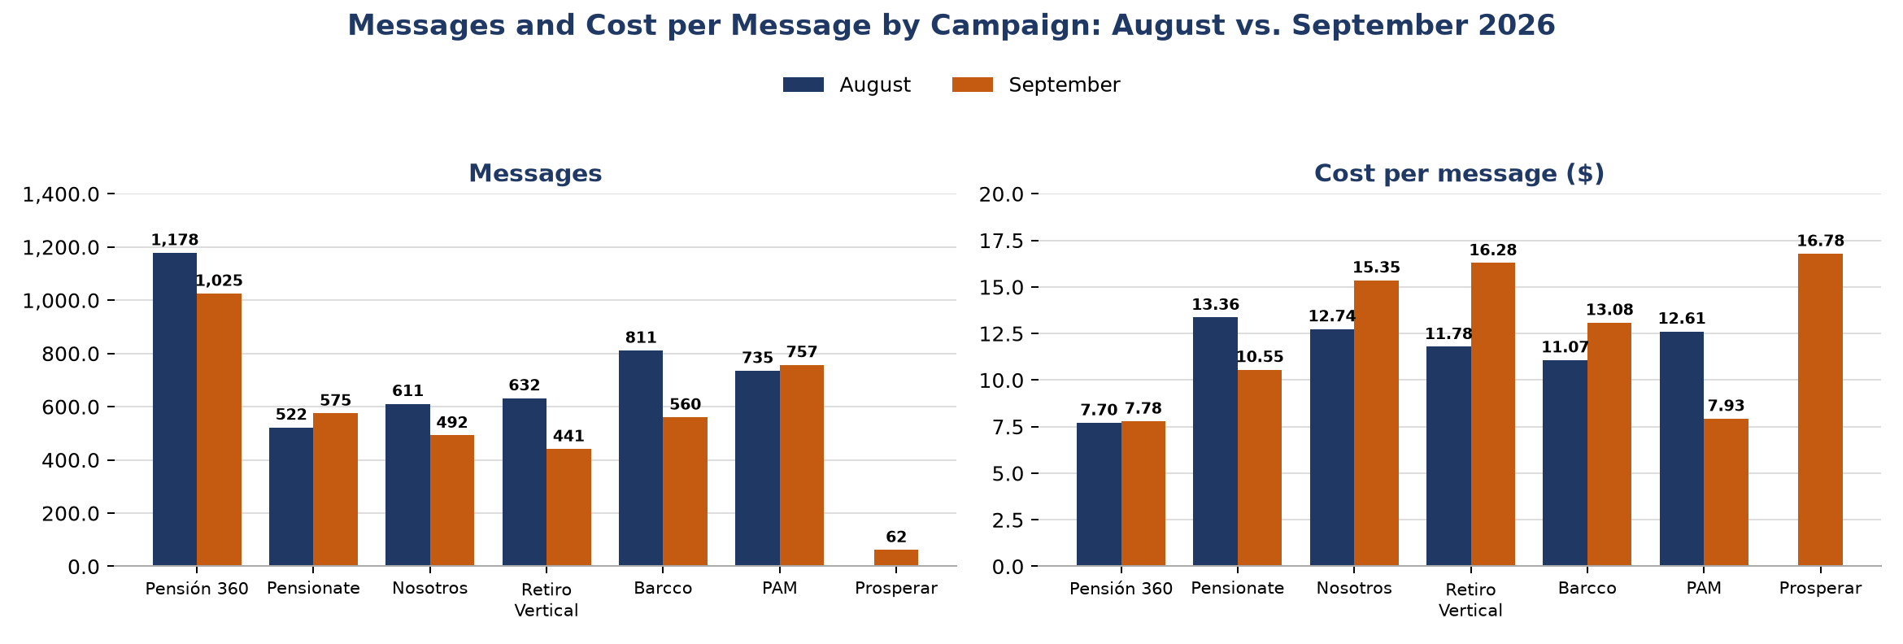
Chart 2. Messages and cost per message by campaign: August vs. September 2026.

Efficiency indicators
Indicator | August | September | Change
Cost per message | $11.03 | $11.45 | +3.8%
Cost per assigned | $1,238.00 | $1,961.18 | +58.4%
Cost per closure | $6,190.00 | $14,382.02 | +132.3%
Cost per 1,000 impressions | $48.21 | $52.29 | +8.5%
Messages per 1,000 impressions | 4.37 | 4.57 | +4.5%
Message → assigned conversion | 0.89% | 0.58% | -0.31 pp
Assigned → closure conversion | 20.0% | 13.6% | -6.4 pp

Calc. from total spend ($43,146.05) and the monthly summary figures. Spend includes Prosperar; if the summary totals exclude Prosperar, cost indicators are slightly overstated (cost per message on campaign-level data: $11.03).

Analysis and observations
Lower spend and higher delivery cost reduced the audience. Spend fell 12.9% while impressions fell 19.7%: each 1,000 impressions cost 8.5% more ($48.21 → $52.29). Messages fell less than impressions (-16.0%), so response per impression held up slightly (4.37 → 4.57 messages per 1,000 impressions).
The main loss is after the message. Cost per message barely moved (+3.8%), but only 22 of 3,769 messages became assigned (0.58%) and 3 became closures (13.6% of assigned). Cost per closure more than doubled to $14,382. Unlike August, the closing stage also weakened. With 22 assigned and 3 closures, these rates rest on small numbers and can move sharply month to month.
Two campaigns improved, three deteriorated. PAM grew messages with 35.3% less spend, cutting its cost per message from $12.61 to $7.93; Pensionate grew messages 10.2% with 13.0% less spend ($13.36 → $10.55). Both were rebuilt on their July structure on 15 Sep, which is consistent with the team's observation that the July configuration performed better, though September's frequent changes do not allow this to be attributed with certainty. Retiro Vertical (+38.2% cost per message), Nosotros (+20.5%) and Barcco (+18.1%) became more expensive. Pensión 360 stayed the most efficient campaign ($7.78) and the largest by volume (26.2% of messages).
Prosperar generated 62 messages at $16.78 each in its first 10 days, the highest cost per message of the month. It is too early to judge.

B. MÉVIAL

What did we do during September?
- The Phase 1 campaign stayed active all month without changes, as the team was occupied with Pensiones México.
- Two promotional videos were prepared.
- Planned change: switch the campaign CTA to WhatsApp. This is blocked: the ad account must first be verified (personal or business verification) before the campaign can be optimized or changed.
- Landing page optimization in progress: a more mobile- and user-friendly design that shows less information at once and gives users the option to take the diagnostic or talk to an advisor first.

Results
Indicator | August | September | Change
Campaign status | Active from 7 Aug | Active all month | —
Landing page views (Meta) | 3,577 | 2,922 | -18.3%
Investment | €251.56 | €300.04 | +19.3%
Cost per landing page view | €0.070 | €0.103 | +46.0%
Impressions / reach (Meta) | — | 104,557 / 54,151 | —
Users who started the diagnostic (GA4) | approx. 1,677 | 2,096 | +25.0%
Users who reached step 2 (GA4) | 8 | 2 | -6
Step 1 → step 2 rate | 0.48% | 0.10% | -0.38 pp
Diagnoses completed (GA4) | — | 0 | —

Changes and rates are calc. August covers 7–31 Aug (25 days); September covers 30 days. Meta landing page views and GA4 diagnostic users are measured differently and are not directly comparable.
Ad (September) | Landing page views | Share | Spend | Cost per view
Reel 72 | 2,800 | 95.8% | €284.62 | €0.102
Reel Eze | 63 | 2.2% | €8.77 | €0.139
Reel general | 59 | 2.0% | €6.65 | €0.113
TOTAL | 2,922 | 100.0% | €300.04 | €0.103

Diagnostic funnel (GA4, September)
Step | Active users | Note
Step 1 | 2,096 | 2,094 abandoned (99.9%)
Steps 2, 3 and 4 | 2 | Both users from Andalusia
Step 5 | 2 | Both abandoned
Step 6 / Diagnosis completed | 0 | —

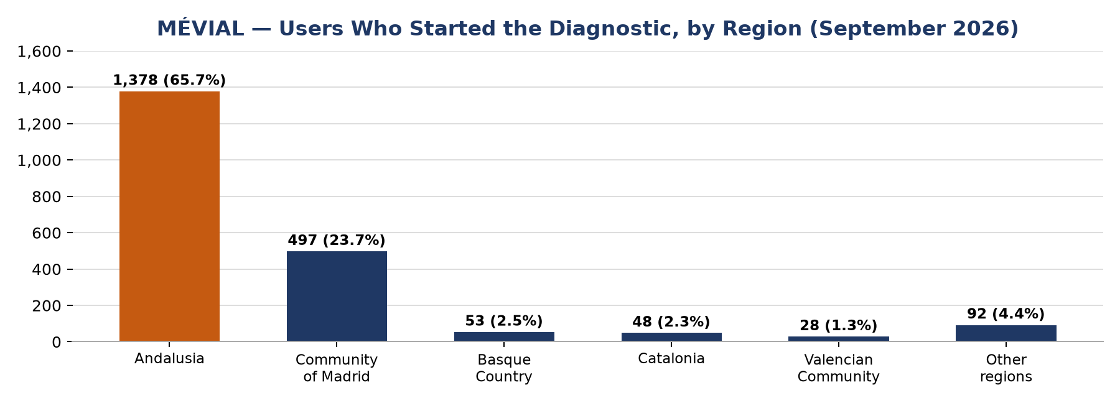
Chart 3. MÉVIAL: users who started the diagnostic, by region (GA4, September 2026). “Other regions” is calc.

Comparison with August and analysis
- Traffic cost more and arrived more slowly. Spend rose 19.3% while landing page views fell 18.3%, so cost per view rose 46.0%. Average daily views fell from 143 to 97 (calc.).
- The diagnostic still fails at step 1. More users started it (2,096 vs. approx. 1,677), but only 2 reached step 2 (8 in August) and none completed it. The step 1 drop-off identified in August has not been addressed, as no changes were made in September.
- Traffic is almost entirely one ad. Reel 72 delivered 95.8% of landing page views.
- 34.3% of diagnostic users came from outside Andalusia (Community of Madrid 23.7%). The campaign targets Málaga, Seville and Córdoba, with Advantage+ Audience turned off in August. This mismatch should be checked in the ad set's location settings and GA4.
- Next step depends on ad account verification, which is required before the WhatsApp CTA can be introduced.

C. Other clients / projects

DR. GUILLERMO
No update was reported for this client in September.

3. Overall comparison with August
Indicator | August | September | Change | Abs. Δ
Paid reach | 358,211 | 291,478 | -18.6% | -66,733
Paid impressions | 1,027,101 | 825,175 | -19.7% | -201,926
Messages | 4,489 | 3,769 | -16.0% | -720
Assigned | 40 | 22 | -45.0% | -18
Closures (sales) | 8 | 3 | -62.5% | -5
Spend | $49,520 | $43,146.05 | -12.9% | -$6,373.95

Pensiones México paid campaigns. MÉVIAL is reported separately in section 2B.
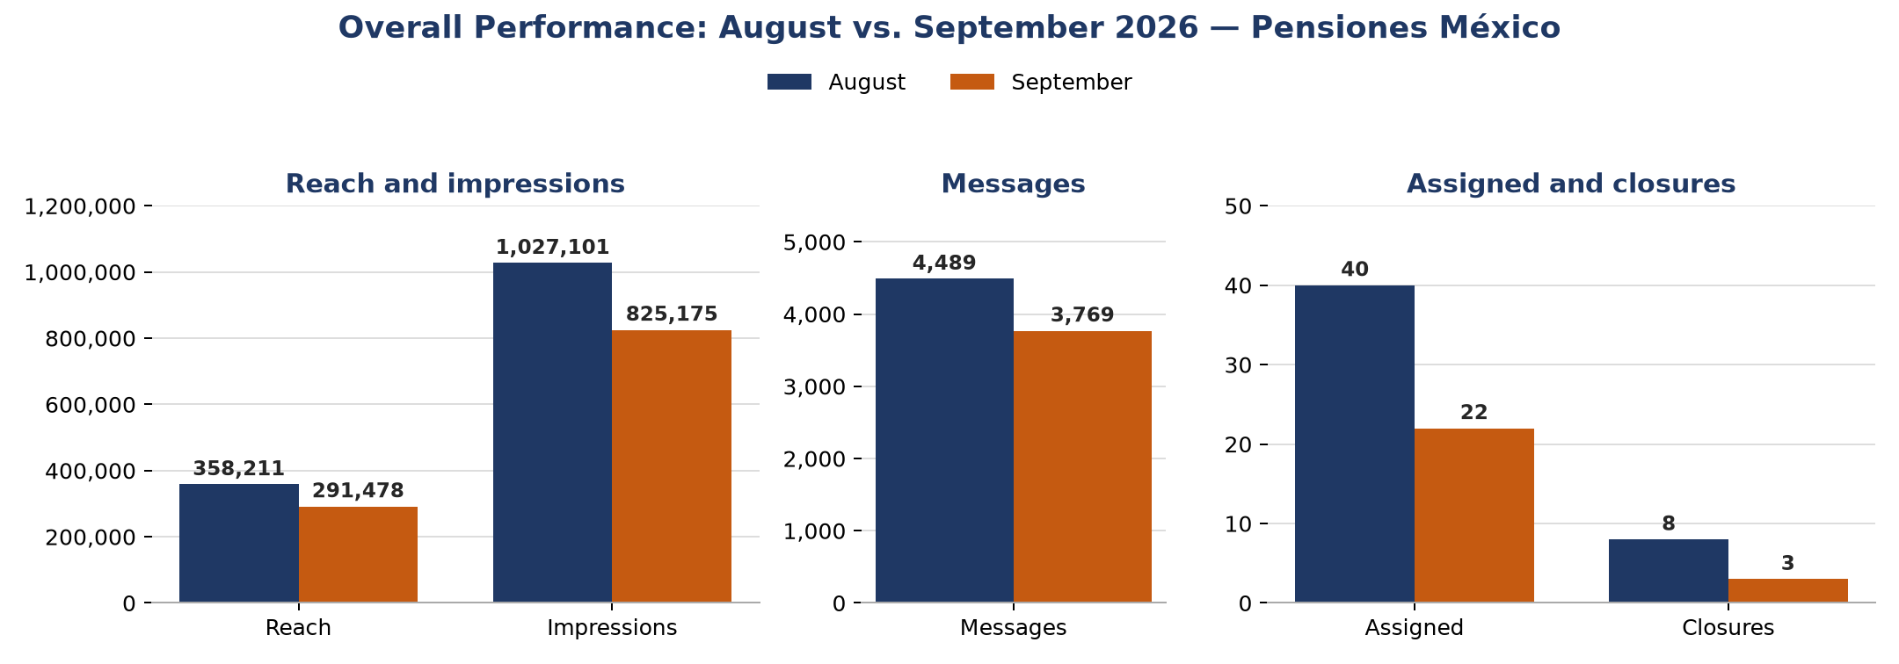
Chart 4. Overall performance: August vs. September 2026 (Pensiones México).
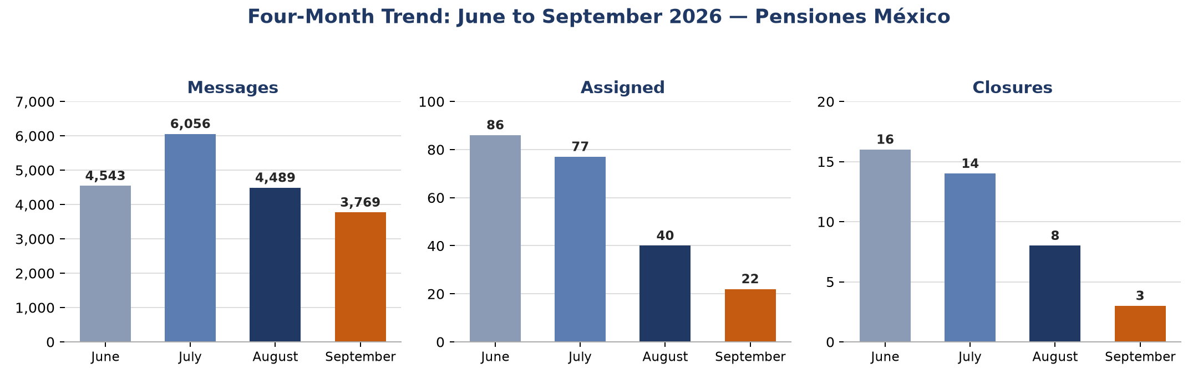
Chart 5. Messages, assigned and closures, June to September 2026 (Pensiones México).
Over four months, assigned fell from 86 to 22 and closures from 16 to 3, while messages peaked in July (6,056).

What changed compared with August, and why?
- Less spend, more expensive delivery. Spend -12.9% and cost per 1,000 impressions +8.5% led to 19.7% fewer impressions; the most direct cause of lower message volume.
- Weaker downstream conversion. Message → assigned fell to 0.58% and assigned → closure to 13.6%, so cost per assigned (+58.4%) and per closure (+132.3%) rose far more than cost per message (+3.8%).
- Frequent restructuring. Major rounds on 4, 15, 21 and 28–29 Sep, including the return to the July configuration (15 Sep) and the age range change to 60–65+ (21 Sep).
- Accounts and channels. GHL set up as four advisor sub-accounts; PAM moved to a new business portfolio and ad account (15 Sep); Barcco moved to WABA (29 Sep).
- Retiro Vertical active again from 4 Sep after verification (deactivated on 31 Aug), but with the steepest rise in cost per message ($11.78 → $16.28).
- New campaign Prosperar (21 Sep): 62 messages for $1,040.32 in its first 10 days.

Status of August's objectives
Objective set for September | Status
Complete the transition of campaign management to the four Mexican advisors | Pending (GHL now organized as one sub-account per advisor)
Implement GHL funnels and automations | In progress: configuration issues; technical support from Andres and Lorgio
Recover at least 25% of contacts who stop responding | Pending
Develop trust-building and follow-up content | Pending
Improve conversion from conversations to assigned and closures | Not achieved: message → assigned 0.89% → 0.58%; assigned → closure 20.0% → 13.6%
Maintain at least 40% of July's message volume (~2,400) | Achieved: 3,769 messages (62.2% of July)
Continue testing the strongest creative approaches | Ongoing: advisor Reels introduced; two Reel angles tested on Pensión 360 from 28 Sep
MÉVIAL: measure the new contact flow and improve step 1 of the diagnostic | Not progressed: no campaign changes; 2 of 2,096 users passed step 1

4. What are we currently working on?
- Long-term GHL solution, with technical support from Andres and Lorgio.
- Daily analysis of the Mexico campaigns, with new promotional and organic material produced alongside.
- Returning to the July settings for WhatsApp usage, location and city configuration.
- Optimizing the messaging funnel: reviewing the messages and follow-ups being sent.
- Retargeting strategies.
- Evaluating a test budget (reserving part of the budget for testing); at idea stage.
- Results of the 28–29 Sep changes (new Pensión 360 and Retiro Vertical campaigns, Barcco on WABA) are still to be evaluated.
- MÉVIAL: ad account verification and the landing page redesign.

5. Objectives for October

Main objective
Recover message volume and lead quality at Pensiones México by applying the July WhatsApp, location and city configuration and optimizing the messaging funnel, while fixing the GHL setup.

Other objectives
- Optimize the messaging funnel (messages and follow-ups) to improve message → assigned conversion.
- Develop and test retargeting strategies.
- Resolve the GHL configuration issues with technical support.
- Review the cost increase at Retiro Vertical, Nosotros and Barcco, and measure the 28–29 Sep changes and Prosperar.
- MÉVIAL: complete ad account verification, switch the CTA to WhatsApp, launch the optimized landing page and fix the step 1 drop-off.

6. Supervisor's comments

Problems and risks identified
- Downstream conversion is the main weakness. 3,769 messages produced 22 assigned and 3 closures; cost per closure rose to $14,382. The closing stage weakened for the first time (20.0% → 13.6%).
- Four-month decline. Assigned 86 → 77 → 40 → 22 and closures 16 → 14 → 8 → 3 from June to September.
- Rising delivery cost. Cost per 1,000 impressions rose 8.5% while spend fell 12.9%.
- GHL complexity. Seven business portfolios for one client delayed the funnel and automation work.
- Attribution. Restructuring on six dates in the month makes it hard to know which change worked.
- MÉVIAL stalled. No changes in September; cost per view rose 46.0%, the diagnostic produced no completions, and ad account verification is blocking the next step.

Proposals and opportunities
- Use PAM and Pensionate as references: both increased messages while cutting cost per message after their July-based rebuild on 15 Sep.
- Make changes in fewer, clearly measurable rounds so results can be attributed.
- Focus the messaging-funnel review on the message → assigned step, where most volume is lost.
- Keep all campaign pages inside business portfolios to avoid repeating the PAM access issue.
- MÉVIAL: complete ad account verification first, then fix diagnostic step 1 and check why a third of diagnostic users are outside the target region.

Needs and process observations
- Continued technical support for GHL (Andres and Lorgio).
- Reconcile the campaign-level figures with the monthly summary each month (September messages: 3,912 by campaign vs. 3,769 in the summary; impressions: 828,183 for the six continuing campaigns vs. 825,175).

