DISCOVERY PHASE & PRODUCT ARCHITECTURE
Process Manuals Agent
Administrative consulting · Process documentation
Business Requirements Document (BRD)

Prepared for | Executive Management and the Product & Development team
Purpose | Define what the agent must capture, how it behaves when corporate information is missing, and the exact structure of the manual it produces
Status | Draft for review
Version / date | 1.0 · September 2026
Next phase | Architecture mapping and template build by the development team

Contents
1. Executive summary
2. Business purpose and value
3. How process manuals are built in practice
4. Guiding rule: client reality first
5. Required inputs
6. Optional inputs (corporate context)
7. Compensation logic: when optional inputs are missing
8. The deliverable: structure of the process manual
9. Output standards for each component
10. Annexes and tools for operational staff
11. How the agent works, step by step
12. Scaling the manual to the size of the company
13. Scope: what the agent will and will not do
14. Acceptance criteria
15. Decisions requested and open points
Appendix A. Process owner questionnaire (question bank)
Appendix B. Worked example: one procedure, every format
Appendix C. Glossary
Appendix D. References consulted

1. Executive summary
A process manual tells the people in an area how their work is done: what triggers it, who does each step, which system they use, what rules apply, what can go wrong and what evidence they must keep. Consulting firms have produced these manuals by hand for decades. The work is slow because most of it is not writing. It is finding out how the work really happens, reconciling that with whatever documents the company already has, and filling the gaps with sensible practice.
The Process Manuals Agent automates that work while keeping the method a good consultant would use. It interviews the process owners through a structured questionnaire, reads any corporate documents the client can provide, and produces a complete manual: BPMN flowcharts, a step-by-step narrative, a RACI matrix, policies and business rules, a risk and control matrix, and the blank forms, logs and checklists staff use to show the work was done.
The design rests on one rule. The manual describes the client's real operation, not a textbook one. What the process owner confirms is the primary source. Where the client has no organisational chart, job descriptions or internal regulations, the agent proposes them from recognised practice for a company of that sector and size, but every proposal is marked as such and stays marked until a named person accepts, adjusts or rejects it.
3  required input blocks | 4  optional corporate inputs | 11  standard blocks in every procedure | 100%  of content tagged by origin

What this document asks management to approve
- The split between required and optional inputs (Sections 5 and 6), including the rule that the agent stops rather than guesses when a required input is missing.
- The compensation logic and its limits (Section 7): what the agent may propose on its own and what it must never propose.
- The manual structure and output standards (Sections 8 to 10) as the blueprint for the development team.

2. Business purpose and value
In most companies, procedures live in the heads of a few experienced people. When those people are away, leave or are overloaded, the work slows down, mistakes repeat and new staff take months to learn what should take weeks. Auditors, banks, certification bodies and investors also ask for documented processes, and a company that cannot produce them loses time and credibility.
Documenting processes by hand is expensive for the same reason it is valuable: it needs many conversations and careful cross-checking. The agent takes the repetitive part of that effort, so consultants and process owners spend their time on judgement and validation rather than on formatting and chasing documents.
Problem today | How the agent addresses it
Knowledge sits with a few people | A structured questionnaire captures each process from the person who owns it
Old manuals describe a company that no longer exists | Old documents are read as history and checked against what owners say today
Small firms have no chart, job profiles or policies to start from | The agent proposes a sized, sector-appropriate baseline, clearly marked for validation
Flowchart, narrative and responsibilities contradict each other | All components are built from one register, so a step or role is described the same way everywhere
Manuals describe steps but not risks or evidence | Every procedure includes its risks, controls and the forms that prove execution
Manuals go out of date the day they are printed | Version control, owners and review dates are built into every page and form

Who benefits
Stakeholder | Benefit
Clients | A usable manual in their own terms, sized to their company, with clear owners and evidence
Process owners and staff | Less time in workshops; a clear reference for daily work and for training new people
Consultants | Fewer hours on drafting and formatting, more on analysis and improvement
Auditors and control functions | Risks, controls and evidence mapped to each step, ready for review
Management | Consistent quality across engagements and a lower risk of documenting something that is not true

3. How process manuals are built in practice
Before defining the agent's outputs, we reviewed how process documentation is structured in international standards, in public administration guides that have been used for decades, and in firms of very different sizes. The aim was to avoid inventing a format and instead follow what auditors, certifiers and staff already recognise.

3.1 International standards and frameworks
Reference | What it contributes | How the agent uses it
ISO 9001:2015 and ISO 10013:2021 | ISO 9001 asks organisations to control "documented information": approve it before release, keep it current, identify changes and prevent use of obsolete versions. ISO 10013 gives guidance on structuring it (organisational charts, work instructions, checklists, records) and does not impose a fixed hierarchy. | Document control block on every procedure and form; revision history; records retention table
BPMN 2.0 (OMG, also published as ISO/IEC 19510) | The standard notation for process diagrams. Its descriptive level uses a small set of shapes close to traditional flowcharting, meant for business readers. | All flowcharts, limited to the descriptive palette (Section 9.1)
BPMN "Method and Style" (B. Silver) | Widely used labelling conventions: activities as verb plus object, gateways as questions, one end event per distinct end state, messages named as nouns. | Flowchart style rules
APQC Process Classification Framework | A cross-industry catalogue of business processes organised in levels: category, process group, process, activity and task. | Reference list of typical activities, used to ask better follow-up questions and spot missing steps
SIPOC (Six Sigma) | One-page view of Suppliers, Inputs, Process, Outputs and Customers, used before detailed mapping. | Header of each procedure and area process map
RACI / Responsibility Assignment Matrix | Responsible, Accountable, Consulted, Informed. Accepted rule: exactly one Accountable per activity. | RACI template and automatic checks
COSO Internal Control – Integrated Framework (2013) | Five components and 17 principles. Control activities are deployed through policies that set expectations and procedures that put them into action. | Structure of policies, business rules and the risk and control matrix
IIA Three Lines Model (2020) | Separates first-line roles (operations, including support functions), second-line roles (risk, compliance, quality) and third-line independent assurance (internal audit). | "Line" column in the risk and control matrix
US EPA QA/G-6, Guidance for Preparing SOPs | A public, widely copied guide for standard operating procedures with a suggested format for administrative procedures, including checklists. | Writing rules for the narrative and checklist design

3.2 Public administration guides in Latin America
Government bodies in Mexico have published technical guides for preparing "manuales de procedimientos" for many years, and the same structure appears in manuals across the region. Examples include guides from the Secretaría de Relaciones Exteriores, the Secretaría de Salud, the Suprema Corte de Justicia de la Nación, UNAM and CONALEP. Their common elements are the most practical reference for clients in the region, because many staff have already seen manuals built this way:
- Front matter: introduction, objective of the manual, legal and regulatory framework, and a glossary.
- For each procedure: purpose, scope, operating policies ("políticas de operación"), a narrative description in a table (responsible role, activity number, activity description, document used), a flowchart with standard symbols, reference documents, records, and a change history.
- Records table: for each record, its code, where it is kept, how long it is kept and who is responsible for keeping it.
- Forms and instructions: blank formats attached to the manual, each with instructions for filling it in.
Enrique Benjamín Franklin Fincowsky's textbook "Organización de empresas" (McGraw-Hill), used widely in business schools in the region, treats administrative manuals and procedure manuals as a core tool of organisational analysis and follows the same logic.

3.3 How practice changes with company size
The same manual would be wrong for a ten-person workshop and for a listed group. ISO's own guidance for small enterprises stresses that the standard's requirements are generic and must be applied in a way that suits the organisation. What we observed across sizes:
 | Micro and small | Medium | Large or regulated
Where the knowledge is | Owner and one or two key staff | Department heads; partly in documents | Formal process architecture and document control
Documents usually available | Few or none; spreadsheets, messaging groups | Organisational chart, some job profiles and policies, often outdated | All of the above, plus delegation of authority, internal audit reports
Segregation of duties | Often impossible; one person approves and executes | Partial | Expected and tested
What the manual must do | Capture know-how, set basic rules, protect against the main risks | Align departments, clarify responsibilities, prepare for growth or certification | Support compliance, audit, training at scale, and integration of acquisitions
Main risk in documenting | Over-engineering: a manual nobody reads | Documenting the org chart instead of the real work | Documenting the policy instead of the practice

3.4 What we adopt
Observed practice | How the agent applies it
Procedures describe who, what, when, how and where, in a numbered table | The narrative uses a 5W1H table whose step numbers match the flowchart
Flowcharts use one recognised notation | BPMN 2.0, descriptive level, with fixed style rules
Each activity has one accountable role | RACI check: exactly one "A" per row, enforced before release
Controls are tied to risks and to evidence | Risk and control matrix links each control to a step and a form
Documents carry code, version, date and approvals | Standard header and revision history on every procedure and form
Depth depends on size and regulation | Three depth levels: Essential, Standard and Enhanced (Section 12)

4. Guiding rule: client reality first
The most common failure in process documentation is a manual that describes how the work ought to be done, or how it was done five years ago, rather than how it is done now. Staff notice immediately and stop using it. The second failure, specific to an automated agent, is filling gaps with plausible text that nobody at the client ever confirmed.
To prevent both, every piece of content passes through one central record, the Process Fact Register. Each step, role, rule, system, risk and control is recorded there once, with a tag that says where it came from. Every component of the manual reads from the register, so the flowchart, the narrative, the RACI and the control matrix always describe the same thing in the same words.
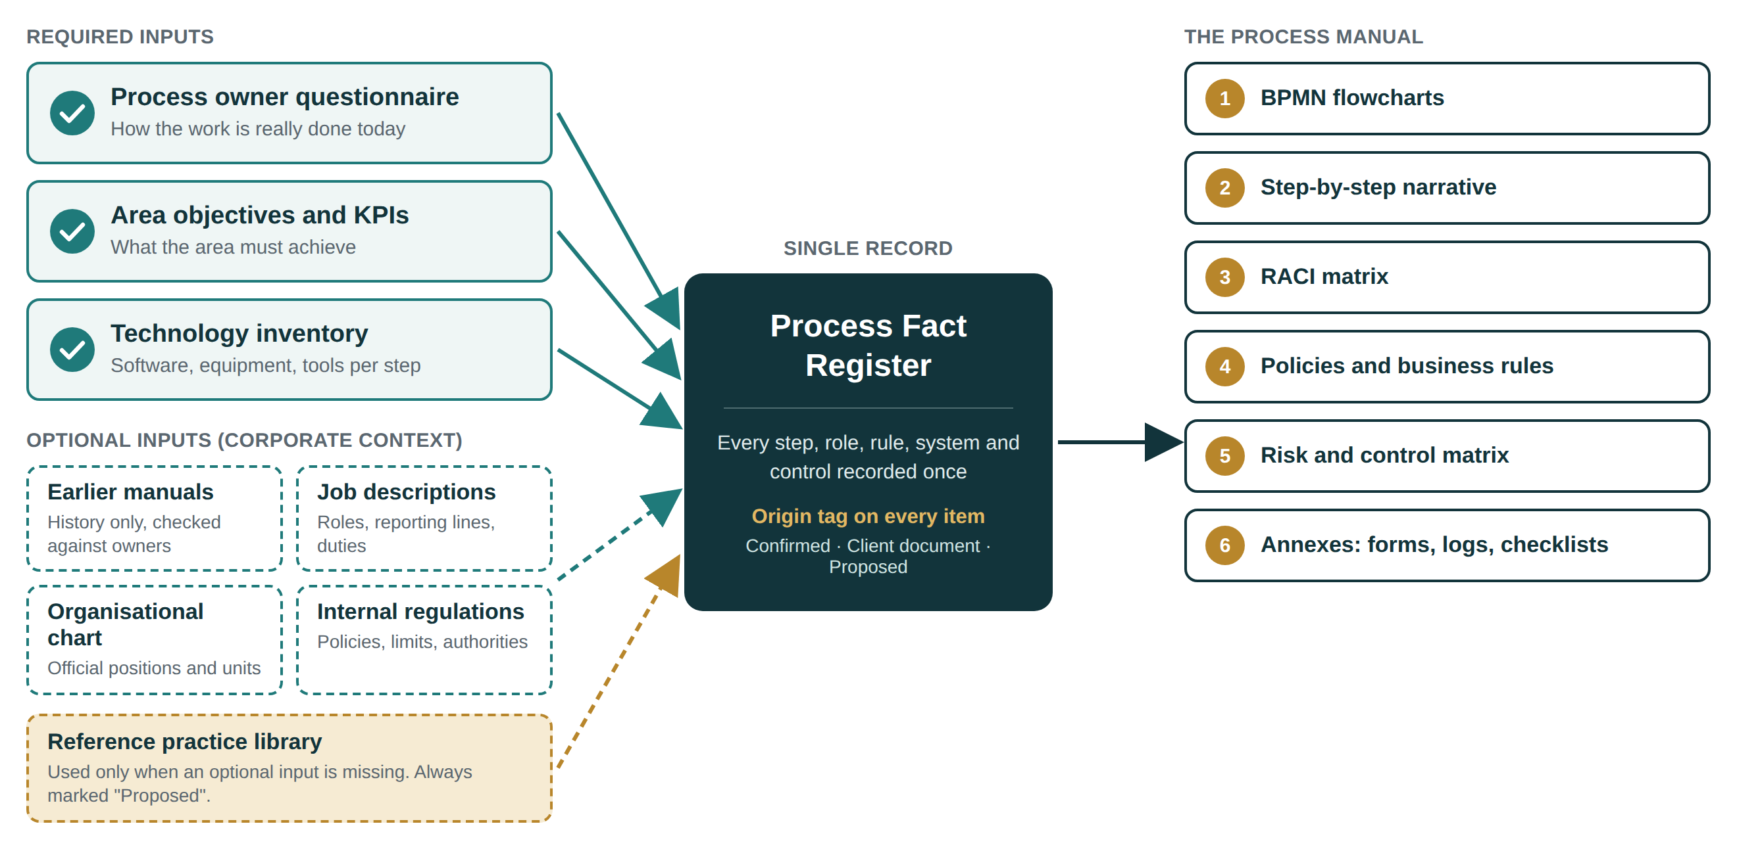
Figure 1. From inputs to the manual through one register

4.1 The six rules
Rule | What it means in practice
1. The owner's account comes first | How work is done today is taken from the process owner. Old manuals and reference practice never overwrite it.
2. Every item carries its origin | Each entry is tagged Confirmed (process owner), Client document (from a file, not yet confirmed) or Proposed (reference practice suggested by the agent).
3. Proposals are never passed off as fact | A proposed chart, profile, policy or control is visibly marked until a named person accepts, adjusts or rejects it.
4. Conflicts are recorded, not hidden | If an old manual says one thing and the owner another, the manual follows the owner and the difference goes to the gap log. Gaps often point to real risks.
5. No legal statement without a source | The agent may point out that a type of regulation usually applies. It never states a legal obligation, deadline or retention period as fact unless the client or its adviser confirms it.
6. One fact, used everywhere | A role name, step or limit is defined once in the register and appears identically in every component.

4.2 Origin tags and the life of a proposal
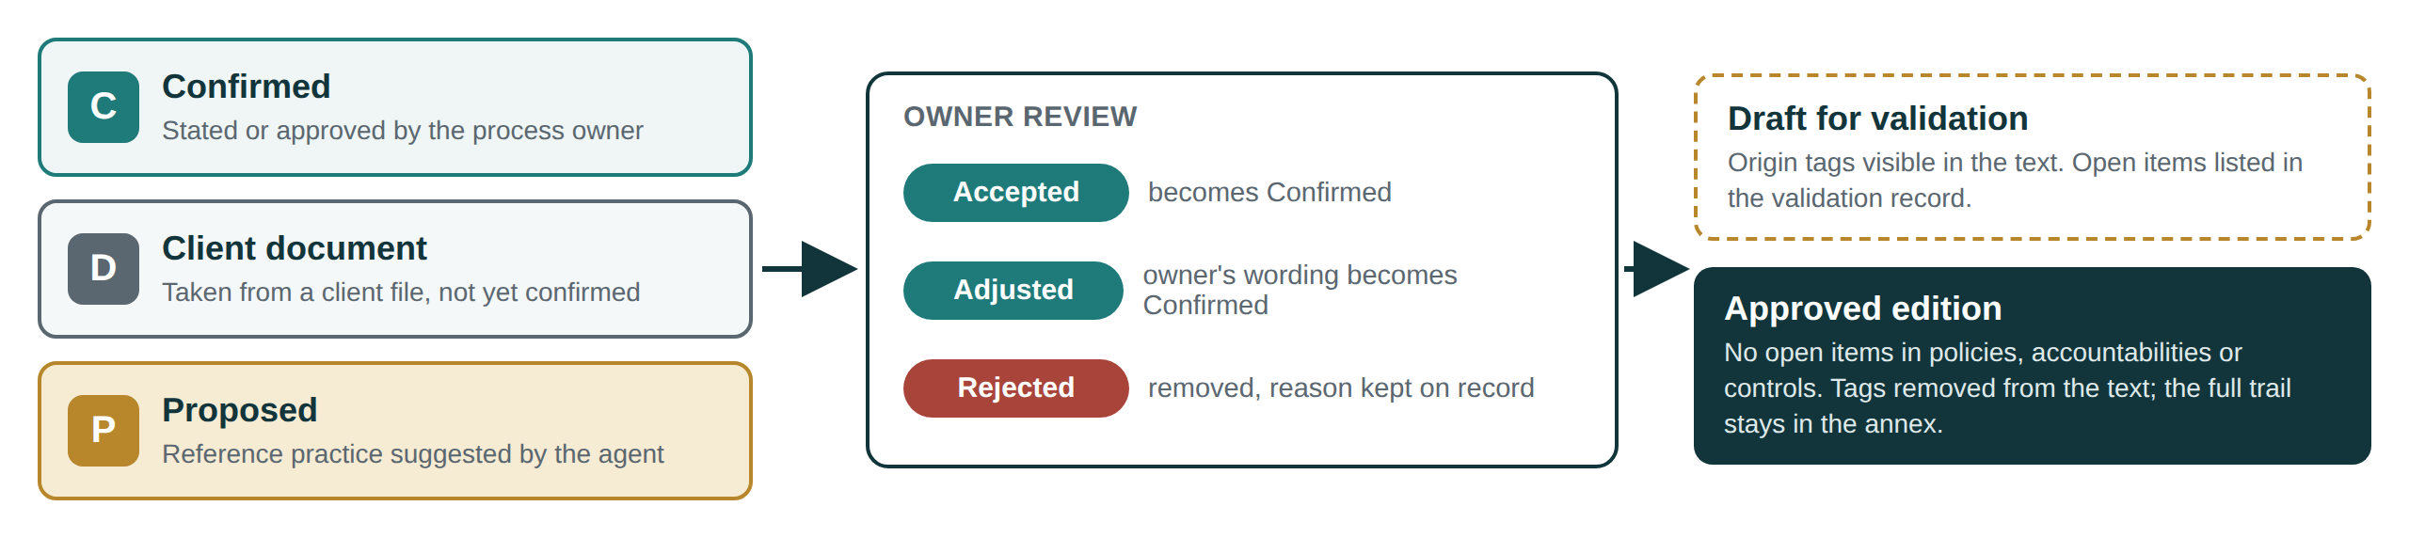
Figure 2. Origin tags, owner review and release status
The working draft shows the tags next to the text, so reviewers can see at a glance what still needs a decision. The approved edition removes the tags from the body to keep the manual readable for operational staff, and keeps the full trail in the Validation Record annex (form F-10). An approved edition cannot be issued while any proposal remains open in policies, accountabilities (the "A" in the RACI) or controls.

5. Required inputs
Three blocks of information are mandatory. Without them the manual would describe assumptions rather than the client's operation. If any of them is missing or incomplete for a given process, the agent does not draft that procedure. It lists exactly what is missing and asks for it.

5.1 Strategic questionnaire with the process owners (As-Is)
The questionnaire is the backbone of the manual. It is answered by the person who owns each process, ideally in a guided session with the consultant, and follows the order in which experienced analysts interview: from broad to specific, open questions first, the same questions for every process so answers can be compared. It covers ten blocks; the full question bank is in Appendix A.
Block | What it captures | Feeds
1. Identity | Process name, purpose in one sentence, owner, internal or external customer | Identification, objective
2. Boundaries | Trigger that starts it, output that ends it, what is out of scope | Scope, start and end events
3. Sequence | Main steps in order, who does each, typical duration | Flowchart, narrative, RACI
4. Decisions and exceptions | Where decisions are made, criteria, approvals and limits, what happens when something goes wrong | Gateways, business rules
5. Inputs, outputs, handoffs | Documents and data received and delivered, from and to whom | SIPOC, message flows
6. Systems and tools | Software, equipment, spreadsheets or paper used at each step | Narrative (How, Where), data stores
7. Volume and timing | Frequency, volume per period, peaks, deadlines, cycle time | Narrative (When), KPIs
8. Records | What evidence is kept, where, for how long | Records table, annexes
9. Problems and risks | Pain points, errors, rework, past incidents, dependence on key people | Risk and control matrix
10. Rules and constraints | Internal rules and regulations the owner knows apply | Policies and business rules

Completeness gate
The agent will not draft a procedure until blocks 1 to 6 are answered: a named owner, a clear start and end, the steps with their roles, the decisions, the handoffs and the systems used ("none" is a valid answer). Blocks 7 to 10 improve the manual and are requested, but a procedure can be drafted without them; the gaps are listed in the validation record.

5.2 Objectives and indicators of the area
A manual that does not state what the area is trying to achieve cannot say whether a procedure works. The client must state at least one objective for the area. For each indicator the client already uses, the agent records a standard indicator card:
Field | Content | Example
Name | Short, unambiguous name | Purchase order cycle time
Purpose | Which objective it measures | Timely supply to operations
Formula | Numerator, denominator, unit | Days from approved request to issued order
Data source | System or record where the data comes from | ERP purchasing module
Frequency | How often it is measured and reviewed | Monthly
Target and threshold | Expected value and the level that triggers action | Set by the client
Owner | Role that answers for the result | Purchasing manager

Many small and medium firms have objectives but no formal indicators. In that case the requirement is still met by the stated objective, the absence of indicators is recorded, and the agent proposes three to five candidate indicators linked to it, tagged Proposed. Targets are always left for the client to set.

5.3 Technology inventory
People cannot follow a procedure that names the wrong system. The inventory lists every tool used in the processes in scope, including the informal ones (shared spreadsheets, messaging groups, paper forms), which are often where the real work and the real risks sit.
Type | Fields captured
Software and systems | Name, module, purpose, steps where it is used, user roles, whether it is the official record for that data, who administers access
Machinery and equipment | Name, function, steps where it is used, operator qualification required, safety or maintenance relevance
Informal tools | Spreadsheets, shared folders, messaging, paper forms: purpose, owner, where stored, which step relies on them

6. Optional inputs (corporate context)
Corporate documents save time and add detail, but they are treated with care. Documents describe what someone once decided; the questionnaire describes what happens now. The agent reads every document provided, extracts what is useful with a page reference, and compares it with the owners' answers before anything reaches the manual.
Input | What it adds | How it is handled
Earlier or obsolete manuals | Structure, historical rules, existing form codes, terminology staff already use | Treated as history. Each item is checked against the questionnaire; differences go to the gap log. Nothing is copied without confirmation.
Prior job descriptions | Titles, reporting lines, duties, required qualifications | Mapped to the roles in each RACI. Duties performed by a role that are not in its description, or described duties nobody performs, are flagged.
Current organisational chart | Official positions, units and reporting lines | Used as the catalogue of roles: flowchart lanes and RACI columns use these position names. Differences from what owners describe are logged.
Internal regulations | Policies, codes, authority limits, delegation of authority, internal rules | Source of policies and business rules, each cited to the document and clause. Where a regulation conflicts with actual practice, the conflict is raised, not resolved silently.

Accepted formats are Word, PDF (including scans), Excel and images. When a scanned document cannot be read reliably, the agent says so and asks for a better copy rather than guessing the text.

7. Compensation logic: when optional inputs are missing
Many clients, especially small ones, have none of the optional documents. The agent must still deliver a complete manual. It does this by building a profile of the company and drafting a reference proposal for each missing piece, based on recognised practice for that sector, size and country. The proposal gives the client something concrete to react to, which is faster than starting from a blank page, but it is never presented as the client's reality.
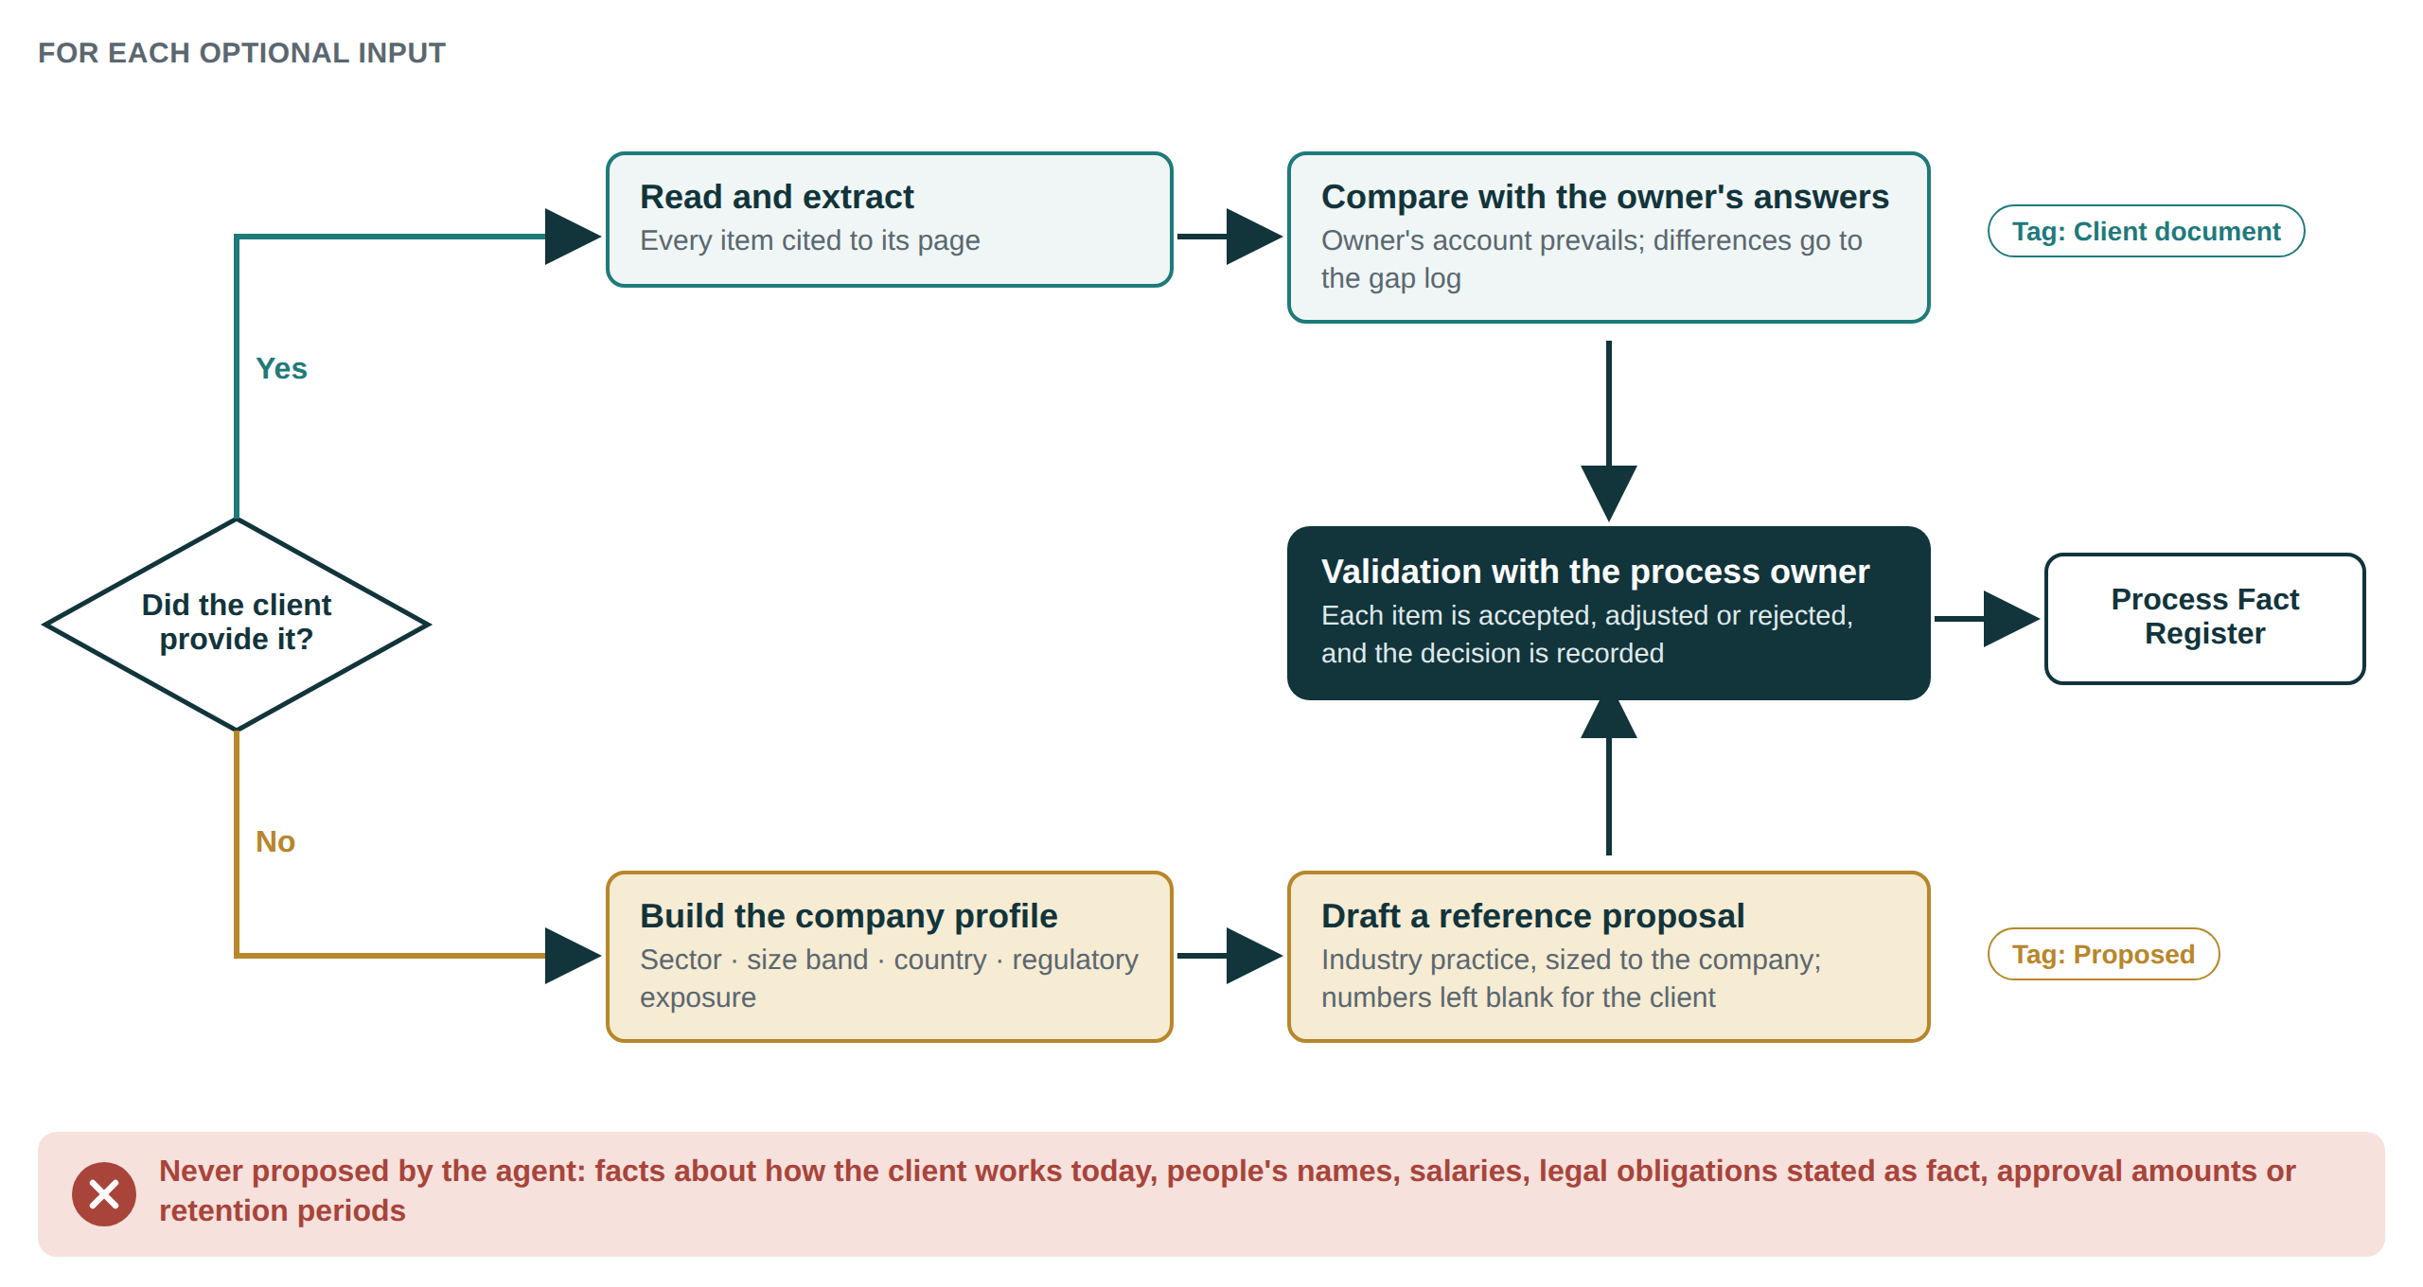
Figure 3. Compensation logic for each optional input

7.1 The company profile
The reference practice depends on four attributes captured at set-up: sector (using a standard industry classification), size band (by headcount; the European Commission, for example, defines micro as fewer than 10 employees, small as fewer than 50 and medium as fewer than 250), country (which determines the regulatory context and the language of the manual) and regulatory exposure (for example a listed company, a financial or health-sector licence, or export activity). Size bands vary by country, so the exact definitions are a decision for the architecture phase.

7.2 Behaviour for each missing input
Missing input | What the agent does | What it leaves for the client
Earlier manual | Builds the manual from the standard structure in Section 8. Uses the reference list of typical activities for that type of process to ask follow-up questions and point out steps the owner may have left out. Suggested steps become questions to the owner, never steps in the manual. | Confirming whether each suggested step exists
Job descriptions | Drafts a role profile for every role that appears in the procedures. Purpose and responsibilities are derived from the confirmed steps in the RACI, so they are tagged Confirmed. Competencies and typical qualifications for that role in that sector and size are tagged Proposed. | Qualifications, grading and pay (never proposed)
Organisational chart | Builds a functional chart from the roles captured in the interviews and proposes a reference structure for the area, sized to the company. Flags spans of control that look unusually narrow or wide for the type of work, using published guidance as a reference. | Final structure and reporting lines; people's names
Internal regulations | Proposes baseline policies and business rules drawn from internal control practice (authorisation, segregation of duties, record keeping, access to systems, handling of exceptions). Where a legal requirement usually applies, it is listed as "to be confirmed with legal counsel". | Amounts, thresholds, retention periods and any legal interpretation
Indicators (when only objectives exist) | Proposes three to five indicators linked to each stated objective, with formula and data source. | Targets and thresholds

7.3 Limits: what the agent never proposes
- Facts about the client's current operation. Who does what, which system is used, how long something takes: these come only from the client.
- Names of people. The manual refers to positions. Names change; positions last.
- Pay, grading or performance judgements about any role or person.
- Legal obligations stated as fact, including retention periods, filing deadlines and regulatory thresholds.
- Numeric limits such as approval amounts. The agent may offer a structure ("approvals above [amount] require the Finance Director") and leave the value blank for the client.

7.4 How proposals are validated
Every proposal carries a one-line reason ("why this is suggested") and its basis (for example "common segregation-of-duties practice under COSO control activities"). Proposals are grouped in the Validation Record so the process owner can go through them in one sitting and mark each one Accept, Adjust or Reject. Rejected proposals are removed from the manual and the reason is kept. The manual may be issued as a "Draft for validation" with open items listed; the approved edition requires that no proposal remains open in policies, accountabilities or controls.

8. The deliverable: structure of the process manual
Every manual produced by the agent follows the same structure, whatever the size of the client. What changes with size is the depth of each part (Section 12), not the order. A reader who knows one manual can find their way in any other.
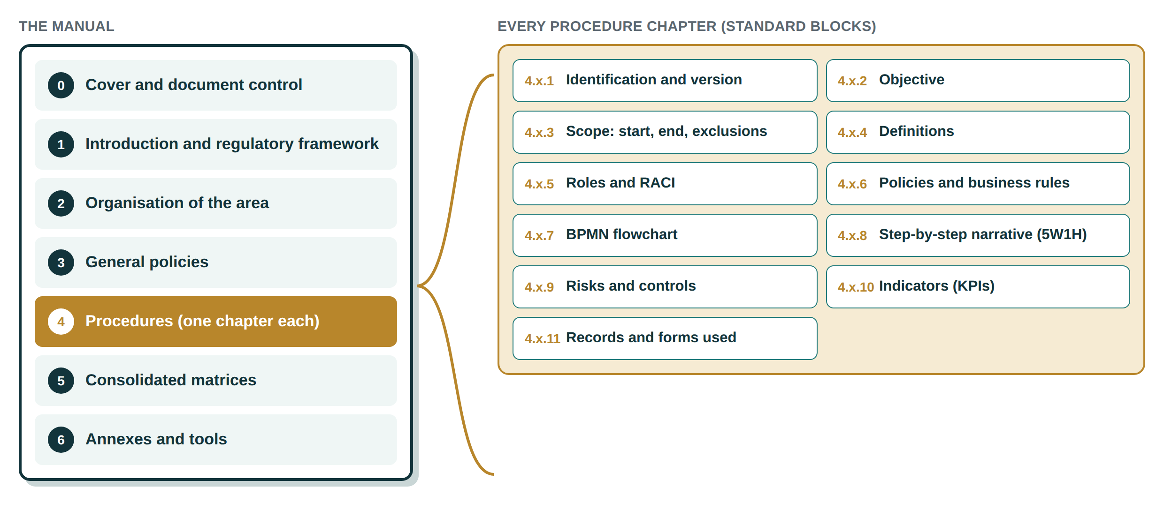
Figure 4. Manual structure and the standard blocks inside every procedure chapter

8.1 Parts of the manual
Part | Contents
0. Cover and document control | Manual title and code, area, version, effective date, prepared by, reviewed by, approved by (positions and signatures), distribution list, revision history
1. Introduction and regulatory framework | Purpose of the manual, scope (area, processes, sites), how to use it, applicable laws and internal regulations (confirmed or marked for confirmation)
2. Organisation of the area | Organisational chart, summary of roles, area process map (the processes and how they connect) and a SIPOC for each process
3. General policies | Policies that apply to all procedures of the area
4. Procedures | One chapter per procedure, each with the eleven standard blocks
5. Consolidated matrices | Master RACI across procedures, full risk and control matrix, indicator dashboard definition
6. Annexes and tools | Blank forms, logs and checklists; full role profiles; reference documents; records retention table; validation record; glossary

8.2 The eleven standard blocks of each procedure
Block | Content and rule
4.x.1 Identification and version | Name, code (for example PUR-01), owner (position), version, effective date, next review date
4.x.2 Objective | One or two sentences: what the procedure achieves and why it matters. This is where "why" lives, so it is not repeated at every step
4.x.3 Scope | Where it starts (trigger), where it ends (final output), which units or sites it covers, and what is explicitly excluded
4.x.4 Definitions | Only terms specific to this procedure; general terms go to the glossary
4.x.5 Roles and RACI | Positions involved and their RACI assignment for every step
4.x.6 Policies and business rules | Rules that govern this procedure, each with its identifier and source
4.x.7 BPMN flowchart | One diagram (or a main diagram with linked sub-processes) following Section 9.1
4.x.8 Step-by-step narrative | 5W1H table, numbered to match the flowchart
4.x.9 Risks and controls | Extract of the risk and control matrix for this procedure
4.x.10 Indicators | Indicator cards relevant to this procedure
4.x.11 Records and forms | Every record produced and every form used, with code, storage location, retention and responsible role

8.3 Where each type of document sits
Quality practice separates policies, processes, procedures, work instructions and records, each written for a different reader. The manual follows the same layers so that a manager and an operator can each find the level of detail they need.
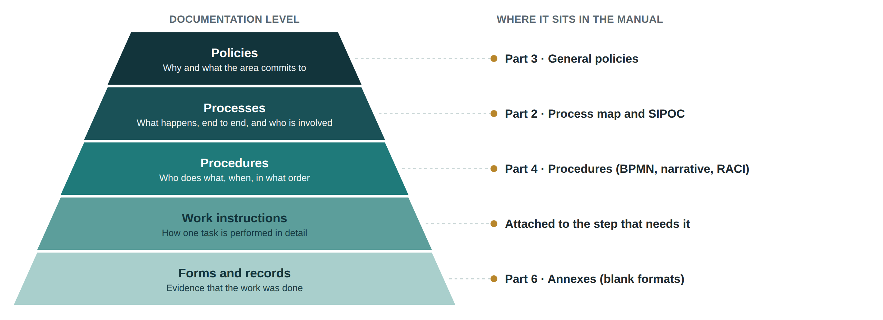
Figure 5. Documentation levels and where each one sits in the manual

8.4 File formats delivered
Item | Format | Why
The manual | Word (.docx) and PDF | Word so the client can maintain it; PDF for controlled distribution
Flowcharts | BPMN 2.0 XML (.bpmn) and image | The .bpmn file opens in standard modelling tools, so the client is not tied to us
RACI, risk and control matrix, indicators | Excel (.xlsx) | Easy to filter, update and use in audits
Annex forms | Word and Excel | Ready to print or fill in digitally

9. Output standards for each component

9.1 Flowcharts (BPMN 2.0)
The agent draws flowcharts in BPMN 2.0 using only the descriptive level of the notation: the shapes business readers understand without training. Advanced event types, compensation and executable details are not used in client manuals. The permitted palette:
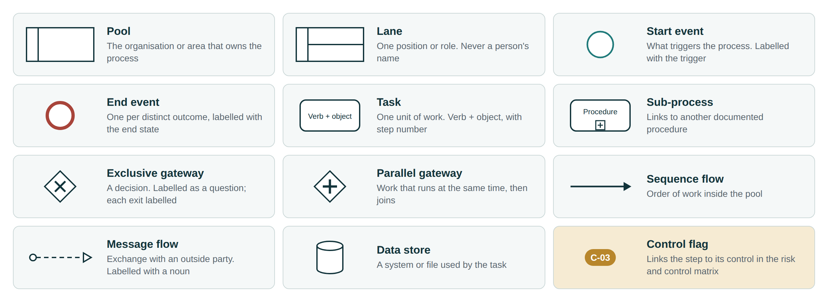
Figure 6. Permitted BPMN elements and how each is used

Style and layout rules
# | Rule
F1 | One diagram per procedure. If it grows beyond about fifteen tasks, part of it becomes a sub-process with its own diagram (design target, to keep each diagram readable on one page).
F2 | Flow runs left to right; lanes are horizontal; the pool is named after the organisation or area.
F3 | Each lane is a position from the role catalogue, never a person's name. External parties (customers, suppliers, authorities) are separate pools connected by message flows.
F4 | Each task is labelled verb plus object ("Approve purchase request"), carries its step number, and uses exactly the same wording as the narrative.
F5 | Every start event is labelled with its trigger. If a process has different triggers, each has its own labelled start event.
F6 | Every distinct outcome has its own end event, labelled with the end state ("Order issued", "Request rejected").
F7 | Exclusive gateways are labelled as a question; every outgoing path is labelled with the answer.
F8 | Every path leads to an end event. No loose ends, no flows that start or stop in mid-air.
F9 | Systems appear as data stores next to the task that uses them.
F10 | Steps that carry a control show a control flag with the control identifier from the risk and control matrix.
F11 | Lines should not cross where it can be avoided; message flows are labelled with the name of what is sent, as a noun.
F12 | Each diagram is exported as valid BPMN 2.0 XML and checked by opening it in a standard modelling tool before release.

The example below applies these rules to a short purchasing procedure. The same procedure is used in Appendix B to show every other format.
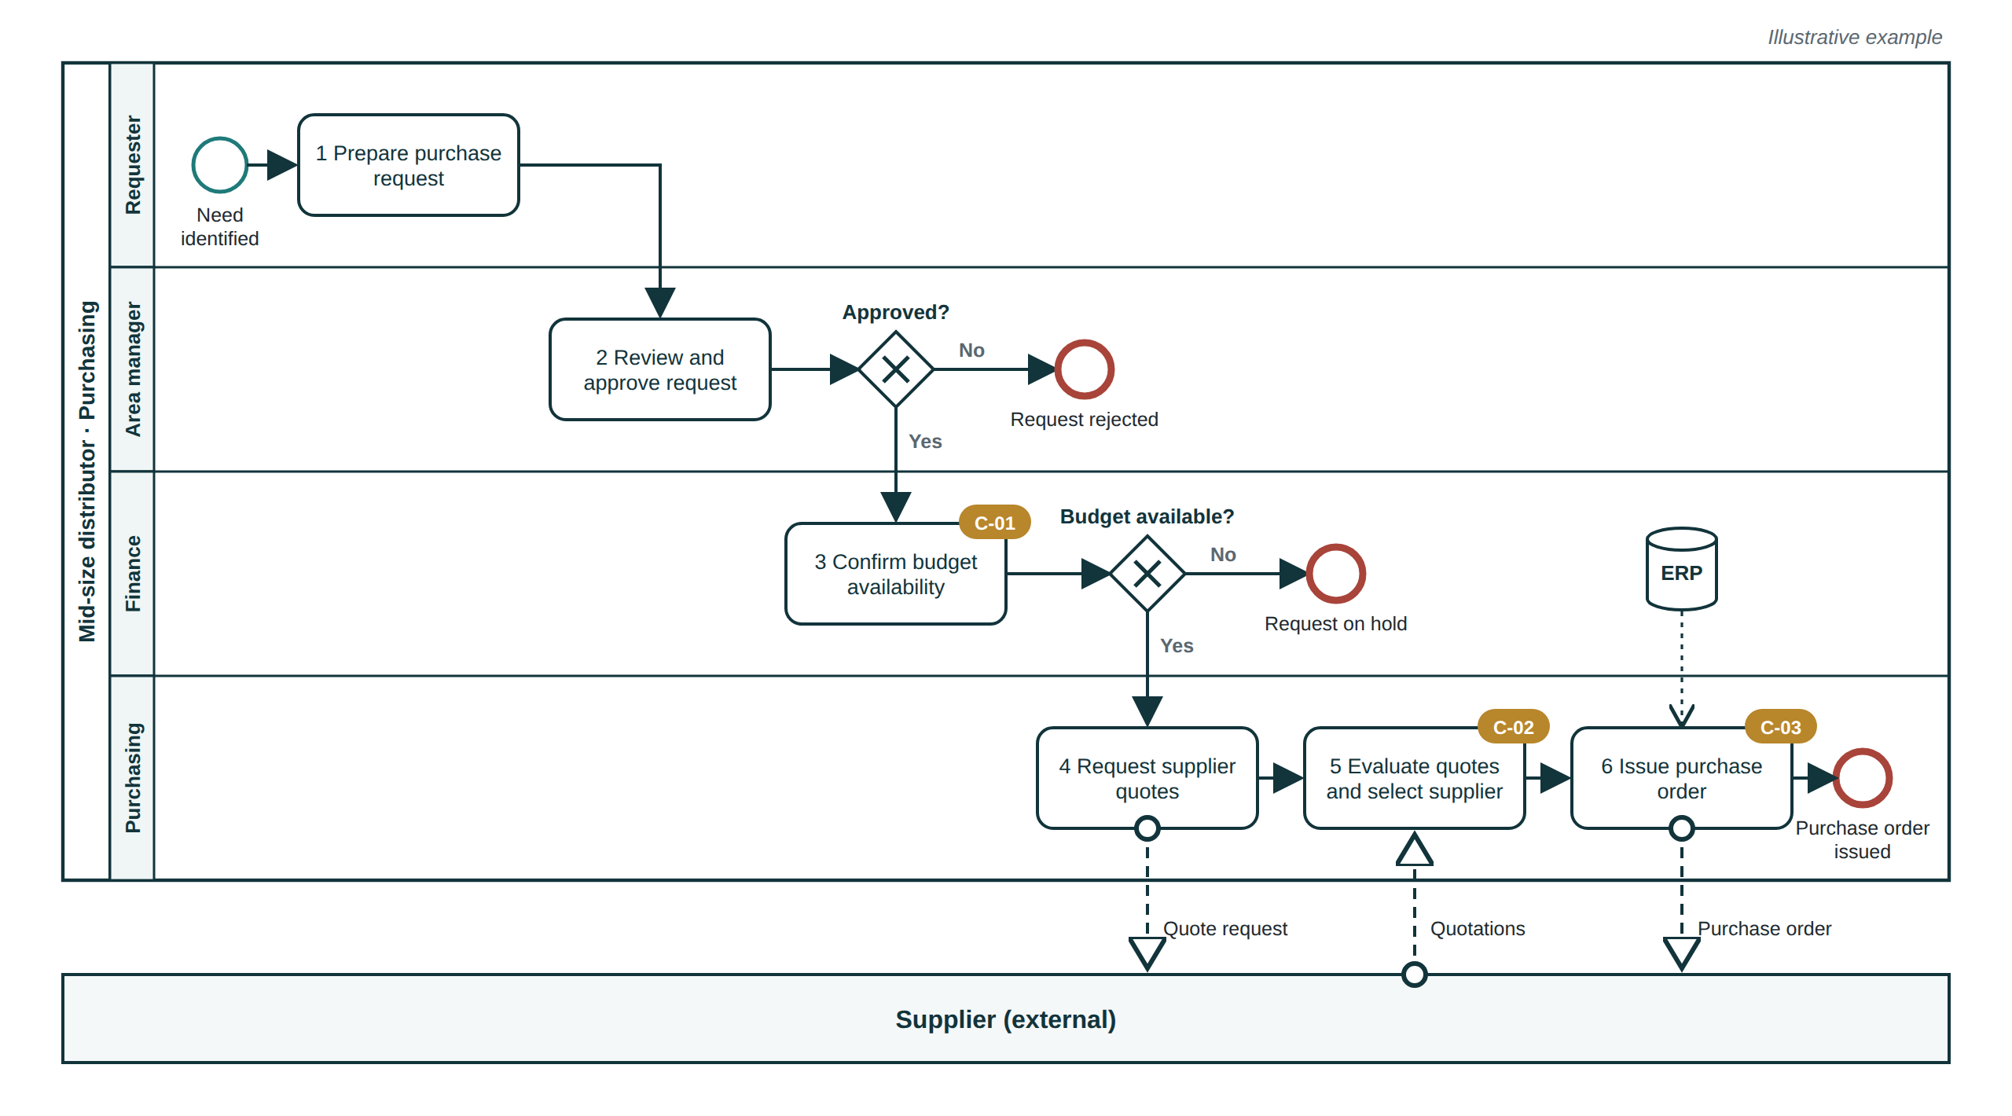
Figure 7. Example flowchart following the rules above (illustrative)

9.2 Step-by-step narrative (5W1H)
The narrative explains each step in words, for readers who find a table easier than a diagram and for detail a diagram cannot carry. It is a table with one row per step, numbered exactly as in the flowchart. Why the procedure exists is stated once in its objective, and why a rule exists is stated in the policy, so the table focuses on the other five questions.
Column | Question | Content rule
No. |  | Step number, identical to the flowchart
Activity | What | Starts with a verb in the present tense; one action per step
Responsible | Who | Position that performs the step (the "R" in the RACI)
Method | How | How the step is done: system and screen, form code, criteria applied, linked work instruction if any
Timing | When | Trigger or moment, and any deadline confirmed by the owner ("within two working days of receipt")
Place | Where | Physical location or system where the step happens
Output |  | What the step produces and where the record is kept; control identifier if the step carries one

Writing rules
- Short sentences in plain language, using the terms staff already use. Terms that need explaining go to the glossary.
- One action per step. If a step needs "and then", it is two steps.
- Decisions are written as conditions: "If the request is within budget, continue to step 4; otherwise go to step 3a."
- No vague timing or quality words ("promptly", "as appropriate", "regularly") unless the manual defines them.
- Forms are referred to by code and name; systems by their official name from the technology inventory.

9.3 RACI matrix
Rows are the steps of the procedure (same numbers), columns are the positions (same as the flowchart lanes). Each cell holds R, A, C, I or is empty. The agent produces one RACI per procedure and a master RACI for the area, plus a summary of the load on each role.
Letter | Meaning | Rule applied
R | Responsible: does the work | At least one per step
A | Accountable: answers for the result and approves | Exactly one per step. If the owner names two, the step is split
C | Consulted: gives input before the step | Kept to those whose input changes the outcome
I | Informed: told after the step | Kept to those who act on the information

Automatic checks run before release: every step has one A and at least one R; every lane in the flowchart appears in the RACI; no role is Responsible for two steps that should be separated (for example approving a payment and executing it). In small companies one person often holds R and A for the same step; that is accepted and noted, and where duties cannot be separated the matrix shows the compensating control.

9.4 Policies and business rules
The manual separates the two, because they are written and tested differently. A policy states the area's commitment or principle ("No purchase is committed without an approved purchase order"). A business rule is a specific, testable condition that puts it into practice ("Purchases above [amount] require the Finance Director's approval"). This follows the COSO principle that control activities are deployed through policies that set expectations and procedures that carry them out.
Field | Content
Identifier | POL-[area]-[nn] for policies; BR-[procedure]-[nn] for business rules
Statement | One rule per statement, written with "must" or "must not", measurable where possible
Type | Authorisation, constraint, calculation, timing, documentation or compliance
Applies to | Procedure and step numbers
Source and origin tag | Regulation and clause, owner confirmation, or Proposed
Owner | Position that maintains the rule
Exceptions | When the rule may be set aside and who may authorise it
Effective and review date | When it applies from and when it will be reviewed

9.5 Risk and control matrix
For each procedure the agent identifies what could go wrong, how likely and serious it is, and what control prevents or detects it. The format follows the risk and control matrices used by internal audit and external auditors, simplified for smaller clients (Section 12).
Column | Content
Risk ID and step | R-[procedure]-[nn], linked to the step where the risk arises
Risk description | Event, cause and consequence in one sentence
Category | Operational, financial reporting, compliance, fraud, information technology, health and safety
Inherent rating | Likelihood and impact on the scale defined at the start of the matrix, before controls
Control ID and description | C-[nn]: who does what, when, how, and what evidence it leaves
Control type | Preventive, detective or corrective
Nature | Manual, manual using system data, or automated
Frequency | Per transaction, daily, weekly, monthly, quarterly or yearly
Control owner | Position responsible for performing the control
Evidence | Form or record code that proves it was done
Key control | Yes / No
Line | First line (operations) or second line (risk, compliance, quality), following the IIA Three Lines Model
Residual rating | Likelihood and impact after the control

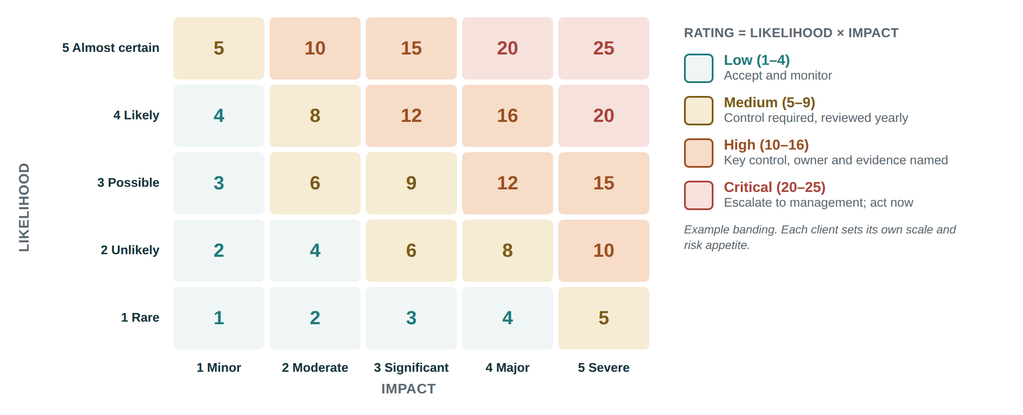
Figure 8. Example rating scale for likelihood and impact
The client sets the scale and the risk appetite; the figure above is the default offered when the client has none. Where segregation of duties is not possible, the matrix states the compensating control (for example an owner's monthly review of all payments, or an independent reconciliation).

10. Annexes and tools for operational staff
A manual is only useful if staff can show that they followed it. The annexes are the blank formats they fill in during daily work. They follow the same design everywhere so that a person who has used one can use any other.

10.1 Design standard shared by every form
- Header: company name and logo, form title, code, version, page x of y.
- Code: [area]-[procedure number]-F[nn], for example PUR-01-F02, so every record traces back to its procedure.
- Instructions: a short note on who fills it in, when, and where it is kept.
- Fields: labelled, with units, in the order the work is done.
- Sign-off block: completed by, reviewed by, date.
- Footer: retention period and location as set in the records schedule (F-07).

10.2 The standard set
Code | Form | Purpose and key fields | Filled in by
F-01 | Execution checklist | Confirms critical items at a defined pause point. Item, step reference, OK, initials, sign-off | Person performing the work
F-02 | Activity log | Record of each transaction or execution. Date, reference, step, performed by, output, remarks | Responsible role
F-03 | Approval form | Authorisation evidence. Request, amount or scope, approver per authority level, decision, date | Requester and approver
F-04 | Exception and incident log | What went wrong and what was done. Date, step, event, immediate action, root cause, corrective action, owner, closed | Anyone; reviewed by owner
F-05 | Control evidence log | Proof that each control ran. Control ID, period, performed by, reviewed by, result, evidence reference | Control owner
F-06 | Indicator tracking sheet | Indicator, period, actual, target, status, comment and action | Process owner
F-07 | Records retention schedule | Record, code, where kept, retention period (confirmed by client), disposal method, responsible role | Process owner
F-08 | Change request and revision history | Version, date, change, reason, requested by, approved by | Document controller
F-09 | Read-and-understood record | Employee, position, procedure, version, date, trainer, signature | Supervisor
F-10 | Validation record | Item, origin tag, proposed text, decision (accept/adjust/reject), decided by, date | Process owner

10.3 Checklist design rules
Checklists fail when they try to list everything. The agent follows the practice popularised by Atul Gawande's work on surgical and aviation checklists:
- Choose the type. READ-DO for infrequent or complex tasks, where the person reads each item and does it. DO-CONFIRM for routine work, where people work from experience and then stop to confirm.
- Define the pause point: the exact moment in the procedure when the checklist is used.
- Keep it short: roughly five to nine items per pause point, limited to the steps that are most dangerous to skip.
- Use the words of the job, fit it on one page and keep the layout plain.
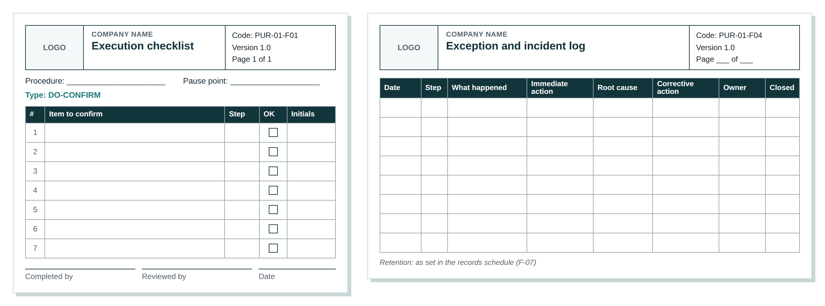
Figure 9. Two of the standard blank formats (execution checklist and exception log)

11. How the agent works, step by step
The process below is described at management level. Technical design is left to the architecture phase. Two steps are gates: the agent does not move on until they are passed.
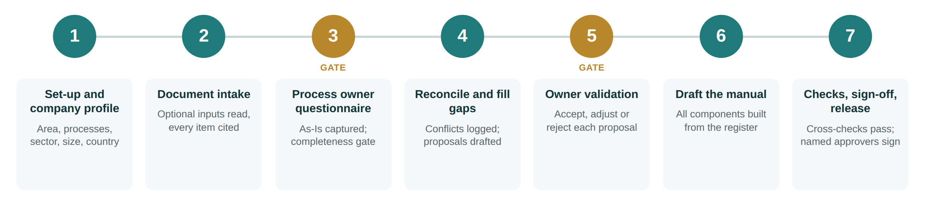
Figure 10. The seven-step process from set-up to release
Step | What happens | What management can rely on
1. Set-up and company profile | The consultant records the area, the processes in scope, sector, size band, country and regulatory exposure. | The right depth and reference practice are chosen from the start.
2. Document intake | Optional documents are uploaded, read and indexed; every extracted item keeps its page reference. | Nothing enters the manual without a traceable source.
3. Process owner questionnaire (gate) | Owners answer the questionnaire; the agent asks follow-up questions where answers are vague or contradictory. Blocks 1 to 6 must be complete. | No procedure is drafted on assumptions.
4. Reconcile and fill gaps | Documents are compared with answers; conflicts go to the gap log; missing corporate inputs are covered by tagged proposals. Everything is recorded in the Process Fact Register. | One agreed version of each fact, with its origin on record.
5. Owner validation (gate) | Proposals and conflicts are reviewed with the owner and accepted, adjusted or rejected. | The client decides; the agent does not.
6. Draft the manual | Flowcharts, narrative, RACI, policies, risk and control matrix, indicators and annexes are generated from the register. | All components agree with each other by construction.
7. Checks, sign-off and release | Automatic cross-checks run (Section 14); the consultant reviews; named client approvers sign; files are released in Word, PDF, BPMN and Excel. | A manual that has been checked and approved by people.

Cross-checks run before release
- Every flowchart task has a narrative row with the same number and wording, and every narrative row has a task.
- Every step has exactly one Accountable and at least one Responsible in the RACI.
- Every lane appears as a RACI column and exists in the role catalogue.
- Every control in the matrix is linked to a step and to an evidence form that exists in the annexes.
- Every form referenced in the narrative exists in the annexes, and every annex form is used somewhere.
- No text in an approved edition carries a Proposed tag in policies, accountabilities or controls.
- Every .bpmn file is valid BPMN 2.0 XML.

12. Scaling the manual to the size of the company
The structure is always the same; the depth is set by the company profile. Three levels keep the manual proportionate: a micro business receives a short, usable document, and a regulated group receives the detail its auditors expect.
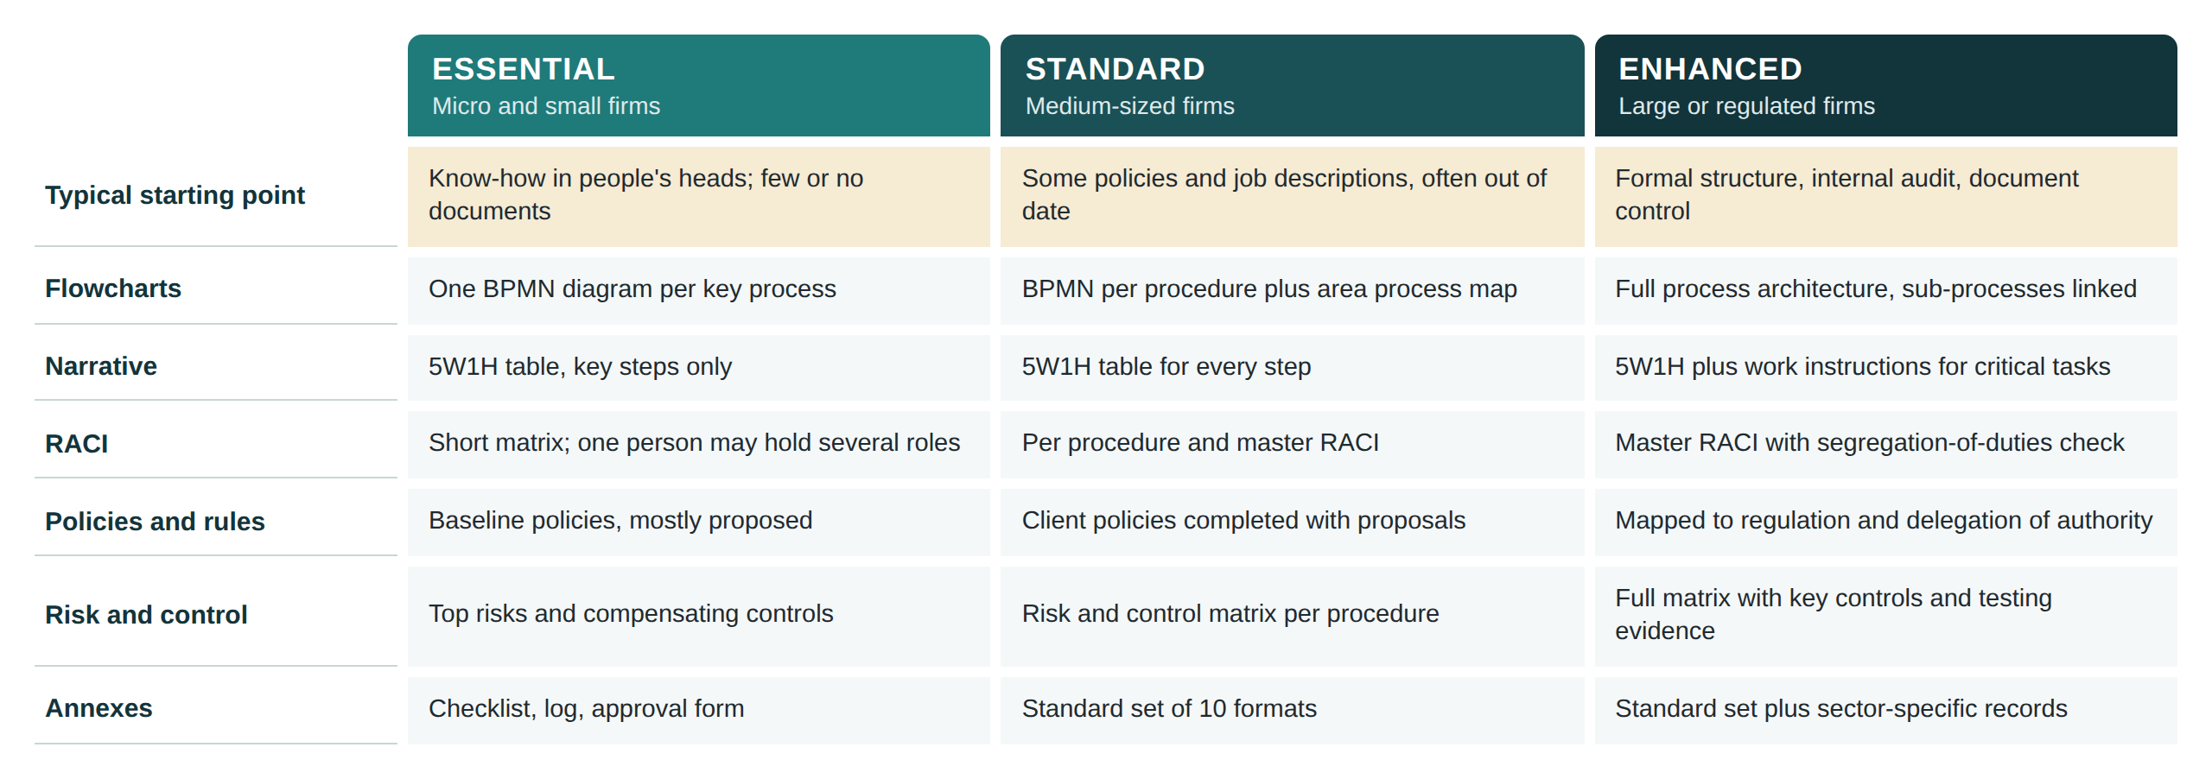
Figure 11. Depth of each component by level
The level is proposed by the agent from the profile and confirmed by the consultant at set-up. A client may choose a higher level for a specific process, for example when preparing for certification or an audit.

13. Scope: what the agent will and will not do
These boundaries define the blueprint for the development team. Anything outside them would need a separate decision.
The agent WILL | The agent will NOT
✓ Document the current operation of the processes in scope, as confirmed by their owners  ✓ Stop and ask when a required input is missing  ✓ Read the client's documents and cite every item to its source  ✓ Propose charts, role profiles, policies, controls and indicators when they are missing, clearly marked  ✓ Produce BPMN flowcharts, 5W1H narrative, RACI, policies and rules, risk and control matrix, indicators and annex forms  ✓ Keep every component consistent with the others  ✓ Record conflicts and improvement opportunities in a separate log  ✓ Size the manual to the company | ✕ Present a proposal as the client's current practice  ✕ Invent steps, roles, systems or timings  ✕ Name individuals in flowcharts, RACI or controls  ✕ Propose salaries, grading or performance assessments  ✕ State legal obligations, deadlines or retention periods as fact without confirmation  ✕ Set approval amounts, thresholds or indicator targets  ✕ Redesign processes beyond improvements the owner accepts  ✕ Certify compliance with ISO or any regulation, or replace sign-off by the client and the consultant

14. Acceptance criteria
The development team and management can use these criteria to judge whether the built agent meets this brief.
Criterion | Target
Procedures drafted while a required input block (1 to 6) was incomplete | None
Items in the working draft without an origin tag | None
Open proposals in policies, accountabilities or controls in an approved edition | None
Flowchart tasks that match a narrative step in number and wording | 100%
Steps with exactly one Accountable role | 100%
Controls linked to a step and to an existing evidence form | 100%
Forms referenced in the text that exist in the annexes | 100%
Flowchart files that validate as BPMN 2.0 and open in a standard modelling tool | 100%
Individuals named in flowcharts, RACI or controls | None
Manuals released without named client approval | None

15. Decisions requested and open points

For management
- Approve the input model: three required blocks, four optional inputs and the completeness gate.
- Confirm the "client reality first" rules and the limits on what the agent may propose.
- Approve the manual structure and output standards as the blueprint for the development team.

Open points to settle during architecture mapping
Open point | Why it matters
Size band definitions per country | Headcount bands differ by country and sector; they set the depth level
Content and upkeep of the reference practice library | Proposals are only as good as the library; someone must own and review it
How the questionnaire is delivered (guided session, online form, or both) | Affects answer quality and the consultant's time
Default risk scale (5×5 or 3×3) for small clients | Simpler scales are easier to use; finer scales are expected by auditors
Who signs the approved edition on the client side | Sets accountability for the content
Languages of the manual | Affects templates, terminology and review
BPMN tool used to validate files before release | Defines the technical check behind flowchart rule F12

Appendix A. Process owner questionnaire (question bank)
Questions are asked in this order for every process. The consultant may add questions; the agent adds follow-ups when an answer is vague, contradicts a document or leaves a path without an end.
1. Identity | 1. What is this process called in your area?  2. In one sentence, what is it for?  3. Who owns it: who answers if it fails?  4. Who receives its result, inside or outside the company?
2. Boundaries | 1. What event or request starts it?  2. What is the final result, and when is it considered finished?  3. What looks related but is handled by another process?
3. Sequence | 1. Walk me through the steps in the order they happen.  2. Who does each step (position, not name)?  3. How long does each step usually take?  4. Which steps are done at the same time?
4. Decisions and exceptions | 1. Where is a decision made, and on what criteria?  2. Who approves what, and up to what limit?  3. What happens when something is missing, wrong or late?  4. What is the most common exception, and how is it handled?
5. Inputs, outputs, handoffs | 1. What information or documents do you receive, and from whom?  2. What do you hand over, and to whom?  3. Where do handoffs usually get stuck?
6. Systems and tools | 1. Which system or tool is used at each step?  2. Is any step done in a spreadsheet, on paper or by message?  3. Which system holds the official record?
7. Volume and timing | 1. How many times does this happen per day, week or month?  2. Are there peaks in the year?  3. Are there fixed deadlines, internal or external?
8. Records | 1. What evidence is kept that the work was done?  2. Where is it kept, and for how long?
9. Problems and risks | 1. What goes wrong most often?  2. What has gone wrong in the past that you would not want to repeat?  3. Which step depends on one person only?  4. Where is there rework?
10. Rules and constraints | 1. Which internal rules govern this process?  2. Which laws or regulations do you understand apply?  3. Are there customer or supplier contract terms that affect it?
Objectives and indicators | 1. What must this area achieve this year?  2. How do you know whether the process is working?  3. Which figures do you already track, how, and how often?
Technology inventory | 1. List every system, piece of equipment and informal tool used in the area.  2. For each: what it is used for, at which steps, who uses it, who controls access.

Appendix B. Worked example: one procedure, every format
This example shows how the formats fit together for the purchasing procedure in Figure 7. The company, roles and rules are illustrative. Values in square brackets are left for the client.

Identification and scope
Field | Content
Procedure | PUR-01 Purchase request to purchase order · Version 1.0 · Owner: Purchasing Manager
Objective | Buy what operations need, from suitable suppliers, within the approved budget, with evidence of each approval
Scope | Starts when an area identifies a need; ends when a purchase order is issued or the request is rejected or put on hold. Excludes receipt of goods and payment (procedures PUR-02 and FIN-03)

SIPOC
Suppliers | Inputs | Process | Outputs | Customers
Requesting areas; Finance; suppliers | Purchase request; budget; quotations | Request, approve, check budget, quote, select, order | Purchase order; rejection notice | Requesting area; supplier; Accounts payable

Narrative (extract)
No. | Activity | Responsible | How | When | Where | Output
1 | Prepares purchase request | Requester | Completes form PUR-01-F03 with item, quantity, date needed | When a need is identified | ERP | Request in ERP
2 | Reviews and approves request | Area manager | Checks need and priority; approves or rejects in ERP | Within [n] working days | ERP | Approved or rejected request
3 | Confirms budget availability | Finance analyst | Compares amount with available budget line | On approval | ERP | Budget check [C-01]
4 | Requests supplier quotes | Buyer | Sends request to at least [n] suppliers from the approved list | On budget confirmation | E-mail / ERP | Quote requests
5 | Evaluates quotes and selects supplier | Buyer | Scores price, lead time and terms on comparison sheet | When quotes are received | ERP | Comparison [C-02]
6 | Issues purchase order | Purchasing manager | Creates and signs order in ERP; sends to supplier | After selection | ERP | Purchase order [C-03]

RACI
Step | Requester | Area manager | Finance | Buyer | Purchasing mgr.
1 Prepare request | R | A |  | I
2 Approve request | I | A/R
3 Confirm budget |  | I | A/R
4 Request quotes |  |  |  | R | A
5 Select supplier | C |  |  | R | A
6 Issue order | I |  | I | C | A/R

Policy and business rules
ID | Statement | Type | Origin
POL-PUR-01 | No purchase may be committed to a supplier without an approved purchase order. | Authorisation | Confirmed
BR-PUR01-01 | Purchases above [amount] must be approved by the Finance Director before the order is issued. | Authorisation | Proposed
BR-PUR01-02 | At least [n] quotations must be obtained for purchases above [amount], unless a sole-source exception is approved. | Constraint | Proposed

Risk and control matrix (extract)
Risk | Rating | Control | Type | Owner | Evidence
R-PUR01-01 Purchase exceeds budget because availability is not checked, causing overspend | L3 × I3 = 9 | C-01 Finance confirms budget line before quotes are requested | Preventive, manual | Finance analyst | ERP budget check log
R-PUR01-02 Supplier chosen on relationship rather than merit, leading to higher cost or fraud | L2 × I4 = 8 | C-02 Comparison sheet signed by buyer and reviewed by Purchasing manager | Preventive, manual | Purchasing manager | PUR-01-F05
R-PUR01-03 Order issued without authority for its amount | L2 × I4 = 8 | C-03 ERP blocks orders above the approver's limit | Preventive, automated | Purchasing manager | ERP approval trail

Likelihood and impact ratings in this example are illustrative; in a real engagement they come from the owner's answers and the client's scale.

Appendix C. Glossary
Term | Meaning
As-Is | How a process is actually performed today, as opposed to how it should be (To-Be)
BPMN | Business Process Model and Notation, the international standard for drawing process diagrams
Business rule | A specific, testable condition that governs a step, such as an approval limit
Compensating control | A control that reduces a risk when the ideal control, such as separating two duties, is not possible
Control | An action that prevents or detects an error or irregularity, and leaves evidence
Gap log | The record of differences between documents and what process owners describe
Origin tag | The label showing whether an item is Confirmed, from a Client document, or Proposed
Pause point | The moment in a procedure when a checklist is used
Policy | A statement of the area's commitment or principle that guides decisions
Process owner | The person who answers for a process and its results
Process Fact Register | The single record inside the agent where every step, role, rule, system and control is stored with its origin
RACI | Responsible, Accountable, Consulted, Informed: the roles each position plays in a step
Segregation of duties | Splitting authorisation, custody, recording and reconciliation between different people so no one can both make and hide an error
SIPOC | Suppliers, Inputs, Process, Outputs, Customers: a one-page view of a process
Work instruction | Detailed description of how to perform a single task

Appendix D. References consulted
- ISO 9001:2015 Quality management systems: Requirements (clause 7.5, documented information).
- ISO 10013:2021 Quality management systems: Guidance for documented information.
- ISO, ISO 9001:2015 for Small Enterprises: What to do? Advice from ISO/TC 176.
- Object Management Group, Business Process Model and Notation (BPMN) 2.0; ISO/IEC 19510.
- Bruce Silver, BPMN Method and Style, 2nd edition, and the BPMN style rules published by Trisotech and methodandstyle.com.
- APQC, Process Classification Framework (PCF) and "Understanding the elements of APQC's PCF".
- COSO, Internal Control: Integrated Framework (2013).
- The Institute of Internal Auditors, The IIA's Three Lines Model (July 2020).
- US Environmental Protection Agency, Guidance for Preparing Standard Operating Procedures, EPA QA/G-6 (EPA/600/B-07/001).
- IIBA, A Guide to the Business Analysis Body of Knowledge (BABOK Guide) v3, elicitation techniques.
- Guías técnicas para la elaboración de manuales de procedimientos: Secretaría de Relaciones Exteriores, Secretaría de Salud, Suprema Corte de Justicia de la Nación, UNAM, CONALEP (Mexico).
- E. B. Franklin Fincowsky, Organización de empresas, McGraw-Hill.
- A. Gawande, The Checklist Manifesto (2009).
- McKinsey & Company, "How to identify the right spans of control for your organization".
- European Commission Recommendation 2003/361/EC on the definition of micro, small and medium-sized enterprises.
- ASQ, SIPOC resources; SHRM, job description guidance.

