NEPOPS — DIGITAL MARKETING
BASE + SECONDARY CAMPAIGN STRATEGY
Field | Detail
Client | Pensiones México (Meta campaigns)
Prepared for | Prerana Subedi and management
Date | October 2026
Data used | September 2026 report (spend, messages, cost per message, assigned, closures); sales and backlog figures for June–October; 14 assigned leads in October to date
Purpose | Assess how to test secondary campaigns without touching the current (base) campaigns, and what the sales backlog says about follow-up and pipeline health

Figures marked “calc.” are calculated from the data above. Meta platform behaviour is summarised from the sources in Appendix A; confirm settings in Ads Manager before building, as Meta changes options often.

Summary
- The backlog matters more than it looks. 31% to 100% of each month's sales came from leads generated in earlier months (calc.), and one May lead closed in August. Follow-up over 30–90 days is part of the sales process, not an extra.
- September is at risk. None of September's 22 assigned leads has closed yet. Its 3 sales all came from August leads. Recovering September and August leads is the fastest available win.
- Start with recovery, not prospecting. The cheapest first secondary activity is a staged GHL reactivation of old conversations, backed by a small retargeting campaign to people who already engaged. Both target people who already know the brand.
- Keep the base untouched for real. Any edit to a base ad set (budget, audience, creative) can send it back into learning. Secondary campaigns must be new, separate campaigns; the base gets no edits during the test window.
- Same city, different people. In the same location, separate the secondary by audience (retargeting custom audiences) rather than geography. Meta only enters one of your own ad sets per auction, so some overlap is managed, but heavy overlap raises costs.
- Budget the secondary small and separately: about 15–25% of the base campaign's daily budget, funded as new money rather than taken from the base. At September's costs, a prospecting ad set would need $56–116/day to reach Meta's ~50 results/week learning threshold, which is too much pressure; accept “learning limited” and judge results over 14 days.
- One test per city at a time, with fixed decision rules written before launch, so a bad week does not trigger panic changes.

1. What the sales backlog tells us

Sales by month and lead origin
Month | Sales from earlier leads (backlog) | Sales from same-month leads | Total sales | Backlog share
June | 5 (May leads) | 11 | 16 | 31.3%
July | 8 (June leads) | 6 | 14 | 57.1%
August | 3 (2 July + 1 May leads) | 5 | 8 | 37.5%
September | 3 (August leads) | 0 | 3 | 100.0%
October (to date) | 5 August leads pending | — | — | —

Totals match the closures in the monthly reports (16, 14, 8, 3). Two entries in the source notes were read as follows and should be confirmed: September's “August sales from August: 0” is read as 0 sales from September leads; October's “backlogs from August: 5” is read literally (August leads, still pending).
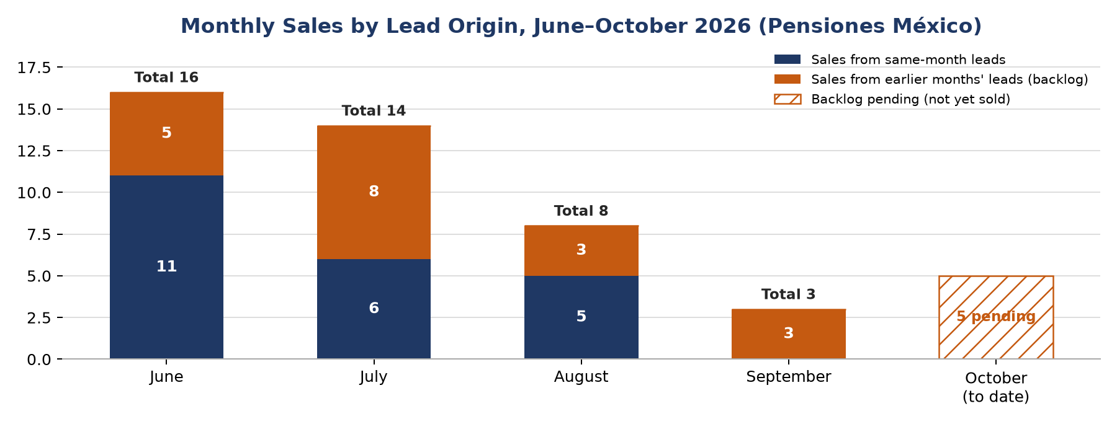
Chart 1. Monthly sales split by lead origin.

Cohort view: how each month's leads converted
Lead month | Assigned | Sold to date | Assigned → sale | Still open
June | 86 | 19 (11 + 8) | 22.1% | —
July | 77 | 8 (6 + 2) | 10.4% | —
August | 40 | 8 (5 + 3) | 20.0% (up to 32.5% if the 5 pending close) | 5 pending
September | 22 | 0 | 0.0% so far | Not reported
October (to 7 Oct) | 14 | — | — | —

Calc. May leads also produced 6 sales (5 in June, 1 in August), but May's assigned total is not available.
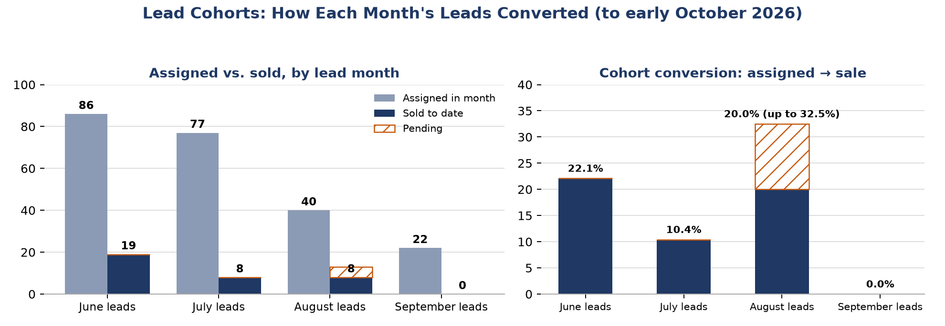
Chart 2. Assigned leads and sales by lead month.

What this means
- A large share of sales closes in the following month or later. Backlog accounted for 31–57% of sales from June to August and all of September's sales. The sales cycle regularly runs past 30 days, and at least one lead took about three months.
- Monthly conversion figures mix cohorts. The monthly report divides a month's closures by that month's assigned leads, but many of those closures belong to earlier leads. September's 13.6% assigned → closure was entirely August leads; September's own leads have converted at 0% so far. Tracking by lead month gives a truer picture.
- Lead quality varies by cohort. June's leads converted at 22.1% and August's at least 20.0%, but July's at 10.4% despite high volume (77 assigned). Volume alone does not guarantee sales.
- The pipeline is thin and depends on follow-up. Sales fell from 16 to 3 in three months. The 5 pending August leads are about two months old and are the most immediate revenue at risk.
- October started faster. 14 assigned in the first 7 days (7 on 7 October alone) compares with 22 in all of September, about 2.7 times the daily pace (calc.). One week, and one unusually strong day, is too early to call a recovery, but it raises the importance of fast, consistent follow-up so this volume does not become another backlog.

Pipeline health actions
- Track every lead in GHL with: creation date, assigned date, advisor, source campaign, current stage, last contact date, and sale date. Report conversion by lead month (cohort), not only by calendar month.
- Review open leads weekly by age band: 0–7 days, 8–30, 31–60, 61–90 and 90+ days.
- Prioritise in order: the 5 pending August leads, then September's 22 assigned leads, then October's new assignments.
- Record a reason for every lead that goes quiet or says no (price, timing, documents, trust, not eligible). This shows what the follow-up content needs to answer.

2. The base + secondary model
The base campaigns protect volume; the secondary campaigns are where learning happens. This only works if the two are kept strictly separate.
Rule | Why
Secondary campaigns are new, separate campaigns (not new ad sets inside the base campaign) | Avoids changing the base campaign's structure and budget distribution
No edits to base ad sets during a test (budget, audience, creative, placements) | Significant edits restart Meta's learning phase and would contaminate the comparison
One clear purpose and one primary KPI per secondary campaign | Makes the result readable after 14 days
Secondary budget is new money, not taken from the base | Cutting the base budget is itself an edit and recreates the pressure you want to avoid
One secondary test per city at a time | Two tests in the same city compete with each other and blur results
Decision rules written before launch | Prevents reactive changes after one bad day

3. Secondary campaign options
Option | Purpose and audience | Primary KPI | Fit and risk | Priority
A. GHL reactivation (no ad spend) | Staged follow-up of old conversations and open leads in GHL | Replies, re-assigned leads, sales from old leads | Highest value per cost; limited by messaging-window rules (Section 4) | 1
B. Retargeting | People who already engaged with the Page, Instagram, videos or sent a message; customer-list audiences from GHL | Cost per message and message → assigned rate vs. base | Small audiences, so cheap but slow; good for trust content | 2
C. New creative angle | Same broad audience as base, new angle (e.g. advisor-led or testimonial Reels) | Cost per message vs. base | Competes with base for the same people; keep budget small | 3
D. WhatsApp destination | Same audience, click-to-WhatsApp ad to the official WhatsApp Business Platform (WABA) | Cost per conversation and assigned rate | Barcco has been on WABA since 29 Sep; measure it first; WABA messages outside 24 h need paid templates | 3
E. Different audience | e.g. a different age band, or adult children of retirees | Cost per message, assigned rate | Highest uncertainty; test after A and B | 4

Recommended order: start A immediately, add B in the two cities with the most open leads, and only then test C, D or E one at a time.

4. Lead recovery: GHL's role and the messaging rules
GHL is the right place to run recovery: it holds the contact history and can run staged workflows. But how you can re-contact someone depends on the channel they used.
Channel | What you can send | Implication for old leads
Messenger / Instagram | Free-form replies within 24 hours of the person's last message. The HUMAN_AGENT tag allows a manual reply by a person within 7 days (it requires Meta approval). Tags cannot carry promotional content. | Conversations older than 7 days cannot be reopened by message. Recover them with retargeting ads, or by phone or WhatsApp if a number was captured.
WhatsApp Business Platform (WABA) | Free-form messages within 24 hours of the customer's last message; outside that, only approved templates. Marketing templates are charged per message (a third-party summary lists about US$0.04 per message in Mexico; verify). | Old WhatsApp leads can be re-contacted with approved templates, at a small cost per message.
Phone / SMS | Direct contact by the advisor | Best for warm leads with a captured number, such as the pending August leads

From 1 October 2026, Meta also charges for service messages and utility templates inside the 24-hour WhatsApp window, with the first 1,000 service messages per number per month free (per third-party summaries of Meta's pricing). Check the current rate card.

Staged reactivation plan (by lead age)
Stage | Leads | Action | Channel
1 | Pending and recently assigned (August–October) | Advisor contact within the week; clear next step (documents, appointment) | Phone / WhatsApp
2 | Messaged in the last 7 days, no reply | Manual follow-up by the advisor | Messenger (human agent), WhatsApp
3 | 8–90 days old | Approved WhatsApp template with a simple reason to reply; retargeting with trust content | WABA template + retargeting ads
4 | 90+ days old | One reactivation attempt, then retargeting only | Template or retargeting

- Send in small batches (e.g. one stage or one city per day) so advisors can answer replies quickly and results can be measured per stage.
- Tag each contact by stage and outcome in GHL so recovered sales can be counted separately.
- Use GHL's “Add to Custom Audience” workflow action to feed open leads into a Meta retargeting audience automatically, and to remove people once they are assigned or sold.
- Use GHL's Conversions API action to send “assigned” and “sale” events back to Meta. Over time this lets Meta learn which messages become real leads, not just which people send messages.
- Privacy: Mexico's new personal data law (in force since 21 March 2025) requires free, specific and informed consent, and fresh consent when data is used for a new purpose. Confirm that the privacy notice covers follow-up messages and ad audiences before uploading contact lists to Meta.

5. Custom Audiences and retargeting
Audience | Source | Suggested window | Use
People who messaged the Page / Instagram | Page or Instagram engagement (check it is listed in your account) | 30–180 days | Retarget conversations that went quiet
Page and Instagram engagers | Page / Instagram engagement | 30–90 days | Warm audience for trust content
Video viewers (50%+) | Video engagement | 30–90 days | People who watched the Reels
Open leads from GHL | Customer list (phone numbers) via GHL workflow | Live, updated by GHL | Recovery of known leads
Assigned and sold contacts | Customer list from GHL | Live | Exclude from all campaigns; later a lookalike source

- Retention limits differ between Meta's interface and its API documentation (365 vs. 730 days for Page audiences), so confirm the maximum window when building.
- Detailed-targeting exclusions (interests, behaviours) have been removed, but Custom Audience exclusions still work, including with Advantage+ Audience.
- Retargeting audiences per city will be small. Expect low daily volume, so judge them on cost per message and message → assigned rate, not volume.
- Lookalikes from sold customers need a reasonably large source list; at the current sales volume this is a later step.

6. Two campaigns in the same location without competing
When two of your own ad sets target the same person, Meta does not let them bid against each other: it enters only the ad with the highest total value into that auction (“auction overlap”). This protects price, but heavy overlap causes the weaker ad set to under-deliver or pay more. The aim is therefore to give the secondary campaign different people, not just a different ad.
Separation method | Touches base? | Effect | Recommendation
Different audience: secondary = retargeting custom audiences only | No | Small, distinct pool; overlap limited to people the base would also reach | Best first option
Exclude the retargeting audience from the base | Yes (targeting edit) | Cleanest separation | Only at a planned moment, not mid-test
Different geography inside the city | Yes, if base covers the whole city | Clean, but Barcco's base now covers all of Monterrey in one bubble | Not available without editing base
Different creative or destination only | No | Same people, so the ad sets fight for the same auctions | Only with a small budget

Example: Barcco in Monterrey
- Base (untouched): the current Barcco campaign (whole Monterrey, one bubble, age 60–65+, WABA since 29 Sep, $250/day).
- Secondary: a new campaign targeting only Custom Audiences in Monterrey: people who messaged or engaged in the last 90 days, plus open Barcco leads from GHL; exclude assigned and sold contacts. Trust and advisor content, not the same ads as the base. $40–60/day.
- KPI: message → assigned rate higher than the base, at a cost per message no more than about 1.5 times the base ($13.08 in September).
- Watch: the base's daily messages and cost per message. If the base drops noticeably after launch, the overlap is costing you; pause the secondary rather than editing the base.
Existing overlap to be aware of: Barcco and PAM both target Monterrey (age 60–65+), and Pensión 360 and Nosotros both target CDMX. They run under different Pages and ad accounts, so Meta treats them as separate advertisers that bid against each other for the same older audience. This may be pushing up delivery cost (cost per 1,000 impressions rose 8.5% in September). It is a hypothesis worth checking before adding more campaigns in those cities.

7. Budget for a secondary campaign
Meta's learning phase typically needs about 50 optimisation events per ad set within 7 days to stabilise. At September's cost per message, this is what a prospecting secondary ad set would need:
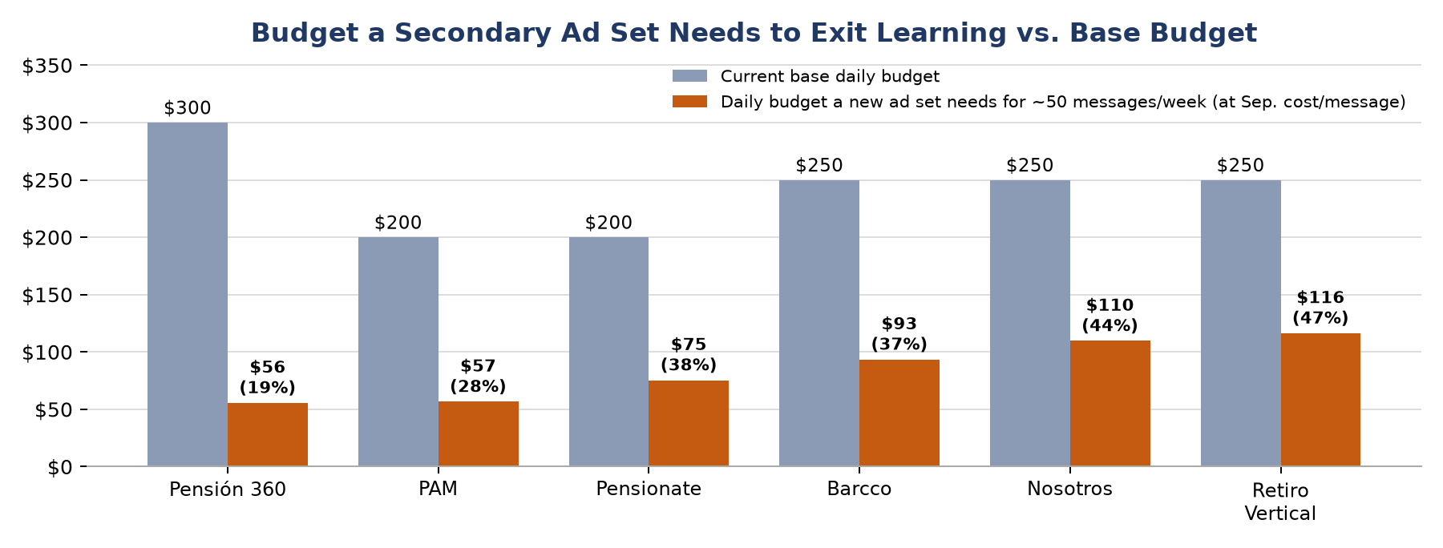
Chart 3. Daily budget for ~50 messages/week (calc. as 50 × September cost per message ÷ 7) vs. current base daily budget.
Campaign | Base budget/day | Sep. cost/msg | Needed for 50 msgs/week | Recommended secondary (15–25%) | Expected msgs/week at 20%
Pensión 360 | $300 | $7.78 | $56/day (19%) | $45–75/day | ~54
PAM | $200 | $7.93 | $57/day (28%) | $30–50/day | ~35
Pensionate | $200 | $10.55 | $75/day (38%) | $30–50/day | ~27
Barcco | $250 | $13.08 | $93/day (37%) | $40–60/day | ~27
Nosotros | $250 | $15.35 | $110/day (44%) | $40–60/day | ~23
Retiro Vertical | $250 | $16.28 | $116/day (47%) | $40–60/day | ~22

- Recommendation: about 15–25% of the base budget, as additional spend. For Barcco that is $40–60/day. Only Pensión 360 can realistically reach the learning threshold at that level.
- Retargeting is sized by audience, not by learning: start at $25–40/day per city and raise it only if frequency stays reasonable and costs hold.
- Account-level cap: keep all secondary spend at or below about 15% of total base budget at first ($1,550/day → about $230/day across all tests).
- Scaling a winner: raise budget by about 20% at a time, no more often than every 3–4 days, to avoid resetting learning.

8. How long Meta needs to learn
- Threshold: about 50 optimisation events per ad set in 7 days. It applies per ad set, not per campaign or per ad account.
- Same ad account does not skip learning. Account history and the Page's past data help Meta's predictions, but every new ad set starts its own learning phase.
- Significant edits reset learning: budget changes (sources suggest above roughly 20%), targeting, creative, optimisation event and bid strategy.
- What to expect at our costs: a secondary ad set at $40–60/day will usually show “Learning limited”. That is acceptable for a test, but results are noisier, so do not judge before 7 days, and decide at 14 days.
- Minimum evidence before deciding: about 30–50 messages in the secondary, plus its assigned count. Message → assigned matters more than cost per message.

9. 30-day test plan and decision rules
Week | Actions
Week 1 | Contact the 5 pending August leads and September's 22 assigned leads. Set up GHL fields, stages and age bands. Build Custom Audiences and the GHL audience sync. Agree each test's KPI and stop rules.
Week 2 | Launch GHL reactivation stages 2–3 in small batches. Launch one retargeting campaign in one or two cities (e.g. Barcco Monterrey). No base edits.
Week 3 | Day-7 check only (no changes unless a stop rule triggers). Keep reactivation running.
Week 4 | Day-14 decision: keep, scale ~20%, or stop. If kept, add the next test (C, D or E) in a different city.

Decision rule (agree before launch) | Action
Cost per message above 2× base after spending about 5× base cost per message, with no assigned leads | Stop the test
Base messages fall clearly below their 14-day average after launch | Pause the secondary, not the base
Day 14: message → assigned at or above base and cost per assigned at or below base | Keep and scale ~20%
Day 14: mixed results | Keep 7 more days, or change one variable only

10. Other ways to get more from the campaigns
- Measure quality, not just messages. Send “assigned” and “sale” events from GHL to Meta through the Conversions API, and report cost per assigned and per sale by campaign each week.
- Tag the source of every conversation. Use a different pre-filled message or reference per campaign so GHL shows which campaign each lead came from.
- Response speed. Set a target response time for advisors and track it in GHL; slow first replies are a likely cause of message → assigned losses (to be confirmed with the data).
- Advisor capacity. If October's pace continues, four advisors will receive far more leads than in September. Agree how many each can follow up before increasing spend.
- Channel stability. WhatsApp accounts were blocked in August. The official WhatsApp Business Platform, as now used by Barcco, is more stable but costs per message; compare it on assigned leads, not only cost per message.
- Fewer, measurable changes. September had restructuring on six dates. With the base + secondary model, base changes become rare and planned, and tests happen in the secondary.

11. Information needed to refine this plan
- Assigned leads and sales by campaign (not only totals), to see which campaigns produce buyers, not just messages.
- Whether the secondary budget can be added on top of the base, and the maximum monthly amount.
- Confirmation of the two backlog entries noted in Section 1.
- Which channel each open lead came through (Messenger, WhatsApp App, WABA), to plan the reactivation channel.
- The size of the Custom Audiences per city, once built.

Appendix A. Sources
- Learning phase (~50 optimisation events in 7 days; resets after significant edits): AdManage, “Facebook ads learning phase guide”; Jetfuel Agency, “What is the Meta Ads learning phase? (2026)”; The Ad Spend, “Learning phase”.
- Auction overlap: Jon Loomer, “Auction Overlap” (jonloomer.com/glossary/auction-overlap).
- Engagement Custom Audiences and retention limits: Meta for Developers, “Engagement Custom Audiences”; AdsUploader, “Facebook custom audience” guide.
- Custom Audience exclusions still available; detailed-targeting exclusions removed: AdsUploader, “Facebook custom audience exclusions”; Linear Design, “Meta's Advantage+ Audience”.
- Messenger 24-hour window and HUMAN_AGENT tag (7 days); retired tags in 2026: Meta for Developers, “Send a Message” and Messenger Platform changelog.
- WhatsApp pricing and 24-hour window, including the 1 October 2026 change: Meta for Developers, “Pricing on the WhatsApp Business Platform”; respond.io, “WhatsApp pricing change 2026”.
- GHL workflow actions “Add to Custom Audience” and Conversions API: Growthable, “List of workflow actions for GoHighLevel”; Mastermind help, “Workflow Action: Facebook – Add To Custom Audience”.
- Mexico personal data law (LFPDPPP, in force 21 March 2025): Hogan Lovells, “Mexico's new federal data protection law”; Garrigues, “México: nueva Ley Federal de Protección de Datos Personales”.

